CHAPTER 1
INTRODUCTION

GST is a new buzz in the arena of Indian Business environment. GST in a very small time period has become the talk of town and the matter of discussion for all. Goods and Service tax is one of the largest tax reforms after the independence of this country. GST is a destination based tax and levied at a single point at the time of consumption of goods or services by the ultimate consumer. GST is based on the principle of value added tax (VAT).GST law emphasizes on voluntary compliance and on accounts based reporting and monitoring system. It is a comprehensive levy and envisages tax collection on both goods and services at the same rate.
Internationally, GST was first introduced in France and now more than 160 countries have introduced GST. Most of the countries, depending on their own socio -economic formation, have National level GST or Dual GST.
GST is collected and paid at all stages of the supply chain. All business pays GST when they buy, supplies assets, or services for running their business. GST registrants will charge and collect GST on taxable goods and services that they provide. The GST paid on their purchases (input tax) will be set off from the GST they charged and collected (output tax). If the output tax exceeds the input tax the difference is to be remitted to the customs authorities. On the other hand, the end customer is borne to pay the ultimate GST. It is levied and collected on value addition at each stage of sale or purchase of goods or supply of services based on input tax credit method without state boundaries, there is no distinction between taxable goods and taxable services. That they are taxed at single rate in a supply chain of goods and services till the goods and services reach the consumer. The administrative power generally vests with a single authority to levy tax on goods and services.
Goods & Services Tax Law in India is a comprehensive, multi-stage, destination - based tax that will be levied on every value addition. To understand this, we need to understand the concepts under this definition. Let us start with the term „Multistage‟. Now, there are multiple steps an item goes through from manufacture or production to the final sale. Buying of raw materials is the first stage. The second stage is production or manufacture. Then, there is the warehousing of materials. Next come the sale of the product to the retailer. And in the final stage, the retailer sells you – the end consumer – the product, completing its life cycle. Goods and Services Tax (GST) is an indirect tax which was introduced in India on 1 July 2017 and was applicable throughout India which replaced multiple cascading taxes levied by the central and state governments.
1.2 SIGNIFICANCE OF THE STUDY
The idea behind having one consolidated indirect tax to subsume currently existing indirect taxes is to benefit the Indian economy in a number of ways. It will help the country„s businesses gain a level playing field. It will put us on par with foreign nations who have a more structured tax system. It will also translate into gains for the end consumers who not have to pay cascading taxes any more. There will now be a single tax on goods and services. In addition to the above, the Goods and Services Tax Law aims at streamlining the indirect taxation regime. As mentioned above, GST will subsume all indirect taxes levied on goods and service, including State and Central level taxes. The GST mechanism is advancement on the VAT system, the idea being that a unified GST Law will create a seamless nationwide market. It is also expected that Goods and Services Tax will improve the collection of taxes as well as boost the development of Indian economy by removing the indirect tax barriers between states and integrating the country through a uniform tax rate
1.3 STATEMENT OF THE PROBLEM
GST is the single tax on the supply of goods and services, right from the manufacturer to the consumer. Credits of input taxes paid at each stage will be available in the subsequent stage of value addition, which makes GST essentially a tax on value addition at each stage. The final consumer will thus bear only the GST charged by the last dealer in the supply chain, with set off benefits at all the previous stages. In this, context local trader (last dealer) should have a thorough knowledge on GST and its application on various products. Therefore it is important to analyze and study the awareness level of traders about goods and service tax. Hence this study is conducted.
  - OBJECTIVES OF THE STUDY
- To check awareness of traders about goods and service tax
- To identify issues encountered by local traders while applying GST\
- To know the level of satisfaction towards the implementation of GST
- Overview on traders attitude towards GST
1.5 SCOPE OF THE STUDY
The study titled “AWARENESS ABOUT GST AMONG LOCAL TRADERS WITH SPECIAL REFERENCE TO KANNUR AREA” is limited in Kannur district
1.6 METHODOLOGY
It may include publications, research interviews, surveys and other techniques and could include both present and historical information. Research methodology has many dimensions and research methods to constitute a part of research methodology. Simply research methodologies are a way to systematically solve research problem.
1.6 .1 SOURCE OF DATA
Both primary and secondary sources are used for smooth conduct of study.
- PRIMARYSOURCE
In order to achieve the objective of the study, primary data were collected by using well-structured questionnaire from 50 traders who pay GST
- SECONDARY SOURCE
These are the data already collected by someone else for his purpose, is utilized by the investigator for his purpose.The various secondary data that are used for the study are articles, journals, website, newspaper, journals etc.
1.6.2 RESEARCH DESIGN
The Combination of descriptive and analytical design is used in this study to describe the state of affairs of the individuals and approach towards specific research.
- SAMPLE SIZE
This refers to the number of items to be selected from the population constitute the sample. The sample size used for study is 50.
- SAMPLING TECHNIQUE
Convenience sampling technique is used for the study. That means sampling is obtained by selecting such units of the universe which may be conveniently located and contacted.
1.6.3 TOOLS FOR ANALYSIS OF DATA
A. PERCENTAGE METHOD
The present study used percentage analysis method. Percentage analysis is the method to present raw streams of data as a percentage for better understanding. Simple percentage method has been used for analysis of primary data collected.
Percentage of respondents = number of respondents / total number of respondent *100
1.7 LIMITATIONS OF THE STUDY
- Some of the respondents were not co-operate with the survey.
- The study was undertaken only for a particular period.
- Time is less.
- The survey was on the awareness level of traders in a particular area hence the results is applicable to that area only.
- The data are collected through personal interview.So they may be chance of personal bias so there is lack of accuracy.
1.8 CHAPTERISATION
This study consist of five chapters
- Chapter 1 consists of introduction and design of the study
- Chapter 2 consist of Review of literature
- Chapter 3 consist of Profile of the study
- Chapter 4 consist of data analysis and interpretation
- Chapter 5 consist of finding conclusion and suggestions

CHAPTER-2
REVIEW OF LITERATURE
Kausalya’s Arthasastra: His works state that the taxes are often perceived to be a measure for raising resources for the government. In the primitive barter economies of the medieval period in Europe and even in ancient India, the primary objective of taxation was to raise resource for the economy.
Mukhopadhyay Sukumar (2005): His study reveals that Revenue growth is the most important aspect by which to judge the success of VAT in Haryana. The deemed growth of revenue estimated by the Commercial Tax Department of Haryana, however, has not taken into account a number of positive factors. As Haryana implemented VAT only in 2003, one year is too short a period to judge its efficiency from a revenue point of view.
Ehtisham Ahmed and Satya Poddar (2009) studied, “Goods and Service Tax Reforms and Intergovernmental Consideration in India” and found that GST introduction will provide simplier and transparent tax system with increase in output and productivity.
Dr. R. Vasanthagopal (2011) studied, “GST in India: A Big Leap in the Indirect Taxation System” and concluded that switching to seamless GST from current complicated indirect tax system in India will be a positive step in booming Indian economy. Success of GST will lead to its acceptance by more than 130 countries in world and a new preferred form of indirect tax system in Asia also.
Nishitha Guptha (2014) in her study stated that implementation of GST in the Indian framework will lead to commercial benefits which were untouched by the VAT system and would essentially lead to economic development.
Jaiprakash ( 2014) in his research study mentioned that the GST at the Central and the State level are expected to give more relief to industry, trade, agriculture and consumers through a more comprehensive and wider coverage of input tax set-off and service tax set off, subsuming of several taxes in the GST and phasing out of CST.
Saravanan Venkadasalam(2014) has analyzed the post effect of the goods and service tax (GST) on the national growth on ASEAN States using Least Squares Dummy Variable Model (LSDVM) in his research paper. He stated that seven of the ten ASEAN nations are already implementing the GST. He also suggested that the household final consumption expenditure and general government consumption expenditure are positively significantly related to the gross domestic product as required and support the economic theories. But the effect of the post GST differs in countries.
Agogo Mawuli (May 2014) studied, “Goods and Service Tax-An Appraisal” and found that GST is not good for low-income countries and does not provide broad based growth to poor countries.
Pinki, Supriya Kamma and Richa Verma (July 2014) studied, “Goods and Service Tax- Panacea for Indirect Tax System in India” implementation of GST is beneficial for central government, state government and as well as for consumers in long run if its implementation is backed by strong IT infrastructure.
Nasir,(2015) reveals that tax morale is the most influence factors to tax awareness. This means government need intense focus on publics‟ knowledge and attitude towards the implementation of GST.
Barhate (2017) found that people have no doubt whatsoever regarding the proposed benefits of GST irrespective of their business type, legal status of business for the reason being they feel irritated by the present system which appears to be cumbersome. Most respondents believe that GST will bring monetary gains to their business and do not anticipate any significant boost in tax compliance costs.
Poonam(2017) The biggest problems in Indian tax system like Cascading effect & tax evasion, distortion can be minimized by implementing GST. A single rate would help to maintain simplicity and transparency by treating all goods and services as equal without giving special treatment to some „special‟ goods and/or services. Shakdwipee,(2017) in his paper inquiring the level of awareness towards GST among the small business owners in Rajasthan state, found that the main areas to be focused include training errors and Computer software availability.
All the above studies reveal that numerous research have conducted in the field of GST in relation to economy, agriculture, effects on consumers, public opinion etc, no study have been conducted on awareness level of local traders about goods and service tax. This research gap compelled me to carry out a research on this topic.

CHAPTER- 3
PROFILE OF THE STUDY
INTRODUCTION TO GST
Goods and Services Tax (GST) is an indirect tax which was introduced in India on 1 July 2017 and was applicable throughout India which replaced multiple cascading taxes levied by the Central and State governments. Goods and Service Tax is applied on services and goods at a national level with a purpose of achieving overall economic growth. Currently, Indian consumers have to pay indirect tax on goods and services such as Value Added Tax, Service Tax, Excise Duty, Customs Duty, etc. Under the current system, each State has a right to levy their own tax on the goods coming into their dominion for sale and consumption, while the Centre levies taxes on manufacture of the goods. All these direct taxes levied on the traders are passed down to the consumer.
The Constitution (One Hundred and Twenty-second Amendment) Bill, 2014 was introduced in the LokSabha by Finance Minister ArunJaitley on 19 December 2014 and bill was passed by the House on 6 May 2015, receiving 352 votes for and 37 against. The GST is governed by a GST Council and its Chairman is the Finance Minister of India.[1] Under GST, goods and services are taxed at the following rates, 0%, 5%, 12%, 18% and 28%.[2] There is a special rate of 0.25% on rough precious and semi-precious stones and 3% on gold. In addition a cess of 15% or other rates on top of 28% GST applies on few items like aerated drinks, luxury cars and tobacco products.[3] GST has been commonly accepted around the world and more than 140 countries have acknowledged the same which ranges between 15%- 20% in most of the countries. The idea behind implementing GST across the country in 29 states and 7 Union Territories is that it would offer a win-win situation for everyone. Manufacturers and traders would benefit from fewer tax filings, transparent rules, and easy bookkeeping; consumers would be paying less for the goods and services, and the government would generate more revenues as revenue leaks would be plugged.
MEANING OF GST
GST is an indirect tax which has put an end to multiple taxes like excise, CST, VAT, Service tax which are levied on different products, starting from the source of manufacturing till reaching the end consumer. It stops differentiating a good from service and will tax both equally. It is a dual taxation proposed regime, where only two components are present such as Central Goods and Service tax (CGST) and State Goods and Service tax (SGST).
IMPACT OF GST
- The GST will be a bit easier for a start business firm because a lot of businesses operate in multiple states, and this complicates their tax burden because all the states in India follows different tax rules which leads to effect in sales growth of business.
- By introducing and implementing GST as a common procedure everyone will easily be able to do the common tax which means every state has the common tax benefits, thus easing out the process to start a business in multiple states and get clear idea on tax.
- The GST this will be eliminated as tax credit can be transferred irrespective of location of buyer and seller. The small business enterprise will be able to expand their business across borders.
- GST reduces the tax burden and there will be no confusion between services and goods in India. The Indian GST will be different than other GST regimes globally. If we see the GST comparison in India and to the other countries few major differences will appear.
- One of the main benefits of Goods and Service Tax bill is that the place of supply rules for goods and services is now uniform across the country but this means that every business needs to comprehend how place of supply can impact their business.
- It depends on the business that everyone needs to comprehend what the place of supply rules and regulations are so, you can charge the right components of the Goods and Service Tax bill.
- GST impacts on the working capital which is very significant for any business concerns. However every business can use GST to tackle their working capital. They can harness GST to their advantage.
- Everyone will be under a uniform taxation system. As a result, a large number of SMEs and start-ups would come under the net of the GST tax.

- The GST will be applicable to alcohol and petroleum, thus widening the gap between these products and other products. These and a few other minor concerns are looming around minds of small and medium businesses.
There is a change for enterprises on moving to GST because it introduces a complete overhaul of the tax rules and returns. Overall, this is a net benefit for businesses because it creates a single set of rules for the sale of goods and services and creates a single tax regime.
3.1.1 GST HISTORY
The implementation of the Goods and Services Tax (GST) in India was a historical move, as it marked a significant indirect tax reform in the country. A single tax is expected to have big advantages. One of the most important benefits of the move is the mitigation of double taxation or the elimination of the cascading effect of taxation. The initiative is now paving the way for a common national market. Indian goods are also expected to be more competitive in international and domestic markets post GST implementation. From the viewpoint of the consumer, there would be a marked reduction in the overall tax burden that is currently in the range of 25% to 30%. The GST, due to its self-policing and transparent nature, is also easier to administer on an overall scale.
3.2 GST MODEL IN INDIA
India follows Dual GST model with the Centre and States simultaneously levying it on a common tax base. The GST to be levied by the Centre on intra-State supply of goods and services would be called the Central GST (CGST) and that to be levied by the States would be called the State GST (SGST). Similarly Integrated GST (IGST) will be levied and administered by Centre on every inter-state supply of goods and services.
3.3 GST
GST stands for “Goods and Services Tax”, and is proposed to be a comprehensive indirect tax levy on manufacture, sale and consumption of goods as well as services at the national level. Its main objective is to consolidates all indirect tax levies into a single tax, except customs (excluding SAD), replacing multiple tax levies, overcoming the limitations of existing indirect tax structure, and creating efficiencies in tax administration.
Introduction of GST would rationalize the tax content in product price, enhance the ability of business entities to compete globally, and possibly trickle down to benefit the ultimate consumer. Constitutional Amendment Act, 2016 contains suitable provisions. SGST is to be administered by the State Governments. The SGST payable could be set off from the SGST credit or the IGST credit available.
3.3.1 FEATURES OF GST
GST is a comprehensive value added tax on goods and services. It is levied and collected on value addition at each stage of sale or purchase of goods or supply of services based on input tax credit method but without State boundaries. There is no distinction between taxable goods and taxable services and they are taxed at a single rate in a supply chain of goods and services till the goods /services reach the consumer. The administrative power generally vests with a single authority to levy tax on goods and services. The main features of GST are as under:-
- GST is based on the principle of value added tax and either “input tax method” or “subtraction” method, with emphasis on voluntary compliance and accounts based system.
- It is a comprehensive levy and collection on both goods and services at the same rate with benefit of input tax credit or subtraction of value of penultimate transaction value.
- No scope for levy of cess, re-sale tax, additional tax, special tax, turnover tax, etc.
- No scope for multiple levy of tax on goods and services, such as sales tax, entry tax, octroi, entertainment tax, luxury tax, etc.
- Zero rating of exports and inter State sales of goods and supply of services.
- Taxing of capital goods and inputs, whether goods or services relatable to Manufacture, at lower rate so as to reduce inventory carrying cost and cost of production.
- A common law and procedures throughout the country under a single administration.
- GST is a destination based tax and levied at single point at the time of consumption of goods or services by the ultimate consumer.
In terms of Section 2 (52) of the CGST Act “Goods” means every kind of movable property other than money and securities but includes actionable claims, growing crops, grass and other things attached to or forming part of land which are agreed to be severed before supply or under a contract of supply.
In terms of Section 2(102) of the CGST Act “Services” means anything other than goods, money and securities but includes activity relating to the use of money or its conversion
    - BENEFITS OF GST
- Ease of starting business: A business having operations across different state needs VAT registration. Different tax rules in different states only add to the complications and incur high procedural fees. GST enables a centralized registration that will make starting a business easier and the consequent expansion an added advantage for SMEs.
- Reduction of tax burden on new business: As per the current tax structure, businesses with a turnover of more than rupees 5 lakh need to pay a VAT registration fee. The government fixed the exemption limit under GST to twenty lakh giving relief to over 60% of small dealers and traders.
- Improved logistics and faster delivery of services: Under the GST bill, no entry tax will be charged for goods manufactured or sold in any part of India. As a result, delivery of goods at inter-state points and toll check posts will be expedited.
- Elimination of distinction between goods and services: GST ensures that there is no ambiguity between goods and services. This will simplify various legal proceedings related to the packaged products. As a result, there will no longer be a distinction between the material and the service component, which will greatly reduce tax evasion.
- Improved GDP growth and FDI: GDP Growth will go Up by about 1 -2 % after the new law stabilizes International Competitiveness will increase by about 5%. Increased Foreign Direct Investments due to improved ease of doing business and serious reform measures.
- Common Market: Tax distortions due to differential tax structures and entry tax impositions. Further check post delays would not be there.
- Reduced corruption: The GST brings down corruption in the country due to use of information technology, less interaction and less discretion.
- Increase in tax revenue: Increased Indirect tax revenue as grey market operators would slowly start joining the mainstream. This would also lead to increased Direct Tax Revenue due to higher sales/ services disclosure.
3.4 LEVY OF GST:
Article 265 of the Constitution of India mandates that, no tax shall be levied or collected except by the authority of law. The Charging Section is a must in any taxing statute for levy and collection of tax. Before imposing any tax, it must be shown that the transaction falls within the ambit of the taxable event and that the person on whom the tax is so imposed also gets covered within the scope and ambit of the charging Section by clear words used in the Section. No one can be taxed by implication.
Every supply will be liable to tax. The nature of tax would depend upon the nature of supply, viz., inter-State supplies will be liable to IGST and intra-State supplies will be liable to CGST and SGST (UTGST).
Section 9 is the charging provision of the CGST Act. It provides that all intraState supplies would be liable to CGST. The levy is on supply of all goods or services or both except on the supply of alcoholic liquor for human consumption. Besides, supply of petroleum crude, high speed diesel, motor spirit (petrol), natural gas and aviation turbine fuel are also included in GST.
Under the GST law, the levy of tax is as follows:
- In the hands of the supplier - on the supply of goods and / or services (referred to as tax under forward charge mechanism);
- In the hands of the recipient – on receipt of goods and / or services (referred to as tax under reverse charge mechanism)In the normal course, the tax would be payable by the supplier of goods and services. However, in specific cases (as may be notified), the onus of payment of tax is shifted to the recipient of goods and / or services. To impose tax on reverse charge basis, the following conditions would be mandatory:
- Notification to be issued by the Central Government specifying the b categories of supply of goods and / or services.
- Should be notified only on recommendation of the Council. When the goods/ services are supplied by a supplier, who is un-registered person to a receiver, who is registered person, the liability to pay tax on such supplies will be on recipient under reverse charge basis
3.4.1 COMPOSITION SCHEME
Composition scheme is a scheme for payment of GST available to small taxpayers whose aggregate turnover in the preceding financial year did not cross Rs.75 Lakh. In the case of following 9 states, the limit of turnover is Rs.50 Lakh in the preceding financial year:-
a) Arunachal Pradesh
b) Assam
c) Manipur
d) Meghalaya
e) Mizoram
f) Nagaland
g) Sikkim
h) Tripura and
I) Himachal Pradesh
3.5 THE GST COUNCIL -SEC 2(36)–
GST COUNCIL will be the body responsible for the following:
- Administration of the GST laws
- Specify the taxes to be levied and collected by the Centre, States and Union Territories under the GST regime
- Specify the goods or services or both that will be subjected/ exempted under the GST regime
- Specify the GST rates
- Specify the threshold limits for registrations and payment of taxes
- Apportionment of IGST between Centre and States/ Union Territories
- Approval of compensation to be paid to the States (for loss on account of Implementation of GST)
- Levy of any special rate or rates of tax for a specified period, to raise additional Resources during any natural calamity or disaster.
- Resolution of disputes arising out of its recommendations
- Imposition of additional taxes in times of calamities and disasters
3.6 GST REGISTRATION
Every business carrying out a taxable supply of goods or services and whose turnover exceeds the threshold limit of Rs. 20 lakh (Rs 10 lakh for North Eastern and hill states) is required to register as a normal taxable person. This process of registration is called GST registration.
The process of registration for GST is different from other registrations in different ways such as:-
- Permission from CGST and SGST Act for registration is required.
- If one authority rejects the process for registration there will be automatic rejection by the other authority.
- There shall be no rejection of application without giving a solid reason to the applicant.
- Application shall be considered to be granted under CGST/SGST Act if the application for registration has been granted under SGST Act/CGST Act.
- The non-residential and casual taxable person would also require registration from GST.
BUSINESSES THAT NEED TO REGISTER UNDER GST IRRESPECTIVE OF THEIR TURNOVER
- Every person who is registered under the Pre-GST law (i.e., Excise, VAT, Service Tax etc.) Needs to register under GST.
- When a business which is registered has been transferred to someone, the transferee shall take registration with effect from the date of transfer.
- Anyone who drives inter-state supply of goods asual taxable person
- Non- resident taxable person Agents of a supplier
- Those paying tax under the reverse charge mechanism
- Input service distributor
- E-commerce operator or aggregator
- Person who supplies via e-commerce aggregator
- Person supplying online information and database access or retrieval services from a place outside India to a person in India, other than a registered taxable person
DOCUMENTS REQUIRED TO REGISTER UNDER GST
Registration of any business entity under the GST Law implies obtaining a unique number from the concerned tax authorities for the purpose of collecting tax on behalf of the government and to avail Input Tax Credit for the taxes on his inward supplies. The following documents must be submitted by persons or entities applying for GST registration
i. PAN Card of the Business and Applicant
GST registration requires the PAN (Permanent Account Number) of the business and authorized signatories/applicant (Directors / Partners
ii. Valid Indian Phone Number and Email address
Mobile number and an email address of the Primary Authorized Signatory is required to be filled at the time of GST registration.
iii. Proof of Place of business
Principal Place of Business is the primary location within the State where a taxpayer's business is performed where the business's books of accounts and records are kept. As a supporting document, keep following documents handy; any document in support of the ownership of the premises such as Latest Property Tax Receipt or Municipal Khata copy or copy of Electricity Bill. Copy of the
valid Rent / Lease Agreement/Consent letter (as applicable) For every additional place of business in the state, proof of such additional place of business.
iv. Valid bank account number from India
You need to mention details of the bank accounts maintained for conducting business. You can enter details of up to 10 Bank Accounts. You will also need to fill the Indian Financial System Code (IFSC) number of the same bank and branch.
v. Other details
3.7 Advantages and Dis-advantages of GST
Implementation of Goods and Services Tax (GST) was one of the long awaited fiscal reform and due to various reasons it was only hanging around and could not circumvent the obstacles for substantially long period of time so much so that people started saying that the reform may not see a light of the day. However, all that is history now and we are lucky to witness the eventual implementation of this tax reform and today we stand at a timeline of 200 days post GST implementation. At this juncture, we need to understand that GST could eventually become a reality only because of the various advantages it brought along. Of course, no reform can be full proof and so is GST and therefore the implementation of GST had its own dis-advantages with few being inherent and intrinsic to the idea of GST, few due to the structure in which it is brought and a lot being due to the manner in which it is implemented which could have been largely avoided.
While we take a stock of GST as of today, we need to acknowledge the efforts taken by government in making it much simpler from the time first model GST code was released in June 2016 to today when we are at the brisk of 200 days post its implementation. While we take a deeper dive in understanding the advantages and disadvantages of GST, we need to appreciate the fact that this being a transactional tax its advantages and disadvantages cannot be equated for all. For instance, it is possible that one sector or industry is largely benefitted due to implementation of GST while other sector or industry has taken the exactly opposite position.
The point that we need to take home is that many advantages and disadvantages of GST can be closely understood only when its impact is measured industry or sector wise. For example, Logistics, Automobile, Construction etc. are few sectors which have been largely benefitted by implementation of GST whereas Banking, Tourism, North-East Manufacturers etc. are the sectors which faced a sparely adverse effect. Without divulging into impact of GST and its advantages/ disadvantages at sector or industry level, this article brings about the general advantages and disadvantages that are widely applicable to all the sectors, industries and consumers in common. The list of advantages and disadvantages in GST can be very long, but herein we look at some of the major ones as explained below:
CHAPTER- 4
DATA ANALYSIS AND INTERPRETATION
TABLE NO.4.1

CLASSIFICATION ON THE BASIS OF GENDER

(Source : primary data)
GENDER | NO .OF RESPONDENTS | PERCENTAGE
Female | 12 | 24
Male | 38 | 76
Total | 50 | 100

FIGURE NO.4.1

CLASSIFICATION ON THE BASIS OF GENDER

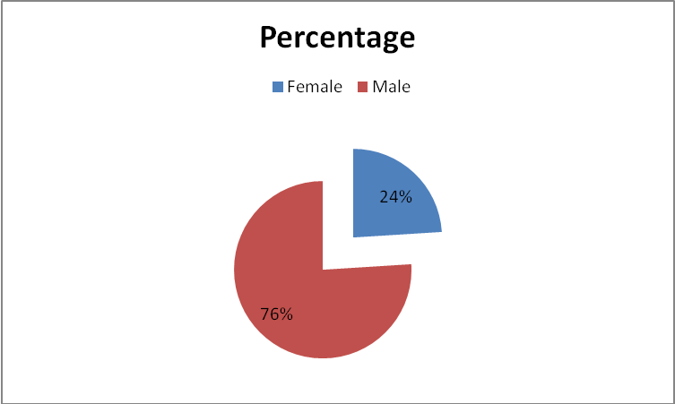

INTERPRETATION
Table 4.1 shows that, out of 50 respondents 76 per cent respondents are male and 24 percent respondents are female. At the time of survey female respondents found much lower than male. So according to the survey it is clear that the no.of female traders are comparatively less.

TABLE NO.4.2

AGE CLASSIFICATION OF RESPONDENTS
AGE | NO .OF RESPONDENTS | PERCENTAGE
BELOW 20 | 2 | 4
20-30 | 6 | 12
30-40 | 13 | 26
40-50 | 21 | 42
ABOVE 50 | 8 | 16
TOTAL | 50 | 100
(Source: primary data)

FIGURE NO.4.2

AGE CLASSIFICATION OF RESPONDENTS

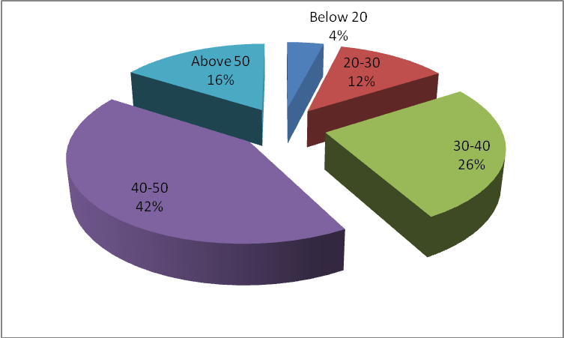

INTERPRETATION

Table no. 4.2 shows that most of the traders are aged between 40-50.42 per cent of traders are in between 40-50 and 26 per cent of traders are in between 30-40.

TABLE NO.4.3

CLASSIIFICATION OF TRADERS ON THE BASIS OF QUALIFICATION

EDUCATION QUALIFICATION | NO. OF RESPONDENTS | PERCENTAGE
Uneducated | 2 | 4
SSLC | 22 | 44
Plus Two | 15 | 30
Ug | 7 | 14
Pg | 2 | 4
Others | 2 | 4
Total | 50 | 100
(Source :Primary data)

FIGURE NO.4.3

4.3 CLASSIIFICATION OF TRADERS ON THE BASIS OF QUALIFICATION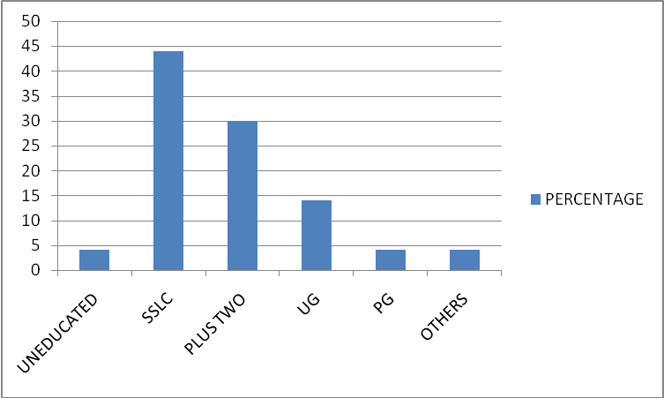

INTERPRETATION

Table no 4.3 reveals that 4 percent of respondents are uneducated. 44 percent are of primary education 30 percent of respondent are matriculate. Only 14 percent were Graduate. 4 percent are post graduated. That means majority of the traders are educated.
TABLE NO.4.4

CLASSIFICATION ON THE BASIS OF TYPE OF BUSINESS

Type of business | No .of respondents | Percentage
Stationery | 16 | 32
Bakery and cool bar | 6 | 12
Footwear | 7 | 14
Mobile shop | 4 | 8
Pharmacy | 3 | 6
Textiles | 9 | 18
Restaurants | 3 | 6
Others | 2 | 4
Total | 50 | 100
(Sources: Primary data)

FIGURE N O.4.4

CLASSIFICATION ON THE BASIS OF TYPE OF BUSINESS

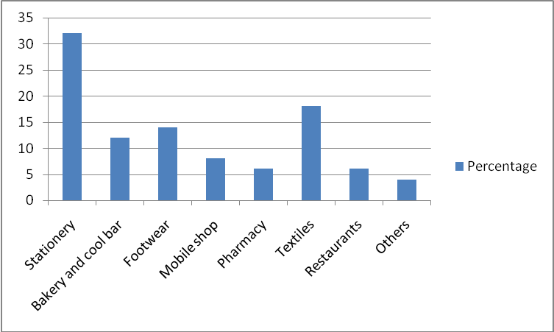

INTERPRETATION

Table no 4.4 shows that 32 percent of respondents are running business of stationery. 18 percent are running textiles. 14 per cent respondents are footwear. 12 percent are of with bakery business. It reveals that the study all areas of local market.
TABLE NO.4.5

CLASSIFICATION ON THE BASIS OF MONTHLY TURNOVER
TURNOVER | NO .OF RESPONDENTS | PERCENTAGE
LESS THAN 1 LAKH | 1 | 2
1-5 LAKH | 3 | 6
5-10 LAKH | 6 | 12
10-15 LAKH | 16 | 32
15-20 LAKH | 10 | 20
ABOVE 20 | 14 | 28
TOTAL | 50 | 100
(Sources: Primary data)

FIGURE NO.4.5

CLASSIFICATION ON THE BASIS OF MONTHLY TURNOVER

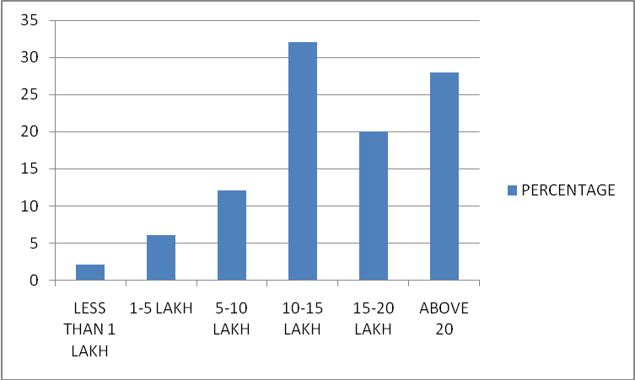

INTERPRETATION

Table no 4.5 shows that 28 percent of respondents have a monthly turnover above 20 lakh. 32 percent of respondent have turnover in between 10-15 lakh.2 percent of respondents turnover fall under below 1 lakh.

TABLE NO.4.6

CLASSIFICATION ON THE BASIS OF LEVEL OF AWARENESS AMONG TRADERS ABOUT GST

PARTICULARS | NO .OF RESPONDENTS | PERCENTAGE
Not at all aware | 3 | 6
Slightly aware | 10 | 20
Somewhat aware | 15 | 30
Moderately aware | 20 | 40
Extremely aware | 2 | 4
Total | 50 | 100
(Sources: Primary data)

FIGURE NO.4.6

CLASSIFICATION ON THE BASIS OF LEVEL OF AWARENESS AMONG TRADERS ABOUT GST

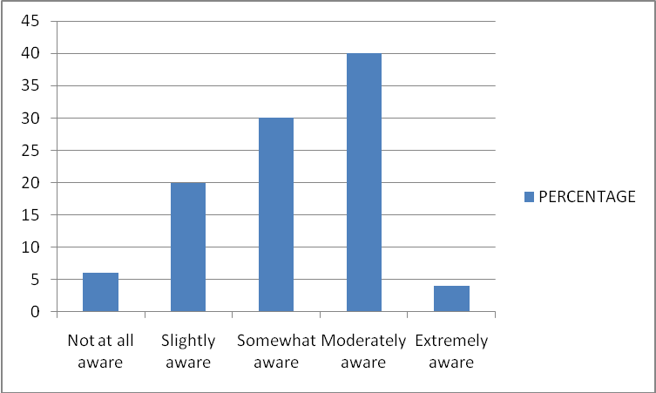

INTERPRETATION
Table no 4.6 reveals the awareness of traders about goods and service tax. There for it is clear that majority of traders are moderately (40%) aware about the newly implemented GST tax system.
TABLE NO.4.7

REGISTERED UNDER PREVIOUS TAX SYSTEM

PARTICULARS | NO. OF RESPONDENTS | PERCENTAGE
Yes | 39 | 78
No | 11 | 22
Total | 50 | 100
(Source: primary data)

FIGURE NO.4.7

REGISTERED UNDER PREVIOUS TAX SYSTEM

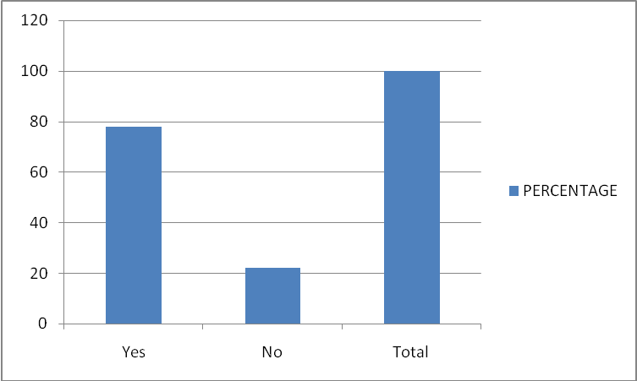

INTERPRETATION
Table no 4.7 reveals that 78 percent of respondent are registered under previous tax system and only 22 percent of respondent are not a registered dealer under previous tax system. That means majority of respondents are registered dealers of VAT.

TABLE NO 4.8

CLASSIFICATION ON THE BASIS OF TRADERS THOSE WHO HAVE GSTIN

PARTICULARS | NO OF RESPONDENTS | PERCENTAGE
Yes | 16 | 32
No | 34 | 68
Total | 50 | 100
(Source: primary data)

FIGURE NO 4.8
CLASSIFICATION ON THE BASIS OF TRADERS THOSE WHO HAVE GSTIN

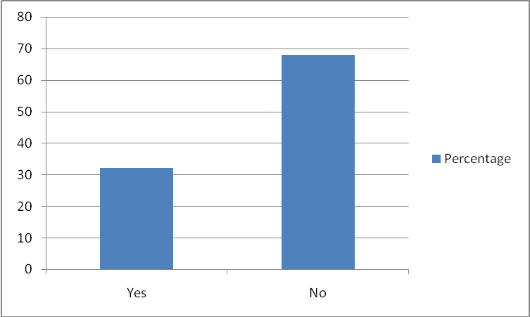

INTERPRETATION
Table no 4.8 shows that only 32 per cent of respondent have GST Identification No (GSTIN0. 68 per cent of respondent did not have GSTIN. Therefore the majority traders who are under the study are not registered in GST.
TABLE NO 4.9

AWARENESS ABOUT GST COUNCIL

PARTICULARS | NO OF RESPONDENTS | PERCENTAGE
Not at all aware | 6 | 12
Slightly aware | 13 | 26
Somewhat aware | 16 | 32
Moderately aware | 8 | 16
Extremely aware | 7 | 14
Total | 50 | 100
(Source: primary data)

FIGURE NO.4.9

AWARENESS ABOUT GST COUNCIL

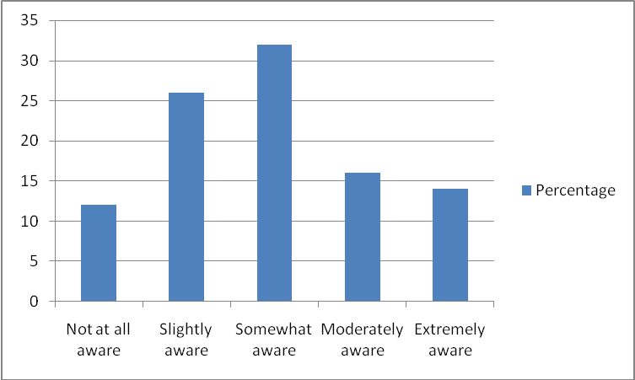

INTERPRETATION

Table no 4.9 express the local trader’s awareness about GST system. The majority of persons are aware an average (32%). It shows that the awareness level of trader’s is on an average.

TABLE NO 4.10
COSTS AFTER IMPLEMENTATION OF GST
PARTICULARS | NO OF RESPONDENTS | PERCENTAGE
Decreased | 14 | 28
No Change | 16 | 32
Increased | 20 | 40
Total | 50 | 100
(Source: primary data)

FIGURE NO 4.10
COST AFTER IMPLEMENTATION OF GST

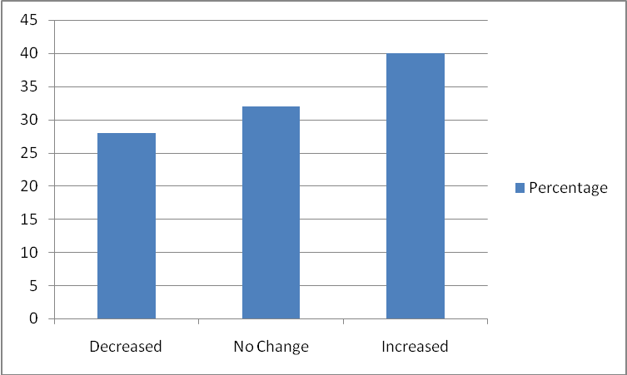

INTERPRETATION

Table no 4.10 reveals that 40 per cent of respondent’s cost increased and 28 per cent decreased while implemented GST. 32 per cent remain unchanged. This shows that GST neither increased or decreased cost of the trading class.

TABLE NO 4.11

DIFFICULTIES IN GST TAX FILING

PARTICULARS | NO OF RESPONDENTS | PERCENTAGE
Very difficult | 3 | 6
Difficult | 14 | 28
Neutral | 18 | 36
Easy | 10 | 20
Very easy | 5 | 10
Total | 50 | 100
(Source: primary data)

FIGURE NO.4.11

DIFFICULTIES IN GST TAX FILING

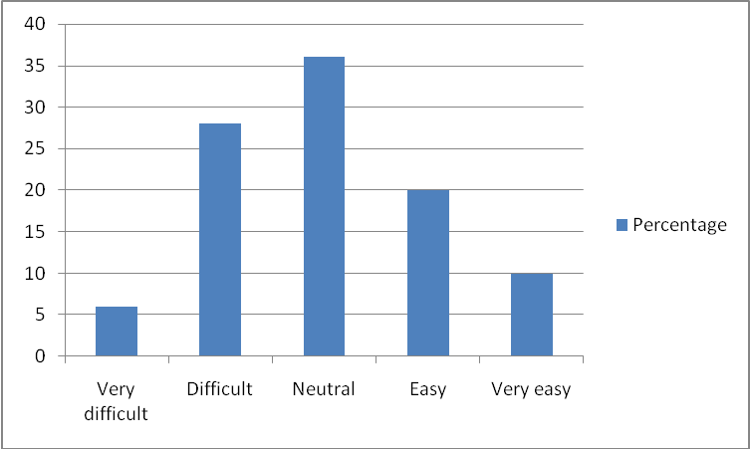

INTERPRETATION
Table no 4.11 shows that 28% of respondents are faced difficulties in GST tax filing. The majority of the respondents does not face difficulties in complying with tax requirements.

TABLE NO 4.12

INFLUENCE OF GST ON PROFIT MARGIN
PARTICULARS | NO OF RESPONDENTS | PERCENTAGE
Not at all influential | 8 | 16
Slightly influential | 10 | 20
Somewhat influential | 15 | 30
Moderately influential | 14 | 28
Extremely influential | 3 | 6
Total | 50 | 100
(Source: primary data)

FIGURE NO.4.12

INFLUENCE OF GST ON PROFIT MARGIN

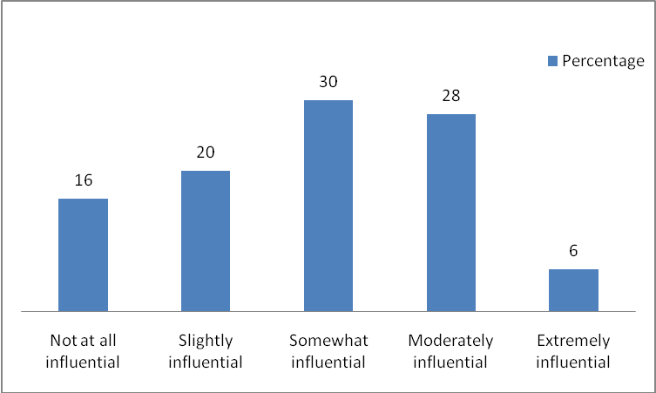

INTERPRETATION

Table no4.12 shows the influence of GST on profit margin. GST has an average influence on profit margin of local trader’s in the locality.

TABLE NO 4.13

ACCEPTABILILTY OF GST RATES

PARTICULARS | NO OF RESPONDENTS | PERCENTAGE
Totally Unacceptable | 1 | 2
Unacceptable | 4 | 8
Slightly unacceptable | 6 | 12
Neutral | 11 | 22
Slightly acceptable | 10 | 20
Acceptable | 18 | 36
Total | 50 | 100
(Source: primary data)

FIGURE NO.4.13

ACCEPTABILITY OF GST RATES

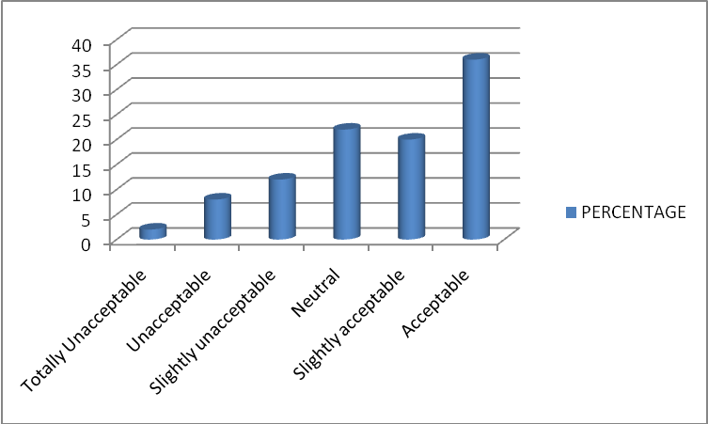

INTERPRETATION

Table no 4.13 reveals the acceptability of newly implemented GST rates. Majority of the traders accept the tax rates proposed under GST.
TABLE NO 4.14

INFLUENCE OF GST ON SALES

PARTICULARS | NO. OF RESPONDENTS | PERCENTAGE
Not at all influential | 9 | 18
Slightly influential | 11 | 22
Somewhat influential | 16 | 32
Influential | 12 | 24
Extremely influential | 2 | 4
Total | 50 | 100
(Source: primary data)

FIGURE NO.4.14

INFLUENCE OF GST ON SALES

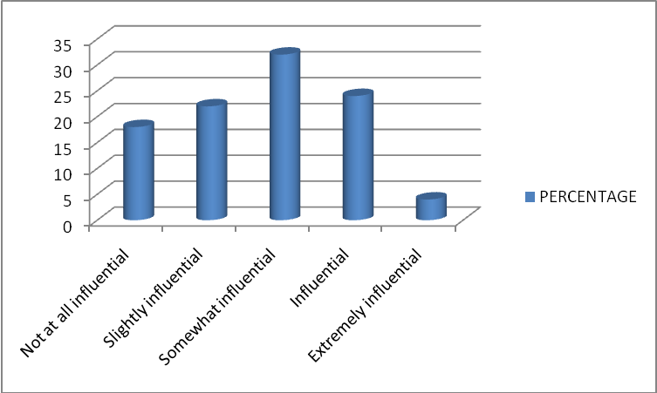

INTERPRETATION

Table no 4.14 reveals the influence of GST on various local traders. The influence of GST is on an average among the local traders because most of the local traders did not have GST. Therefore its influence is also moderate.

TABLE NO.4.15

KNOWLEDGE ON PENALTIES UNDER GST

KNOWLEDGE | NO. OF RESPONDENT | PERCENTAGE
No | 7 | 14
Low | 5 | 10
Somewhat | 6 | 12
Neutral | 16 | 32
Moderate | 14 | 28
High | 2 | 4
Total | 50 | 100
(Source: primary data)

FIGURE NO.4.15

KNOWLEDGE ON PENALTIES UNDER GST

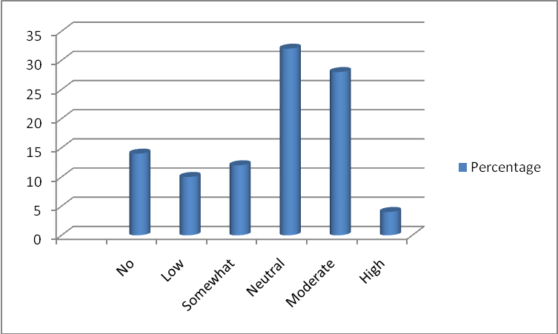

INTERPRETATION

Table no 4.15 expresses the knowledge of traders about various penalties which comes under GST. Majority of them have knowledge on penalties in neutrally.

TABLE NO 4.16
AFFECT OF GST ON ACCOUNTING COST

PARTICULARS | NO OF RESPONDENT | PERCENTAGE
No affect | 9 | 18
Minor affect | 12 | 24
Neutral | 15 | 30
Moderate affect | 11 | 22
Major affect | 3 | 6
Total | 50 | 100
(Source: primary data)

FIGURE NO.4.16
AFFECT OF GST ON ACCOUNTING COST

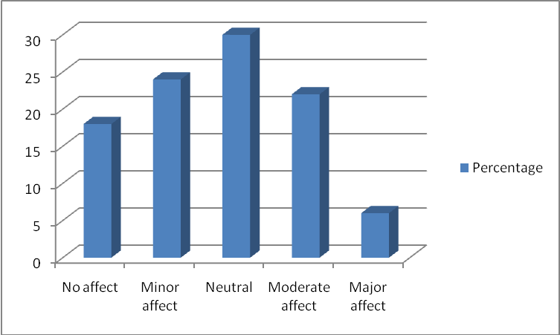

INTERPRETATION

Table no 4.16 shows the affect of GST on Accounting cost .The majority of people neutrally affect of GST cost. That means GST has an average affect on traders.

TABLE NO 4.17
GST HAS INCREASED LEGAL COMPLIANCE

PARTICULAR | NO .OF RESPONDENTS | PERCENTAGES
Strongly Disagree | 5 | 10
Disagree | 10 | 20
Neutral | 20 | 40
Agree | 6 | 12
Strongly Agree | 9 | 18
Total | 50 | 100
(Source: primary data)

FIGURE 4.17
GST HAS INCREASED LEGAL COMPLIANCE
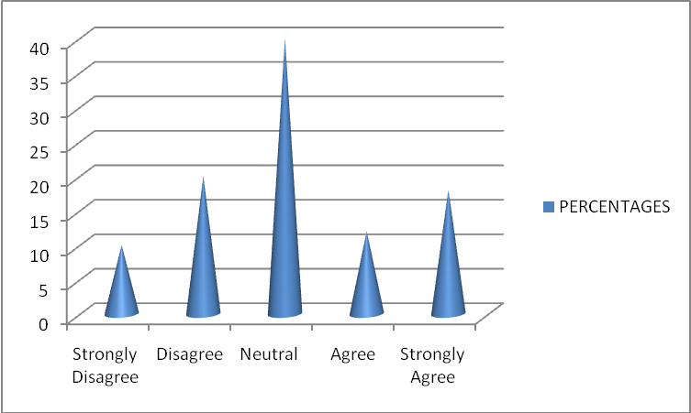

INTERPRETATION
Table no 4.17 ravels that 40 % respondents are neutral above the statement and 10% respondents are strongly disagree above statement

TABLE NO 4.18
GST SHIFTED TAX BURDEN TO COMMON PEOPLE
PARTICULARS | NO .OF RESPONDENTS | PERCENTAGES
Yes | 40 | 80
No | 10 | 20
Total | 50 | 100
(Source: primary data)
FIGURE 4.18
GST SHIFTED TAX BURDEN TO COMMON PEOPLE
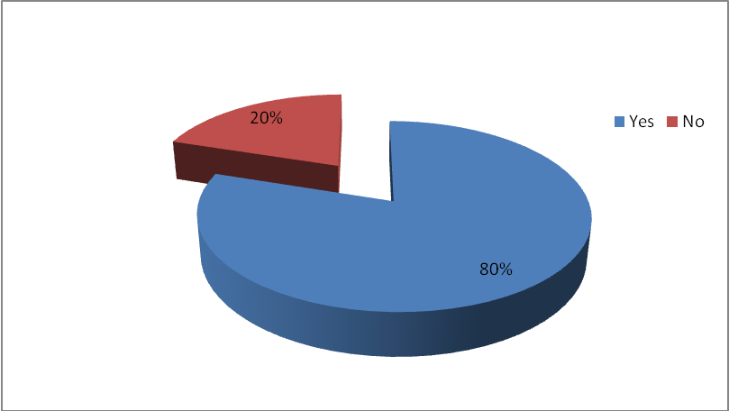

INTERPRETATION
Table No 4.18 reveals that above 80 % respondents agrees that GST shifted tax burden to common people

TABLE NO 4.19

KNOWLEDGE OF TRADERS

PARTICULARS | NO .OF RESPONDENTS | PERCENTAGES
SGST | 22 | 44
CGST | 16 | 32
IGST | 12 | 24
Total | 50 | 100
(Source: primary data)
FIGURE 4.19

KNOWLEDGE OF TRADERS

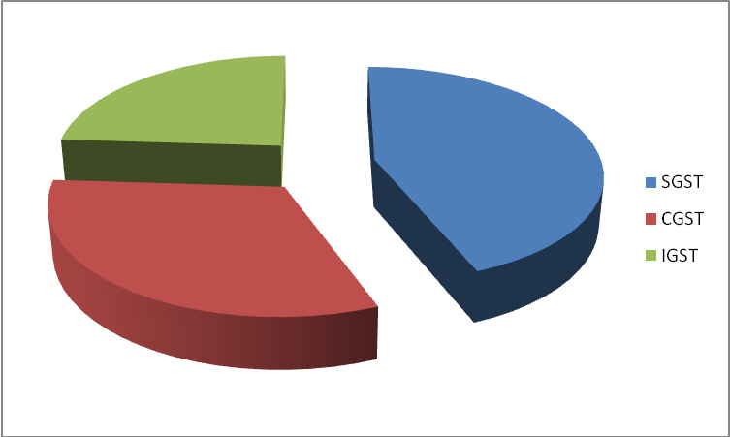

INTERPRETATION
Table No 4.19 reveals majority of respondents knowledge of SGST , next come CGST and finally IGST with less percentage.

TABLE NO 4.20
OPINION ABOUT GST

PARTICULARS | NO OF RESPONDENTS | PERCENTAGE
Very negative | 2 | 4
Negative | 5 | 10
Neutral | 17 | 34
Positive | 22 | 44
Very positive | 4 | 8
Total | 50 | 100
(Source: primary data)

FIGURE NO 4.20
OPINION ABOUT GST

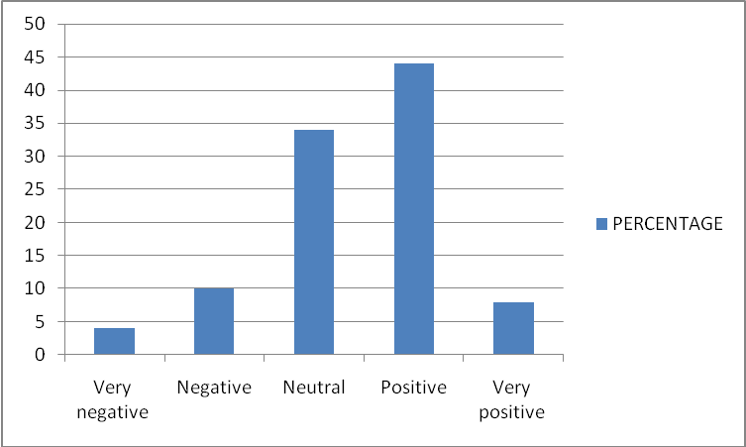

INTERPRETATION
Table 3.19 expresses the overall opinion of local traders about GST. The Majority (44%) of the traders has a positive opinion on GST. They approach this regime confidently as a bridge not a block.

CHAPTER- 5
FINDINGS, SUGGESTIONS AND CONCLUSION
5.1 FINDINGS

- It is understood from the survey that majority of the respondents (76 %) are male.
- it is found that most of the respondents (42%) are having the age of 40 to 50years
- It reveals that majority of the respondents (44%) are with primary education
- Most of the respondents were dealers of stationery business
- The majority (32%) of respondent have turnover in between 10-15 lakh.
- There is no relationship between socio-economic profile of the respondents Such as age, education status, and level of knowledge on issue of GST There is a relationship between gender and their level of knowledge on issue of GST.
- Most of the traders are registered under previous tax system.
- Majority of the traders are not at all aware they only have a little knowledge of GSTIN.
- Traders are not at all aware about GST council
- 40% of respondents cost increased and 32% decreased while implementation of GST.
- 28% of respondents face difficulties in GST tax filing.
- GST has an average influence on profit margin of local trader’s in the locality.

- Certain GST rates are not fully acceptable by the traders while some of them are beneficial.
- The influence of GST on sales averagely affected the local traders. The most of the traders did not have GST.
- Awareness level of the respondents on penalties under GST is relatively high.
- Respondents are in the opinion that the cost is neutrally effect of the advent of GST..
- Majority of the respondents have an opinion that the GST has increased legal compliance
- The majority of respondents have an opinion that the GST shifted tax burden to common people.
- GST has various structural divisions such as, SGST, CGST, and IGST. The Local traders are aware about SGST and knowledge on CGST especially IGST is relatively low.
- Large part of traders is in a positive view towards GST. Thus it will be a very good platform for the success of GST.

5.2 SUGGESTIONS

This study is completed to measure the “awareness of local traders about goods and service tax”. With the implementation of GST India took a step towards unified common national market. It aims to bring in increased efficiency and compliance and also boost government’s „ease of doing business‟ initiative. Some of the suggestions made on the basis of study are:
- Relief must be given to small scale operators and particularly reduced processes should be applicable to them. They do not have finance or resource to comply. Much of India’s business is one or two man show.
- Rates should be rationalized and reduced to make the business competitive and in interest of compliance and economic growth
- Technological glitches of the GST network should be sorted out.
- The local traders should be aware with the GST and its future achievements
- Ordinary merchants should get clear and up to date information on GST
- GST rates should be more precise and clear and this will be acceptable to all sections of the society.

5.3 CONCLUSION

Traders / merchants are the fortune builder of our economy. They will continue to implement the national development program both for their personal and national benefit. These groups are one of the factors contributing to the progress and development of the country. Providing adequate and relevant fundamental information is necessary to make them better understand the general principle of GST by organizing seminar, talk, training, course and forum in order to increase awareness and knowledge and also conform to regulation. No doubt that GST will give India a world class tax system by grabbing different treatment to manufacturing and service sector with a collaborative effort of trading class.

BIBLIOGRAPHY

BOOKS
- Dr. Venugopalan.K, “Basics of research methodology”, Kannur university
- Krishnaswami O.R, “Research Methodology in Social Sciences”, Mumbai, Himalaya Publishing House, pp.63-71
JOURNAL
- AJMS Vol.6 No.2 July-December 2017 A Study on Public Awareness towards Goods and Services Tax (Amendment) Bill in Sivakasi Region
- Students ‟ Perception towards the Newly Implemented Goods and Services Tax ( GST ) in Malaysia. International Journal of Contemporary Applied Sciences, 2(6), 80–99.
- Monika Sehrawat *1, Upasana Dhanda (2015) GST in India: A Key Tax Reform International Journal of Research – Granthaalayah, Vol. 3, No. 12(2015): 133-141
- Pacific Business Review International Volume 9 Issue 8, Feb. 2017Measuring Awareness about Implementation of GST: A Survey of Small Business Owners of Rajasthan

NEWSPAPERS
- The Hindu(Delhi), 2nd july2017
- India Today( Kochi ) 10TH December 2017
- The Economic Times(Trivandrum) 11th January 2018
WEBSITES
- www.firstspot.com
- www.livemint.com
- www.wikipedia.com
- http//www.gstindia.com/
- http//www.taxguru.in/
- http//www.gstconcil.in/

QUESTIONNAIRE

NAME………………………………………………….

1. Gender

Female Male

2. Age

Below 20 20-30 30-40 40-50

Above 50

3. Education

Uneducated SSLC +2 UG

PG Others

4. Type of business

Stationery Pharmacy

Bakery and cool bar Textiles

Footwear Restaurants

Mobile shop Others

5. What is your monthly turnover

Less than 1 lakh 1-5 lakh

5-10 lakh 10-15 lakh

10-15 lakh above 20 lakh

6. Are you aware about GST

Not at all aware slightly aware

Somewhat aware moderatelyy

Extremely aware
7. Are you a registered dealer under previous tax system?

Yes No

8. Do you have GSTIN?

Yes No

9. Are you aware of GST Council?

Not at all aware slightly aware

Somewhat aware moderately aware

Extremely aware

10. Whether the accounting cost increased or decreased after the GST?

Increased Decreased No Change

11. Have you had any difficulties in GST tax filing?

Very difficult Difficult

Neutral Easy Very easy

12. How GST has influenced the profit margin?

Not at all influential slightly influential

Somewhat influential moderately influential

Extremely influential

13. Did the rates proposed under GST on each item is acceptable to you?

Totally unacceptable Unacceptable

Slightly unacceptable Neutral Slightly acceptable

Acceptable Perfectly acceptable

14. Did GST influence your sales behaviour

Not at all influential Slightly influential
Somewhat influential Influential
Extremely iinfluential
15. Do you know what are the penalties imposed by GST?

No Low Somewhat

Neutral Moderate High

16. Do you have any software solution to handle accounts? If yes how GST affected your accounting cost?

No affect Minor affect

Neutral Moderate affect

Major affect

17. Do you agree that GST has increased legal compliance?

Strongly agree Positive

Very positive
Disagree

Neutral

18. Do you think that GST shifted tax burden to common people?

Yes

No

19. Knowledge of the following?

SGST

CGST

IGST
20. Give suggestion if any.

