TABLE OF CONTENTS
CHAPTER NO. | TITLE | PAGE NO.
1 | INTRODUCTION | 1-10
2 | REVIEW OF RELATED LITERATURE | 11-16
3 | PROFILE OF THE INDUSTRY  PROFILE OF THE ORGANIZATION | 17-47
4 | DATA ANALYSIS & INTERPRETATION | 48-81
5 | FINDINGS, RECOMMENDATIONS AND CONCLUSIONS | 82-85
 | BIBLIOGRAPHY
 | ANNEXURES

  - Introduction
Role of social media in marketing has become indispensable. Companies across various industries, particularly in the IT sector, are leveraging social media platforms to build brand awareness, engage with audiences, and drive business growth. Atmios Technology, a forward-thinking IT solutions provider, recognizes the potential of social media as a strategic tool for communication, promotion, and customer engagement. Atmios Technology operates in a highly competitive domain, offering cutting-edge services in software development, cloud computing, AI-driven solutions, and digital transformation. In such a dynamic environment, establishing a strong digital presence is crucial. Social media platforms provide Atmios with a cost-effective and powerful means of connecting with potential clients, partners, and technology enthusiasts.
Social media has reshaped the way companies like Atmios interact with their target audiences. Through platforms like LinkedIn, X (formerly Twitter), Instagram, YouTube, and Facebook, Atmios has the opportunity to showcase its innovations, highlight success stories, and share valuable content tailored to specific user segments. The transition from traditional marketing to digital channels is especially relevant for IT companies. Unlike conventional advertising, social media enables two-way communication, instant feedback, and measurable impact. Atmios Technology seeks to understand how well it is utilizing these capabilities to foster stronger relationships and drive conversions.
This project report aims to study the effectiveness of social media marketing strategies implemented by Atmios Technology. The focus is on evaluating how these efforts contribute to the company's visibility, audience engagement, lead generation, and overall brand perception in the IT market. The data for this report is collected through a combination of primary and secondary research. Primary data includes surveys and interviews with Atmios’s marketing team, while secondary data involves performance analytics from social media dashboards and benchmarking with industry standards.
Social Media Marketing (SMM) refers to the use of social media platforms such as Facebook, Instagram, LinkedIn, YouTube, and Twitter to promote products, services, and brands. It is a digital marketing strategy that enables organizations to connect with their target audience, increase brand awareness, engage customers, and achieve business objectives through online interactions. Social media marketing has become one of the most effective communication tools for businesses because it allows direct interaction with customers and provides opportunities for instant feedback.
Social media marketing focuses on creating and sharing valuable content that attracts and engages users. The content may include text, images, videos, infographics, stories, and live sessions. Effective social media marketing helps organizations build strong relationships with customers, improve customer loyalty, and enhance brand reputation. It also provides businesses with valuable insights into customer preferences and behavior.
The growth of internet usage and smartphone adoption has significantly increased the importance of social media marketing. Organizations use social media platforms to communicate information about products and services, launch promotional campaigns, provide customer support, and strengthen their online presence. Through social media marketing, companies can reach a wider audience at a lower cost compared to traditional marketing methods.

Objectives of Social Media Marketing
- To create brand awareness among customers.
- To increase customer engagement and interaction.
- To promote products and services effectively.
- To improve customer relationships and satisfaction.
- To increase website traffic and business growth.
- To build customer trust and brand loyalty.

Importance of Social Media Marketing
- Enhances brand visibility.
- Improves customer communication.
- Increases customer engagement.
- Supports cost-effective promotion.
- Helps in market research and customer feedback.
- Strengthens brand image and reputation.
- Generates leads and business opportunities.

Components of Social Media Marketing

Content Marketing
Content marketing involves creating and sharing useful, relevant, and engaging content to attract and retain customers.

Social Media Advertising
Paid advertisements on social media platforms help organizations reach a larger and targeted audience.

Customer Engagement
Engagement includes likes, comments, shares, reviews, and direct interactions with customers.

Influencer Marketing
Organizations collaborate with influencers to promote products and services and increase brand reach.

Analytics and Performance Measurement
Social media analytics help organizations measure campaign performance, audience engagement, and marketing effectiveness.

Benefits of Social Media Marketing
- Increased brand awareness.
- Better customer engagement.
- Improved customer satisfaction.
- Greater market reach.
- Enhanced brand credibility.
- Higher conversion opportunities.
- Competitive advantage in the market.

Social Media Marketing and Customer Satisfaction
Social media marketing plays a significant role in influencing customer satisfaction. Regular communication, informative content, quick responses to customer queries, and engaging promotional activities help customers develop a positive perception of a brand. Organizations that effectively utilize social media platforms can improve customer experiences, build trust, and encourage customers to recommend their services to others.
  - Statement of Research Problem
The research problem addressed in this study revolves around the uncertainty regarding the effectiveness of social media marketing strategies implemented by Atmios Technology and Software Solutions. Although the company actively engages in social media promotions, there is a lack of clear understanding about how these efforts contribute to key business outcomes such as brand visibility, customer engagement, lead generation. Additionally, the absence of a structured framework to analyze platform-specific performance, audience behavior, and campaign success hinders the company's ability to make informed decisions and optimize its marketing strategies. This study seeks to bridge this gap by evaluating the current practices and identifying areas for improvement to enhance the overall impact of social media marketing.
  - Significance / Scope of the Study
The study on the effectiveness of social media marketing strategies implemented by Atmios Technology and Software Solutions is significant as it helps evaluate how social media platforms contribute to brand awareness, customer engagement, trust, and overall customer perception. In today's digital environment, social media has become an essential marketing tool for organizations to communicate with existing and potential customers. Understanding the effectiveness of these strategies enables the company to assess its current performance and identify areas that require improvement.
The study provides valuable insights into customers' opinions regarding the relevance, attractiveness, informativeness, and engagement level of the content shared by Atmios. It helps the organization understand audience preferences and expectations, which can support the development of more effective social media campaigns. The findings of the study can assist management in making informed decisions related to digital marketing investments and content strategies.
The scope of this study is limited to analyzing the effectiveness of social media marketing strategies implemented by Atmios Technology and Software Solutions. It focuses on major platforms such as Facebook, LinkedIn, Instagram, and Twitter, evaluating key performance metrics including reach, engagement, and conversion rates. The study targets both existing and potential customers who interact with the company through these platforms. It is geographically limited to regions where the company actively operates. Input is gathered from marketing and sales teams to assess how well social media efforts align with business objectives and customer engagement goals.
1.4 Objectives of the Study
- To study the effectiveness of social media marketing strategies implemented by Atmios Technology and Software Solutions.
- To identify the social media platforms through which customers become aware of Atmios.
- To examine customer engagement with Atmios's social media content.
- To analyze the influence of social media marketing on customer satisfaction and trust.
- To suggest measures for improving the effectiveness of Atmios's social media marketing strategies.

1.5 Hypothesis of the Study
Hypothesis 1
Relationship Between Gender of Respondents and Overall Satisfaction with Atmios's Social Media Marketing Strategies
H₀: There is no significant relationship between the gender of respondents and their overall satisfaction with Atmios's social media marketing strategies.
H₁: There is a significant relationship between the gender of respondents and their overall satisfaction with Atmios's social media marketing strategies.
Hypothesis 2
Relationship Between Gender of Respondents and Likelihood of Recommending Atmios
H₀: There is no significant relationship between the gender of respondents and their likelihood of recommending Atmios based on its social media presence.
H₁: There is a significant relationship between the gender of respondents and their likelihood of recommending Atmios based on its social media presence.
Hypothesis 3
Relationship Between Gender of Respondents and Trust in Information Shared by Atmios on Social Media
H₀: There is no significant relationship between the gender of respondents and their trust in information shared by Atmios on social media.
H₁: There is a significant relationship between the gender of respondents and their trust in information shared by Atmios on social media.

1.6. Methodology of the Study
1.6.1 Research Design
A research design is a detailed and organized plan that outlines the approach and procedures for carrying out a research study. It involves the techniques used for gathering, evaluating, and interpreting data to effectively respond to the research objectives or hypotheses.
This particular study is focused on assessing the Effectiveness of social media marketing in Atmios Technology and Software Solutions. The evaluation is carried out by using structured surveys to a representative sample of Atmios's customer base to gather measurable data on customer perceptions, engagement levels, and responses to current social media campaigns. In-depth interviews and focus group discussions has been conducted with internal marketing team members to gain deeper insights into the challenges faced and potential areas for improvement in social media strategies.
1.6.2 Method of Data Collection
In order to analyse the Effectiveness of social media marketing in Atmios Technology and Software Solutions, the study relies on primary and secondary data collected through online questionnaires and information already available with the company.
The study is based on both primary and secondary data.
1.6.2.1 Primary Data:
Data were collected directly from respondents using a structured questionnaire.
1.6.2.2 Secondary Data:
Data were collected from journals, books, websites, company reports, and other relevant published sources.
1.6.3 Population of the Study
The population of the study consists of all customers, followers, and users who interact with the social media platforms of Atmios Technology and Software Solutions. These individuals form the target population from which the data for the study is collected.
1.6.4 Sampling Unit
The sampling unit of the study comprises individual respondents who follow, view, engage with, or are aware of the social media activities of Atmios Technology and Software Solutions.
1.6.5 Sample Size
The sample size selected for the study is 100 respondents. The responses collected from these respondents are used for analyzing the effectiveness of social media marketing activities undertaken by the company.
1.6.6 Sampling Technique
The study adopts the Convenience Sampling Technique, a non-probability sampling method. Respondents are selected based on their accessibility and willingness to participate in the survey. This technique helps in collecting data within the limited time available for the study.
1.6.7 Tools Used for Analysis
The collected data are analyzed using the following statistical tools:
- Percentage Analysis
- Tables and Charts
- Chi-Square Test
These tools help in interpreting the responses and drawing meaningful conclusions regarding the effectiveness of social media marketing in Atmios Technology and Software Solutions.
1.7 Limitations of the Study
- The study is limited to a sample size of 100 respondents only.
- The findings are based on the opinions and perceptions of the respondents.
- Due to time constraints, an in-depth analysis could not be conducted.
- The accuracy of the study depends on the sincerity of the responses provided by the participants.
- The study is confined to the social media marketing strategies implemented by Atmios Technology and Software Solutions only.
1.8 Chapter Scheme
The report is divided into 5 chapters:
Chapter I: Introduction
It includes the introduction to the project report and information about Atmios Technology and Software Solutions. It also covers the statement of the problem, significance of the study, scope of the study, objectives of the study, and research methodology, which comprises sample design and size, sources of data, and tools used for analysis.
Chapter II: Review of Literature
This chapter represents the review of literature relating to social media marketing strategies, digital marketing, customer engagement, brand awareness, and customer satisfaction. It presents various studies conducted by researchers and provides a clear understanding of the subject under study.
Chapter III: Profile of Industry and Profile of Organisation
The third chapter deals with the profile of the information technology industry and the company profile of Atmios Technology and Software Solutions. It explains the growth and development of the IT industry, the importance of digital marketing, recent trends in social media marketing, and the role of technology companies in the digital era. The company profile includes the history, vision, mission, services, objectives, and business operations of Atmios Technology and Software Solutions.
Chapter IV: Data Analysis and Interpretation
This chapter includes the analysis and interpretation of data collected from respondents. The collected data are analyzed using percentage analysis and chi-square test and presented through tables for better understanding.

Chapter V: Findings, Suggestions and Conclusion
This chapter deals with the major findings of the study, suggestions for improving the effectiveness of social media marketing strategies, and the conclusion drawn from the study.

2.1 Review of Literature
Sl no | Author | Findings
1 | Dr Lingam Sampath (2024) | This study examines the impact of social media marketing on Indian businesses, highlighting its role in boosting brand visibility and consumer engagement. It identifies key platforms like Facebook, Instagram, and TikTok, along with challenges such as regulations and digital reputation management. The research also points to growth opportunities through analytics, personalization, and influencer marketing, offering insights for marketers and future research.
2 | B Jayalakshmi, Mr C Suresh (2024) | This study highlights the rapid growth of digital marketing in India, driven by increased internet usage. It examines changes in consumer behavior during the pandemic, the rise of e-commerce, and the need for personalized, targeted marketing. The findings show that internet awareness is key to digital marketing success, and businesses must adapt to evolving trends to stay competitive.
3 | Mahabub Basha (2023) | Mahabub Basha (2023) This study investigates the impact of AI on marketing by conducting interviews with 15 marketing professionals from Indian companies. It highlights the benefits, challenges, ethical concerns, and strategic changes before and after AI adoption in marketing. The findings suggest that integrating AI can boost business performance, profitability, and competitive advantage, while also identifying gaps for future strategic marketing research
4 | Musammat Tahmina Khanom (2023) | This study reviews the role of social media platforms in attracting consumer interest and compares social media marketing with other marketing methods. Using a qualitative approach, it highlights that while social media is popular and effective, over-reliance without assessing pros and cons can be risky. The study concludes that marketers should focus on using all platforms responsibly and productively, choosing strategies based on their specific goals.
5 | Tobias Ahnfeld, Alexander Hahn, Jan Joosten, Katharina Klug, Dirk Totzek (2023) | This study highlights the importance of pre-testing social media ads and explores the challenges of objectively assessing ad performance. It outlines how a multi-method approach combining facial coding and eye-tracking can help identify successful ads before launch. The findings emphasize the growing importance of user experience research (via digital empathy) for social media advertising and performance marketing.
6 | Taanika Arora, Bhawna Agarwal (2022) | This study presents a conceptual model exploring how factors like entertainment, informativeness, credibility, incentives, and user motivations influence attitudes toward social media advertising, and how these attitudes affect purchase intention. Using survey data from 472 Indian social media users, the study employed structural equation modeling. The results show that all identified factors significantly shape users’ attitudes toward social media ads, which in turn strongly predict their intention to make purchases.
7 | Guillaume Hervet, Ivan A Guitart (2022) | This study examines the effectiveness of social media display ads in a startup context through field experiments reaching over 800,000 users. Results show that most ad impact (98%) occurs within two hours, with an overall elasticity of 0.815. Interestingly, adding informative claims reduces click-through rates (CTR) by up to 43%, while ad repetition boosts CTR by nearly 20%. However, using characters or gender-congruent ads does not significantly affect CTR. The findings offer practical insights for startups on optimizing ad content and timing
8 | Evi C Waworuntu, Deske W Mandagi, Anthony S Pangemanan (2022) | This study explores how social media marketing (SMM) affects brand image and purchase intention for local products among Generation Z. Based on survey data from 184 Gen Z respondents and analyzed using SmartPLS, the findings show that SMM significantly enhances both brand image and purchase intention. Additionally, brand image plays a mediating role, meaning SMM boosts brand image, which in turn increases the likelihood of purchase.
9 | Musammat Tahmina Khanom (2023) | This study reviews the role of social media platforms in attracting consumer interest and compares social media marketing with other marketing methods. Using a qualitative approach, it highlights that while social media is popular and effective, over-reliance without assessing pros and cons can be risky. The study concludes that marketers should focus on using all platforms responsibly and productively, choosing strategies based on their specific goals.
10 | Kiran Nair, Ruchi Gupta (2021) | The purpose of this paper is to explore the various application of artificial intelligence (AI) to social media and digital advertising professionals and agencies to specialize to an advanced degree and maintain collaboration and creativity to bring a better return on investment.
11 | Nader Seyyedamiri, Ladan Tajrobehkar (2021) | Findings show that although social content marketing and e-trust influenced the effectiveness of the product development process, e-trust did not play a mediating role in the relationship between social content marketing and effectiveness of product development process in high-tech companies.
12 | Yash Chawla, Grzegorz Chodak (2021) | This study investigates the effectiveness of different Facebook post formats in a real business setting. The findings reveal that placing a web-link in the comments, rather than in the post caption, yields better engagement. Additionally, the study highlights
13 | Sujeet Kumar Sharma (2021) | The study investigates the increasing significance of social media in today’s marketing landscape. It delves into the ways social media platforms shape consumer purchasing decisions and offers strategic recommendations to enhance the effectiveness of social media as a marketing instrument.
14 | Gokhan Aydin, Nimet Uray, Gokhan Silahtaroglu (2021) | This study aims to provide strategic guidelines for improving consumer brand effectiveness on social media by analyzing factors that influence user engagement, such as reposts, comments, and likes. The study applied four machine learning algorithms to identify key drivers of engagement. Results show that videos, images, post frequency, and interactivity significantly impact engagement. Additionally, platform and brand differences play a crucial role, indicating that a one-size-fits-all approach is ineffective. The study stands out for its detailed analysis of post features and use of advanced predictive techniques.
15 | Vasu Unnava, Ashwin Aravindakshan (2021) | This study explores how brand posts on one social media platform can influence engagement both on the same platform (direct effects) and across others (spillover effects), as well as how past engagement can extend a post’s impact over time (carryover effects). Using empirical analysis, the study confirms that these effects are significant and vary by platform. It offers practical insights for marketers on how to maximize engagement and return on investment by strategically allocating content and resources across platforms, supported by a proposed resource allocation model.
16 | Niko Garuda Adiyono, Tantri Yanuar Rahmat, Rina Anindita (2021) | Technological advancements have made the internet essential for communication and business. In marketing, businesses now use digital content shared on social media to promote their products more widely and effectively. Social media platforms, with user-friendly video and effect features, offer valuable tools for online businesses to attract and engage potential customers, making them key channels for business growth.
17 | Krishanu Bhattacharyya, Bikash Ranjan Debata (2021) | This study examines the effectiveness of social media display ads in a startup context through field experiments reaching over 800,000 users. Results show that most ad impact (98%) occurs within two hours, with an overall elasticity of 0.815. Interestingly, adding informative claims reduces click-through rates (CTR) by up to 43%, while ad repetition boosts CTR by nearly 20%. However, using characters or gender-congruent ads does not significantly affect CTR. The findings offer practical insights for startups on optimizing ad content and timing
18 | Reem Abdurahman Al-Mohammadi, Heba Gazzaz (2020) | This study explores the effectiveness of social media marketing , focusing on its impact on sales, brand awareness, and customer loyalty. Data from consumer surveys and manager interviews reveal that success depends on targeting the right audience with suitable content. The results show that social media boosts marketing communication and promotions, enhances brand awareness, and positively influences consumer loyalty and sales.
19 | Abu Bashar, Irshad Ahmad, Mohammad Wasiq (2012) | The paper highlights the growing importance of social media in modern marketing. It examines how social media influences consumer buying decisions and suggests ways to enhance its effectiveness as a marketing tool.
20 | Charity Pradiptarini (2011) | This study analyzes social media marketing's effectiveness by examining Twitter activity and sales data from major companies, along with a student survey. It finds that content quality, company engagement, and integration with other marketing channels strongly influence success. While Generation Y are frequent users of social media, they are not necessarily the primary target of social media marketing, and measuring ROI requires a detailed, strategic approach.
3.1 Industry Profile
The Information Technology (IT) industry is one of the most dynamic and rapidly evolving sectors globally. It encompasses a wide range of services and products including software development, hardware manufacturing, IT consulting, networking, data management, cybersecurity, cloud computing, and emerging technologies such as artificial intelligence (AI), machine learning (ML), and blockchain. The IT industry plays a critical role in driving digital transformation across all sectors, including finance, healthcare, education, retail, and government.
India is a global leader in the IT sector, known for its large pool of skilled professionals, cost-effective solutions, and strong export-oriented service models. Major cities like Bengaluru, Hyderabad, Pune, and Chennai have become prominent IT hubs. Key players in the Indian IT industry include Tata Consultancy Services (TCS), Infosys, Wipro, HCL Technologies, and Tech Mahindra, along with numerous startups and mid-sized firms. The industry significantly contributes to employment generation and the national GDP.
Trends shaping the industry include increased adoption of cloud services, growing demand for cybersecurity solutions, expansion of e-governance projects, and the integration of AI in business operations. With ongoing innovation and increasing reliance on technology, the IT industry is expected to grow steadily, playing a vital role in shaping the future of global business and communication.
3.1.1 Sectors of it Industry
- Software Development: Involves designing, coding, testing, and maintaining software applications and systems for various uses, including enterprise, web, and mobile platforms.
- Hardware and Infrastructure: Focuses on the manufacturing and maintenance of physical components like computers, servers, networking equipment, and storage devices.
- IT Services and Consulting: Provides businesses with advisory, implementation, and support services to help them leverage technology effectively.
- Networking and Telecommunications: Covers the development and management of network systems (LAN, WAN, the internet) and telecom infrastructure to enable communication and data transfer.
- Cybersecurity: Involves protecting systems, networks, and data from cyber threats through security tools, policies, and practices.
- Cloud Computing: Offers on-demand access to computing resources such as servers, storage, and applications over the internet.
- Artificial Intelligence (AI) and Machine Learning (ML): Focuses on developing systems that can simulate human intelligence and improve decision-making through data-driven learning.
- Data Analytics and Big Data: Specializes in collecting, analyzing, and interpreting large volumes of data to support strategic decisions.
- Internet of Things (IoT): Connects physical devices to the internet, enabling real-time data exchange and automation.
3.1.2 Industry Trends
- Increased Adoption of Artificial Intelligence and Machine Learning: AI and ML are being widely integrated into business processes for automation, predictive analytics, customer service (chatbots), and personalization, improving efficiency and decision-making.
- Growth of Cloud Computing: Cloud services (like AWS, Microsoft Azure, Google Cloud) continue to grow as businesses shift to flexible, scalable, and cost-effective infrastructure. Hybrid and multi-cloud strategies are also gaining traction.
- Expansion of Remote and Hybrid Work Technologies: Post-pandemic, organizations are investing more in remote collaboration tools, virtual desktops, and secure remote access to support flexible work environments.
- Rise in Cybersecurity Demand: With increasing cyber threats, organizations are investing heavily in advanced cybersecurity measures such as zero-trust architecture, endpoint protection, and security automation.
- Focus on Data Analytics and Big Data: Companies are using big data tools and analytics to understand customer behaviour, improve services, and drive data-driven decision-making.
- Internet of Things (IoT) Integration: IoT is being used across industries to connect devices, monitor operations in real-time, and enable automation in sectors like manufacturing, healthcare, and smart cities.
Figure 3.1
Industry Trends
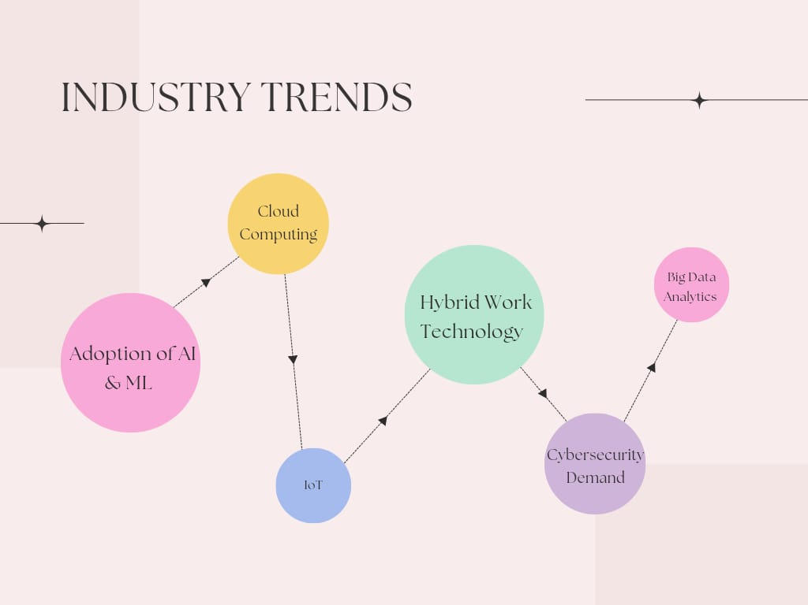
Source: Secondary data
3.1.3 Global Scenario
The global Information Technology (IT) industry has become a vital pillar of the world economy, enabling digital transformation across all sectors—from healthcare and education to manufacturing and finance. With rapid advancements in technologies like cloud computing, artificial intelligence (AI), machine learning (ML), blockchain, and the Internet of Things (IoT), the IT industry is continuously reshaping how businesses operate and how people interact with technology. Companies across the globe are investing heavily in digital infrastructure to improve efficiency, enhance customer experience, and gain competitive advantages.
The United States leads the global IT industry, with major tech giants like Microsoft, Apple, Google, Amazon, and IBM driving innovation and setting global trends. China is rapidly expanding its presence, especially in areas such as e-commerce, telecommunications, and AI. Meanwhile, India has established itself as a global outsourcing hub, providing IT services, business process outsourcing (BPO), and software development to clients around the world. European countries are also making significant contributions, particularly in cybersecurity, fintech, and data privacy, supported by strong regulatory frameworks like the GDPR.
Emerging markets in Asia, Latin America, and Africa are experiencing increased digital adoption, driven by expanding internet access, mobile technology, and supportive government policies. These regions are becoming important players in the global IT ecosystem, creating opportunities for growth and innovation. Despite its vast potential, the industry also faces challenges such as cybersecurity threats, data privacy concerns, talent shortages, and evolving regulations. However, with continuous technological innovation and global collaboration, the IT industry is expected to maintain its strong growth trajectory in the coming years.
Figure 3.2
Global Scenario
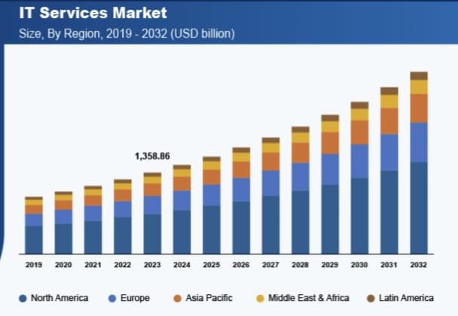
Source: Secondary data
3.1.4 National Scenario
The Indian IT industry is one of the most dynamic and fastest-growing sectors in the country, playing a crucial role in its economic development. It has transformed India into a global technology hub, contributing significantly to GDP, employment, and exports. The industry spans across software development, IT services, business process outsourcing (BPO), consulting, and emerging technologies like artificial intelligence (AI), cloud computing, and data analytics. The government's support through initiatives like Digital India, Startup India, and Make in India has further fueled the sector's growth and innovation.
India is a global leader in IT services and outsourcing, with major players like TCS, Infosys, Wipro, HCL, and Tech Mahindra catering to clients worldwide. The country’s strong pool of skilled professionals, cost-effectiveness, and robust digital infrastructure have made it a preferred destination for IT and BPO services. Indian IT companies serve a wide range of industries, including banking, healthcare, retail, and manufacturing. Additionally, the presence of numerous IT parks and Special Economic Zones (SEZs) in cities like Bengaluru, Hyderabad, Pune, and Noida has helped consolidate India’s position in the global IT market.
In recent years, the Indian IT industry has increasingly shifted toward high-value services such as digital transformation, cybersecurity, cloud services, and automation. Startups and tech-driven enterprises are also emerging rapidly, especially in fields like fintech, edtech, and healthtech. However, the sector faces challenges such as intense global competition, data privacy concerns, and a growing need to reskill the workforce in line with technological advancements. Despite these hurdles, India’s IT industry continues to be a key driver of economic growth and innovation on both national and international levels.

Figure 3.3
National Scenario
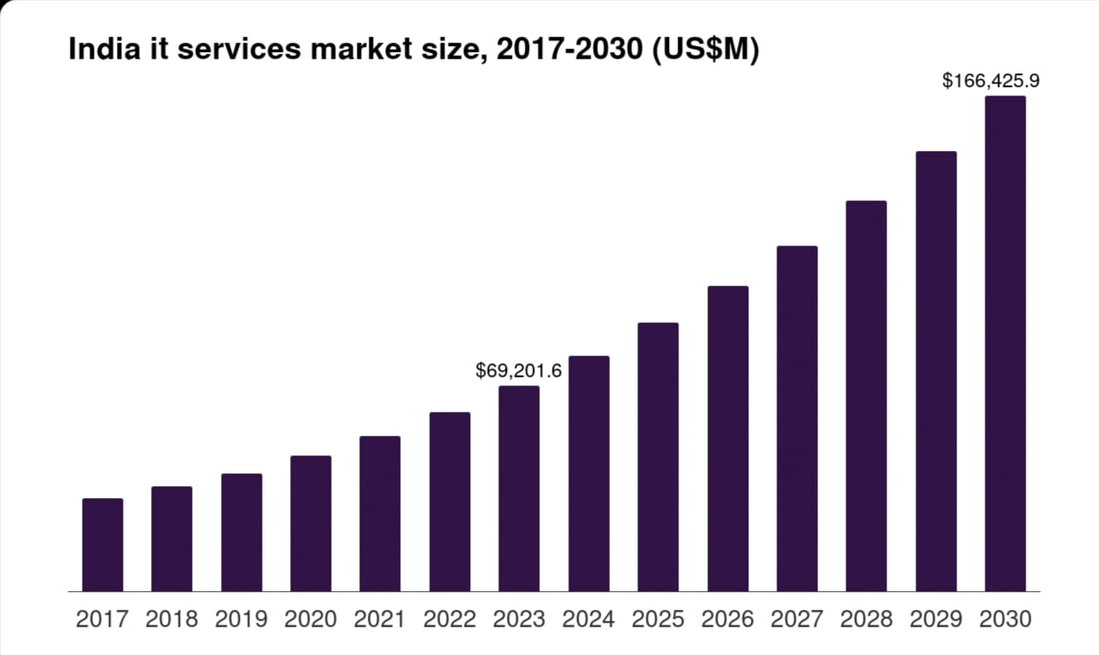
Source: Secondary data
    - Problems and Prospects
Problems
- Cybersecurity threats
As digital reliance intensifies, cyber threats have become more sophisticated and pervasive. Ransomware attacks, AI-driven phishing schemes, and advanced persistent threats (APTs) are increasingly targeting businesses and consumers alike. The World Economic Forum highlights that AI-powered cybercrime and social engineering attacks are among the top concerns in 2025. To combat these threats, IT companies must invest in advanced security solutions, which can be both costly and complex to implement.
- Rapid technological changes
The pace of technological advancement presents a significant challenge for IT firms. Emerging technologies like quantum computing are poised to revolutionize various sectors, but many companies are unprepared for their integration. IBM's Jay Gambetta warns that failing to invest in quantum readiness now could leave businesses at a disadvantage. Staying current requires continuous staff training, system upgrades, and adaptability, demanding substantial resources.
- Skilled talent shortage
Despite a growing demand for professionals skilled in AI, data science, cybersecurity, and cloud computing, the supply of qualified talent remains insufficient. Over 13,000 tech workers have faced layoffs in 2025, yet the demand for technical talent has never been more urgent. By 2026, over 90% of global organizations are expected to face IT skills shortage challenges, potentially leading to significant losses.
- High competition and price pressure
The global IT industry is highly competitive, especially in software development and IT services. Companies face pressure to deliver high-quality solutions at lower costs, which can reduce profit margins and affect service quality. In regions like the UK, business confidence in the services sector has dropped to its lowest level in two and a half years, partly due to rising cost pressures.
- Data privacy and regulatory compliance
With growing concerns about data privacy, governments have introduced strict regulations like the GDPR and CCPA. Ensuring compliance with different international standards can be complex, especially for companies operating across borders. Evolving data privacy regulations are shaping the way businesses approach compliance, emphasizing the importance of building trust and maximizing security.
- Infrastructure challenges in emerging markets
In developing regions, limited internet connectivity, lack of technological infrastructure, and power reliability issues can hinder IT development and service delivery. For instance, in Asia, the rapid advancement of AI is outpacing the development of data center infrastructure, leading to bottlenecks in computing capacity.

- Project failures and cost overruns
Many IT projects face delays, budget overruns, or fail to meet client expectations due to poor planning, changing requirements, or technical issues. A forthcoming paper by Bent Flyvbjerg of Oxford University sheds light on why so many IT projects go awry, emphasizing the need for better project management practices.
- Intellectual Property (IP) theft and piracy
Software piracy and IP theft remain significant concerns, especially in regions with weak legal enforcement. The U.S. Trade Representative's 2025 Special 301 Report identifies challenges with border, criminal, and online enforcement against counterfeits, highlighting the ongoing issues related to IP protection.
Promising Prospects
- Expansion of Artificial Intelligence and Machine Learning
Artificial Intelligence (AI) and Machine Learning (ML) are revolutionizing industries by automating tasks, enabling predictive analytics, and enhancing decision-making processes. The demand for AI-powered solutions is surging across sectors like healthcare, finance, retail, and manufacturing. Companies are increasingly investing in AI to improve efficiency and gain competitive advantages. However, this rapid adoption also raises concerns about job displacement, particularly in white-collar roles, necessitating workforce reskilling and adaptation.
- Growth of Cloud Computing
Cloud computing continues to be a cornerstone of digital transformation, offering scalable and cost-effective IT infrastructure. With the rise of remote work and digital operations, businesses are increasingly migrating to cloud platforms to enhance flexibility and innovation. In 2025, 33% of organizations are spending over $12 million annually on public cloud services, reflecting the growing reliance on cloud infrastructure.

- Rise of Data Analytics and Big Data
The explosion of digital data has made data analytics and big data essential for informed decision-making. Organizations are leveraging advanced analytics to forecast trends, personalize customer experiences, and optimize operations. The global big data and analytics industry is projected to grow at a CAGR of 14.9% between 2024 and 2032, reaching $1.088 trillion by 2032.
- Strong Demand for Cybersecurity
As cyber threats become more sophisticated, the demand for robust cybersecurity solutions is escalating. Businesses are investing in advanced security measures, including AI-driven threat detection and proactive defense strategies, to protect sensitive data and maintain trust. The cybersecurity industry is expected to experience significant growth, with investments in AI-enhanced security tools becoming a priority.
- Digital Transformation Across Industries
Organizations across various sectors are embracing digital transformation to enhance efficiency and customer experience. This includes adopting digital tools, platforms, and processes to streamline operations and drive innovation. In 2025, over 94% of organizations are engaged in digital initiatives, underscoring the pervasive nature of digitization
- Government support and Policy Push
Governments worldwide are promoting digital ecosystems through supportive policies, incentives, and infrastructure development. In India, the 2025-26 budget has allocated ₹10,000 crore to establish a Fund of Funds Scheme focused on deeptech, aiming to bolster innovation and position the country as a global innovation hub.
- Start-up and Innovation Ecosystem
The IT industry continues to foster a vibrant startup culture, particularly in fields like fintech, edtech, healthtech, and SaaS. Cities like Chennai are emerging as significant hubs for deep-tech funding, attracting venture capitalists and driving innovation. In 2024, Chennai-based startups completed over 95 funding rounds, securing a total investment of $795.88 million.
Figure 3.4
Problems and Prospects
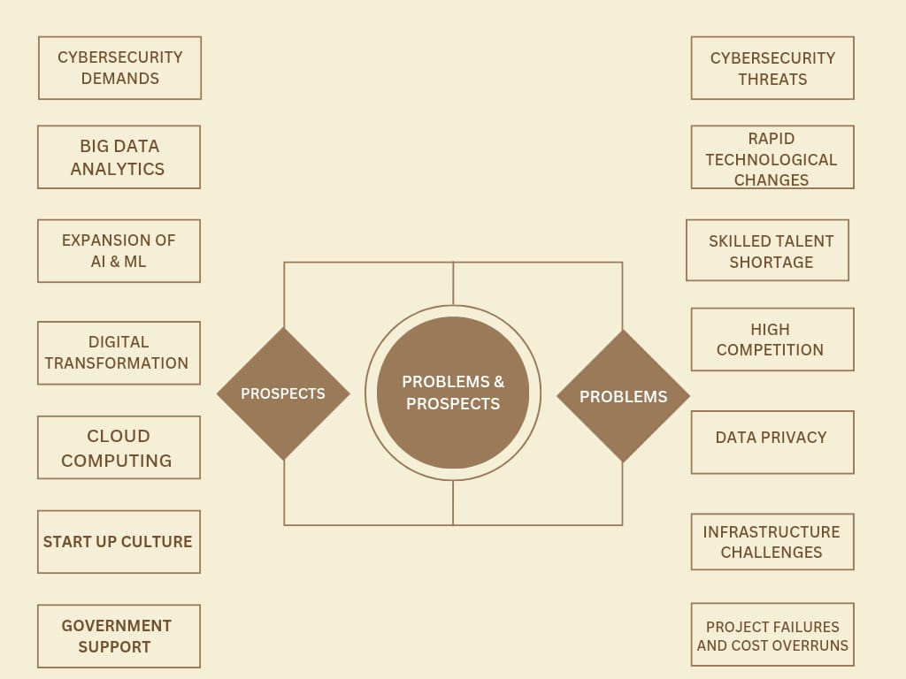
Source: Secondary data

3.2 Company Profile
Atmios Technologies and Software Solutions, established in 2019, has positioned itself as a dynamic and future-ready organization driven by innovation and technological excellence. The company’s multidisciplinary services are rooted in a deep understanding of industry needs and the evolving digital landscape. Atmios specializes in a wide range of domains, including robotics, custom software development, human resources solutions, training and development programs, website design, and strategic digital marketing. By integrating these services, Atmios offers end-to-end solutions that not only address current business challenges but also prepare organizations for long-term success in a technology-driven world. Each solution is tailored to the client’s goals, ensuring measurable impact, increased efficiency, and sustainable growth.
The company’s success is built on a foundation of dedicated professionals who bring a unique blend of creativity, technical acumen, and industry experience. Atmios serves a broad spectrum of clients—from ambitious startups looking to establish a digital footprint, to mid-sized firms seeking scalable solutions, and large enterprises aiming to innovate and optimize at scale. The team works closely with clients to understand their unique needs, develop strategic roadmaps, and implement solutions that drive transformation. By fostering a culture of continuous improvement and client-centric innovation, Atmios Technologies and Software Solutions continues to be a trusted partner for businesses aiming to thrive in an increasingly competitive and automated global market.
3.2.1 Mission Statement
Our mission is to provide businesses with integrated, innovative solutions that optimize operations, enhance customer engagement, and unlock new opportunities for growth. By combining expertise in robotics, software development, human resources, training, website design, and digital marketing, we deliver tailored strategies that drive measurable results. We are committed to empowering our clients with the tools, technologies, and talent they need to succeed in an ever-evolving digital landscape.
3.2.2 Vision Statement
Our vision is to be the leading catalyst for digital transformation, where innovation and human potential converge to empower businesses across industries. We strive to create intelligent, scalable solutions that enhance productivity, foster creativity, and build sustainable growth.
3.2.3 Nature of the Organization
Technology-Focused and Innovation-Driven
Atmios Technology and Software Solutions positions itself at the forefront of the IT industry by emphasizing innovation and technology-driven practices. The company likely offers a comprehensive suite of digital services including custom software development, web and mobile application development, and cutting-edge technologies such as cloud services, artificial intelligence (AI), automation, and data analytics. These services are designed to address complex business challenges and create value through intelligent, scalable technology solutions. Atmios’s commitment to innovation ensures it stays competitive in a fast-evolving digital landscape.
Service-Oriented
As a growing IT firm, Atmios places a strong focus on its clients, delivering tailored solutions that meet specific business requirements. The company is likely involved in IT consulting, application development, maintenance and support, and system integration services. This client-centric approach ensures that each project is customized to deliver maximum impact and efficiency. By providing end-to-end services, Atmios adds value throughout the digital transformation journey of its clients.
Project-Based and Agile in Approach
Atmios follows a project-based operational model that incorporates agile methodologies—a common and effective practice in the IT industry. This means projects are broken into manageable phases or sprints, allowing for continuous collaboration with clients, timely feedback, and iterative improvements. The agile approach enables the company to remain flexible, quickly adapt to changing requirements, and ensure timely and quality delivery of solutions.

Skilled Human Capital
Being a knowledge-intensive organization, Atmios relies heavily on a team of skilled professionals to drive its success. The workforce may include software engineers, UI/UX designers, quality assurance analysts, and project managers who bring a mix of technical skills, creativity, and problem-solving capabilities. The company’s performance and reputation are largely dependent on the collective expertise and dedication of its employees, making human capital a crucial asset.
Start-up or Mid-Sized Culture
Based in Kochi, Atmios operates with a startup or mid-sized business culture that is dynamic, fast-paced, and innovation-driven. Such a culture promotes flexibility, rapid decision-making, and encourages a hands-on approach across all levels. A flat organizational structure fosters open communication, minimizes bureaucracy, and promotes collaboration, which is vital for creativity and responsiveness in the tech industry.
Customer-Centric and Solution-Oriented
Atmios’s approach is likely centered around solving customer problems by understanding their needs deeply and offering tailored, scalable, and user-friendly digital solutions. This focus on solving real business pain points helps the company build long-term partnerships and maintain high levels of customer satisfaction and retention. Through proactive engagement and consistent value delivery, Atmios aims to position itself as a trusted technology partner for its clients.
3.2.4 Service Profile
Software Development
This is a core offering that focuses on creating customized software solutions based on the unique needs of clients across various industries. The service covers the complete software development lifecycle (SDLC), which includes requirement analysis, system design, coding, quality assurance testing, deployment, and post-launch maintenance. The company develops a wide range of software—from enterprise resource planning (ERP) systems and customer relationship management (CRM) platforms to mobile apps and embedded software—ensuring scalability, security, and performance.
Website Design and Development
Professional and responsive web development services are provided to help clients build a strong online presence. This includes visually appealing designs with intuitive user interfaces (UI) and smooth user experiences (UX). Services also cover content management systems like WordPress or Joomla, e-commerce platforms, and SEO-friendly architecture. Website optimization for speed, performance, and mobile responsiveness is also a key focus.
Digital Marketing
The company offers a full suite of digital marketing services to enhance brand visibility and customer engagement in the online space. These services include Search Engine Optimization (SEO), Search Engine Marketing (SEM), Pay-Per-Click (PPC) advertising, social media marketing across platforms like Facebook, Instagram, and LinkedIn, and email marketing campaigns. The goal is to generate leads, improve conversion rates, and build brand loyalty through data-driven marketing strategies.
IT Consulting
IT consulting services are tailored to assist businesses in planning, implementing, and managing technological solutions effectively. Consultants help evaluate current IT environments, identify gaps, and recommend strategies for digital transformation. This includes software selection, cloud adoption, cybersecurity planning, and overall IT roadmap development aligned with business objectives.
Human Resources and Staffing Solutions
This service supports organizations in recruiting and managing technical talent. It includes technical staffing, contract hiring, talent sourcing, onboarding support, and workforce planning. The company helps clients find qualified professionals for software development, data analytics, cloud services, and more. Employee engagement and retention strategies may also be included as part of HR consulting.
Training and Development
The company offers corporate training programs designed to reskill or upskill employees in various technical domains. These include courses in programming, artificial intelligence (AI), machine learning (ML), cybersecurity, data analytics, and cloud computing. Training can be delivered on-site, virtually, or through customized e-learning modules. This ensures that teams stay current with technological advancements and best practices.
Robotics and Automation
Services in this domain involve designing, programming, and integrating robotic systems to automate repetitive tasks in industrial and service sectors. The company offers solutions that utilize sensors, actuators, IoT devices, and AI for smart automation. Applications may include robotic process automation (RPA), industrial robots for manufacturing, or smart home/business automation.
Cloud Services
These include the setup, management, and optimization of cloud infrastructure. The company supports migration from on-premises systems to cloud platforms such as Amazon Web Services (AWS), Microsoft Azure, and Google Cloud. Cloud services may involve hosting applications, data storage, backup and recovery, and performance tuning. Clients benefit from increased flexibility, scalability, and cost-efficiency.
Cybersecurity Solutions
A full range of cybersecurity services is offered to protect organizations from threats like malware, phishing, ransomware, and data breaches. The company conducts security audits, penetration testing, and risk assessments. It also implements firewalls, antivirus software, encryption protocols, and ensures regulatory compliance (e.g., GDPR, HIPAA). Employee awareness training and incident response planning are also part of the offering.
Maintenance and Support
Ongoing support services ensure that clients' digital systems remain secure, efficient, and up to date. This includes troubleshooting, bug fixes, software updates, server management, and performance monitoring. The company offers Service Level Agreements (SLAs)
Figure 3.5
Logo of the Company
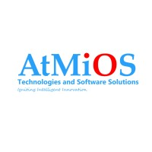
Source: Secondary data
3.2.5 Department Wise Detailed Analysis
Department of Software Development
The Software Development department at Atmios Technologies serves as the fundamental driving force behind the company’s capability to deliver customized technology solutions tailored to client specifications. This team is deeply involved in the entire software creation process, from initial design and coding to rigorous testing and ongoing maintenance. Their projects span a wide array of applications, including bespoke web applications, mobile apps compatible with both iOS and Android platforms, and complex enterprise-level software solutions that support large-scale business operations. By catering to diverse technological needs, the department ensures that each software product is uniquely crafted to solve specific client challenges effectively.
Utilizing a broad spectrum of modern programming languages and frameworks—such as Java, .NET, Python, React, and Angular—the developers emphasize building software that is not only functional but also scalable, secure, and highly efficient. This technical versatility allows the team to select the most appropriate tools and technologies for each project, optimizing performance and future-proofing the applications. Additionally, the developers focus on seamless integration with third-party APIs, which enables enhanced functionality and interoperability with other systems. Automation of repetitive processes is another key focus area, aimed at improving operational efficiency and reducing the likelihood of errors.
The team strictly follows industry-standard Software Development Life Cycle (SDLC) methodologies to ensure that every project moves systematically through phases like requirement analysis, design, development, testing, deployment, and maintenance. Close collaboration with clients and internal stakeholders is integral throughout this process, allowing for continuous feedback and refinements that ensure the final product aligns perfectly with client expectations and business goals. This collaborative and methodical approach enables Atmios Technologies to consistently deliver reliable, high-quality software solutions that drive client success and foster long-term partnerships.
Department of it Infrastructure & Cloud Services
The IT Infrastructure & Cloud Services department at Atmios Technologies plays a critical role in managing and maintaining the essential technology backbone that supports both the company’s internal operations and its client-facing solutions. This department is responsible for designing, deploying, and managing the physical and virtual infrastructure required for smooth business functions. This includes overseeing server hardware, configuring and maintaining network architecture, managing data storage systems, and ensuring that all components work together efficiently to support various applications and services. By maintaining a robust and reliable infrastructure, the team enables seamless access to data and resources, which is vital for uninterrupted business activities.
In addition to managing traditional IT infrastructure, this department places strong emphasis on cybersecurity to protect sensitive information and maintain compliance with industry standards. They implement multiple layers of defense such as firewalls, intrusion detection systems, encryption, and regular security audits to safeguard against threats like data breaches, malware, and unauthorized access. The team also ensures that all network systems are optimized for performance, minimizing latency and downtime to provide users and clients with fast, secure, and reliable access to digital resources. This proactive approach to IT infrastructure management helps reduce operational risks and builds client confidence in Atmios Technologies’ ability to protect their data assets.
With the growing adoption of cloud technologies, the IT Infrastructure & Cloud Services department has expanded its focus to include cloud computing solutions such as migrations to platforms like AWS, Microsoft Azure, and Google Cloud. They assist clients in transitioning from on-premises systems to scalable cloud environments that offer flexibility, cost efficiency, and enhanced disaster recovery capabilities. This team also handles virtualization technologies that allow for more efficient resource utilization and easier management of IT environments. Additionally, they develop and maintain disaster recovery and backup strategies, ensuring that both Atmios Technologies and its clients can quickly recover from unexpected outages or data loss, thereby guaranteeing business continuity and operational resilience.
Department of Technical Support & Training
The Technical Support and Training team at Atmios Technologies serves as a crucial link between the company’s advanced technology solutions and the clients who use them. Their primary role is to provide timely and effective assistance whenever clients encounter technical issues, software bugs, or operational challenges. By troubleshooting and resolving these problems promptly, the support team ensures that client systems continue to operate smoothly without disruption. This ongoing support helps maintain client confidence in the technology and reduces downtime, which is essential for business productivity.
Beyond simply resolving issues, this department takes a proactive approach by developing and delivering comprehensive training programs tailored to meet the diverse needs of various user groups. These training initiatives aim to empower clients by enhancing their understanding of the software and tools implemented by Atmios Technologies. The programs can range from interactive live workshops and webinars to pre-recorded video tutorials, detailed user manuals, and easily accessible FAQs. Such resources help users quickly get up to speed, enabling them to maximize the utility of the technology while minimizing reliance on direct support.
By focusing on client education and self-sufficiency, the Technical Support and Training team contributes significantly to the successful adoption and long-term satisfaction of Atmios Technologies’ solutions. Well-trained users are more confident and capable, which leads to fewer support requests and a smoother overall experience. This not only benefits clients but also allows the company to allocate support resources more efficiently. Ultimately, the team’s efforts help build strong client relationships and reinforce the value of Atmios Technologies as a trusted technology partner.
Department of Human Resources (HR)
The Human Resources (HR) department at Atmios Technologies plays a central role in cultivating a productive and engaged workforce. It begins with talent acquisition, where HR develops strategic hiring practices to attract highly qualified candidates who align with the company’s values and technical requirements. This includes drafting compelling job descriptions, sourcing candidates through various channels, conducting structured interviews, and managing onboarding processes to ensure new hires are seamlessly integrated into the organizational culture. The department also actively manages internship programs that serve as a talent pipeline, giving students and fresh graduates an opportunity to gain hands-on experience and potentially transition into full-time roles.
Beyond recruitment, HR is instrumental in fostering professional growth and employee satisfaction. The department coordinates training and development programs tailored to individual roles and career aspirations, including technical upskilling, soft skills enhancement, and leadership development. Regular performance evaluations help identify high-potential employees, recognize achievements, and create pathways for advancement. At the same time, HR spearheads employee engagement through initiatives like wellness programs, mentorship schemes, feedback surveys, and recognition awards, all of which contribute to a positive and inclusive workplace environment that encourages collaboration and innovation.
HR also ensures organizational health through compliance, policy enforcement, and conflict resolution. The department keeps the company aligned with labor laws, health and safety standards, and ethical employment practices. It develops and updates company policies on matters like harassment prevention, leave entitlements, and workplace conduct. Additionally, HR serves as a neutral party for addressing grievances and mediating disputes, thereby maintaining harmony and mutual respect across all levels of the organization. Ultimately, HR at Atmios Technologies functions not just as an administrative unit, but as a strategic partner in achieving long-term business success by empowering the people who drive it.
Department of Sales & Marketing
The Sales & Marketing department at Atmios Technologies plays a pivotal role in expanding the company’s market presence and generating revenue. The marketing team is tasked with building brand awareness and establishing a strong digital footprint. Through in-depth market research, they identify key trends, understand customer needs, and analyze competitors to craft effective strategies that position Atmios as a leader in the tech services space. They manage a range of marketing initiatives including search engine optimization (SEO), pay-per-click advertising, social media campaigns, and email outreach. Content creation, such as blog posts, whitepapers, and promotional videos, is also a key component, helping to educate the market and showcase the company’s capabilities.
On the other side, the sales team focuses on converting marketing-generated leads into clients through direct engagement. Their responsibilities involve identifying potential clients, initiating contact, conducting product or service demonstrations, and tailoring proposals that align with client needs. They play a critical role in contract negotiation and closing deals, requiring a deep understanding of both the company’s offerings and the specific challenges faced by each prospect. In addition to acquiring new clients, the sales team also nurtures ongoing relationships with existing customers to encourage repeat business and explore opportunities for upselling or cross-selling complementary services.
Together, the Sales & Marketing teams function as a unified force to drive business development. Marketing lays the groundwork by creating interest and visibility, while sales executes targeted efforts to secure and retain business. Their collaboration ensures that messaging remains consistent and aligned with company goals. By regularly analyzing performance metrics and client feedback, they continuously refine their approach for better engagement and conversion rates. This synergy not only sustains a healthy sales pipeline but also strengthens Atmios Technologies' position in an increasingly competitive market.

Figure 3.6
Department Structure
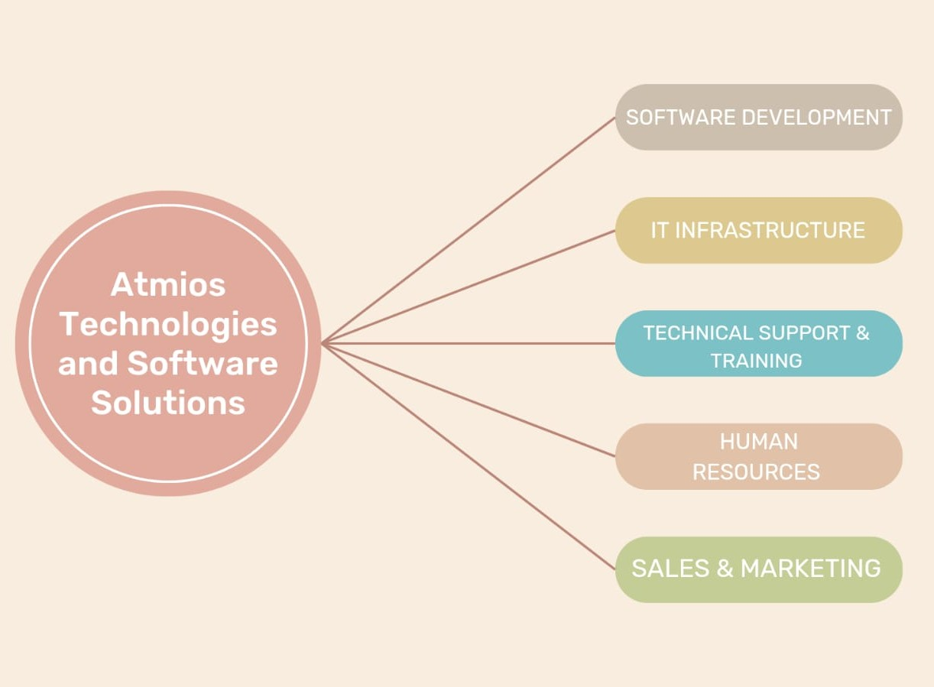
Source: Secondary Data
Business Process Flow
Client Engagement
- Goal: Establish initial contact and convert leads into signed clients.
- Lead Generation: Atmios might use digital marketing, SEO, LinkedIn, cold emails, or referrals to attract potential clients.
- Initial Contact & Requirement Gathering: Business analysts or sales teams communicate with the lead to understand their needs, technical requirements, budget, and deadlines.
- Proposal & Quotation: A formal document is prepared outlining the scope of work, deliverables, pricing, timelines, and technologies.
- Contract Signing: Once the client approves the proposal, legal agreements are signed, formally kicking off the partnership.
Project Planning
- Goal: Lay down a strong foundation with detailed planning and resource allocation.
- Assigning Project Manager: A dedicated PM is assigned to oversee delivery and communication.
- Team Allocation: Based on the requirements, designers, developers, testers, and DevOps engineers are assigned.
- Timeline & Milestone Planning: Milestones and deadlines are planned using project management tools (e.g., Jira, Trello).
- Tool & Resource Allocation: The team sets up project environments, software tools, and version control systems (e.g., GitHub, Bitbucket).
Design & Development
- Goal: Transform the concept into a functional digital product.
- UI/UX Design: Designers create wireframes, prototypes, and visual interfaces using tools like Figma or Adobe XD.
- System Architecture Planning: Developers decide on frameworks, database structures, and APIs.
- Coding & Integration: Frontend, backend, and databases are developed, and modules are integrated.
- Continuous Client Feedback: Agile methodology may be used, involving regular sprints and feedback loops.
Testing & QA
- Goal: Ensure the product is error-free and performs as intended.
- Unit Testing: Developers write test cases to check individual code units.
- Integration Testing: The entire system is tested to ensure modules work well together.
- UAT (User Acceptance Testing): Clients test the system to verify it meets their expectations.
- Bug Fixing: Identified issues are tracked, assigned, resolved, and retested.

Deployment
- Goal: Move the application to a live production environment.
- Production Environment Setup: Servers and hosting platforms (AWS, Azure, DigitalOcean, etc.) are configured.
- Final Deployment: The stable version of the product is launched.
- Performance Monitoring: Tools like Google Analytics, New Relic, or custom dashboards track system performance.
Maintenance & Support
- Goal: Ensure long-term system stability, security, and efficiency.
- SLA-Based Support: Service Level Agreements define response times and support availability.
- Updates and Upgrades: Regular updates to fix bugs, patch security issues, or add features.
- Performance Optimization: Continuous monitoring to improve speed, scalability, and user experience.
Feedback & Relationship Management
- Goal: Strengthen client trust and generate future business.
- Client Feedback Collection: Surveys, meetings, or calls are used to gather feedback.
- Case Studies/Testimonials: Success stories are documented for future marketing and client credibility.
- Repeat Business or Upselling: Long-term clients are offered additional services like mobile apps, SEO, or digital marketing.

Figure 3.7
Business Process Flow
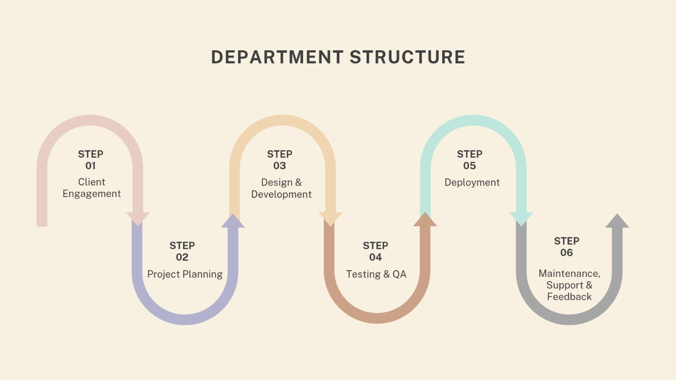
Source: Secondary data
3.2.6 Swot Analysis
Strengths of Atmios Technology and Software Solutions
- Diverse service portfolio
Atmios Technologies demonstrates a strategic advantage by offering a comprehensive range of services that span across robotics, software development, digital marketing, HR solutions, and professional training. This all-in-one service model allows businesses to streamline their vendor interactions, saving time and resources while enhancing coordination across various aspects of their operations. Clients seeking both tech-driven products and organizational support can find end-to-end solutions without needing to engage multiple firms.
The diversity also facilitates cross-functional innovation, where insights from one domain (like digital marketing) can enhance another (such as software design or training modules). This interconnected approach creates added value, as clients benefit from solutions that are not just technically sound but also strategically aligned with business goals. It also helps Atmios tap into various market segments—from startups to enterprises—broadening their client base and market influence.
- Skilled workforce
At the heart of Atmios Technologies is its team of highly skilled professionals, adept in both technical domains like software engineering and robotics, and business areas such as marketing and HR consultancy. This multidisciplinary talent pool allows the company to offer well-rounded, practical solutions that are not only technologically robust but also aligned with client business models. These professionals are capable of quickly adapting to new challenges, ensuring timely delivery and high client satisfaction.
Moreover, the workforce’s adaptability and learning mindset empower the company to stay ahead of technology trends. Employees are encouraged to innovate and continuously upgrade their skills, which contributes to the company’s agility in deploying cutting-edge solutions. This human capital advantage allows Atmios to stand out in a competitive market, offering both technical depth and strategic insight.
- Client-centric approach
Atmios Technologies places a strong emphasis on understanding the unique needs of each client, adopting a highly personalized approach to solution delivery. Rather than offering generic services, they invest time in comprehending the client’s industry, challenges, and goals, enabling them to create tailor-made strategies that drive real value. This fosters trust and long-term partnerships, as clients feel heard and supported.
Additionally, this client-centric ethos extends to post-delivery support, ensuring continuous engagement and improvements based on feedback. The proactive communication style, collaborative working model, and focus on measurable outcomes help in building sustainable relationships. As a result, clients are more likely to return for additional services and refer others, amplifying the company’s reach through word-of-mouth.
- Innovation-driven
Innovation is a core pillar of Atmios Technologies’ operations. The company actively explores emerging technologies such as artificial intelligence (AI), machine learning, and automation to create forward-thinking solutions that are not only relevant today but also scalable for tomorrow. This future-proofing approach allows clients to gain a competitive edge, as they benefit from tools and systems designed with tomorrow’s challenges in mind.
Their innovation strategy is not limited to technology alone—it spans business processes and customer engagement models as well. Atmios continuously refines its methodologies to improve efficiency, reduce time-to-market, and boost service quality. This makes the company attractive to clients who are seeking digital transformation partners capable of helping them adapt and thrive in fast-changing environments.
- Cost advantage
Being headquartered in Kochi, India, Atmios Technologies leverages the country’s favorable economic conditions to offer high-quality services at competitive prices. Lower operational and labor costs enable the company to provide cost-effective solutions without compromising on standards or innovation. This is particularly appealing to clients in Western markets who are looking for reliable yet affordable outsourcing partners.
This cost advantage extends beyond simple affordability—it allows Atmios to invest more into service development and employee training while maintaining reasonable pricing. International clients especially benefit from this value proposition, as they can access world-class technology and consulting expertise at a fraction of what it would cost in developed countries, making Atmios a strong choice in the global outsourcing landscape.
Weakness of Atmios Technology and Software Solutions
- Limited Brand Recognition
Atmios Technology and Software Solutions may face challenges in establishing a strong brand presence compared to more established competitors. This limited brand recognition can impact the company's ability to attract new clients, form strategic partnerships, and recruit top-tier talent. In a competitive industry, a well-recognized brand often serves as a trust signal to potential clients and employees, influencing their decision-making processes.
To address this, Atmios could invest in targeted marketing strategies, such as content marketing, participation in industry events, and leveraging social media platforms to increase visibility. Building a strong online presence through thought leadership articles, case studies, and client testimonials can also enhance credibility. Additionally, forming partnerships with established organizations can provide opportunities for co-branding and access to a broader audience.
- Resource Constraints
Operating with a workforce size ranging between 51-200 employees, Atmios may encounter limitations in scaling operations rapidly or investing heavily in research and development. Resource constraints can hinder the company's ability to take on larger projects, expand service offerings, or respond swiftly to market demands. This limitation can also affect employee workload, potentially leading to burnout or decreased productivity.
To mitigate these challenges, Atmios could prioritize projects based on strategic importance and resource availability. Implementing efficient project management practices and leveraging automation tools can optimize existing resources. Exploring funding opportunities, such as grants or partnerships, can provide additional capital for growth initiatives. Furthermore, investing in employee training and development can enhance productivity and enable the company to do more with its current workforce.
- Dependence on Interns
While internship programs can bring fresh perspectives and serve as a pipeline for future talent, an over-reliance on interns for project execution may impact the consistency and quality of deliverables. Interns typically require training and supervision, and their limited experience can lead to longer project timelines or increased error rates. Additionally, the transient nature of internships can result in knowledge gaps and discontinuity in ongoing projects.
To address this, Atmios should ensure a balanced workforce composition, where interns complement rather than constitute the core project teams. Establishing structured internship programs with clear objectives, mentorship, and evaluation processes can enhance the effectiveness of interns. Moreover, converting high-performing interns to full-time employees can retain institutional knowledge and reduce the learning curve associated with onboarding new team members. Implementing comprehensive documentation practices can also ensure knowledge retention and continuity in projects.
Opportunities of Atmios Technology and Software Solutions
- Growing Demand for Digital Transformation
The global surge in digital transformation presents a significant opportunity for Atmios. Businesses across various sectors are increasingly adopting technologies like Artificial Intelligence (AI), the Internet of Things (IoT), and automation to enhance efficiency and competitiveness
Atmios can leverage its expertise in AI and automation to offer tailored solutions that meet the evolving needs of businesses. By focusing on sectors such as manufacturing, healthcare, and logistics, where digital transformation is rapidly gaining traction, Atmios can position itself as a key player in providing innovative and efficient solutions. Additionally, investing in research and development to stay abreast of emerging technologies will enable Atmios to deliver cutting-edge services to its clients.
- Expansion into New Markets
Exploring emerging markets and industries offers Atmios the chance to diversify its client base and revenue streams. India's digital economy is poised for significant growth, propelled by robust government support, technological advancements, and rising digital adoption across various industries. By tapping into these emerging markets, Atmios can capitalize on the increasing demand for IT services and solutions.
Furthermore, expanding into sectors such as education, agriculture, and retail, which are undergoing digital transformation, can open new avenues for Atmios. Tailoring services to meet the specific needs of these industries will not only broaden Atmios's market reach but also establish its presence in diverse sectors, thereby enhancing its resilience against market fluctuations.
- Strategic Partnerships
Forming alliances with other tech firms or educational institutions can significantly enhance Atmios's service offerings and access to new technologies and talent. Strategic partnerships can lead to collaborative innovation, resource sharing, and expanded market reach. For instance, partnerships with educational institutions can facilitate research and development initiatives, as well as provide a pipeline of skilled graduates ready to contribute to Atmios's projects.
Collaborations with other tech companies can also enable Atmios to offer integrated solutions, combining expertise from different domains to deliver comprehensive services to clients. Such partnerships can also open doors to new markets and customer segments, fostering business growth and competitiveness.
- Government Initiatives
Leveraging government programs promoting digitalization and startup growth can provide financial incentives and support for Atmios's expansion. The Indian government's Startup India initiative offers various schemes to support startups, including financial assistance, infrastructure support, and regulatory benefits. By aligning with these initiatives, Atmios can access resources that facilitate business development and innovation.
Additionally, government-led digitalization efforts across sectors such as healthcare, education, and agriculture present opportunities for Atmios to contribute its expertise. Participating in government projects can enhance Atmios's portfolio and credibility, while also contributing to national development goals. Engaging with these initiatives can also provide exposure to large-scale projects, offering substantial growth prospects for the company.
Threats of Atmios Technology and Software Solutions
- Intense Competition
The Indian IT industry is highly competitive, with numerous domestic firms and multinational corporations vying for market share. Established players like Infosys, Wipro, and Accenture have significant resources, extensive client bases, and strong brand recognition, making it challenging for newer entrants like Atmios to establish a foothold. These industry giants often have the advantage of scale, allowing them to offer a broader range of services and more competitive pricing.
To navigate this competitive landscape, Atmios must focus on differentiating itself through specialized services, innovation, and exceptional customer service. Building niche expertise in emerging technologies or specific industry verticals can help Atmios carve out a unique market position. Additionally, developing strategic partnerships and investing in marketing efforts can enhance brand visibility and credibility, enabling the company to compete more effectively against larger rivals.
- Rapid Technological Change
The IT sector is characterized by rapid technological advancements, with new tools, platforms, and methodologies emerging continuously. Staying abreast of these changes requires ongoing investment in research and development, employee training, and infrastructure upgrades. For a company like Atmios, with limited resources, keeping pace with technological evolution can be a significant challenge.
Failure to adapt to technological changes can result in outdated service offerings, reduced competitiveness, and potential loss of clients seeking more innovative solutions. To mitigate this risk, Atmios should foster a culture of continuous learning and innovation, encouraging employees to stay updated with industry trends. Collaborating with educational institutions and participating in industry forums can also provide insights into emerging technologies and best practices, ensuring the company remains at the forefront of technological developments.
- Cybersecurity Risks
As businesses increasingly rely on digital solutions, the risk of cyberattacks and data breaches has escalated. Cybersecurity threats can compromise sensitive client information, disrupt operations, and damage a company's reputation. In India, cyberattacks targeting organizations have been rising, with incidents doubling year-over-year, highlighting the growing risk for IT companies.
For Atmios, ensuring robust cybersecurity measures is crucial to maintaining client trust and compliance with data protection regulations. This involves implementing comprehensive security protocols, regular system audits, and employee training programs to mitigate potential vulnerabilities. Investing in advanced cybersecurity infrastructure and staying informed about emerging threats can help Atmios protect its assets and uphold its reputation in the industry.

Figure 3.8
Swot Analysis
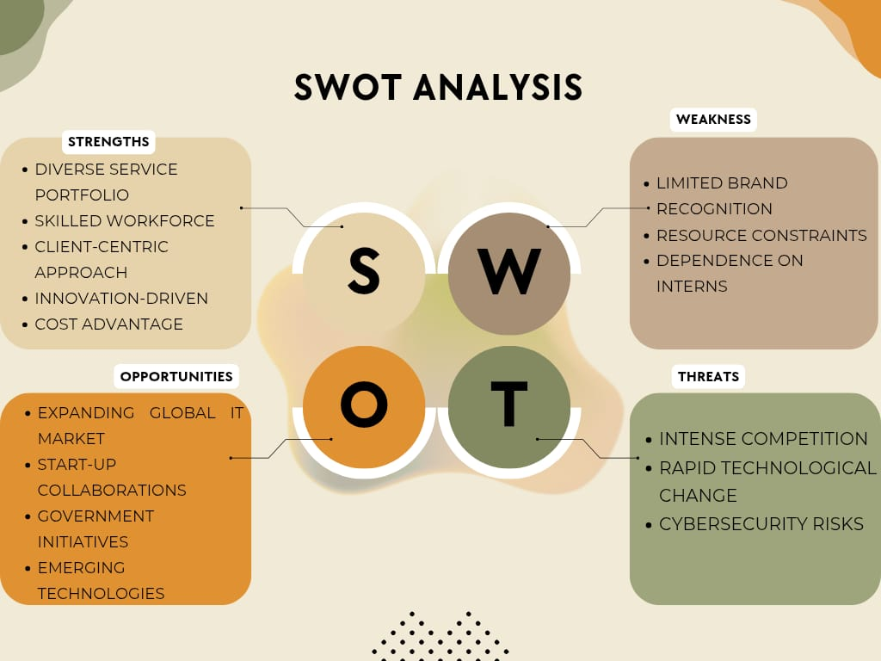
Source: Secondary data

Table 4.1
Age of Respondents
Age Group | Frequency | Percentage
Below 20 years | 12 | 12.00
20–30 years | 38 | 38.00
31–40 years | 25 | 25.00
41–50 years | 15 | 15.00
Above 50 years | 10 | 10.00
Total | 100 | 100.00
Source: Primary Data
Chart 4.1
Age of Respondents

Interpretation
Table 4.1 shows the age group of respondents. The majority of the respondents (38.00%) belong to the 20–30 years age group, followed by 25.00% in the 31–40 years category. Respondents aged 41–50 years constitute 15.00%, while 12.00% are below 20 years. The lowest proportion of respondents (10.00%) belongs to the above 50 years age group. This indicates that most respondents are young adults who are active users of social media platforms.

Table 4.2
Gender of Respondents
Gender | Frequency | Percentage
Male | 55 | 55.00
Female | 40 | 40.00
Transgender | 2 | 2.00
Prefer not to say | 1 | 1.00
Other | 2 | 2.00
Total | 100 | 100.00
Source: Primary Data
Chart 4.2
Gender of Respondents

Interpretation
Table 4.2 shows the gender of respondents. The majority of the respondents (55.00%) are male, followed by 40.00% female respondents. A small percentage of respondents belong to the transgender (2.00%) and other (2.00%) categories, while 1.00% preferred not to disclose their gender.

Table 4.3
Educational Qualification of Respondents
Educational Qualification | Frequency | Percentage
SSLC/Plus Two | 15 | 15.00
Diploma | 20 | 20.00
Undergraduate | 35 | 35.00
Postgraduate | 25 | 25.00
Other | 5 | 5.00
Total | 100 | 100.00
Source: Primary Data
Chart 4.3
Educational Qualification of Respondents

Interpretation
Table 4.3 shows the educational qualification of respondents. A majority of the respondents (35.00%) are undergraduates, followed by 25.00% postgraduates. Diploma holders account for 20.00%, while 15.00% have completed SSLC/Plus Two. Only 5.00% belong to the other educational qualification category.

Table 4.4
Occupation of Respondents
Occupation | Frequency | Percentage
Student | 30 | 30.00
Employee | 40 | 40.00
Business Owner | 12 | 12.00
Professional | 10 | 10.00
Other | 8 | 8.00
Total | 100 | 100.00
Source: Primary Data
Chart 4.4
Occupation of Respondents

Interpretation
Table 4.4 shows the occupation of respondents. Most of the respondents (40.00%) are employees, while 30.00% are students. Business owners represent 12.00% of the sample, followed by professionals at 10.00%. The remaining 8.00% belong to the other category.

Table 4.5
Frequency of Social Media Usage
Frequency | Frequency | Percentage
Daily | 50 | 50.00
Several Times a Week | 25 | 25.00
Weekly | 12 | 12.00
Occasionally | 8 | 8.00
Rarely | 5 | 5.00
Total | 100 | 100.00
Source: Primary Data
Chart4.5
Frequency of Social Media Usage

Interpretation
Table 4.5 shows the frequency of social media usage among respondents. Half of the respondents (50.00%) use social media daily. Another 25.00% use it several times a week, indicating a high level of engagement with social media platforms.

Table 4.6
Most Frequently Used Social Media Platform
Platform | Frequency | Percentage
Facebook | 20 | 20.00
Instagram | 35 | 35.00
LinkedIn | 18 | 18.00
YouTube | 22 | 22.00
Other | 5 | 5.00
Total | 100 | 100.00
Source: Primary Data
Chart 4.6
Most Frequently Used Social Media Platform

Interpretation
Table 4.6 shows the most frequently used social media platform among respondents. Instagram is the most preferred platform with 35.00% of respondents, followed by YouTube with 22.00%. Facebook accounts for 20.00%, while LinkedIn represents 18.00% of the respondents.

Table 4.7
Source of Awareness about Atmios Technology and Software Solutions
Source | Frequency | Percentage
Social Media | 40 | 40.00
Website | 20 | 20.00
Friends/Family | 18 | 18.00
Advertisement | 15 | 15.00
Other | 7 | 7.00
Total | 100 | 100.00
Source: Primary Data
Chart 4.7
Source of Awareness about Atmios Technology and Software Solutions

Interpretation
Table 4.7 shows how respondents first learned about Atmios Technology and Software Solutions. The largest share of respondents (40.00%) became aware of the company through social media, highlighting the effectiveness of digital platforms in creating brand awareness.

Table 4.8
Frequency of Coming across Atmios's Social Media Content
Response | Frequency | Percentage
Very Often | 28 | 28.00
Often | 35 | 35.00
Sometimes | 22 | 22.00
Rarely | 10 | 10.00
Never | 5 | 5.00
Total | 100 | 100.00
Source: Primary Data
Chart 4.8
Frequency of Coming across Atmios's Social Media Content

Interpretation
Table 4.8 shows how often respondents come across Atmios's social media content. A majority of respondents (35.00%) reported that they often encounter the company's content, indicating a strong social media presence.

Table 4.9
Attractiveness of Atmios's Social Media Posts
Response | Frequency | Percentage
Very Attractive | 25 | 25.00
Attractive | 40 | 40.00
Neutral | 20 | 20.00
Unattractive | 10 | 10.00
Very Unattractive | 5 | 5.00
Total | 100 | 100.00
Source: Primary Data
Chart 4.9
Attractiveness of Atmios's Social Media Posts

Interpretation
Table 4.9 shows respondents' opinion regarding the attractiveness of Atmios's social media posts. A significant 40.00% of respondents find the posts attractive, while 25.00% consider them very attractive.

Table 4.10
Relevance of Atmios's Social Media Content
Response | Frequency | Percentage
Highly Relevant | 22 | 22.00
Relevant | 42 | 42.00
Neutral | 18 | 18.00
Slightly Relevant | 12 | 12.00
Not Relevant | 6 | 6.00
Total | 100 | 100.00
Source: Primary Data
Chart 4.10
Relevance of Atmios's Social Media Content

Interpretation
Table 4.10 shows the relevance of Atmios's social media content to respondents' interests. The majority of respondents (42.00%) perceive the content as relevant, while 22.00% consider it highly relevant, indicating that the content effectively matches audience interests.

Table 4.11
Informativeness of Atmios's Social Media Content
Response | Frequency | Percentage
Very Informative | 24 | 24.00
Informative | 41 | 41.00
Neutral | 18 | 18.00
Less Informative | 11 | 11.00
Not Informative | 6 | 6.00
Total | 100 | 100.00
Source: Primary Data
Chart 4.11
Informativeness of Atmios's Social Media Content

Interpretation
Table 4.11 shows the informativeness of Atmios's social media content. A majority of the respondents (41.00%) perceive the content as informative, while 24.00% consider it very informative, indicating that the content effectively provides useful information to the audience.

Table 4.12
Engagement Level of Atmios's Social Media Content
Response | Frequency | Percentage
Very Engaging | 20 | 20.00
Engaging | 43 | 43.00
Neutral | 19 | 19.00
Less Engaging | 12 | 12.00
Not Engaging | 6 | 6.00
Total | 100 | 100.00
Source: Primary Data
Chart 4.12
Engagement Level of Atmios's Social Media Content

Interpretation
Table 4.12 shows the engagement level of Atmios's social media content. The highest percentage of respondents (43.00%) find the content engaging, suggesting that the company successfully captures audience attention through its social media activities.

Table 4.13
Interaction with Atmios's Social Media Posts
Response | Frequency | Percentage
Very Frequently | 18 | 18.00
Frequently | 36 | 36.00
Occasionally | 24 | 24.00
Rarely | 14 | 14.00
Never | 8 | 8.00
Total | 100 | 100.00
Source: Primary Data
Chart 4.13
Interaction with Atmios's Social Media Posts

Interpretation
Table 4.13 shows how frequently respondents interact with Atmios's social media posts. The largest group of respondents (36.00%) frequently engage with the posts through likes, comments, and shares, reflecting a satisfactory level of audience interaction.

Table 4.14
Effectiveness of Atmios's Social Media Campaigns in Capturing Attention
Response | Frequency | Percentage
Very Effective | 23 | 23.00
Effective | 40 | 40.00
Neutral | 20 | 20.00
Ineffective | 11 | 11.00
Very Ineffective | 6 | 6.00
Total | 100 | 100.00
Source: Primary Data
Chart 4.14
Effectiveness of Atmios's Social Media Campaigns in Capturing Attention

Interpretation
Table 4.14 shows the effectiveness of Atmios's social media campaigns in capturing attention. A considerable 40.00% of respondents rate the campaigns as effective, indicating their success in attracting audience interest.

Table 4.15
Clarity of Communication of Products and Services
Response | Frequency | Percentage
Very Clearly | 21 | 21.00
Clearly | 44 | 44.00
Neutral | 18 | 18.00
Unclear | 11 | 11.00
Very Unclear | 6 | 6.00
Total | 100 | 100.00
Source: Primary Data
Chart 4.15
Clarity of Communication of Products and Services

Interpretation
Table 4.15 shows respondents' views on how clearly Atmios communicates its products and services through social media. The majority of respondents (44.00%) believe that the information is communicated clearly.

Table 4.16
Trust in Information Shared by Atmios on Social Media
Response | Frequency | Percentage
Very Likely | 19 | 19.00
Likely | 42 | 42.00
Neutral | 22 | 22.00
Unlikely | 11 | 11.00
Very Unlikely | 6 | 6.00
Total | 100 | 100.00
Source: Primary Data
Chart 4.16
Trust in Information Shared by Atmios on Social Media

Interpretation
Table 4.16 shows the level of trust respondents place in information shared by Atmios on social media. The highest percentage of respondents (42.00%) are likely to trust the information provided by the company.

Table 4.17
Responsiveness of Atmios to Customer Queries on Social Media
Response | Frequency | Percentage
Very Responsive | 20 | 20.00
Responsive | 41 | 41.00
Neutral | 21 | 21.00
Less Responsive | 12 | 12.00
Not Responsive | 6 | 6.00
Total | 100 | 100.00
Source: Primary Data
Chart 4.17
Responsiveness of Atmios to Customer Queries on Social Media

Interpretation
Table 4.17 shows respondents' perception of Atmios's responsiveness to customer queries on social media. A majority of respondents (41.00%) consider the company responsive, reflecting positive customer communication practices.

Table 4.18
Effectiveness of Social Media Presence in Building Brand Awareness
Response | Frequency | Percentage
Very Effective | 24 | 24.00
Effective | 39 | 39.00
Neutral | 19 | 19.00
Ineffective | 12 | 12.00
Very Ineffective | 6 | 6.00
Total | 100 | 100.00
Source: Primary Data
Chart 4.18
Effectiveness of Social Media Presence in Building Brand Awareness

Interpretation
Table 4.18 shows the effectiveness of Atmios's social media presence in building brand awareness. The majority of respondents (39.00%) feel that the company's social media activities are effective in increasing awareness of the brand.

Table 4.19
Effectiveness of Social Media in Improving Brand Perception
Response | Frequency | Percentage
Very Effective | 22 | 22.00
Effective | 43 | 43.00
Neutral | 18 | 18.00
Ineffective | 11 | 11.00
Very Ineffective | 6 | 6.00
Total | 100 | 100.00
Source: Primary Data
Chart 4.19
Effectiveness of Social Media in Improving Brand Perception

Interpretation
Table 4.19 shows the effectiveness of social media in improving respondents' perception of Atmios. The highest percentage of respondents (43.00%) believe that social media positively influences their perception of the brand.

Table 4.20
Likelihood of Recommending Atmios Based on Social Media Presence
Response | Frequency | Percentage
Very Likely | 25 | 25.00
Likely | 40 | 40.00
Neutral | 18 | 18.00
Unlikely | 11 | 11.00
Very Unlikely | 6 | 6.00
Total | 100 | 100.00
Source: Primary Data
Chart 4.20
Likelihood of Recommending Atmios Based on Social Media Presence

Interpretation
Table 4.20 shows the likelihood of respondents recommending Atmios based on its social media presence. A significant 40.00% of respondents are likely to recommend the company, indicating the positive impact of its social media marketing strategies.

Table 4.21
Atmios Regularly Shares Valuable and Useful Content on Social Media
Response | Frequency | Percentage
Strongly Agree | 23 | 23.00
Agree | 42 | 42.00
Neutral | 18 | 18.00
Disagree | 11 | 11.00
Strongly Disagree | 6 | 6.00
Total | 100 | 100.00
Source: Primary Data
Chart 4.21
Atmios Regularly Shares Valuable and Useful Content on Social Media

Interpretation
Table 4.21 shows respondents' opinion on whether Atmios regularly shares valuable and useful content on social media. The majority of respondents (42.00%) agree with the statement, indicating that the content is perceived as beneficial and informative.

Table 4.22
The Visual Quality of Atmios's Social Media Content is Appealing
Response | Frequency | Percentage
Strongly Agree | 25 | 25.00
Agree | 40 | 40.00
Neutral | 19 | 19.00
Disagree | 10 | 10.00
Strongly Disagree | 6 | 6.00
Total | 100 | 100.00
Source: Primary Data
Chart 4.22
The Visual Quality of Atmios's Social Media Content is Appealing

Interpretation
Table 4.22 shows respondents' perception regarding the visual quality of Atmios's social media content. A significant 40.00% of respondents agree that the visual presentation of the content is appealing.

Table 4.23
Atmios's Social Media Marketing Helps Me Understand Its Services Better
Response | Frequency | Percentage
Strongly Agree | 24 | 24.00
Agree | 41 | 41.00
Neutral | 18 | 18.00
Disagree | 11 | 11.00
Strongly Disagree | 6 | 6.00
Total | 100 | 100.00
Source: Primary Data
Chart 4.23
Atmios's Social Media Marketing Helps Me Understand Its Services Better

Interpretation
Table 4.23 shows whether Atmios's social media marketing helps respondents understand its services better. The highest percentage of respondents (41.00%) agree with the statement, suggesting that social media serves as an effective communication tool.

Table 4.24
Social Media Promotions by Atmios Influence My Interest in Its Services
Response | Frequency | Percentage
Strongly Agree | 22 | 22.00
Agree | 43 | 43.00
Neutral | 17 | 17.00
Disagree | 12 | 12.00
Strongly Disagree | 6 | 6.00
Total | 100 | 100.00
Source: Primary Data
Chart 4.24
Social Media Promotions by Atmios Influence My Interest in Its Services

Interpretation
Table 4.24 shows the influence of Atmios's social media promotions on respondents' interest in its services. A majority of respondents (43.00%) agree that the promotions positively influence their interest in the company's offerings.

Table 4.25
Overall Satisfaction with Atmios's Social Media Marketing Strategies
Response | Frequency | Percentage
Strongly Agree | 26 | 26.00
Agree | 41 | 41.00
Neutral | 16 | 16.00
Disagree | 11 | 11.00
Strongly Disagree | 6 | 6.00
Total | 100 | 100.00
Source: Primary Data
Chart 4.25
Overall Satisfaction with Atmios's Social Media Marketing Strategies

Interpretation
Table 4.25 shows the overall satisfaction of respondents with Atmios's social media marketing strategies. The majority of respondents (41.00%) agree that they are satisfied with the company's social media marketing efforts, indicating a favorable evaluation of its digital marketing performance.

Hypothesis -1
H₀: Gender of respondents and trust in information shared by Atmios on social media are independent.
H₁: Gender of respondents and trust in information shared by Atmios on social media are dependent.
Table: 4.26
Relationship between Gender of Respondents and Trust in Information Shared by Atmios on Social Media
Observed Table (O)
Trust in Information | Male | Female | Total
Very Likely | 12 | 7 | 19
Likely | 25 | 17 | 42
Neutral | 13 | 9 | 22
Unlikely | 7 | 4 | 11
Very Unlikely | 3 | 3 | 6
Total | 60 | 40 | 100
Source: Primary Data

Expected Table (E)
Trust in Information | Male | Female
Very Likely | 11.4 | 7.6
Likely | 25.2 | 16.8
Neutral | 13.2 | 8.8
Unlikely | 6.6 | 4.4
Very Unlikely | 3.6 | 2.4
Source: Primary Data
Chi-Square Calculation
Basis | O(M) | E(M) | (O−E)²/E(M) | O(F) | E(F) | (O−E)²/E(F)
Very Likely | 12 | 11.4 | 0.0316 | 7 | 7.6 | 0.0474
Likely | 25 | 25.2 | 0.0016 | 17 | 16.8 | 0.0024
Neutral | 13 | 13.2 | 0.0030 | 9 | 8.8 | 0.0045
Unlikely | 7 | 6.6 | 0.0242 | 4 | 4.4 | 0.0364
Very Unlikely | 3 | 3.6 | 0.1000 | 3 | 2.4 | 0.1500
Total |  |  | 0.1604 |  |  | 0.2407
Source: Primary Data
Result
χ² Value = 0.4011
Degrees of Freedom = 4
Level of Significance = 0.05
Table Value of χ² = 9.488
Since the calculated value (0.4011) is less than the table value (9.488), the null hypothesis is accepted.
Interpretation
There is no significant association between gender of respondents and trust in information shared by Atmios on social media. Hence, respondents' trust in the information provided through Atmios's social media platforms does not significantly differ based on gender.

Hypothesis - 2
H₀: There is no significant relationship between the gender of respondents and their likelihood of recommending Atmios based on its social media presence.
H₁: There is a significant relationship between the gender of respondents and their likelihood of recommending Atmios based on its social media presence.
Table: 4.27
Relationship between Gender of Respondents and Likelihood of Recommending Atmios
Observed Table (O)
Likelihood of Recommending Atmios | Male | Female | Total
Very Likely | 15 | 10 | 25
Likely | 24 | 16 | 40
Neutral | 11 | 7 | 18
Unlikely | 6 | 5 | 11
Very Unlikely | 4 | 2 | 6
Total | 60 | 40 | 100
Source: Primary Data

Expected Table (E)
Basis | Male | Female
Very Likely | 15.0 | 10.0
Likely | 24.0 | 16.0
Neutral | 10.8 | 7.2
Unlikely | 6.6 | 4.4
Very Unlikely | 3.6 | 2.4
Source: Primary Data
Chi-Square Calculation
Basis | O(M) | E(M) | (O−E)²/E(M) | O(F) | E(F) | (O−E)²/E(F)
Very Likely | 15 | 15.0 | 0.0000 | 10 | 10.0 | 0.0000
Likely | 24 | 24.0 | 0.0000 | 16 | 16.0 | 0.0000
Neutral | 11 | 10.8 | 0.0037 | 7 | 7.2 | 0.0056
Unlikely | 6 | 6.6 | 0.0545 | 5 | 4.4 | 0.0818
Very Unlikely | 4 | 3.6 | 0.0444 | 2 | 2.4 | 0.0667
TOTAL |  |  | 0.1026 |  |  | 0.1541
Source: Primary Data
Result
χ² Value = 0.2567
Degrees of Freedom = 4
Level of Significance = 0.05
Table Value of χ² = 9.488
Since the calculated value (0.2567) is less than the table value (9.488), the null hypothesis is accepted.
Interpretation
There is no significant relationship between the gender of respondents and their likelihood of recommending Atmios based on its social media presence. Hence, recommendation behaviour does not significantly differ according to gender.

Hypothesis - 3
H₀: There is no significant relationship between the gender of respondents and their trust in information shared by Atmios on social media.
H₁: There is a significant relationship between the gender of respondents and their trust in information shared by Atmios on social media.
TABLE NO: 4.28
Relationship between Gender of Respondents and Trust in Information Shared by Atmios on Social Media
Observed Table (O)
Trust in Information | Male | Female | Total
Very Likely | 12 | 7 | 19
Likely | 25 | 17 | 42
Neutral | 13 | 9 | 22
Unlikely | 7 | 4 | 11
Very Unlikely | 3 | 3 | 6
Total | 60 | 40 | 100
Source: Primary Data
Expected Table (E)
Basis | Male | Female
Very Likely | 11.4 | 7.6
Likely | 25.2 | 16.8
Neutral | 13.2 | 8.8
Unlikely | 6.6 | 4.4
Very Unlikely | 3.6 | 2.4
Source: Primary Data
Chi-Square Calculation
Basis | O(M) | E(M) | (O−E)²/E(M) | O(F) | E(F) | (O−E)²/E(F)
Very Likely | 12 | 11.4 | 0.0316 | 7 | 7.6 | 0.0474
Likely | 25 | 25.2 | 0.0016 | 17 | 16.8 | 0.0024
Neutral | 13 | 13.2 | 0.0030 | 9 | 8.8 | 0.0045
Unlikely | 7 | 6.6 | 0.0242 | 4 | 4.4 | 0.0364
Very Unlikely | 3 | 3.6 | 0.1000 | 3 | 2.4 | 0.1500
TOTAL |  |  | 0.1604 |  |  | 0.2407
Source: Primary Data
Result
χ² Value = 0.4011
Degrees of Freedom = 4
Level of Significance = 0.05
Table Value of χ² = 9.488
Since the calculated value (0.4011) is less than the table value (9.488), the null hypothesis is accepted.

Interpretation
There is no significant association between gender of respondents and trust in information shared by Atmios on social media. Hence, trust in information shared through Atmios's social media platforms does not significantly differ based on gender

5.1 Findings
- The majority of the respondents (38.00%) belong to the 20–30 years age group.
- Most of the respondents (55.00%) are male.
- A significant proportion of respondents (35.00%) are undergraduates.
- The majority of the respondents (40.00%) are employees.
- Half of the respondents (50.00%) use social media on a daily basis.
- Instagram is the most frequently used social media platform among respondents (35.00%).
- Most respondents (40.00%) became aware of Atmios Technology and Software Solutions through social media.
- The majority of respondents (35.00%) often come across Atmios's social media content.
- A significant percentage of respondents (40.00%) find Atmios's social media posts attractive.
- Most respondents (42.00%) consider Atmios's social media content relevant to their interests.
- The majority of respondents (41.00%) perceive Atmios's social media content as informative.
- Most respondents (43.00%) find Atmios's social media content engaging.
- A significant proportion of respondents (36.00%) frequently interact with Atmios's social media posts.
- The majority of respondents (40.00%) believe that Atmios's social media campaigns are effective in capturing attention.
- Most respondents (44.00%) feel that Atmios clearly communicates its products and services through social media.
- A significant percentage of respondents (42.00%) are likely to trust information shared by Atmios on social media.
- The majority of respondents (41.00%) perceive Atmios as responsive to customer queries on social media.
- Most respondents (39.00%) believe that Atmios's social media presence effectively builds brand awareness.
- A significant percentage of respondents (43.00%) feel that social media positively improves their perception of the brand.
- The majority of respondents (40.00%) are likely to recommend Atmios based on its social media presence.
- Most respondents (42.00%) agree that Atmios regularly shares valuable and useful content on social media.
- A significant proportion of respondents (40.00%) agree that the visual quality of Atmios's social media content is appealing.
- The majority of respondents (41.00%) agree that Atmios's social media marketing helps them understand its services better.
- Most respondents (43.00%) agree that Atmios's social media promotions influence their interest in its services.
- A significant percentage of respondents (41.00%) express overall satisfaction with Atmios's social media marketing strategies.
Chi Square Test
- The Chi-square test between gender of respondents and overall satisfaction with Atmios's social media marketing strategies revealed that the calculated Chi-square value was lower than the table value. Hence, there is no significant relationship between gender and overall satisfaction with Atmios's social media marketing strategies.
- The Chi-square test between gender of respondents and likelihood of recommending Atmios based on its social media presence indicated that the calculated Chi-square value was less than the table value at the 5% level of significance. Therefore, there is no significant relationship between gender and respondents' likelihood of recommending Atmios.
- The Chi-square test between gender of respondents and trust in information shared by Atmios on social media showed that the calculated Chi-square value was lower than the table value. Hence, there is no significant relationship between gender and trust in information shared by Atmios on social media.

5.2 Suggestions
- Atmios Technology and Software Solutions should increase the frequency of engaging content to improve audience interaction on social media platforms.
- The company may focus more on Instagram and other popular platforms to reach a larger audience effectively.
- Interactive content such as polls, quizzes, contests, and live sessions can be introduced to enhance user engagement.
- More customer success stories, testimonials, and case studies can be shared to strengthen brand credibility and trust.
- The company should provide regular updates about its products, services, and technological developments to keep followers informed.
- Social media campaigns can be designed with creative visuals and innovative content to capture greater audience attention.
- Atmios may improve responsiveness to customer queries by ensuring timely replies and active communication across social media channels.
- Personalized content based on audience interests and preferences can help increase relevance and customer engagement.
- The organization should encourage followers to share, comment, and participate in discussions to build a stronger online community.
- Performance metrics such as reach, engagement rate, impressions, and conversions should be monitored regularly to evaluate and improve social media marketing effectiveness.
- Collaborating with industry experts, influencers, and educational content creators can help expand brand visibility and attract new audiences.
- The company should maintain consistency in posting schedules to ensure continuous audience engagement and brand recall.
- More video-based content, including tutorials, demonstrations, and informative reels, can be used to increase user interest and interaction.
- Social media content should clearly highlight the unique features and benefits of the company's services to differentiate it from competitors.

5.3 Conclusion
Atmios Technologies has established a strong digital presence through initiatives such as the Dharshana E-learning Platform, creating awareness and trust among its target audience. To improve audience engagement and conversion, the company should focus on interactive content, a stronger brand narrative, influencer collaborations, and data-driven marketing strategies. Continuous monitoring of performance metrics and regular content optimization will help enhance customer interaction, strengthen brand loyalty, and support the long-term success of its social media marketing efforts.

BIBLIOGRAPHY

BIBLIOGRAPHY
BOOKS:
- Abu Bashar, Irshad Ahmad, Mohammad Wasiq (2012) : It examines how social media influences consumer buying decisions and suggests ways to enhance its effectiveness as a marketing tool.
- Sujeet Kumar Sharma (2021): It delves into the ways social media platforms shape consumer purchasing decisions and offers strategic recommendations to enhance the effectiveness of social media as a marketing instrument.
- Dr Lingam Sampath (2024): This study examines the impact of social media marketing on Indian businesses, highlighting its role in boosting brand visibility and consumer engagement.
- Charity Pradiptarini (2011): This study analyzes social media marketing's effectiveness by examining Twitter activity and sales data from major companies, along with a student survey.
- Reem Abdurahman Al-Mohammadi, Heba Gazzaz (2020): This study explores the effectiveness of social media marketing, focusing on its impact on sales, brand awareness, and customer loyalty.
- B Jayalakshmi, Mr C Suresh (2024): This study highlights the rapid growth of digital marketing in India, driven by increased internet usage.
- Krishanu Bhattacharyya, Bikash Ranjan Debata (2021): This study explores how to measure the success and ROI of social media in B2B contexts, a common challenge for organizations
- Mahabub Basha (2023): It highlights the benefits, challenges, ethical concerns, and strategic changes before and after AI adoption in marketing.
- Musammat Tahmina Khanom (2023): The purpose of this paper is to explore the various application of artificial intelligence (AI) to social media and digital advertising
- Kiran Nair, Ruchi Gupta (2021): Findings show that although social content marketing and e-trust influenced the effectiveness of the product development process, e-trust did not play a mediating role in the relationship between social content marketing and effectiveness of product development process in high-tech companies.
- Nader Seyyedamiri, Ladan Tajrobehkar (2021): This study investigates the effectiveness of different Facebook post formats in a real business setting.
- Yash Chawla, Grzegorz Chodak (2021): This study presents a conceptual model exploring how factors like entertainment, informativeness, credibility, incentives, and user motivations influence attitudes toward social media advertising.
- Taanika Arora, Bhawna Agarwal (2022): This study aims to provide strategic guidelines for improving consumer brand effectiveness on social media by analyzing factors that influence user engagement, such as reposts, comments, and likes.
- Gokhan Aydin, Nimet Uray, Gokhan Silahtaroglu (2021): This study explores how brand posts on one social media platform can influence engagement both on the same platform and across others.
- Vasu Unnava, Ashwin Aravindakshan (2021): Technological advancements have made the internet essential for communication and business.
- Niko Garuda Adiyono, Tantri Yanuar Rahmat, Rina Anindita (2021): This study examines the effectiveness of social media display ads in a startup context through field experiments.
- Guillaume Hervet, Ivan A Guitart (2022): This study explores how social media marketing affects brand image and purchase intention for local products among Generation Z.
- Evi C Waworuntu, Deske W Mandagi, Anthony S Pangemanan (2022): This study investigates factors influencing brand loyalty, focusing on the role of social media marketing.
- Suha Fouad Salem, Sharif Omar Salem (2021): This study highlights the importance of pre-testing social media ads and explores the challenges of objectively assessing ad performance.
- Tobias Ahnfeld, Alexander Hahn, Jan Joosten, Katharina Klug, Dirk Totzek (2023): This study highlights the importance of pre-testing social media ads and explores the challenges of objectively assessing ad performance.

JOURNALS
- Journal of Digital Marketing and Social Media Marketing
- International Journal of Research in Marketing
- Journal of Interactive Marketing
- International Journal of Marketing Studies
- Journal of Marketing Communications
- Journal of Consumer Marketing
- International Journal of Business and Management
- Journal of Business Research
- International Journal of Scientific Research and Management
- International Journal of Advanced Research in Management and Social Sciences
WEBSITES
- Atmios Technology and Software Solutions Official Website
- Google Scholar
- ResearchGate
- Academia.edu
- Statista
- HubSpot Blog
- Hootsuite Blog
- Sprout Social Insights
- Social Media Examiner
- MarketingProfs

ANNEXURE

QUESTIONNAIRE

A STUDY ON EFFECTIVENESS OF SOCIAL MEDIA MARKETING STRATEGIES IMPLEMENTED BY ATMIOS TECHNOLOGY AND SOFTWARE SOLUTIONS
1. Age
- Below 20 years
- 20–30 years
- 31–40 years
- 41–50 years
- Above 50 years
2. Gender
- Male
- Female
- Transgender
- Prefer not to say
- Other
3. Educational Qualification
- SSLC/Plus Two
- Diploma
- Undergraduate
- Postgraduate
- Other
4. Occupation
- Student
- Employee
- Business Owner
- Professional
- Other
5. How often do you use social media?
- Daily
- Several times a week
- Weekly
- Occasionally
- Rarely

Social Media Marketing Effectiveness
6. Which social media platform do you use most frequently?
- Facebook
- Instagram
- LinkedIn
- YouTube
- Other
7. How did you first learn about Atmios Technology and Software Solutions?
- Social Media
- Website
- Friends/Family
- Advertisement
- Other
8. How often do you come across Atmios's social media content?
- Very Often
- Often
- Sometimes
- Rarely
- Never
9. How attractive do you find Atmios's social media posts?
- Very Attractive
- Attractive
- Neutral
- Unattractive
- Very Unattractive
10. How relevant is the content shared by Atmios to your interests?
- Highly Relevant
- Relevant
- Neutral
- Slightly Relevant
- Not Relevant
11. How informative do you find Atmios's social media content?
- Very Informative
- Informative
- Neutral
- Less Informative
- Not Informative
12. How engaging do you find Atmios's social media content?
- Very Engaging
- Engaging
- Neutral
- Less Engaging
- Not Engaging
13. How frequently do you interact with Atmios's social media posts (likes, comments, shares)?
- Very Frequently
- Frequently
- Occasionally
- Rarely
- Never
14. How effective are Atmios's social media campaigns in capturing your attention?
- Very Effective
- Effective
- Neutral
- Ineffective
- Very Ineffective
15. How clearly does Atmios communicate its products and services through social media?
- Very Clearly
- Clearly
- Neutral
- Unclear
- Very Unclear
16. How likely are you to trust information shared by Atmios on social media?
- Very Likely
- Likely
- Neutral
- Unlikely
- Very Unlikely
17. How responsive is Atmios to customer queries on social media?
- Very Responsive
- Responsive
- Neutral
- Less Responsive
- Not Responsive
18. How effective is Atmios's social media presence in building brand awareness?
- Very Effective
- Effective
- Neutral
- Ineffective
- Very Ineffective
19. How effective is social media in improving your perception of Atmios?
- Very Effective
- Effective
- Neutral
- Ineffective
- Very Ineffective
20. How likely are you to recommend Atmios based on its social media presence?
- Very Likely
- Likely
- Neutral
- Unlikely
- Very Unlikely
21. Atmios regularly shares valuable and useful content on social media.
- Strongly Agree
- Agree
- Neutral
- Disagree
- Strongly Disagree
22. The visual quality of Atmios's social media content is appealing.
- Strongly Agree
- Agree
- Neutral
- Disagree
- Strongly Disagree
23. Atmios's social media marketing helps me understand its services better.
- Strongly Agree
- Agree
- Neutral
- Disagree
- Strongly Disagree
24. Social media promotions by Atmios influence my interest in its services.
- Strongly Agree
- Agree
- Neutral
- Disagree
- Strongly Disagree
25. Overall, I am satisfied with Atmios's social media marketing strategies.
- Strongly Agree
- Agree
- Neutral
- Disagree
- Strongly Disagree

