# CHAPTER – I

# EXECUTIVE SUMMARY

## INTRODUCTION

Migration is the term which means the movement of people from one place to another in searching of employment, better condition of living, better educational facilities, to live a better life etc. According to the demographic dictionary of United Nations,” migration is such an event in which people move from one geographical area to another geographical area. When people leaving their place of residence go to live permanently in another area, this is called migration”. Migration may be permanent or temporary with the intension of return to the place of origin in future.

There are different type of migration mainly internal and international. Internal migration is the type of migration in which the people migrate state within the country. The internal migration is very common in every country and mostly take place at initial and medium stage of urbanization. Internal migration consist of seasonal migration, rural to rural migration, rural to urban migration etc. Labor migration also a kind of migration.

Labor migration generally defined as a cross border movement for the purpose of employment in a foreign country or within the country. Movement of labor is one of the four fundamental economic freedom along with the free movement of goods services and capital simply labor migrants defines as those who move for the purpose of employment. The encyclopedia Britannia defines “migrant labor as casual and unskilled worker who move about systematically from one region to another offering their services on a temporary usually seasonal basis”

International migration is the type of migration in which the people migrated from one country to another country for various purposes etc. There are many restrictions and rules to be followed by the individuals in order to migrate from one country to another. The internal migration is mostly seen in the semiskilled and unskilled workers in the rural and semi urban areas. Were as international migration is mostly seen in the professionals and skilled people.

In many countries like America, Canada, Australia, New Zealand, Singapore, out of the total increase in population there has been a greater contribution of international migration

In the beginning from Britain and late from Germany, Scandinavia, etc. The European in large number crossed the Atlantic Ocean for permanent settlement in America. America is considered a country of vast resources and new technology and people moved to that country to try their luck for material prosperity. The second noteworthy stream of migration was from south Europe and east Europe to settle in Latin America. People from Europe also migrated to Australia New eland and South Africa.

The chines and Indians played an important role in Asia migration. People who migrated from India were mainly laborers who moved to Burma, Sri Lanka, and Malaya, Fiji in search of job in rubber tea, coffee and sugarcane plantation. The most important migration of population in Asia was due to the partition of India in 1947. According to an estimate nearly 72 lakh people migrated to Pakistan from India and almost the same number migrated from Pakistan to India.

In the history of international migration there migration of Israel is a noteworthy event, where in for a number of years people migrated in lakhs. During May 1948 to December 1951, the population of this new nation was 6.5 to 6.8 lakh which was more than double the original population. In no country of the world migration of such huge size has taken so rapidly

In international migration, labor mobility is one of the major determine of migration. World wide disparity in income can be reduced with the mobilization of labor from one country to another. Diffusion of technology is responsible for the transfer of skilled population. In 1825 with the removal of legal barriers from the skilled population emigration in the United Kingdom and with the machinery exports in 1842 to Europe, the workers and British entrepreneurs have contributed greatly in developing railway and coalmining

Migration from India has taken from beginning of civilization, certain migration has been limited to merchant and sailors. But over the last two countries it has acquired a very different magnitude and pattern. Migration between India and other countries of the world has taken place since ancient time’s foe pilgrimage, higher studies, trade and employment. According to Kinsley davits the size of population migrating from India to other countries was higher than the population emigrating from other countries to India between1901-31. In 1937 25 lakh Indians were lively in other countries.

The fall global magnitude of labour migration is difficult to ascertain, because not all countries monitor their migration flows, and fewest skill report on those flows. It is unquestionable however that the phenomenon is significant and growing the 120 estimates that in 2010 there are about 105.4 million economically active migrants across the world representing 44%of total migrant population.

Interstate labour mobility averaged 5-6.5 million people between 201 and 2011 yielding an interstates migrant’s population of about 60 million and an inter district migrations high as 80 million, according to the economic survey 2016-17. The report states that are plausible hypothesis for this acceleration in migration is that the rewards in the form of prospective income and employment opportunities have become greater than the costs and risks that m of migration entails. Higher growth and a multitude of economic opportunities could therefore have been the catalyst for such an accelerate.

The Kerala migration survey 2014 has found that flow of keratitis to abroad till continues mainly because of the states in ability to provide suitable jobs for the increasing number of educated youths and the glamour associates with gulf emigration was still strong among the state youth. According this survey largest number of emigration from Kerala in 2014 originated from Malappuram district (444100 or18.8% of the total) Kannur district come second with 290000 emigrants or 12.4 percentage of the total.

There are a number of push and pull factors which leads to the migration of people. Push factors are those which push people to move from our place another. They include lack of employment at the place of residence moving out in search of job or land better employment opportunities, low income, poor quality of land, lack of modern facilities, natural calamities like famine, earthquake, flood etc. Pull factors are those which attract people from place to another. It include large employment opportunities, health facilities, favorable climate, absence of discrimination on the basis of race, caste religion and politics

There are a number of factors which retarding migration. Family attachment is a very important factors which stands in the process of movement of people especially in traditionalistic societies, much attachment within the family prevent migration. Differences in language is also a main factor. People migration to a country or a region within a country having different language are unable to adjust themselves at the new

place higher cost of living, lack of will power, higher transportation cost etc. will also prevent the migration of people from one place to another.

# CHAPTER – II

# PROBLEM STATEMENT

## STATEMENT OF THE PROBLEM

The process of labour migration is very old and it is an international phenomenon. Migration is the movement of people from one place of abode to another. Kerala accounts for about two third of the Indian migrants (IMF survey 1978) to gulf countries in the year 1977 and vast majority of emigrants from India to the gulf countries are from Kerala (ministry of labour, 2009). As the effect of migration and foreign remittance on the economy of Kerala in general and on the standard of living of the people and their family are very important. Labours normally migrate to take advantage of better economic opportunities. Kerala labour market is constituted by features like high unemployment rate labour shortage, lower economic participation of females and higher propensity for migration. High literacy rate, better education and lack of professional and skilled jobs had promoted keralities to look for higher wages and skilled labour outside India. This trend has led to a declined in the availability of work force in Kerala. Lack of job was the main reason for migration of keralities.

In this context the present study tries to examine the push and pull factors determining labour migration and the socio economic conditions of the migrant labours and their family. And tryto check whether family attachment will influence migration.

## IMPORTANCE OF THE STUDY

Migration is the international phenomenon and it has its effects on the economic and development of their countries. The out migration of labour from Kerala to other state in India and to other countries and role of remittance sent by them migrants labours is well- known. According to the study of Kannan and Hari 2002, more than 10% of the state population live outside the state, and majority of this migration is for job purpose. Labour migration from Kerala has always been seen as one of the major source of economic and social transformation of Kerala economy.

The foreign remittance to Kerala accounted a significant share in state domestic product. Which averaged at 21% during 1991-92 to 1999-2000, and 22% in 2004 and it increase Kerala per capita annual income 5678. Migration has also significant labour market effect. The major impact of the labour market is the reduction of unemployed youths and non-agricultural laboures. The Kerala migration survey 2007 observed that the unemployment to 12.2% in 2007. Migration will be take place because of several reasons. Lack of employment opportunities and low wage accompanied by poverty is the major reason which leads to labour migration.

## OBJECTIVE

* + 1. To identified the factors determining labour migration.
    2. To examine the role of family ties in labour migration.
    3. To analyse the economic benefits enjoyed by the migrant labours and their families.

## METHODOLOGY

Migration for employment is an important global issue, which now affects most countries in the world. This study tries to identify the factors determining labour migration and the socio economic condition of the migrant labours and their families.

## Methods of data collection

The methodology used in the study involves both primary and secondary data.

## Sources of primary data

The primary data required for the study has been collected using 2 sets of well-designed questionnaire prepared according to the specific objectives of the study. Ie one sets of questionnaire for migrant labours and the second is for their parent. Primary data collected by employing sample method.

## Sampling plan

Random sampling technique has been used for the study. 50 samples taken from the migrant labours in Kannur district and their families.

## Sources of secondary data

The secondary data collected from various sources like NSSO, ILO and other government publications. And through various journals like southern economics. Internet facility also used for collecting data.

## Area of the study

Study conducted through focusing various areas in Kannur district.

## Period of analysis

The primary data required for the study has been collected during the period of December 2017 using a well-designed interview schedule.

## Tools of analysis

For the purpose of analysis and interpretation of data, simple statistical tools like averages, percentages, bar diagrams, pie charts etc. have been used.

## CHAPTER OUTLINE

The content of present study presented in 4 chapter as followings:

**Chapter 1:** The first chapter consist of an introduction about labour migration, statement of the problem,important of the study, review of literature, objectives of the study methodology and limitations.

**Chapter 2:** It deals with certain theories of labour migration.

**Chapter 3:** This chapter contains the presentation, analyses and interpretation of primary data with the help of appropriate statistical tools and techniques.

**Chapter 4:** This chapter summaries the major findings and conclusion of the study.

## LIMITATIONS OF THE STUDY

* + - Collection of primary data from labour in-migrants was a difficult task
    - There is a limited response from sample household in the case of income and saving pattern.
    - There is limited time period for the study.

## REVIEW OF LITERATURE

Anne Harrison, Annika Swanson (2004) article appear claiming that remittance can be more important for developing countries than official development assistance (ODA) or foreign direct investment (FDI), and that the size of remittance in relation to gap suggest that remittance can be a significant source of development finance. And only migrants sent remittance to another country nevertheless, there is a strong presumption of a link between migration and remittance and the only way we found to allocate remittance received to their country of origin was to assume a direct relationship exists. there are many reasons why a person may wish move from one country to another, it may be to avoid civil unrest or natural disaster to look for more promising economic possibilities or to rejoin family members etc. whatever the causes of migration there are economic as well as social consequence for both the home country and host country.The fact that migration patterns and remittance flow are initially linked. Migration seems to be primarily a domestic issue concerned with social policy remittance are increasingly seen as a means of assisting development in their world countries and a way of encouraging self-help by the national of these countries instead of governmental interaction but rich countries. According to them not all people working in another country are migrants to that country. In a number of countries, may people live in one country and work in another, crossing the border daily, weekly or perhaps only once a year but for a period less than a year. These border & seasonal workers may provide a significant source of funding to their home countries from another economy, even though they do not cease to be resident of their own countries .The earnings of these workers may be referred to colloquially as workers, remittance in official statistics. Rather they are treated as compensation of employees paid abroad

Odded stark and C Simon fan (2011) states that an increase in the probability of work abroad , where the return to schooling are higher than at home, induces more individuals in a developing country to acquire education , which leads to an increase in the supply of educated workers in the domestic market. Where there is a sticky wage rate the demand for labour at home will be constant, with a rising supply and constant demand, the rate of unemployment of educated workers in the domestic labour market will increase. Thus the prospect of employment abroad cause involuntary educated unemployment at home. A government that is concerned about educated unemployment and might there for be expected to encourage unemployed educated people to migrate will nevertheless under certain conditions, elect to restrict the extent of the migration of educated individuals.

Lynne Millward, DianeHouston, Dora Brown &Martyn Barrett (1997) examines possible causes of gender segregation and its link to skill shortage in the UK labour market by investigation young people’s perception about work and their preference for jobs.in particular, the aim is to identify ways of ensuring that young people’s occupational choices are not determined by their gender or stereotypical views about whether females or males can do particular jobs. In their study they got the conclusion that the power of gender stereotypes and identities to dictate occupational perception. Preferences and decision is undeniable. However what boys and girls say they want from their jobs is more similar than different and it young people have more information about the details of work, pay and lifestyle they are concerned by gender stereotypes. It therefore seems likely that gender segregation can be reduced by engaging young people with information advice and guidance which causes on the realities on job tasks, pay and lifestyle. Therefore there needs to be a better way of signaling to young people the benefits of particular career choices.

The study of omen(1992) analyses the unemployment problem of Kerala comes out with the following finding: the educated unemployment cannot be solved by the improvement in demand but it is the problem related to the education system which produced job seekers rather than job creators the non-educated unemployment can be solved through the creation of job opportunities unionization is responsible for most of the labour problems of Kerala the preference for soft jobs has made manual work less attractive and less respectable. Though the study highlighted the importance of structural change in education in order it solve the problem of unemployment, it neglected the important of demand in terms of the aspiration of the educated people.

Sabah.-banal R, Samsudin A R , Singh and Juliana (2017) aims to explore the factors related to job preference among youth living in marginalized and non-marginalized areas in Sabah(Malaysia).four dimensions related to job preference were identified in this study that is community, job comfort, job goals and self-realization. The study also explore difference in job preferences by gender and ethnicity. The study found no significant difference in job preference among marginalized and non-marginalized youth. Job comfort was found to be the terms of gender, job preference among young men and women differed only in the dimension of communality in non-marginalized communities and in the dimension of self-realization in marginalized communities.

Pathuma joy (2016) observed that rural labour marketing India has undergone remarkable changes over the years. Changes in production structure occurs change in the employment pattern and workers move from agricultural to nonagricultural employment from rural to urban areas. Deficiency of manual laborers is a major problem faced by the Kerala economy. Farmer’s contractors, businessmen, industrial and other categories of employers find it difficult to carry on activities and completed their operations in time due to scarcity of manual workers. Emergence of migrant laborers into the labour market of Kerala was a relief to the manual labour deficit market and they supply cheaper labour force in the labour market. Migrant workers engage in almost all activities as engaged by native workers.

Dileepsaikia(2008) studied that in recent years Kerala has been experiencing a large influx of migrant workers from different parts of India. High wages, large employment opportunities and shortage of local labour make Kerala an active job market for workers outsides the state. And it is found that the nature of employment of the worker has barely changed even after migration. Almost all the migrants are engaged in temporary work and none of then have registered in any employment agency, more than two third of the migrants are employment in various manual works such as construction helper, bricks maker, cased laborer trick helper etc. The most prominent positive impact of labour migration on Kerala economy are contribute to state income, increasing of life and contribution to a high human development, reducing poverty and relative deprivation etc.

Raveesh.s(2013) mainly focuses on socio economic aspect of brain drain. According to oxford advanced learner’s dictionary brain drain is the movement of highly skilled and qualified people to a country where they can work in better conditions and earn more money-brain brain can also be named as “human capital heights” because it resembles the case of capital flight in which man migration of financial capital is involved. Indian diaspora is a geographically diversified diaspora, which is spread in many as 110 countries. The government of India estimated that there are 30 million Indian. Diaspora spread across the world. The 30 million Indian human resources which is working for the developed countries are highly skilled. We are generating valuable human capital with own valuable money which is collected from the tax payers. But the tragedy is were sending one skilled human resource for the development of developed countries. India is becoming a major supplier of human capital for the advanced economics. India in selling large number of these specialists. Compared to other important origin countries. Brain drain is the current socio economic problem of our country

DilipSaikia (2014) states that the economic conditions of the migrant workers in Kerala. In recent years Kerala has been experiencing a large influx of migrant workers from different parts of India. Higher wages, large employment opportunities and shortage of local laborers make Kerala a lucrative job market for workers from outside the state. The purpose of this paper is to examine the characteristics and economic condition of the migrants workers in Kerala based on data from a sample survey of 116 migrant workers carried out during September – October 2008 in the Trivandrum district of Kerala, this paper analyses the migrants demographic and house hold details, living conditions, occupational pattern, wage and, income, consumption and savings and remittances etc.

Joseph k v (1988) analyses the intrastate and interstate migration pattern of keralaties and the consequence upon the state’s economy. He examined the peasant migration that took during the period before and after the formation of Kerala state that come to an end changing the pattern of migration to industrial and urban areas. According to him population pressure on land coupled with unemployment was the main reason for peasant migration and migrants included skilled, unskilled and professionally qualifier person. On the basis of the study he claimed that an independent peasantry with absolute rights in land is a pre-condition for growth.

International labour organization (2000) study was elaborated by the Self Employment Women’s Association (SEWA), based upon result on field work conducted by members of SEWA Delhi and SEWA Kerala. In this article states that the demand for domestic workers is on the increase both within INDIA and in several other countries. This study seek to understand the problems of migrant labour in domestic worker and to assesses the nature and extend of abuse with a view to ascertaining whether these workers have been victims of forced labourexploitation. It examine two of the most frequented migration routes for female domestic workers: one emigration route from the state of Kerala in southern India to the Arab countries and the other being an internal route in eastern India from the state of Jharkhand to new Delhi. The study reveals that in Kerala , the need for money to meet present day exigencies is the major push actor for women particularly widows and single mothers to travel abroad as domestic workers. In Jharkhand the majority of migrant are young women some skill below the age of sixteen, who leave mainly because of lack of work opportunities locally and for more survival, this study reveals that the majority of migrants domestic workers to the Arab states and some of the internal migrants from Jharkhand are victims of trafficking and forced labour of the international clarification of these crime.

Jacklinewahba (2015) expressed that returnees being a potential resources, not all developing countries benefit from their return. Return migration can have multiple benefits.it allows migrants who have accumulated savings abroad to case credit constraints at home and setup a business. Also emigrants from developing countries who have invested in their human capital may earn higher wage when they return. However whether the country become benefits from return migrants depends on the migrant’s success in accumulating savings and human capital and on the home countries ability to make use of returnees skills and investment to benefit from returnees home countries need policies that encourage returnee’s investment and labour market reintegration. Through employment abroad. Migrants can increase their income acquire new skills and accumulated savings and assets. When migrants return, they transfer both the financial and human capital accumulation abroad. However benefits materialize in the home country only if return migrants are successful overseas in gaining skill, knowledge and savings and if the home country has the right policies to encourage investment by returnees and to use their skill.

SumitaDodani and Ronald e Laporte(2000) states that brain drain is defined as the migration of health personnel in search of the better standard of living quality of life, higher salaries, access to advanced technologic and more stable political condition in different places worldwide. This migration of health professional for better opportunities, both within countries and across international borders, is of growing concern worldwide because of its impact on health system in developing countries. This article seeks to raise questions, like why talented people leave their countries. What are the consequence of such migration and identify key issue and provide solutions which would enable immigrant healthy professional not share their knowledge, skill and innovative capacities and thereby enhancing the economic development of their countries.

UNESCO and MPIMMG (2012) studied that, skilled migration has been the object of intense scientific and policy debates for nearly five decades. This is quite understandable as few issues display greater complexity skilled migration is marked by a number of fundamental dilemmas and tradeoffs in terms, for instance of conflicting right to development, education , migration and equality. It is also often opposes political principals, ethical and political imperatives (such as global justice, individual freedom, or the control of people’s mobility) as well as actors (such as status corporations and migrants themselves).New idea and perspectives have regularly reshaped the way skilled migration is apprehended, a few buzz words brain drain, brain gain or waste for e.g.: have played a central role in embodying the key arguments and in some cases, certain policy initiatives. These macro consideration have developed along more detailed analysis, which address different aspects of skilled migration, with a particular emphasis on sophisticated empirical economic assessments of its impact on economic growth and development. This study express the issue raised by the skilled migration in a transversal manner. These include political implications, economic and political impact, and ethical dilemmas.

Dr. Praveen Kadoth and Dr. Tina Kuriakose Jacob (2013) examines the prospects for the migration of nurses from Kerala to the EU and the challenges in this regard. The paper takes up the case of two EU countries – the Netherlands and Denmark. Netherland and Denmark have recruited small numbers of Indian nurses and operation theatre assistants in the recent past. Both countries are contending with present and future shortage of nursing staff, yet there is a discernible mismatch between their immigration policies with respect to nurses and the demand of hospitals employers. In this context, sporadic network driven migration of nurses mostly from Kerala has registered greater success but there has been less space for the evolution of a coordinated approach to migration from India i.e. between govt’s, recruiting agencies and employers. In this study also states that fear of losing tenure and social security benefits tend to constraint temporary return of professionals to home country. And it is imperative to improve salary and working condition of all nurse in India if nurses are to have the incentives to return and work in India.

Zachariak.c and Irudayarajan.s (2004) studied about women emigration to gulf countries from Kerala. Their studies shows an increasing trend in the number of unmarried women migrating to gulf countries. Most of these emigrants were unemployed possessing good educational qualification and their main purpose of emigration was employment as well as earning. Their study observed a shifting future for female emigration to the gulf countries from Kerala, who possess sufficient qualification and are able to compete in the labour market with the male from Kerala as well as from other developing countries.

Shaji kFrancis (1990) studied the trend oflabour mobility based on Kuttanad region of Kerala, analyzed the special nature of the Kerala labour market-co existence of severe shortage of laboures and rampant unemployment. According to him the raising up of the reserve price of section of labouresdue to rise in educational level, improvement in living conditions, reduction in poverty and inequality, redistribution of land a situation. But the most important is there is the reduction in the work participation of youth, especially educated, who wish to remain idle than to work in paddy fields. This national shortage of laboures has led to seasonal migration of labourers from neighboring area and mechanization of farming operation. He also found that labour militancy has considerably declined in the region.

Thomas Isaac TM (1997)studied the consequences of out migration upon the domestic employment situation, impact of remittance upon the economy, problems and prospects of re-integration of returned migrants and implication in the distribution of assets and income. According to him unemployment is the major reason of out migration, education provided ability to tap employment opportunities outside the state the emigration has resulted in reduction of unemployment, labour shortages increases of general wages\ rate and price levels as well as change in consumption habits and has adversely effected agriculture. But gulf war supply of labour from other Southeast Asian countries etc. has effected keralite emigrants adversely

Anna de Pooli, MariapaMendola. (2014) investigate the labour market effect of international migration on child work in countries of origin. For this they use an original cross country survey data set, which combines information on international migration with detailed individual level data on dated labour at age 5-14 in a wide range of developing countries. This study reveals that globalization in generate and international migration flows in particulars may lead to a greater demand for both adult child labour.

However the emigration supply shocks in the adult labour force can raise family earnings in a May that tends to reduce child labour. This workers mobility across national borders may have an ambiguous impact on child labour through changes in the competitive labour market. If poverty and child labour reduction are policy goals improving labour market integration and removing barriers to cross borders mobility of workers may hit some of the economic roots of child labour in developing countries.

Kannan, C.T. (1978), conducted a study of cultural adaptation of young people and their parents of Asian immigrants of Britain and found that cultural integration existed among the first generation immigrants; cultural assimilation in the case of second-generation immigrants and their children but complete neglect of their tradition and culture in the case of third generation immigrants and the younger people. Thus, according to him, migration leads to cultural assimilation.

Beret Helene Vandemb (1997) explained the role of women in migration, the importance of family ties, the contextual causes of migration and the characteristics of migration flows based on narratives, through the story of "Amma". According to him narratives based on stories of individuals explain individual behaviour in relation to the structural forces and has an important place in the study of Third World Migration.

Jisuk Chun (1996)7, in his study of the causal relationship between migration and employment changes, causes and consequences of migration, found that both employment and migration affect each other, but the effect of employment on net migration is stronger than that of the vice versa. According to him, economic factors like employment and investment opportunities are the most important determinants of migration and migration is a means of achieving economic efficiency and equality.

Gore, M.S. (1970) observed that Hindi speaking migrant workers in Mumbai received a wide variety of help from their friends and relatives, which in turn, and indicated that the entire process of this migration was much more family- village based.

Michael Tharakan, P.K. (1976) has made an analysis of the causes and consequences of migration that has taken place in Kerala during 1930-60. According to him a large number of peasants, especially belonging to Syrian Catholic community has migrated from Travancore region to various hilly parts of Malabar. The study found that increase in the pressure of cultivable land due to increase in population, commercial development of agriculture in Travancore and availability of plenty of land in Malabar were the reasons for the migration.

Shaji K. Francis (1990), based on Kuttanad region of Kerala, analyzed the special nature of the Kerala labour market - coexistence of severe shortage of labourers and rampant unemployment. According to him the raising up of the reserve price of a section of labourers due to rise in educational level, improvement in living conditions, reduction in poverty and inequality, redistribution of land, demographic factors etc., are the reasons for such a situation. But the most important is the reduction in the work participation of youth, especially educated, who wish to remain idle than to work in paddy fields. This notional shortage of labourers has led to seasonal migration of labourers from neighboring areas and mechanization of farming operations. He also found that labour militancy has considerably declined in the region.

Jeena, T.S. (1997)analyzed the socio-economic characteristics of inter- district migrants and the impact of migration upon agriculture as well as on deforestation. According to her people with less resource, endowments and technical skills migrated for economic betterment to other areas, where land is plenty with less constraint in operating. The study found that in the initial stages, migration was slow but it gained momentum gradually and has led to deforestation as well as changes in the cropping pattern of Kerala.

Shekhar, T.V. (1998), analyzed the issues related to gulf emigration and return emigration in the context of the sending community. He found that most of the retumees had no special plans about their future career and this has led to waste of time and money. Thus, according to him, proper guidance to the returnees is essential to utilise their limited savings for productive purposes as well as to help them to enter the labour market.

Zachariah, K.C. (1999), studied the causes and consequences of migration and return migration and observed that migration is the single most dynamic factor that has contributed much to the socio-economic development of the state. According to them various demographic factors, stagnation in agriculture, accelerated development in the growing economic and employment opportunities in metropolitan as well as in gulf countries were the major reasons for migration. The study shows that Malappuram district has sent the large number of migrants and rehabilitation of return emigrants in the district is a serious problem. The study also found that some return migrants have entered in to the labour market on the basis of skills and experiences acquired on emigration in the form of self-employment, labourers in non-agricultural sectors and in private sector.

Prakash, B.A. (2000), discussed the various socio-economic consequences of return emigration from Gulf countries in the state of Kerala. According to him lack of employment opportunities in gulf is the major reason for return along with minor reasons such as reduction in wage rates, strict enforcement of immigration laws and health problems. Further he stated that the economy is experiencing severe economic recession due to large-scale return.

Ajith Kumar, C.(2000) study found that, high educational qualification, satisfactory house-hold income, opposition from parents to do manual work, trying to find self- employment or to migrate to gulf etc. were the major reasons for the paradoxical situation of Kerala labour market i.e. high rate of unemployment and severe labour shortage.

Joseph, K.V. (2001), claimed that migration from Kerala is of recent origin and before the 20" century, simple mode of life and deep-rooted caste structure hindered spatial and occupational mobility of Keralites. But, economic and educational development transformed Keralites into high mobile people and within less than hundred years, Keralites have set foot on almost all parts of the world.

ShobhanaWarrier, M.V. (2001), studied the work environment, working conditions and the various problems faced by the migrant women workers in fish processing industry in different parts of India. The study found that majority of women migrants belong to the age group of 14-28, fiom fishing or agricultural labour families of Thiruvananthapuram, Ernakulam and Alappuzha districts of Kerala. These migrant women were recruited through agents or contractors, face serious problems such as long hours of work without rest and in bad working environment and at low wages as well as exploitation and sexual harassment by the management, contractors/agents, and also fellow workmen. The study also highlighted the experience of a group of workers who have demanded and agitated for reduction in working hours - were compulsorily sent away from the factory to Kerala.

Prakash, B.A. (2002), observed that better educational status, vocational training, knowledge of working languages in the cities and help as well as support received from their friends and relatives helped Keralites in getting employment in formal sectors in Delhi. According to the study, high cost of living was the major problem faced by the migrants and they are ready to live in Delhi by facing this and other problems.

Susantha. K. Banerjee (2002), study shows that emigration and remittances have led to improve the nutritional standards of children, utilisation of health services and reduction in the child mortality as well as improving standard of living of emigrant households. But its extent depends upon the duration of stay, nature of job and educational qualification of emigrants.

Kannan, K. P. (2002), observed that remittances have an important place in Kerala economy; in the nineties remittances exceeded the government expenditure, value added in manufacturing and even value added in industrial sector as a whole.

# CHAPTER II

**THE STUDY**

Several attempts have been made through researchers to explain migration in terms of various theories but these seem to be fragmented. Moreover, there is not a generally accepted theory that can explain international migration. The economic assessment of migration involves both the redistribution of labour and the search of opportunity. For instance Adam Smith, father of economics, viewed that labour migration is due to the imbalance in the labour market at different locations. However, the oldest theoretical approach for explaining the phenomenon of labour migration is based on Ravenstein’s laws of migration in which he highlighted the concept of ‘search of opportunity’ as the main motive for migration. Important labour migration theories are: 1. The Neo- Classical Theory, 2. The Situation Oriented Approach (Push-Pull Hypotheses), 4. The World System Theory, 4. The Dual Labour Market Approach.

## MIGRATION LAWS OF E.G. RAVENSTEIN.

English and German geographer E.G. Ravenstein made one of the first attempts to conceptualize migratory processes in his work ‘Laws of Migration’. Originally, it was seven laws, subsequently, when studying migratory data on the USA and other countries their quantity increased to eleven. Ravenstein migration laws attempt to explain and forecast both internal and international migration. Many of these laws are fair up to the present moment; they continue to serve as a starting point for the majority of migration models even more than a century later that testifies their objectivity and deep theoretical validity. On the basis of studying of large volume of empirical material, Ravenstein allocated the following laws of migration:

* There is a reallocation of the population between territories.
* Territories differ mainly according to economic characteristics.
* Most of migrants move to short distances.
* Migration happens step-by-step.
* To each migratory stream there corresponds the return stream.
* Migrants on long distances migrate in large industry and trade centers.
* City residents are less mobile than residents of rural areas.
* Women are more mobile than men in movements within the country; men are mor mobile than women in movements on long distances.
* Big cities grow mainly because of migration.
* The volume of migration increases with development of the industry, trade and transport.
* The main reasons of migration are economic. Migration laws had a huge impact on the later works in the field of modeling and conceptualization of migratory processes. Based on extensive empirical material, E.G. Ravenstein managed to allocate accurately and rather objectively basic characteristics of migratory processes. However, his laws have quite descriptive character and explanations the migration reasons and the factors promoting reproduction of this phenomenon are absent.

## NEOCLASSICAL THEORY OF MIGRATION.

The neoclassical migration theory based on fundamental researches of the second half of the XX century comes from existence of free competition and the perfect market of production factors. Initially the theory was developed for an explanation of labor migration in the process of economic development. This theory characterizes migratory processes both on macro and micro levels. Migration is a result of geographical distinctions in work supply and demand. A signal to migration is distinctions in wage levels (income) between territories of departure and entrance. It should be noted that the wage level has to be sufficient to cover movement expenses. According to the neoclassical theory, migration study is similar to the solution of a problem of effective resources placement that is why this approach found the practical application in many countries of the world. So, the USSR made attempts to overcome discrepancies between requirements of economics in certain territories and existing on it labor, connected to uneven economic development. The direction of migratory streams is defined by economic characteristics of territories: if they are attractive, there is immigration on the territory, if they are negative - emigration. The direction of these streams (from regions with a low wage to regions with a high wage) and streams of the capital are opposite.

The disadvantage of this model is that labor market cannot be perfect and balancing of demand requires time whereas at the perfect market there would be no unemployment. At least, migration does not counterbalance supply and demand on labor in short terms. The provisions of this theory at the micro level include a number of conceptual assumptions:

* The international labor migration is caused by distinctions in a salary between the countries.
* After the elimination of the wage gap on a global scale movements of labor will stop.
* The human capital streams, in cases of high- and low-qualified labor, can occur in different directions owing to various driving forces influencing these processes.
* Labor market is the main mechanism by means of which there are international streams of labor. Other types of the markets have much more smaller impact.
* The governments of the countries can operate migratory streams, mainly, by influencing on labor market.

According to microeconomic model of an individual choice, certain rational individuals make the decision to migrate on the basis of the expenses and the profit analysis connected to moving. One of key components is the assessment of the expected benefit from an earnings gap. The international migration is understood as a form of investments into the human capital. People choose the movement territory so that in that place they could be the most productive, taking into account their qualification. Substantive, in the countries with the low income the gap in compensation between unskilled and skilled workers can make about 20% whereas in the countries with the high income this gap can be at 10-30 time. However, they have to incur the certain costs connected with expenses on transport, job search, efforts on studying of a new language and culture, psychological expenses of breaking old communications and making new and the other difficulties arising in the process of adaptation to a new residence. The expected benefits from resettlement are more the higher education level of migrants is. It often leads to that migrants, as a rule, have higher education level, than the population of the outcome country in general.

## PUSH/PULL FACTORS MODEL OF EVERETT S. LEE

Along with Ravenstein laws, econometric model of Everett Li developed in the 1960th also belongs to classical migratory theories. According to this model, various groups of migration factors operate on each territory: the holding, pulling and pushing out, defining arrival and leaving, where some factors affect most of people, and some – only certain individuals. In his eminent research, Li (1966) one of the first managed to point the factors influencing migratory processes. Some factors of economic character (unemployment, low level of the income, heavy taxes) can belong to the pushing; social and political (poverty, discrimination, restrictions on a freedom of worship and religions, wars); adverse natural and climatic conditions, etc. The high level of economic development, higher income, safety, opportunity to get access to labor market (including in informal sector that is especially important for illegal immigrants) and other factors belong to pulling ones. Together with pushing and pulling, migratory processes are affected by intermediate factors. Intermediate factors increase with growth in distance between territories and they can act as limiters of migratory streams. These include transportation costs, legislative regulation of movements, availability of information on the alleged region of arrival, etc. Li notes that migration is selective process and the same factors can influence different people differently. He notes that the attracting factors make bigger impact on highly educated people who have a certain position in the outcome region, but they can receive more favorable offers in other place. High mobility is characteristic for highly qualified specialists because migration often means career ladder promotion and increase in the income level. By contrast, the negative, pushing factors play bigger role for low-skilled workers. According to Li, a person becomes the active agent in labor market, who has an opportunity for independent decision-making to migrate or not. The potential migrant will make the decision to migrate in case if the combination of the pulling and pushing factors is so strong that it justifies difficulties, which will be endured by potential migrants in the process of moving. The important characteristic influencing the migration tendency is stay at certain stages of life cycle. So, those who enters labor market or marries are inclined to escape of the parental house, whereas the people who are getting divorced or leaving labor market (for example, retiring) can make reverse migration. In the theory, much attention is paid to econometric characteristics of the migrant and stages of his life cycle. However, Li concentrates on

economic factors of migration, losing sight of non-economic. At the same time, despite a set of the rational reasons of migration, the irrational and personal reasons can also influence this process.

## WORLD SYSTEM THEORY OF WALLERSTEIN

The works of Immanuel Wallerstein considering migration in a context of the world- system paradigm are of considerable interest. According to Wallerstein, the world (or the specific country) is divided on the periphery and the center. As a result of capitalism expansion the periphery structure changes, there is a dispossession of peasants lands, development of the cities. Globalization accelerates migratory processes, and the arising global cities create demand for work of immigrants. According to him, in process of economic relations penetration into the periphery, no capitalistic society forms the mobile population, which is located to migration abroad. Aspired by higher profits and wealth, owners and managers of capitalist firms entered on the territory of the poor countries, which were located on the periphery of world economy, in search of the earth, raw materials, labor and the new consumer markets. In the past, the colonial regimes have helped the market penetration. Those regimes were appointed to poor regions in favor of economic interests of colonial societies. Today it became possible thanks to the neocolonial government and multinational corporations that immortalize the power of national elite, which participate in world economy as capitalists, or offer their country’s resources on the acceptable conditions. According to the world systems theory, migration is a natural result of violations and dislocations, which create in the process of economic development. As capitalism extended in Western Europe, North America, Oceania and Japan, the increasing part of the globe and increasing population were included in world market economy. And as the land, raw materials and labor in peripheral regions fall under influence and control of the markets. The main theoretical views are reduced to the following statements: For achievement of the greatest profit, capitalists seek to mechanize production, to apply industrial resources. Integration and association of lands leads to destruction of traditional land use systems, based on inheritance and a general law of use. Mechanization of production reduces need for manual skills that results in labor redundancy. It is a factor for mobilization of labor. Extraction of raw materials for sale on the world market requires industrial methods that rely on paid work. The offer of a salary creates the labor market based on the new concept of individualism, personal benefit that conducts to social changes. These tendencies promote geographical mobility

of labor in developing countries. Some people – in the process of penetration in their areas of market relations – move to the cities that lead to developing countries urbanization, many go abroad because globalization creates material and ideological communications on regions of the capital emergence. Foreign investments which stimulate economic globalization come from a small number of the world largest cities, whose structural characteristics create a great demand on work of immigrants. Investments and globalization are followed by creation of transport and communication infrastructure, the international movement of labor in general corresponds to the international movement of goods and capitals in the opposite direction. Process of economic globalization creates cultural ties between the main capitalist countries and developing countries adjoining to them. The world economy copes from rather small number of the city centers in which, as a rule, concentrate banking, finance, management, professional services and hi-tech production. In the US, the global cities include New York, Chicago, Los Angeles and Miami, in Europe it is London, Paris, Frankfurt and Milan, in the Pacific Ocean – Tokyo, Osaka, and Sydney. Within these global cities, the big wealth and a highly educated manpower creating steady demand for services of unskilled workers are concentrated. At the same time, movement of heavy industrial production abroad, growth of hi-tech production in the field of electronics, computers and telecommunications, and also expansion of a services sector, such as the health care and education, create the dual structure of labor market with a great demand on workers as at the top and lower levels, but with rather weak demand in the middle. Poorly educated citizens do not wish to take up low-paid workplaces in the lower professional hierarchy, creating steady demand for immigrants. Meanwhile, well- educated citizens and the qualified foreigners apply for highly paid work in the top hierarchy of professional distribution and wealth concentration, what helps to feed demand for immigrants’ services. Citizens with secondary education cling to jobs below average, migrate from the global cities, or rely on social insurance and support programs. The world-system theory claims that the international migration follows the political and economic organization of the extending global market from what six various hypotheses follows: The international migration is a natural consequence of a capitalist formation of the market in developing countries; penetration of global economy into peripheral regions is the catalyst for the international movement. The international labor stream follows the international stream of goods and the capital, but in an opposite direction. Capitalist investments cause the changes forming the mobile population in the peripheral countries while strong material and cultural relations with the main countries are established at the same time, leading to the transnational movements. The international migration is especially characteristic for the former mother countries of colonial powers and their colonies because cultural, language, administrative, investment, transport and communication ties were established long before and they allowed to develop free competition that led to formation of the specific transnational markets and cultural systems. The international migration is connected with globalization of market economy; channels of the government immigration level regulation lie in of corporate foreign investment activity regulation and control of the international streams of the capital and goods. Political and military government interventions of the capitalist countries for protection of their investments abroad and support of the foreign governments in aspiration to expanse in the global market when they fail, make movement of refugees, directed to the concrete key countries, making other form of the international migration. The international migration, eventually, has a little common with a salary or distinctions in employment between the countries; it follows from dynamics of creation of the market and structure of global economy

## DUAL ECONOMIC MODEL OF M.PIORE

As a result of restrictions research of the neoclassical theory of labor migration, M. Piore (1979) developed the theory of dual labor market according to which the international migration is a result of labor market own requirements in modern industrial society. According to this theory, the international migration is caused by a stable demand for immigrants’ work that is inherent in developed countries economic structure. By Piore, immigration in countries of origin is caused by such factors as low wages and high unemployment, and opposite in host countries, where is a need for foreign labor. Piore connected demand for immigrants’ work with four fundamental characteristics of modern industrial society: structural inflation, motivational problems, economic dualism and labor demography. The salary reflects not only of supply and demand conditions, it also transfers the status and prestige, social qualities. People consider that the salary has to reflect the social status. If the employer seeks to attract unskilled labor, he cannot simply raise a salary, as it will break certain communications between the social status and remuneration. If the salary at the lower level of hierarchy increases, there will be pressure upon salary increase at other levels. The salary has to be increased in all official hierarchy to hold them according to their social expectations; this problem is known as structural inflation. Involvement of local workers during shortage of labor by salary increase is expensive and unprofitable operation for the employer that compels it to search more attractive decisions, such as import of migrants who are ready to work for lower wage. The professional hierarchy is also important for motivation of workers as people work not only for the sake of profit, but also for accumulation and maintenance of the social status. Sharp motivational issues arise at the lower layers of official hierarchy because they have no high status, which needs to be supported. This problem is inevitable and cannot be eliminated, because it will always exist in the bottom of any hierarchy. Employers need workers who consider the lower level jobs as a means of earning money, for whom work is only the income, without consequences for the status or prestige. Those are immigrants, the majority from which aspires to earn money for specific goals (to improve a state and wellbeing of the house, construction of the house, payment for school, purchase of land, acquisition of consumer goods). Because of different living conditions in developed and developing countries, the salary of the migrant by local standards is sufficient though he understands that has the low status abroad. Such migrants do not consider themselves as part of the accepting society. The splitting of labor market characterizes industrialized countries, because of an inherent duality between labor and capital. The capital is the fixed production factor whereas work is a variable one: when demand falls, there is a dismissal of workers. This dualism creates distinctions between workers and conducts to bifurcation of labor. Skilled workers in capital-intensive sector work with the best equipment and tools. The employer is compelled to invest in these workers by providing specialized preparation and education. Their work is difficult and demands considerable knowledge and experience. Because of high costs of workers in primary sector, they are tried to be kept from leaving, in this context their labor becomes the factor similar to the capital. In labor-consuming secondary sector, workers have unstable, unskilled work positions, they can be dismissed at any time with insignificant or zero expenses for the employer. Thus, the dualism between labor and the capital extends on labor in the form of the segmented structure of labor market. Low wages, unstable conditions and also lack of reasonable prospects for mobility in secondary sector complicate involvement of local workers who, on the contrary, get a job in primary, capital-intensive sector where salaries are higher, workplaces are safer and there is a possibility of professional improvement. The market economy duality creates a stable demand for workers who are ready to work in inadequate conditions and for a low wage, with small chances for further promotion.

Women and teenagers took these positions earlier. Women were ready to consider temporary job with low earnings since the man was breadwinner in a family and for the woman the family was on the first place and they were not afraid to lose work. For teenagers it was additional opportunity to earn money and to accumulate experience. However these two sources of labor were reduced for three reasons over time: growth of the women share involved in economic activity (emancipation and career aspirations, the development of divorce institute which caused the necessity to support yourself independently), decrease in birth rate and expansion of formal education (decrease in a share of the teenagers involved in work). This imbalance led to increase in demand for immigrants. The theory of dual labor market does not claim and does not deny that actors make rational and mercenary actions as predict microeconomic models. Negative attitude of people in the advanced industrial countries to low-paid workplaces opens opportunities for employment of foreign workers. Consequences of the dual labor market theory differ from similar

# CHAPTER IV

## DATA ANALYSIS AND INTERPRETATION

The chapter is mainly concerned with the analysis of factors determining labour migration and the benefit enjoyed by the migrant labours and their families. And also check whether family ties hinder migration. The data are arranged in tabular and figure format in order to get a clear idea about the factor determining labour migration and also benefits and problem face by migrants and their family.

## TABLE 4.1

**AGE WISE CLASSIFICATION**

|  |  |  |  |
| --- | --- | --- | --- |
| **SL.NO** | **CLASS INTERVAL** | **FREQUENCY** | **PERCENTAGE** |
| **1** | **20- 30** | **34** | **68** |
| **2** | **30- 40** | **11** | **22** |
| **3** | **40- 50** | **4** | **8** |
| **4** | **50- 60** | **1** | **2** |
|  | **TOTAL** | **50** | **100** |

Source: primary data

From the above table, it is clear that majority of the migrants are belonging to the age group of 20- 30. That is 68% of the respondents. 22% of the respondents are belonging to the age group of 30- 40. Only 8% are fall under the category of 40- 50 and 2% is under 50- 60. So it is clear that young people are more attracted for moving out than the Middle Ages.

## TABLE 4.2

**GENDER WISE CLASSIFICATION**

|  |  |  |  |
| --- | --- | --- | --- |
| **SL.NO** | **GENDER** | **FREQUENCY** | **PERCENTAGE** |
| **1** | **Male** | **40** | **80** |
| **2** | **Female** | **10** | **20** |
|  | **TOTAL** | **50** | **100** |

Source: primary data

From the above table, it is clear that 80% of the respondents are male and the remaining 20% is fall under the category of female.

## FIGURE 4.1 EDUCATION WISE CLASSIFICATION

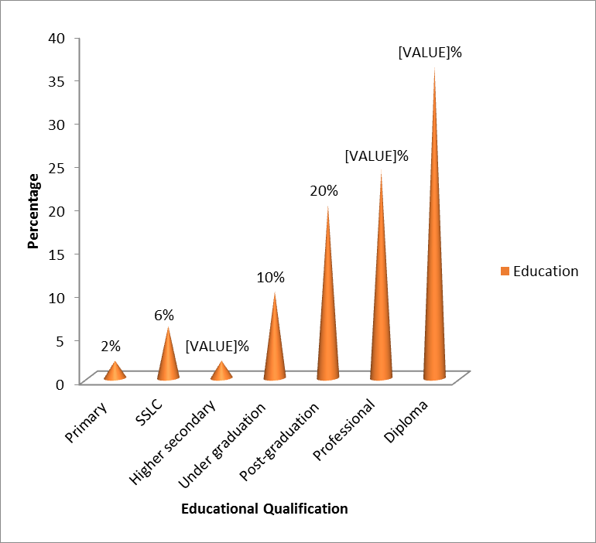

The above table and figure, it is clear that 2% of the migrant workers educational level is primary. 6% of the migrant workers educational qualification is SSLC. Only 2% of the migrants are belonging to the category of higher secondary. 10% of the respondents are completed their degree and 20% have post-graduation. 24% of the migrants are professionals and the remaining 36% are diploma holders.

## TABLE 4.3 MARITAL STATUS

|  |  |  |  |
| --- | --- | --- | --- |
| **SL.NO** | **MARITAL STATUS** | **FREQUENCY** | **PERCENTAGE** |
| **1** | **Married** | **25** | **50** |
| **2** | **Unmarried** | **18** | **36** |
| **3** | **Divorced/widow** | **7** | **14** |
|  | **TOTAL** | **50** | **100** |

Source: primary data

The above table shows that 50% of the migrants are married and 36% are unmarried. Remaining 14% are fall under the category of divorced/widow.

## FIGURE 4.2 OCCUPATIONAL WISE DISTRIBUTION

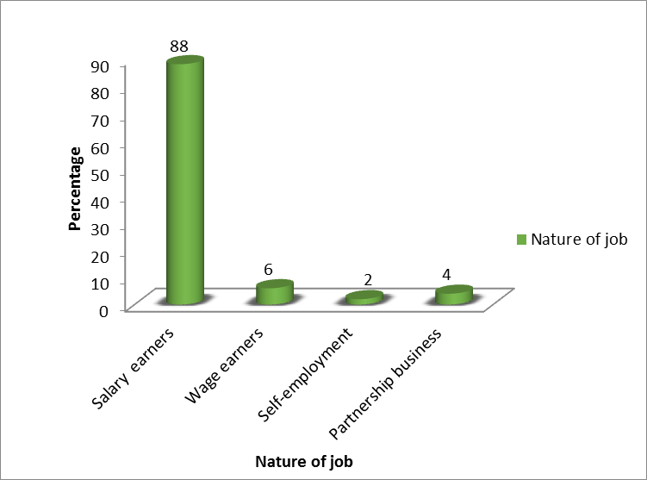

The above graph shows that 88% of the migrant workers are salary earners and 6% are wage earners. Only 2% of the migrants are engaged in self-employed activities and 4% has owning partnership business.

## TABLE 4.4

## PLACE OF WORK

|  |  |  |  |
| --- | --- | --- | --- |
| **SL.NO** | **PLACE OF WORK** | **FREQUENCY** | **PERCENTAGE** |
| **1** | **Outside district** | **7** | **14** |
| **2** | **Outside Kerala** | **16** | **32** |
| **3** | **Outside India** | **27** | **54** |
|  | **TOTAL** | **50** | **100** |

Source: primary data

From the above table it is clear that majority of the migrants are working outside India. That is 54% of the respondents. 32% of the migrants are working outside the state and the remaining 14% are working outside the district. So it is clear that international migration is comparatively greater than the internal migration.

## TABLE 4.5

**INCOME WISE CLASSIFICATION**

|  |  |  |  |
| --- | --- | --- | --- |
| **SL.NO** | **MONTHLY INCOME** | **FREQUENCY** | **PERCENTAGE** |
| **1** | **10000-30000** | **13** | **26** |
| **2** | **30000-50000** | **16** | **32** |
| **3** | **50000-70000** | **14** | **28** |
| **4** | **70000- 90000** | **7** | **14** |
| **TOTAL** |  | **50** | **100** |

Source: primary data

The above table shows the income wise distribution of the respondents. Here 26% of the migrants get a monthly up of RS10000- 30000 per month. 32% get monthly income of RS50000-70000. The remaining 40% will earn up to RS70000- 90000 per month.

## TABLE 4.6

**REASON FOR CHOOSING PRESENT JOB**

|  |  |  |  |  |
| --- | --- | --- | --- | --- |
| **SL.NO** | **FACTORS** | **AGREED** | **NOT AGREED** | **TOTAL** |
| **1** | **Earning** | **49 (98%)** | **1 (2%)** | **50** |
| **2** | **Experience** | **12 (24%)** | **38 (76%)** | **50** |
| **3** | **Become more independent** | **13 (26%)** | **37 (74%)** | **50** |
| **4** | **By compulsion** | **1 (2%)** | **49 (98%)** | **50** |
| **5** | **Solving financial problem** | **6 (12%)** | **44 (88%)** | **50** |

Source: primary data

The reason for choosing present job is given in the above table. Major factors include for earnings, for experience to become more independent, by compulsion from family and friends and for solving financial problems etc. Here 98% of the migrants are doing their job mainly for earning. Making working experience are also important. It will increases their efficiency for doing this job. But only 24% are working for experience. The table provides information about the willingness of respondents to become independent is 26%. Only 2% are doing their job by compulsion from others and the remaining 98% are not. 12% of the respondents are says that they prefer this job for solving their financial problem.

## TABLE 4.7

## MIGRANT’S FIRST JOB OR NOT

|  |  |  |  |
| --- | --- | --- | --- |
| **SL.NO** | **FIRST JOB** | **FREQUENCY** | **PERCENTAGE** |
| **1** | **Yes** | **28** | **56** |
| **2** | **No** | **22** | **44** |
| **TOTAL** |  | **50** | **100** |

Source: primary data

Lack of employment opportunities are one of the important factor which push people to move from one place to another. Here 56% of the migration is take place because they have no job in their home town and the remaining 44% of the migration is not because of this.

## TABLE 4.8

**YEARS OF WORKING OUTSIDE**

|  |  |  |  |
| --- | --- | --- | --- |
| **SL.NO** | **CLASS INTERVAL** | **FREQUENCY** | **PERCENTAGE** |
| **1** | **1 – 5** | **34** | **68** |
| **2** | **5 – 10** | **10** | **20** |
| **3** | **10 – 15** | **5** | **10** |
| **4** | **15- 20** | **1** | **2** |
| **TOTAL** | | **50** | **100** |

Source: primary data

## FIGURE 4.3

**YEARS OF WORKING OUTSIDE**

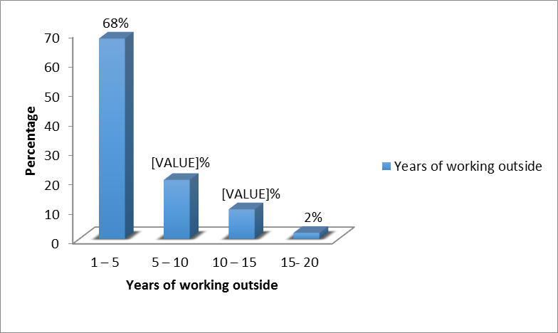

From the above table and figure, it is clear that 68% of the migrants are worked outside for 1-5 years. And 20% will be 5- 10 years. 10% of the migrants are worked outside for 10-15 years and only 2% has worked for a long period of time. That is 15- 20 years.

## TABLE 4.9

**MOST PREFERRED WORK PLACE**

|  |  |  |  |
| --- | --- | --- | --- |
| **SL.NO** | **PREFERRED WORK PLACE** | **FREQUENCY** | **PERCENTAGE** |
| **1** | **Own locality** | **24** | **48** |
| **2** | **Outside district** | **1** | **2** |
| **3** | **Outside state** | **8** | **16** |
| **4** | **Outside India** | **17** | **34** |
|  | **TOTAL** | **50** | **100** |

Source: primary data

Everyone has a preferred way of working. The above table showing the behavior of respondents in preferring their work place. Out of 50 respondents, 24 person preferring job in their own locality. I.e. about 48%. 34% respondents prefer job outside India and only 16% are interested to work outside Kerala. Only 1 person choosing outside district.

## TABLE 4.10

**PREFERENCE FOR CHOOSING OWN LOCALITY**

|  |  |  |  |  |
| --- | --- | --- | --- | --- |
| **SL.NO** | **FACTORS** | **AGREED** | **NOT AGREED** | **TOTAL** |
| **1** | **Safety** | **21(87.5%)** | **3(12.5%)** | **24(100%)** |
| **2** | **Family sentiments** | **22(91.6%)** | **2(8.3%)** | **24(100%)** |
| **3** | **Low cost of living** | **8(34.3%)** | **16(66.7%)** | **24(100%)** |
| **4** | **Communication problem** | **3(12.5%)** | **21(87.5%)** | **24(100%)** |

Source: primary data

## FIGURE 4.4

**PREFERENCE FOR CHOOSING OWN LOCALITY**

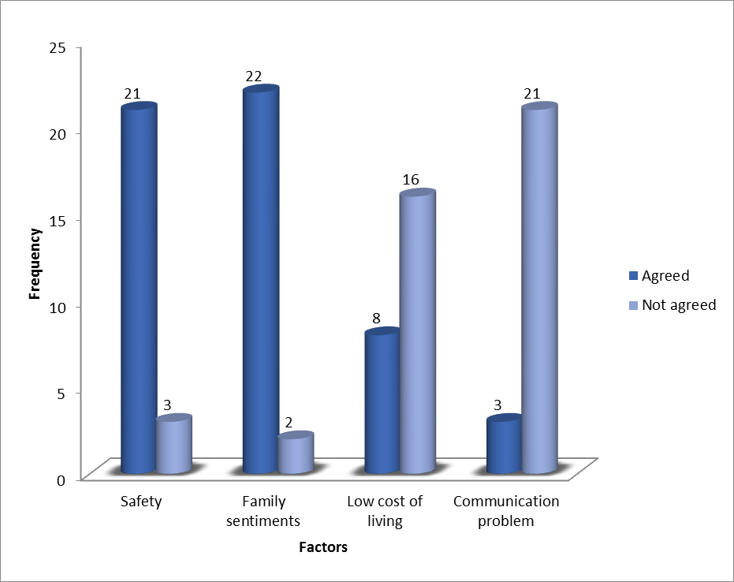

Employees may have their own reasons for preferring job in their own locality. The advantage of having a job close to home are numerous. Out of 24 respondents 21 are preferred it for safety. 22 respondents says that family attachment is one of the important factor which hinders migration. Low cost of living is also another reason for choosing jobs in their own locality. 8 out of 24 respondents are preferred own locality because of this reason. And also because of communication problem3 person are prefer own locality.

## TABLE 4.11

**FACTORS ATTRACTING MIGRATION**

|  |  |  |  |  |  |  |  |  |
| --- | --- | --- | --- | --- | --- | --- | --- | --- |
| **SL. NO** | **FACTORS** | **INTERNATIONAL** | | | **INTERNAL** | | | **TOTAL** |
| **AGREE** | **NOT AGREE** | **TOTAL** | **AGREE** | **NOT AGREE** | **TOTAL** |
| **1** | **Increase in income** | **16**  **(94.1%)** | **1**  **(5.9%)** | **17**  **(100%)** | **6**  **(66.6%)** | **3**  **(34.4%)** | **9**  **(100%)** | **26**  **(100%)** |
| **2** | **Culture** | **1**  **(5.9%)** | **16**  **(94.1%)** | **17**  **(100%)** | **1**  **(11.1%)** | **8**  **(88.9%)** | **9**  **(100%)** | **26**  **(100%)** |
| **3** | **For communication skill** | **3**  **(17.6%)** | **14**  **(82.4%)** | **17**  **(100%)** | **0**  **(0%)** | **9**  **(100%)** | **9**  **(100%)** | **26**  **(100%)** |
| **4** | **Career development** | **10**  **(58.9%)** | **7**  **(41.1%)** | **17**  **(100%)** | **6**  **(66.6%)** | **3**  **(34.4%)** | **9**  **(100%)** | **26**  **(100%)** |
| **5** | **Employment opportunities** | **12**  **(70.5%)** | **5**  **(29.5%)** | **17**  **(100%)** | **6**  **(66.6%)** | **3**  **(34.4%)** | **9**  **(100%)** | **26**  **(100%)** |
| **6** | **Status** | **4**  **(24.5%)** | **13**  **(76.5%)** | **17**  **(100%)** | **1**  **(11.1%)** | **8**  **(88.9%)** | **9**  **(100%)** | **26**  **(100%)** |

Source: primary data

Above table shows the factors which influence a person for migrating for job purpose. For attaining better standard of living through increase in income is one of the important factor 94.1% international migrants are support this were as it is agreed by 66.6% of internal migrants. Better employment opportunities are also attracted them for migration. It is agreed by 70.5% of the international migrants and 66.6% of internal migrants. 58.9% of the international migrants and 66.6% of the internal migrants believes migration will helps to develop a good career for them. 24.5% international migrants consider migration as a status symbol, but only 11.1 internal migrants are support this. 17.6% of the international migrants argue that desire to increase communication skill and 5.1% support that desire to experiencing different culture are also motivated them for migration. But in the case of internal migration no one support that desire to increase communication as a factor and it is only 11.1% support that differences in culture will attract them.

## TABLE 4.12

**RESPONDENTS GOT EMPLOYMENT ACCORDING TO THEIR EDUCATIONAL QUALIFICATION**

|  |  |  |  |
| --- | --- | --- | --- |
| **SL.NO** | **STATUS** | **FREQUENCY** | **PERCENTAGE** |
| **1** | **Equating** | **42** | **84** |
| **2** | **Not equating** | **8** | **16** |
|  | **TOTAL** | **50** | **100** |

Source: primary data

## FIGURE 4.5

**RESPONDENTS GOT EMPLOYMENT ACCORDING TO THEIR EDUCATIONAL QUALIFICATION**

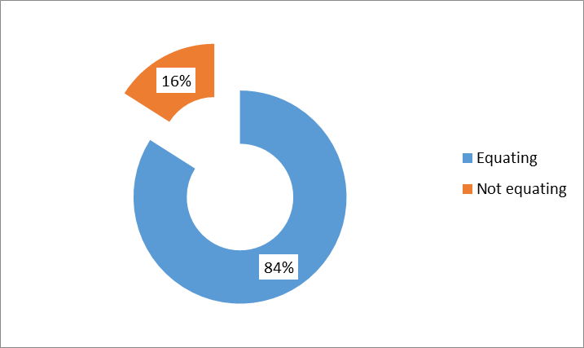

The above table and figure shows that education is the key to better job. But majority of the employees are doing their job which was not equating their educational qualification. Here 84% of the respondents are doing their job which is equating their educational qualification. Were as at the same time the remaining 16% were doing their job which was not equating their educational qualification.

## TABLE 4.13

## PROBLEMS IN WORKPLACE

|  |  |  |  |  |  |  |  |  |
| --- | --- | --- | --- | --- | --- | --- | --- | --- |
| **SL.NO** | **FACTOR** | **INTERNATIONAL** | | | **INTERNAL** | | | **TOTAL** |
| **AGREE** | **NOT AGREE** | **TOTAL** | **AGREE** | **NOT AGREE** | **TOTAL** |
| **1** | **High cost of** | **13** | **14** | **27** | **5** | **18** | **23** | **50** |
| **living** | **(48.1**%**)** | **(51.9%)** | **(100%)** | **(21.7%)** | **(78.3%)** | **(100%)** |
| **2** | **Loneliness** | **3** | **24** | **27** | **5** | **18** | **23** | **50** |
| **(11.1%)** | **(88.9%)** | **(100%)** | **(21.7%)** | **(78.3%)** | **(100%)** |
| **3** | **Missing** | **21** | **6** | **27** | **14** | **9** | **23** | **50** |
| **family** | **(77.8%)** | **(22.2%)** | **(100%)** | **(60.9%)** | **(39.1%)** | **(100%)** |
| **4** | **Missing** | **6** | **21** | **27** | **3** | **20** | **23** | **50** |
| **traditional** | **(22.2%)** | **(77.8%)** | **(100%)** | **(14.1%)** | **(86.9%)** | **(100%)** |
| **culture and** |
| **fest** |
| **5** | **Insecurity** | **3** | **24** | **27** | **0** | **23** | **23** | **50** |
| **(11.1%)** | **(88.9%)** | **(100%)** | **(0%)** | **(100%)** | **(100%)** |

Source: primary data

There are certain problems faces by the migrants in their work place. High cost of living is one of it. Sometimes it may drive migrant workers to back to their home town. Here 48% of international migrants and 21.7% internal migrants facing the problem of high cost of living. In both category majority of them agreed that missing family and friends affect them emotionally.77.8% of international migrants and 60.9%of internal migrants support this. 22.2% of international migrants and 14.3% internal migrants says that they not able to enjoy the traditional holidays in their home town and 11.1%of international migrants and 21.7% of internal migrants faces the problem of lonliness.3….% of international migrants says that they have a fear of security in abroad. It include the problem of job security also. No internal migrants does not face such a problem.

## TABLE 4.14

## LIVING ALONE OR NOT

|  |  |  |  |
| --- | --- | --- | --- |
| **SL.NO** | **STATUS** | **FREQUENCY** | **PERCENTAGE** |
| **1** | **Alone** | **47** | **94** |
| **2** | **With family** | **3** | **6** |
|  | **TOTAL** | **50** | **100** |

Source: primary data

## FIGURE 4.6

## LIVING ALONE OR NOT

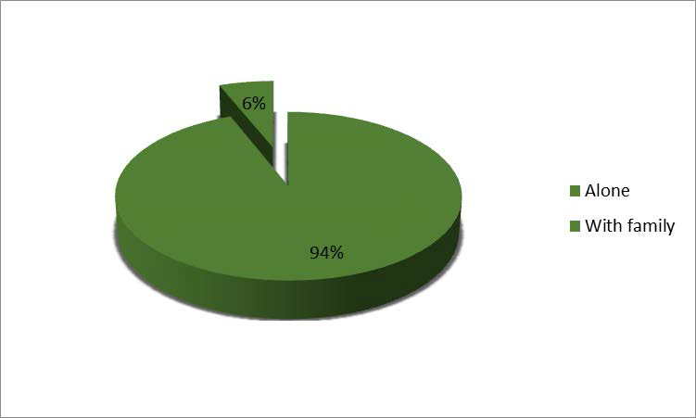

Here majority of the migrants are migrated without their families. 47 out of 50 respondents are live alone in their work place and the remaining 3 has migrated with their families. Generally migrants sent their families only when they are well employed, earning adequate wages, and have adequate housing.

## TABLE 4.15

## PREFERENCE FOR SETTLING

|  |  |  |  |
| --- | --- | --- | --- |
| **SL.NO** | **PREFERENCE** | **FREQUENCY** | **PERCENTAGE** |
| **1** | **Own locality** | **33** | **66** |
| **2** | **In their work place** | **17** | **34** |
|  | **TOTAL** | **50** | **100** |

Source: primary data

## FIGURE 4.7

## PREFERENCE FOR SETTLING

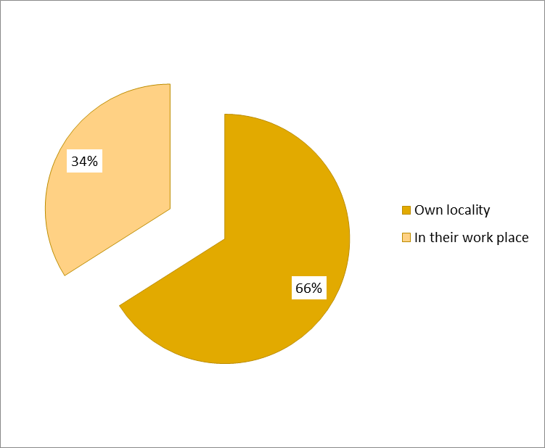

From the above table and figure, it is clear that majority of the migrants are want to settle in their home town than abroad. 33 out of 50 migrant labours have prefer their own locality and the remaining 17 respondents prefer abroad for settling. So it is clear that most migrants have no intension for settling permanently and return to their home country or town within a few years.

## TABLE 4.16

**PROBLEM FACES WHILE SEARCHING A JOB IN THEIR LOCALITY**

|  |  |  |  |  |
| --- | --- | --- | --- | --- |
| **SL. NO** | **PROBLEMS** | **YES** | **NO** | **TOTAL** |
| **1** | **Lack of employment opportunities** | **13(62%)** | **37(74%)** | **50(100%)** |
| **2** | **Law level of income** | **38(76%)** | **12(24%)** | **50(100%)** |
| **3** | **Available jobs are not suited for their educational qualification** | **35(70%)** | **15(30%)** | **50(100%)** |

Source: primary data

In the modern world finding a job is challenging task for anyone, especially those who prefer only the job which equate their educational qualification. The above table shows certain problem faced by job seekers while search a job in their own locality. Here 62% of the respondents says that lack of availability of job in home town is one of the important problem faced by them. Majority of the respondents (76%) says that available jobs are provided very low level of income, which is not satisfactory for them. 70% of the respondents support that in their home town available jobs are not equate their educational qualification.

## TABLE 4.17

**JOB SATISFACTION OF THE MIGRANTS**

|  |  |  |  |
| --- | --- | --- | --- |
| **SL NO** | **LEVEL OF SATISFACTION** | **FREQUENCY** | **PERCENTAGE** |
| **1** | **Highly satisfied** | **20** | **40** |
| **2** | **Satisfied** | **21** | **42** |
| **3** | **Neutral** | **6** | **12** |
| **4** | **Not satisfied** | **3** | **6** |
|  | **TOTAL** | **50** | **100** |

Source: primary data

## FIGURE 4.8

**JOB SATISFACTION OF THE MIGRANTS**

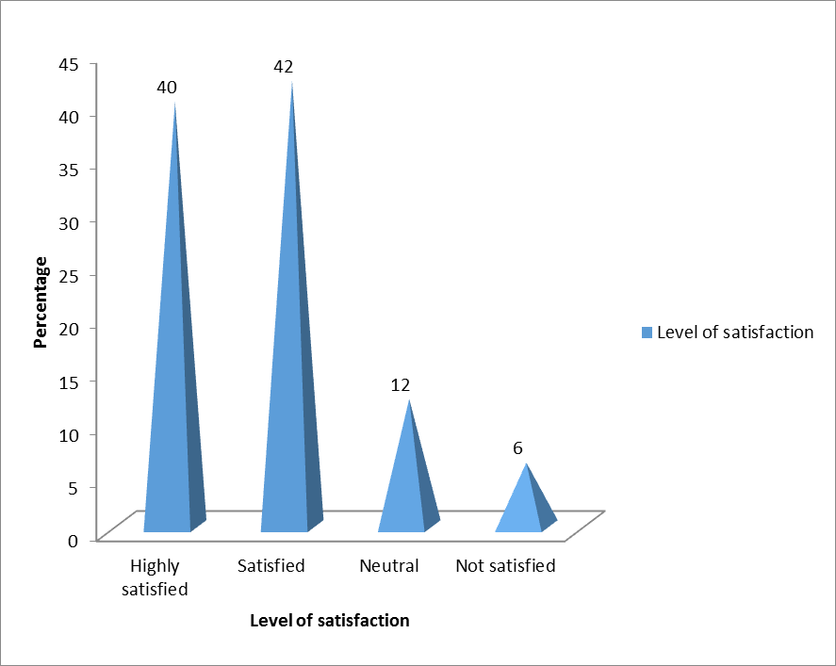

Job satisfaction is a measure of workers contentedness with their job, whether or not they like the job or individual aspects or facets of job such as nature of work. The above table and figure shows that 40% of the migrants are highly satisfied in their job. 42% are just satisfied and 12% migrants have a neutral opinion about their satisfaction. 6% are not satisfied in their work. Because they get low wages for their work.

## TABLE 4.18

**BENEFITS ENJOYED THROUGH MIGRATION**

|  |  |  |  |  |  |  |  |  |
| --- | --- | --- | --- | --- | --- | --- | --- | --- |
| **SL. NO** | **FACTORS** | **INTERNATIONAL** | | | **INTERNAL** | | | **TOTA L** |
| **Agree** | **Not agree** | **Total** | **Agree** | **Not agree** | **Total** |
| **1** | **Increase in** | **15** | **12** | **27** | **11** | **12** | **23** | **50** |
| **income** | **(55.5%)** | **(44.5%)** | **(100%)** | **(47.9%)** | **(52.1%)** | **(100%)** | **(100%)** |
| **2** | **Increase in** | **6** | **21** | **27** | **5** | **18** | **23** | **50** |
| **social** | **(22.3%)** | **(77.7%)** | **(100%)** | **(21.8%)** | **(78.2%)** | **(100%)** | **(100%)** |
| **status** |
| **3** | **Increase in** | **11** | **16** | **27** | **8** | **15** | **23** | **50** |
| **savings** | **(40.8%)** | **(59.2%)** | **(100%)** | **(34.8%)** | **(65.2%)** | **(100%)** | **(100%)** |
| **4** | **Debt** | **17** | **10** | **27** | **8** | **15** | **23** | **50** |
| **repayment** | **(62.9%)** | **(37.1%)** | **(100%)** | **(34.8%)** | **(65.2%)** | **(100%)** | **(100%)** |

Source: primary data

Job of a person is not only benefited to himself, but also his/her family. The above table shows what are the benefits get to the family after the migration of the respondents. Here 55.5% of the respondents says that migration of their child leads to increases their family income were as it is only 47.9% in this case of internal migrants 22.3% of the respondents supported that migration of their child in international level will increases their social status, 21.8% of the families in the category of internal migration are also feels this. 40.8% and 62.9% are supported that there is an increase in their savings and repay their debt respectively. Were as it is 34.8% in both cases under internal migration.

## TABLE 4.19

## PROBLEMS FACES BY PARENTS

|  |  |  |  |  |  |  |  |  |
| --- | --- | --- | --- | --- | --- | --- | --- | --- |
| **SL. NO** | **FACTORS** | **INTERNATIONAL** | | | **INTERNAL** | | | **TOTA L** |
| **Agree** | **Not agree** | **Total** | **Agree** | **Not agree** | **Total** |
| **1** | **Loneliness** | **8**  **(29.6%)** | **19**  **(70.4%)** | **27**  **(100%)** | **4**  **(17.4%)** | **19**  **(82.6%**  **)** | **23**  **(100%)** | **50**  **(100%)** |
| **2** | **Fear of security** | **12**  **(44.5%)** | **15**  **(55.5%)** | **27**  **(100%)** | **10**  **(44.5%)** | **13**  **(56.5%**  **)** | **23**  **(100%)** | **50**  **(100%)** |
| **3** | **Responsibility of the family in old age.** | **17**  **(62.9%)** | **10**  **(37.1%)** | **27**  **(100%)** | **9**  **(48.2%)** | **14**  **(51.8%**  **)** | **23**  **(100%)** | **50**  **(100%)** |
| **4** | **Lack of Caring** | **1**  **(4.8%)** | **26**  **(96.2%)** | **27**  **(100%)** | **0**  **(0%)** | **23**  **(100%)** | **23**  **(100%)** | **50**  **(100%)** |
| **5** | **No contribution in decision making** | **24**  **(88.8%)** | **3**  **(11.2%)** | **27**  **(100%)** | **21**  **(91.3%)** | **2**  **(8.7%)** | **23**  **(100%)** | **50**  **(100%)** |
| **6** | **Emotional problems.** | **13**  **(48.2%)** | **14**  **(51.8%)** | **27**  **(100%)** | **10**  **(44.5%)** | **13**  **(56.5%**  **)** | **23**  **(100%)** | **50**  **(100%)** |

Source: primary data

Migration of a person for job purpose is leads to increases their standard of living, economic and social status etc. but at same time it causes same problems to their family, especially their old aged parents. In the category international migration 88.8% of parents faces the problem of difficulties in decision making. Were as it is 91.3% in the case of internal migration. 62.9% parents is that the entire responsibility of the family lives in mother land will be upon them, in their old age it will create certain problems to them. It is agreed by 48.2% of parents who are come under the category of internal migration. 48.2% parents says that after the migration of the child will reduces the emotional bonding with their child and 29.6% of parents faces the problem of loneliness. At the same time it is 44.5% and 17.4% parents are support this. 44.5% parents in international category and 4.8% under internal category believes that they cannot get proper caring from their child.

## TABLE 4.20

**INCOME TRANSFER INTERVAL**

|  |  |  |  |
| --- | --- | --- | --- |
| **SL.NO** | **INCOME TRANSFER INTERVAL** | **FREQUENCY** | **PERCENTAGE** |
| **1** | **Weekly** | **2** | **4** |
| **2** | **Monthly** | **42** | **86** |
| **3** | **Yearly** | **5** | **10** |
|  | **TOTAL** | **50** | **100** |

Source: primary data

## FIGURE 4.9

**INCOME TRANSFER INTERVAL**

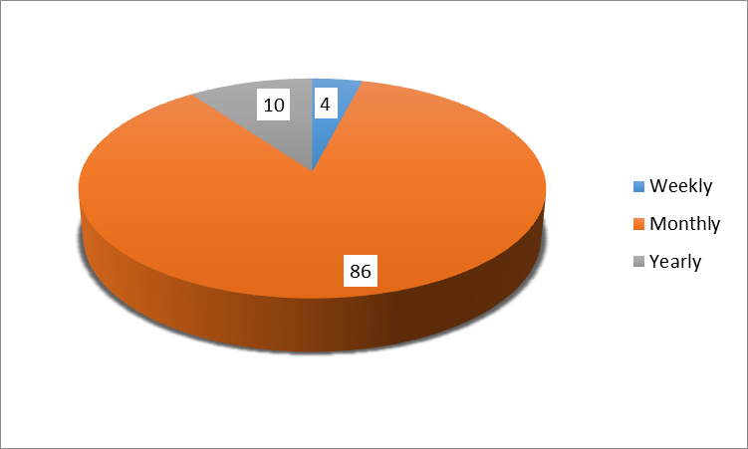

The above table shows and figure, it is that 4% of the migrant workers are send their income to home weekly and majority of the migrant labour are send their money monthly to their homes. The remaining 10% will transfer their income yearly. Such families are already rich and they does not want their child income for meeting their day to day expenses.

## TABLE 4.21

**PARENT’S PREFERENCE FOR THEIR CHILD WORK PLACE**

|  |  |  |  |
| --- | --- | --- | --- |
| **SL.NO** | **PREFERENCE** | **FREQUENCY** | **PERCENTAGE** |
| **1** | **Own locality** | **21** | **42** |
| **2** | **Outside district** | **4** | **8** |
| **3** | **Outside state** | **5** | **10** |
| **4** | **Outside nation** | **20** | **40** |
|  | **TOTAL** | **50** | **100** |

Source: primary data

Parent’s serves as a major influence in their children’s career development.42% of parents who wish to work their child in their own locality. The remaining 58% showed their interest to work their child outside. 40% of parents are support international migration and 18% are prefer internal migration.

## TABLE 4.22

**PREFERENCE FOR CHOOSING OWN LOCALITY**

|  |  |  |  |  |
| --- | --- | --- | --- | --- |
| **SL.NO** | **FACTORS** | **AGREE** | **NOT AGREE** | **TOTAL** |
| **1** | **Safety** | **16(77%)** | **5(23%)** | **21(100%)** |
| **2** | **Emotional feeling** | **17(81%)** | **4(9%)** | **21(100%)** |
| **3** | **Low cost of living** | **1(4.8%)** | **20(95.2%)** | **21(100%)** |

Source: primary data

Parents have several reasons to say that children should work in their own locality. Safety, emotional attachment, low cost of living in their locality. Out of these 16 will says that their child become safer in their own locality than abroad. While considering emotional attachment, as a factor to hinder migration. Its only one percent was selected low cost of living as a factor which hinders labour migration.

## TABLE 4.23

**PARENT’S PREFERENCE FOR MIGRATION**

|  |  |  |  |  |  |  |  |  |
| --- | --- | --- | --- | --- | --- | --- | --- | --- |
| **SL. NO** | **FACTORS** | **INTERNATIONAL** | | | **INTERNAL** | | | **TOTA L** |
| **Agree** | **Not agree** | **Total** | **Agree** | **Not agree** | **Total** |
| **1** | **Earning more** | **13**  **(65%)** | **7**  **(35%)** | **20**  **(100%)** | **2**  **(22%)** | **7**  **(78%)** | **9**  **(100%)** | **29** |
| **2** | **Good standard of living** | **5**  **(25%)** | **15**  **(75%)** | **20**  **(100%)** | **0**  **(0%)** | **9**  **(100%)** | **9**  **(100%)** | **29** |
| **3** | **Career development** | **11**  **(55%)** | **9**  **(45%)** | **20**  **(100%)** | **8**  **(88.9%)** | **1**  **(11.1%)** | **9**  **(100%)** | **29** |
| **4** | **Employment opportunities** | **13**  **(65%)** | **7**  **(35%)** | **20**  **(100%)** | **5**  **(55.5%)** | **4**  **(44.5%)** | **9**  **(100%)** | **29** |

Source: primary data

From the above table it is clear that 58% of the respondents are support migration. In this 70% of the respondents prefer international migration and remaining 30% will prefer internal migration. Here 65% of the respondents believes that migration of their child in International level will helps them to attain better employment and earning more. In the case of internal migration 55.5% parent’s believes migration will helps their child to get better employment and it is only 22% believe in earning more. 55% of parents argue that migration in international level will help to develop a good career for migrants. And 88.9% parents who prefer internal migration will also support this. 25% of parents who support international migration with a view to increase standard of living.

## TABLE 4.24

**PARENT’S SATISFACTION OF CHILDREN’S JOB**

|  |  |  |  |
| --- | --- | --- | --- |
| **SL.NO** | **LEVEL OF SATISFACTION** | **FREQUENCY** | **PERCENTAGE** |
| **1** | **Highly satisfied** | **32** | **64** |
| **2** | **Satisfied** | **16** | **32** |
| **3** | **Neutral** | **2** | **4** |
| **4** | **Not satisfied** | **0** | **0** |
|  | **TOTAL** | **50** | **100** |

Source: primary data

From the above table it is clear that 64% of respondents are highly satisfied in their child present job. Were as it is 32% are satisfied. 4% of parents shows a neutral opinion. No one is feeling this satisfaction.

# CHAPTER V

## FINDINGS, SUGGESIONS AND CONCLUSION

Migration is a universal phenomenon. In recent years international labour migration has become a top socio economic issue and it causes changes in the distribution of income, employment and economic resources and thus leads to structural transformation. The present study aims to find out the factors determining labour migration and the benefits enjoyed by the migrants and their families. The result of the study based on the analysis and interpretation of primary data collected are discussed through major findings.

## FINDINGS

Major finding of the study are.

1. 68 percent of the migrants are fall under the age group of 20-30. Which shows youth are more attracted for moving out than the middle-aged groups.
2. 80 percent of the migrants are males and remaining 20 percent are females. Which shows men are more migrated for job purpose than women.
3. Majority of the migrants have a good educational qualification. That is 20 percentare post graduate, 24 percent are professionals and 36 percent are diploma holders.
4. The study also reveals that 88 percent of migrants are salary earners, 6 percent are wage earners and a small member of persons are engaged in self-employed activities or business. That is 2percentand 4percentrespectively. Which shows that our education system produce job seekers rather than job creators.
5. 54percentmigration is at the international level and 46 percent is at internal level. That is international migration is comparatively greater than the internal migration.
6. The minimum earnings of a migrants is Rs10000 and maximum is Rs90000. Majority of the migrants earn Rs30000-50000 per month.
7. This study finds that lack of employment opportunities in home town is one of the important push factor which leads to migration. 56 percentof the migration is take place because of this.
8. 76 percent of the migrants faces the problem of law level of income provided by the available job in home town while searching a job in their locality.62percentargue that lack of employment opportunities and 30 percent argue that available jobs which are not equate their educational qualification are also push them for migrating.
9. While considering the motivating factors relating to a job, 98 percent consider earning or how much we can earn from a job is one of the important factor.26 percent are motivated with the desire to become independent and 12percentare doing their job for debt repayment. A least number doing their job because of the compulsion from family and friends.
10. While considering the preferred work place, 48percentare prefer their native places. Because they consider they become safer in their home town than abroad. Emotional attachment and communication problem, normally in the case of international migration also hinders migration. Low cost of living also a reason for choosing jobs in own locality.
11. The study also finds that the factors attracting migration. In the case of international migration, 94.1 percentis motivated by the desire to increase their standard of living and 70.5 percent support availability of better employment opportunities will also attracted them. Desire for increasing communication skill and experiencing different culture are also influences the people for migration in a little extent.
12. In the case of internal migrations 66.6 percentmigrants are attracted by higher income, better employment opportunities. And the desire to develop a good career will also leads to internal migration.
13. 84 percent of the migrants are doing their job which equate their educational qualification.
14. 40percentof the migrants are highly satisfied and 42 percentare satisfied in their present job and 6 percentare showing their dissatisfaction.
15. In the case of international migration, 48 percentare faces the problem of high cost of living and 77 percent are missing their family. They also faces missing traditional holidays (22.2 percent), loneliness (11.1 percent) and insecurity by 3 percent migrants.
16. Internal migrants faces certain problems like missing family(60.9 percent), high cost of living(21.7 percent), loneliness(21.7 percent) and missing traditional holidays in their home town by 14.1 percentof migrants.
17. 94 percentmigrants are living alone and 66percenthave no intention for settling permanently and returning their home country/town within a few years.
18. 42 percent of the parents prefer their children to work in their home town.81 percentof them are influence by emotional feelings,77 percent believes that their child become safer in their home town and 4.8 percent are by low cost of living.
19. 40 percent of the parents support international migration, 65 percent of the parents believes that it will help their children to attain better employment and earning more. 55percentconsider it will helps to develop a good career for their children.
20. 18 percent of the parents prefer internal migration. Because of the desire to develop the career of their child (88.9 percent), availability of better employment opportunities (55.5 percent) and for earning (22 percent).
21. 64 percent of the parents are highly satisfied in their children’s present job and no one is dissatisfied. 4 percentshows a neutral opinion.
22. 86 percentof the migrant labors transfer their income once in a month. Migrantshave good financial background transfer their income once or twice in a year.
23. International migration benefited in several ways like repayment of debt (62.9 percent) , increase in family income (55.5 percent), increase in savings(40.8 percent)and increase in social status(22.3 percent).
24. In the case of internal migration there is an increase in family income of 47.9 percentfamilies.37.8percentare also benefited in the form of increase in savings and relief from debt.

## SUGGESTION

## Government should promote job oriented education system in order to attract natives in their state

## Encourage and promote new business and start up in our state

## Provide high salaries and employment opportunities to avoid shirking jobs.

## 5.3 CONCLUSION

Movement of people from India is not new. Especially in the case of labour migrants. Over a period of time the pattern of labour migration has changed. While considering the factors effecting migration lack of employment opportunities, low level of income are the two important push factors and better employment opportunities, higher wages and availability of skill full and professional jobs are the important pull factors which promote labour migration. Earning more or how much we can earn from a job is highly influenced for choosing a job. Family sentimenceor attachment with family is one of the important factor which hinders migration and it may be drive the migrant to return their home town. Migration of a person for job purpose will be benefited not only for him but also his/her family. It may help to develop their family economically in the form of increasing savings and family income. Repayment and relief from debt problems and they can attain a good standard of living. International migration will create greater benefit than internal migration.

**BIBLIOGRAPHY**

Ajith, C. K. (2000). *Unemployment- Labour Scarcity Paradox.A Case study of Trissur district.* University of Calicut.

Beret, H. V. (1995). The place of Narratives in the study of third world migration:The case of spontanious rural migration in Srilanka

Dodani, S., & Laporte, R. E. (2014). Brain Drain from Developing countries:how can drain be converted into wisdomgain? *Royal society of Medicine.*

Francis, S. K. (1990). *Dynamics of rural labour market- analysis of emerging agricultural shortage in a Kerala region.*

Francis, S. K. (1990). *Labour Mobility- case study of Kuttanad,Kerala.*

Jeena , T. (1997). *Internal Migration and its impact on Deforestation and Cropping pattern in kerala.*

Jisuk, C. (1996). *Inter regional migration and regional development .* Ashgate publishing limited.

Joseph, K. (1988). *Migration and economic development in kerala.* Mittal publicatipons New Delhi.

Joy, P. (2016). *Impact of Migrant Workers in The Kerala Economy.*

Kannan, C. (1978). Cultural adaptation of Asian Migrants,First and second generation. book shop limited

Kannan , K. (1988). *Of rural proletarian struggle:mobilisation and organisatiopn of rural workers in south west India.* Oxford university press.

Kodoth, D. P., & Jacob, T. K. (2013). *International Mobility Of Nurses from Kerala(India) to the EU.*

K.V, J. (1988). *Intrastate and Inter State Migration Pttern.*

Millward, L., & Houston, D. (1997). *Young people's job perceptions and preference.* Department of psychology,School of Human sciences.

Prakash, B. (2000, December 16-22). Exodus of Gulf Migrants:Return Emigrants of Varkala town in Kerala.

R, B., A R, S., & singh, S. (2017). *Job preference among Marginalised and Non Marginalised Youths:A Multi Ethnic Study in Sabah.*

Saika, D. (2008). *Economic conditions of the migrant workers in kerals.*

Saika, D. (2014). *Economic Condition Of Migrant Workers in Trivandrum District.*

Shobana, W. M. (2001, september). Economic and political weekly. *Women at Work, Migrant Women in Fish processing industry.*

stark, o., & fans, c. s. (2011). The prospect of migration ,sticky wages and educated unmployement. *Discussion paper on development policy*.

S, R. (2013). Brain Drain:Socio economic impact on indian society. *Humanities and Social Science Invention.*

TM, T. I. (1997). *Consequences of outmigration upon the domestic employement situation;impact of remittence upon the economy, problems and prospect of re-integration of return migrants.*

Wahba, J. (2015). *Who Benifited from Returm migration to Developing countries?* University of Southampton,UK.

Working Conditions of Indian Domestic Workers at Home and Abroad. (2001). *International Labour Organisation.*

UNESCO and MPIMMG. (2014). Skilled Migration and Brain Drain.

Zacharia, K., Matew, E., & Irudaya, R. (2003). *Dynamics of Migration.*

**APPENDIX I**

1. Name:
2. Age :
3. Sex :

Male

Female

1. Educational qualification:

Primary

High School

Higher Secondary

Under Graduate

Post Graduate

Professional Diploma

1. Marital status :

Married

Unmarried

Divorced / Widow

1. Family details :

Name

Age

Relation

Education

Occupation

1. Nature of occupation. :

Salary Earners

Wage Earners

Self-Employees

Partnership Business

1. Place of working. :

Outside district.

Outside Kerala

Outside India

1. Monthly income. :

Below 10000

10000-50000

50000-70000

70000- 90000

1. What is the motivating factor behind preferring this job?

For earn

For making experience

To become independent

By compulsion from family

For solving debt problems

Other- specify

1. Did you prefer to work outside because you are not able to find a job in your locality?

Yes

No

1. Years of working outside
2. Which is your most preferred work place?

Own locality

Outside district

Outside state

Outside nation

1. If choose a, why?

Feeling more safety

Family sentimence

Lower cost of living

Communication problem

Other-specify

1. If choose other than a, why?

For attaining good standard of living

For experiencing different cultures.

For improving communication skill

For better employment opportunities

For career development

As a status symbol

1. Do you think your current employment is equating your educational qualification

Yes

No

1. What are the problems that you face in your workplace?

High cost of living

Loneliness

Missing family and friends

Missing traditional holidays and fest

Other-specify

1. Are you living alone or with family in abroad

Alone

With family

1. Do you want to settle there?

Yes

No

1. After completing your education what are the problems that you faces while searching a job in your locality?

Lack of employment opportunities.

Low level of income.

Available jobs are not suited for your educational qualification.

Others-specify

1. Are you satisfied with your current job?

Highly satisfied.

Satisfied.

Neutral.

Not satisfied

**APPENDIX II**

1. Name:
2. Age:
3. Relation:
4. Occupation
5. What are the benefits that you enjoyed when your child become migrated?

Increase in standard of living

Increases in social status

Increase in savings

Settlement of financial problems

Other-specify

1. What are the problems that you face while your child become migrated?

Loneliness.

Insecurity.

Responsibility of the family is completely upon you

Changes in emotional bonding

Difficulties in decision making

Other-specify

1. Since your child working outside, do you feel like they are not taking care of you anymore?

Yes

No

1. Income transferring interval

Weekly

Once in a month

Once in a year

1. Do you have any preference as to where your child work?

Own locality

Outside district.

Outside state.

Outside nation

1. If choose a why?

Feeling more safety

Emotional attachments

Low cost of living

Other-specify

1. If choose other than a, why?

For earn

For increasing standard of living

For their career development.

For getting better employment opportunities

Other-specify

1. Are you satisfied with your child job?

Highly satisfied.

Satisfied

Neutral

Dissatisfied