CHAPTER 1
INTRODUCTION
Women whose contributions were not accounted and valued in the olden times, now plays a significant role in the development of any society; her status has improved with time. Kudumbhashree, the Kerala State poverty eradication mission, a community network of Neighbourhood groups which covers the entire state addresses three levels of empowerment viz economic, social and women empowerment. Kudumbhashree through its three-tier structure firmly believes in capacitating women to understand and exercise their rights. Kudumbhashree attempts to bring every poor woman in the state to NHGs and enables them to address their issues by improving female work participation, health and nutritional status, participation in decision making, local governance and their role in planning in addition to making them as local entrepreneurs for finding their livelihoods.
Kudumbhashree means prosperity of the family, is the state poverty eradication mission initiated by the Government of Kerala for devoting the absolute poverty from the state. It is a holistic, participatory, women oriented innovative poverty reduction approach implemented through local self-Government’s. The mission follows a process approach rather than a project approach. Kudumbhashree envisages prosperity of the poor families in the state with multiple programmes that will provide them information, create awareness, build up their capability and capacity, enhance their confidence and show them opportunity for better social security and empower them physically, socially, economically and politically.
The empowerment of a person is a state of him in any way he becomes powerful to face all problems belong to him. Women’s empowerment can be defined as promoting women’s sense of self work, their ability to determine their own choices and their rights to influence social change for themselves and others. Kerala is a land of baffling contradictions. Economic and social anarchy existed among women in Kerala centuries ago. Although Kerala was culturally superior, women were always behind men. None of the services of women were glorified. There was a social system in which all the burdens of society were concentrated only on women and they were marginalized and kept within the household. Women have been dominated by men since ancient times. In many families female life was like slavery and more over in society women were always behind. There was universal freedom for men and social exclusion for women in general. Women empowerment also means uplifting of all women to face all problems around them and make them powerful to live them in a social secure stage. The empowerment of women is an essential factor for the sustainable growth of the society. In Kerala, a southern state of India Kudumbhashree, the women's empowerment organization, has given women a social and economic equality. Kudumbhashree is a group of women working under the Kerala State Poverty Eradication Mission and under the jurisdiction of each local self-government institutions.
1.2 SIGNIFICANCE OF THE STUDY
In the modern world, scarcity is a significant problem that affects both developing and impoverished nations. A concentrated effort on the part of the government is seen to be the only way to address the problem of poverty. The Paucity must be filled by empowering women and including them in the development process. It is believed that true advancement can only happen when men and women collaborate on an equal basis. Achieving progress in all disciplines depends on gender equality and the empowerment of women. One of Kudumbhashree's primary objectives is the eradication of poverty, combined with the empowerment of women. The main objective of the Kudumbhashree scheme is to raise the standard of living for under privileged rural women by establishing micro credit and profitable No businesses. Therefore, it's important to assess the causes that led the woman to enlist in Kerala's Kudumbhashree units. Since there isn’t many previous research on the subject at hand, an effort has been made to determine what elements motivate women to enlist in Kerala's Kudumbhashree units.
1.3 STATEMENT OF THE PROBLEM
The emergence of Kudumbhashree among rural women for their overall development is at recent origin and their increase in no is rapid. Women population in India constitute around half of the country’s population. Hence they are regarded as the “Better half of the society”. Kudumbhashree is supposed to enables the rural women who are below the poverty line to be self-sufficient & self-reliant in social, economic & political spheres. The Kudumbhashree & it’s financial policies are considered as significant & emerging trend in the present scenario for the economic empowerment of women. Micro finance programme are promoted as an important strategy for women’s empowerment. Micro finance builds mutual trust & confidence between bankers & rural poor to encourage banking in a segment of population where formal financial institutions usually find it difficult to reach. The present project examines the economic impact of micro finance & whether it contributes to their financial management in Kannur District is selected for the study.
1.4 OBJECTIVES OF THE STUDY
- To know the employment opportunity provided by Kudumbhashree unit.
- To have an idea about the financial assistances provided by the Kudumbhashree.
- To know the changes in standard of living of women in Kudumbhashree.
1.5 SCOPE OF THE STUDY
The present study is to analyses the role of Kudumbhashree in Kannur District. Area of study is limited to Kannur district.
1.6 METHODOLOGY OF THE STUDY
SOURCES OF DATA
For the successful completion at the present study the data required for analysis had been collected from two sources, namely.
- Primary sources
- Secondary sources
- Primary data
The sources of primary data are:
- Direct observations
- Schedule
- Personal interview with Kudumbhashree members
- Informal talk with Kudumbhashree member’s primary data were collected from the 100 respondents. (Kudumbhashree members) from various wards of Kannur. Mainly through observations, direct interview & schedules.

- Secondary data
The secondary data
- Kudumbhashree annual report, municipality developmental reports etc.
- Magazines & journals etc.
- Internet
Sample Size
In this project 100 samples were selected.
Sample Technique
In this study, convenient method of samplings is selected.
Tools and technique used for data collection
Questionnaire
Personnel Interview
Tools for analysis
Statistical tools like tables, percentages and simple bar diagrams are used for analysis.
1.7 LIMITATIONS OF THE STUDY
- The topic selected for the study was vast & requires much more time for the study. Therefore, time was a major limiting factor.
- Kudumbhashree was spread across the country & the pattern of growth at Kundumbashree is not uniform since the study confined to 100 samples, result may not be completely Accurate.
- The respondent’s unwillingness to disclose all the details about the Kudumbhashree & the personal information limits the scope of the study.
1.8 CHAPTER SCHEME
The study has been organized and presented in 4 chapters as discussed below.
- The first chapter is introductory parts which includes statement of the problem, objectives, Methodology, significance of the study, and limitations of the study.
- The second chapter include review of literature.
- The third chapter is the analysis and interpretation of data.
- The fourth chapter is including the findings, suggestions and conclusion.
CHAPTER 2
REVIEW OF LITERATURE
Manjusha (2010) assessed the level of empowerment achieved by the women folk of Ulladan Tribe of the North Paravur Taluk in Ernakulum District of Kerala. The study is an attempt through Kudumbshree units. The findings show that a significant change has come about in the socio-economic life of the women folk in the Taluk. Change was also observed in the political avenues as well as the general skills of the respondents through the Kudumbshree Units. The study suggested that for future development, training and awareness programmes should be conducted for empowering the poor women in that area.
Kenneth and Seena (2012) studied the impact of various programmes that were introduced in order to raise the women from below poverty line in Puthanvelikkara Grama Panchayat of Ernakulum, Kerala. The Questionnaire method was adopted in this study for collecting primary data. The results of the study show that economic development is the base for other developments and Kudumbshree units drastically changed economic independence of the women and their living status.
Beevi and Devi (2011) conducted a study with an aim to assess the role of Self Help Groups in empowering rural women and to identify the major constraints faced by women in Kollam District of Kerala. The study revealed that micro-enterprises are a practicable pathway for improving the economic status. Some factors like education, income and mass media contact were positively and significantly related to the role of the SHGs. The effectiveness of the SHGs in promoting women empowerment was found to be limited by only factors like hesitation to take up innovative scheme; difficulty in playing dual roles by women; lack of confidence, team spirit, effective leadership, managerial skills, working capital and transportation. These thus were found to be the major constraints faced by SHGs.
Jaya (2004) evaluated the functioning of SHGs and identified the factors contributing to the successful functioning and sustainability of groups in Kerala. This was achieved through an exploratory study of selected SHGs in the district of Malappuram in Kerala. The findings of the study show that SHG intervention has indeed improved the living standards. Interestingly, it also inculcated saving and loan repayment habits and brought about a positive change in attitudes and social skills of 52% of the respondent women folk thereby leading to empowerment.
Contrastingly, Shylendra (1998) assessed performances of eight women SHGs in Vidaj village of Gujarat. The SHGs, it was found, failed to enable members realize their potential benefits. The failure was attributed to wrong approaches followed in the SHG formation, lack of clarity about the SHG goals and concept among the members. The study brought to light the need to constitute SHGs with clear understanding of the concept from the beginning itself.
Minimol and Makesh (2012) did a study to identify the level of personal, social, economic and financial empowerment achieved by the members through SHGs. The data was collected from a sample of 200 members of 18 SHGs located within three villages of Cherthala Taluk of Alappuzha, Kerala. Primary data were collected by employing a structured interview schedule, through participant observation, and direct personal discussions with the members of various SHGs. The study concluded that the concept of SHGs for rural women empowerment has not yet run its full course in attaining its objective.
Kavitha et.al (2011) conducted a study on the general acumen of effectiveness of group functioning by the members of women self-help groups (SHGs) in goat farming, operating under Kudumbhashree, in Thrissur district, Kerala. The findings of the study showed that majority of the respondents (76%) perceived the effectiveness of their group functioning as medium. The functioning of the group in terms of official procedures (mean score 1.96) was perceived most effective by the members, followed by that of interpersonal relationships (mean score 1.93) and entrepreneurial activities (mean score 1.76). The study brought to light the need for entrepreneurial training in goat farming along with provision of resources like good quality breeds, grazing land, feed, market and veterinary care for success of the group’s functioning.
Kudumbhashree is a unique poverty eradication mission of the state of Kerala. Many studies have so far conducted in relation with Kudumbhashree and self-help groups in different parts of our country. A brief view of the studies so far conducted is given below.

CHAPTER 3
PROFILE OF THE STUDY
For the sustained economic development and social justice, socio economic status of women should be improved along with that at men socio economic freedom gives the right to determine the course of their lives. Entrepreneurship enhances the women’s social standing the entrepreneurial activity is depended on several complex economic, social and psychological factors. Thus, for any attempt made to understand the entrepreneurial. Activity among women, on analyzing of their socio-economic origins is necessary.
Kudumbhashree, a female- oriented, community- based, poverty reduction project of Government of Kerala. Kerala is an Indian State lying in the south-west part of Indian – sub continent, where many development experiments are being tested, refined and implemented. The mission aims of the empowerment of women, through farming self- help groups and encouraging their entrepreneurial or other wide range of activities. The purpose at the mission is to ensure that the women should no longer remain as passive recipients of public assistance, but active leaders in women involved development initiatives. Kudumbhashree movement was launched by farmer prime minister A P Vajpayee at a function chaired by then local administration minister Paloli Mohammed Kutty at Kottakkunnu in Malappuram on May 17, 1998.
Kudumbhashree is a female- oriented, community based, poverty reduction project of the Government of Kerala. Kerala is an Indian State lying in the south- west part of the Indian subcontinent where many development experiments are being tested, refined and implemented.
KERALA KUDUMBHASHREE PROGRAMMES
Launched by the Government of Kerala in 1998 for wiping out absolute poverty from the state through concerted community action under the leadership at self-governments, Kudumbhashree is to day one of the largest women- empowering projects in the country. The programme has 41 lakhs members and covers more than 50% at the households in Kerala. Built around 3 critical components, micro credit entreneurship and empowerment, the Kudumbhashree initiative has today succeeded in addressing the basic needs of the less privileged women, thus providing them a more dignitied life and a better future. Literal meaning at Kudumbhashree is prosperity of family.
Kudumbhashree have been working on a programme that aims at getting women to discuss the gender dimension at their issues for this we had to break the mould of thrift and credit based discussions which alone were taking place in the NHG, apart from the odd health or other dissemination.
Locally contextualized modules on issues such as women and work women and health, women and mobility, women and entertainment are developed and deliberated in neighbourhood group meetings. The different voices of women and their perceptions about the topics of discussions will be captured on a web- based portal accessible at the level at the local self-government. The portal is being developed with the support of the minister of information technology, Government of India.
Awareness building programmes seems not to leave any sustained impact. It was felt therefore that a learning process in which the women felt themselves to have a stake and would be delivered not through trainings, but through discussions focusing on some other format- press cuttings, poems, skit etc. had to be the mode of delivery. State level constitutions help identify the themes of the “learnings modules.” The content for the learning modules are prepared by local women’s resources persons.
THE MISSION OF KUDUMBHASHREE
The mission of Kudumbhashree is:
“To eradicate absolute poverty in ten years through concerted community action under the leadership of local Governments, by combining self- help with demanded convergence of available services and resources to tackle the multiple dimensions and manifestations of poverty, holistically”. Kudumbhashree is not only envisaged as a mission, but also as a process, a project and a delivery mechanism for the poor. “Kudumbhashree “, through concerted and continuous action, had created sustainable livelihood options to the poorest of the poor in the society.
Kudumbhashree has been continuously evolving and today has moved on from micro finance to local economic development from seeking to provide welfare to the poor, we are enabling the poor to claim entitlements. The search has also been one of transforming participation to citizenship.
OBJECTIVES OF KUDUMBHASHREE
- Ensuring a minimum of 5 years of primary education for all children, belonging to risk families.
- Ensuring better health and nutrition for all families.
- Ensuring basic amenities like safe drinking water, sanitary latrines improved shelter and healthy environment.
- Ensuring zero drop out in school for children belong to poor families.
- Identification of poor families through risk indices- based surveys, with the active participations of the poor and the communities to which they belong.
- Promoting functional literacy among the poor and supporting continuing education.
- To ensure adequate, qualitative, preventive and curative health care to people at the state.
- To ensure health care services to all particularly to the disadvantaged groups like scheduled tribes, scheduled caste and backward closes.
- Facilitating self- identification of the poor families through transparent risk idex composed of socially accepted indicators of poverty through a particular survey.
- To gather, people’s reactions to the programmes and policies of the government and their implementation and to report them back for appropriate action and course corrective measures.
- Improving incomes of the poor through improved skills and investment for self- employment.
ROLE OF LOCAL GOVERNMENT IN KUDUMBHASHREE PROGRAMME
Kudumbhashree a further step to strengthen the decentralization process Kerala, as a front running state in devaluation of powers and funds to local Government has taken a few initiatives in democratic decentralization that have resulted in several innovative practices. It is one among the states where the implementation of the panchayati raj act has been successfully done. Kerala’s local Government system has been working within a clearly defined legal framework for decentralized governance. In 1994, the Kerala Government enacted the panchayati Raj Act 1994, in conformity with 73 rd and 74th. Amendment of the Indian constitution Government of Kerala through peoples planning programme revamped its decentralization process with a series of path breaking measures in 1996. There is a three tier panchayat raj system in Kerala with municipality of village level, block panchayat at intermediate level and district panchayat at district level. Functions are clearly demarcated among all the three tiers of local Government The elected bodies are the executive authority and officials are their secretaries . Full control over staff is given to PRI and absolute right to information is given to the general public. Kudumbhashree is considered oa innovative practice in the field of poverty alleviation and women empowerment. The decentralized planning process in Kerala provided Kudumbhashree a positive environment. Kudumbhashree , an agency carrying out several activities at the cutting edge level, is considered as a further step to strengthen the decentralization process. Unlike many Indian states where SHG networks functions parallel to the local Government, inclusive and empowered community- based organizations of kons work in partnership with the local self Government in planning and implementing the poverty reduction programme. The allocation of nearly one- third of state plan funds to local Government as a grant is significant steps in the decentralization process of Kerala. This has supported and speeded up the process of convergence of series of various dept. and agencies. Local Government support the self help initiatives of poor women through the three tier community based organizations in fact, local Government implement the programme with the facilitation by the state poverty eradication mission.
WOMEN EMPOWERMENT- INTRODUCTION
The topic on “women empowerment” is a burning issue all over the world. “Women empowerment” & “women equality with men” is a universal issue.
Women empowerment refers to the Creation of an environment for women where they can make decisions of their own for their personal benefits as well as for the society. Women empowerment refers to increasing & improving the social, economic, political & legal strength of women & to make them continent enough to claim their right, such as,
- Freely live their life with a sense of self-worth, respect & dignity.
- Have complete control of their life, both within & outside of their home & work place.
- To make their own choices& decisions.
- Have equal rights to participate in social, religious & public activities.
- Have equal social status in the society.
- Have equal rights for social & economic justice.
Women are equally competent, now a days, women are even a head of men in many socio economic activities. Women empowerment also reduces poverty. Sometimes, the money earned by the male members of the family is not sufficient to meet the demand of the family. The added earnings of women help the family to come out the poverty trap. Women are increasingly participating in the national development process. They are making the nation proud by their outstanding performance almost every spheres including medical science, services, engineering etc.
Women empowerment is also advantageous in case of corruption. Women empowerment helps women to get educate & know their rights & duties & hence can stop corruption. Women empowerment leads to decrease in domestic violence. Uneducated women are at higher risk for domestic violence than can educated women. Women empowerment also leads to more economic benefits not to the individuals but to the society as well. Unlike earlier days when they stayed at home only & do only kitchen stuffs, nowadays, they roam outside & also earns money like the male members of the society. Women empowerment helps women to stand on their own legs, become independent & also to earn for their family which grows country’s economy. Women population constitutes around 50% of the world are unemployed. The world economy suffers a lot because of the unequal opportunity for women at work places.
Women empowerment is the empowerment of women which helps them to take their own decisions by breaking all personal limitations of the society & family. Students are generally get this topic to discuss or write some paragraphs or complete essay in their schools & colleges. In order to make the country fully developed country, women empowerment is an essential tool to get the goal of development. Women faces many social challenges today whether it be making soaps & incense in order to secure an income for her family to raising children amidst the harsh income crisis. A woman is dynamic in the many roles she plays. In the village of war here in Maharashtra 400 women stood up & raised their voices to ban alcohol & drugs. Women have withstood perennial health problems due to the lack of toilet facilities & are forced to use fields & open spaces for detection. The art of living empowers women to face the present challenges by providing tool & techniques that help to eliminate individual stress. A sense of community spirit is created that allows for women to face these similar challenges as team rather than individually. The art of living encourages women to find practical solutions to their challenges so that each one becomes self-dependent in their own rights.
Empower yourself with happiness as you take on life daily challenges. Fill in the form below to learn how to embrace like with a renewed enthusiasm every day. In the simplest of words, it is basically the creation of an environment where women can make independent decisions on their personel development as well as shine as equals in society. Women want to be treated as equals so much sonic that if a women rises to the top of her field it should be a common place occurrence that draws. This nothing more than a raised eyebrow at the gender. This can only happen if there is a channelized route for the empowerment of women.
Thus it is no real surprise that women empowerment in India is a hotly discussed topic with no real solution looming in the horizon except to doubly redouble our efforts & continue to forget the sources of all the violence & ill-will towards women.
WOMEN EMPOWERMENT AND KUDUMBHASHREE
Real empowerment occurs only when rights can be legitimately claimed and are university acknowledged. It is the endeavour of Kudumbhashree to bring the discussion in women’s rights and issues into the heart of the development debate. The organizational structure and capacity building programmes of Kudumbhashree attempt to develop the leadership capabilities and opportunities for intervention in development activities. The gender self-learning programme is a unique experiment to consolidate women’s voices and discuss gender disparities. Recently, women empowerment has acquired a very important place in Government development programmes. Seemingly most of the targeted group programmes of the central and state Government are using self-help Group as an instrument for effectively implementing and to make the benefit of tricking down to it destitute. In Kerala, right from the mid-eighties of the post century, micro finance has become a key strategy for poverty alleviation and empowerment. In a sense this is blindly accepted as an effective instrument for the Government scheme and solution for women empowerment. In Kerala the catalyst behind this venture mission called Kudumbhashree a large no of studies has analyzed the many facts and issue of micro credit groups under varying levels and themes of focus. Women empowerment in pre and post joining of the group attracted much scholarly analysis most of them use simple quantitative exercise of to find out whether the empowerment indicators have succeeded in achieving the target with a push from enhanced capabilities. Gender equality and empowerment of women is accented universally as an important aspect of development it is obvious that there is a high gender gap in literally, high dropout rate in girl students, high incense of crime against women, high negligence in economic freedom, law involvement in decision making and very low recognition for their efforts and contributions in agriculture and allied section in India.
KUDUMBHASHREE AND LOCAL ECONOMIC DEVELOPMENT
It is the mission of the Kudumbhashree programme to strengthen both local governments of the women’s community network to take on the challenges in developing their own unique, sustaining models of local economic development. This model involves community participation through the woman’s network in micro level planning of development. It also involves convergence of resources of programmes at the level of local Government The responsible tourism programmes, the special urban livelihood projects and samgra are some of the Kudumbhashree units who perform all the tasks related to rice cultivation of they are able to reap a reasonable income by joining hands with the RT programme. They also contribute to the ecological upliftment of the area by turning the follow land into cultivable land
The relevance of local to economic development needs of a community has increased in recent times, what with climate change and issues of food and water security developing hitherto unexpected dimensions. A local community which through its governance and participation structures is able to generate employment, stimulate local production and ensure the well-being of the most vulnerable of its people would become a role model of inclusive growth. The confluence of Kudumbhashree’s community structure with local governance provide the ingredients for the development of just such a model of local economic development. From reaching out to the poorest of the poor to empowering tribal groups, from caring for the disabled to open up a new world of opportunity to children from poor families, from enabling women find their voice, to empowering them to become the social conscience of the community, Kudumbhashree’s space in social development has been multifaced and challenging. While care of comparison are one end of the social frame work, claiming of upholding rights from the other end.
Kudumbhashree has a role to play in facilitating local economic development that pertains to identification of the constraints and challenges facing a particular micro enterprise, resolution of interpersonal issues that crop up in group enterprises, facilitation of bank linkages, following repayment patterns, assessing training needs etc. This is not a role that can be played out in isolation. It requires constant support of redressed on the part of the LSG for effective facilitation. The strength of the community based organization is the strength of its network. The lakh of women who meet weekly to disburse thrift and credit. It is already seen that less than 10% of these women are taken up with economic activity beyond thrift and credit. Mobilizing them at their families into viable economic activity would first require strengthening of the thrift and credit mechanism. It is through the network that the clarion call for enhanced economic participation is to reach community. It is this network that has to develop the necessary gender ‘muscle’ to be able to fake gender dimension into the care of policy planning and governance at the local level. There has to be a reworking of roles at the local level. There has to be a reworking of roles and responsibilities all round for the LSGs to be able to meaningfully take on myriad functions pertaining to local economic development and for formulating and executing projects that will make a sizable contribution to improving the quality of the life of the people they serve. The evaluation committee of CDs under the leadership of the municipal chairman is envisaged as the forum where this convergence can be brought about.
Though its efforts to engage women in civil society in development issues and opportunities Kudumbhashree in association with the local self-Government of Kerala is charting out new meaning of possibilities for local economic development of citizen centric governance.
CHALLENGES FACED BY WOMEN ENTREPRENEUR
Conflicts between Work and Domestic Commitments
Women's family Obligations also bars them from becoming successful entrepreneurs in both Developed and developing nations. "Having primary responsibility for children, Home and older dependent family members, few women can devote all their Time and energies to their business" (Starcher, 1996)

Gender gaps in education
While women are making major strides in educational attainment at primary and secondary levels, they often lack the combination of education, vocational and technical skills, and work experience needed to support the development of highly productive businesses.
Lack of finance
Access to finance is one of the most common challenges that entrepreneurs face and this is especially true for women who are further impeded by lack of personal identification, lack of property in their own name and the need for their husband's counter signature on many documents.
Legal constraints in family law
The institutional and legal environment is critical to the growth of female-owned enterprises. Laws regulating the private sphere specifically those regarding marriage, inheritance and land can hinder women's access to assets that can be used as collateral when securing a loan.
Heavy household responsibilities
Leave a demand on women especially those in rural areas who have more children. They are required to perform their traditional role as housewives and therefore, they have fewer hours of free time than men, both during the weekend and weekdays. An ILO report on women entrepreneurship identifies the following problems faced by women entrepreneurs.
Lack of family support
Sometimes the family may make the women feel guilty of neglecting household duties in her pursuit of business obligations. Cultural traditions may hold back a woman from venturing into her own business.
Lack of capital
Traditional sources of finance like banks are reluctant to lend to women entrepreneurs especially if they do not have any male or family backing. This is especially true of lower income females. Women do not have adequate finance or legal knowledge to start an enterprise.

Lack of confidence and faith
Lack of role models undermines the self-confidence of women entrepreneurs. The activity of selling is considered abhorrent to the female gender.

Lack of right public/ private institutions
Most public and private incentives are misused and do not reach the women unless she is backed by a man. Also many trade associations like ministries, chambers of commerce do not cater to women expecting women’s organizations to do the necessary thing.
ORGANISATIONS OF KUDUMBHASHREE
The following are the community structures suggested for the rural side:
- Kudumbhashree Ayalkoottam (NHG)
- Kudumbhashree Ward Samithy (ADS)
- Kudumbhashree Panchayat Samithy (CDS)
The paradigm shift in the approach is that any woman who is residing in the Grama Panchayat can become a member of the Kudumbhashree Ayalkoottam irrespective of whether she is in a below poverty line (BPL) family. Since this aspect gives an opening for the above poverty line (APL) families to enter into the community structures envisaged by Kudumbhashree, it is further ensured that majority of the office bearers should belong to BPL families. These structures give added importance to women empowerment both social and economy.

CHAPTER 4
DATA ANALYSIS AND INTERPRETATION
Table No 4.1
Age wise classification
PARTICULARS | NO. OF RESPONDENTS | PERCENTAGE
Below 20 | 15 | 15
20-30 | 28 | 28
30-40 | 45 | 45
40 & above | 12 | 12
TOTAL | 100 | 100
Source: Primary Data
Figure No 4.1
Age wise classification
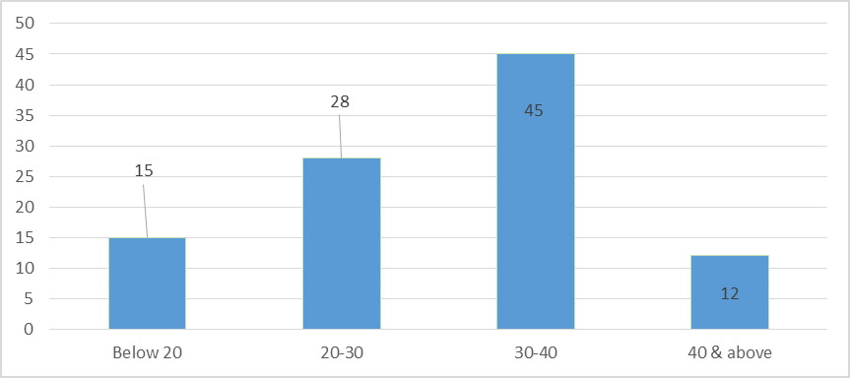

The table and graph No 4.1 shows that 45% of the respondents are from the age group of 30 to 40. 28% of the respondents belongs to the age group of 20 to 30 years. 15% of the respondents are from the age group of below 20 years and 12% of the respondents are from the age group of 40 & above.

Table No 4.2
Marital status
PARTICULARS | NO. OF RESPONDENTS | PERCENTAGE
Married | 46 | 46
Unmarried | 28 | 28
Separated | 6 | 6
Widow | 20 | 20
TOTAL | 100 | 100
Source: Primary Data
Figure No4.2
Marital status
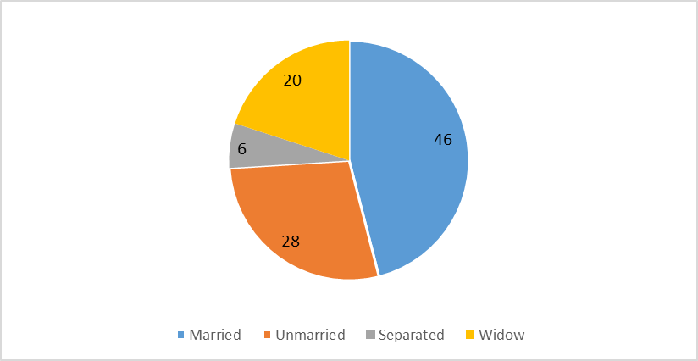

The table and graph No 4.2 shows that 46% of the respondents are married. 28% of the respondents are unmarried. 20% of the respondents are widow and 6% of the respondents are separated.

Table No 4.3
Opinion about income generating activities of Kudumbhashree
RESPONSES | NO. OF RESPONSES | PERCENTAGE
Good | 56 | 56
Excellent | 28 | 28
Satisfactory | 6 | 6
Neutral | 10 | 10
TOTAL | 100 | 100
Source: Primary Data
Figure No4.3
Opinion about income generating activities of Kudumbhashree
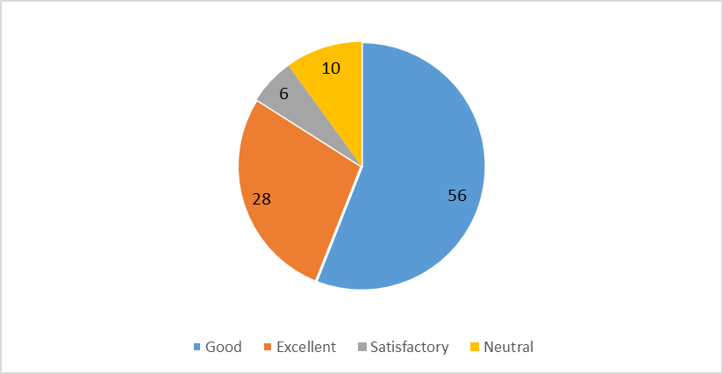

The table and graph No 4.3 shows that 56% of the respondents rate good for the income generating activities of Kudumbhashree. 28% rate excellent. 10% rate neutral and 6% of the respondents opined that they are satisfied with the income generating activities of Kudumbhashree.

Table No 4.4
Educational qualifications
RESPONSES | NO. OF RESPONDENTS | PERCENTAGE
Illiterate | 8 | 8
Primary & UP level | 10 | 10
High school or HSE | 19 | 19
Graduate | 35 | 35
Others | 28 | 28
TOTAL | 100 | 100
Source: Primary Data
Figure No4.4
Educational qualifications

The table and graph No 4.4 shows that 35 percent of the respondents are graduates. 28% of them have other qualifications. 19% have high school or HSE while 10% have primary & UP level education. 8% of the respondents are illiterate.

Table No 4.5
Number of members
RESPONSES | NO. OF RESPONDENTS | PERCENTAGE
10-15 | 60 | 60
15-20 | 24 | 24
20-25 | 10 | 10
25 & above | 6 | 6
TOTAL | 100 | 100
Source: Primary Data
Figure No4.5
Number of members
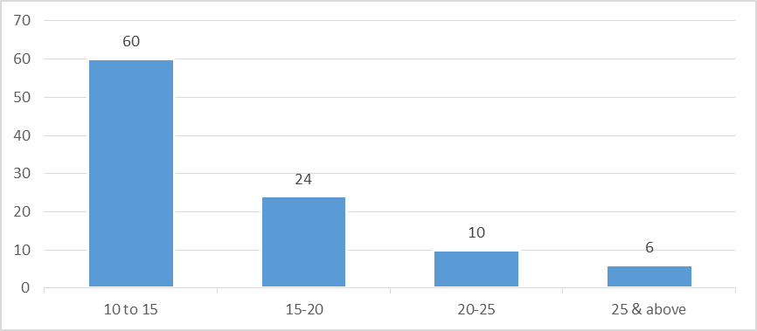

The table and graph No 4.6 shows that the 60% of the respondents said that there are 10 to 15 members in their Kudumbhashree. 24% of the respondents said that there are 15 to 20 members and 10% said that there are 20 to 25 members in their Kudumbhashree.

Table No 4.6
Income generating activities of Kudumbhashree
RESPONSES | NO. OF RESPONDENTS | PERCENTAGE
Caw rearing | 14 | 14
Hotel | 43 | 43
Cottage industry | 12 | 12
Tailoring | 25 | 25
Others (specify) | 6 | 6
TOTAL | 100 | 100
Source: Primary Data
Figure No4.6
Income generating activities of Kudumbhashree
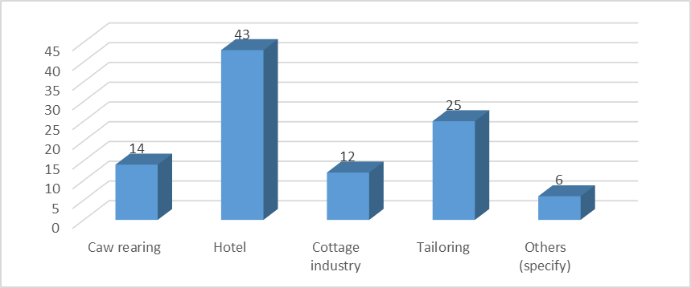

The table and graph No 4.6 shows the 43% of the respondents opined that hotel is their income generating activity of Kudumbhashree. 25% doing tailoring and 14% of the respondents doing caw rearing. 12% said that cottage industry is their income generating activity while 6% of them choose others.

Table No 4.7
No of members engaged in the income generating activities of Kudumbhashree
RESPONSES | NO. OF RESPONDENTS | PERCENTAGE
0-5 | 22 | 22
5-10 | 50 | 50
10-15 | 20 | 20
15 & above | 8 | 8
TOTAL | 100 | 100
Source: Primary Data
Figure No4.7
No of members engaged in the income generating activities of Kudumbhashree
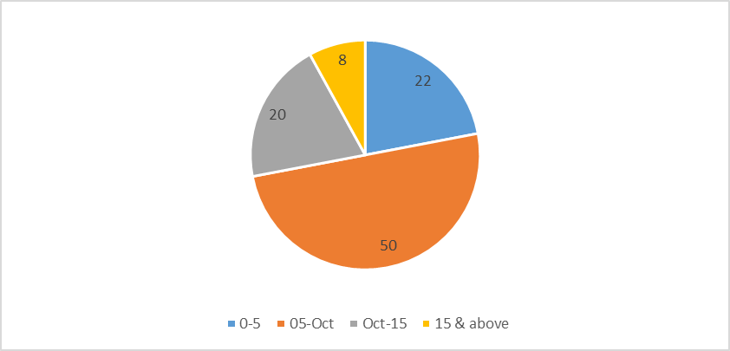
The table and graph No 4.7 shows that the 50% of the respondents opined that 5 to 10 members engaged in the income generating activities of Kudumbhashree. 22% of the respondents said that 0 to 5 members are engaged while 20% of the respondents opined 10 to 15 members engaged in the income generating activities of Kudumbhashree. 8% of the respondents said 15 & above members are engaged in the income generating activities of Kudumbhashree.

Table No 4.8
Have you got any training
RESPONSES | NO. OF RESPONDENTS | PERCENTAGE
Yes | 88 | 88
No | 12 | 12
TOTAL | 100 | 100
Source: Primary Data
Figure No4.8
Have you got any training
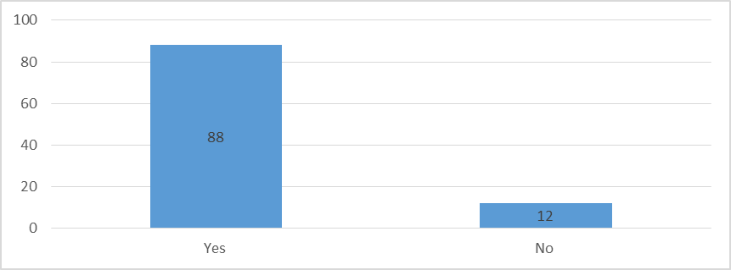
The table and graph No 4.8 shows that the 88% of the respondents got training. 12% of the respondents not get any type of training.

Table No 4.9
Monthly income from Kudumbhashree Unit
RESPONSES | NO. OF RESPONDENTS | PERCENTAGE
Below 5000 | 10 | 10
5000-10000 | 65 | 65
10000-15000 | 7 | 7
15000 & above | 18 | 18
TOTAL | 100 | 100
Source: Primary Data
Figure No4.9
Monthly income from Kudumbhashree Unit
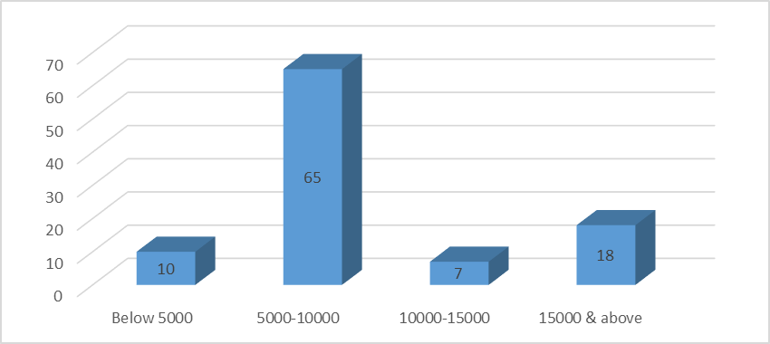
The table and graph No 4.9 shows that 65% of the respondents monthly income is 5000-10000. 18% of the respondents have 15000 & above monthly income from kudumbsree unit. 10% said below 5000 and 7% of the respondents have 10000-15000 monthly income.

Table No 4.10
Monthly income before joining Kudumbhashree
RESPONSES | NO. OF RESPONDENTS | PERCENTAGE
Below 5000 | 50 | 50
5000-10000 | 40 | 40
10000-15000 | 6 | 6
15000 & above | 4 | 4
TOTAL | 100 | 100.00
Source: Primary Data
Figure No4.10
Monthly income before joining Kudumbhashree
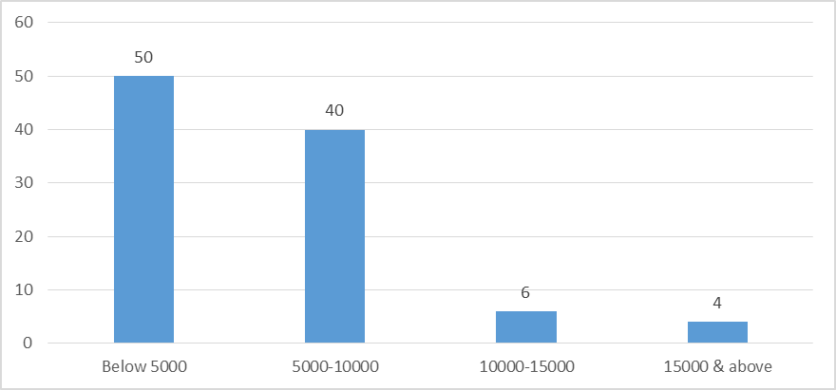

The table and graph No 4.10 shows that 50% of the respondents have below 5000 rupees as monthly income before joining Kudumbhashree. 40% of the respondents have 5000 to 10000 rupees as monthly income before joining Kudumbhashree. 6% of the respondents said 10000-15000 and 4% said that they have 15000 & above rupees as monthly income.

Table No 4.11
Did you work anywhere before joining Kudumbhashree
RESPONSES | NO. OF RESPONDENTS | PERCENTAGE
Yes | 87 | 87
No | 13 | 13
TOTAL | 100 | 100
Source: Primary Data
Figure No4.11
Did you work anywhere before joining Kudumbhashree 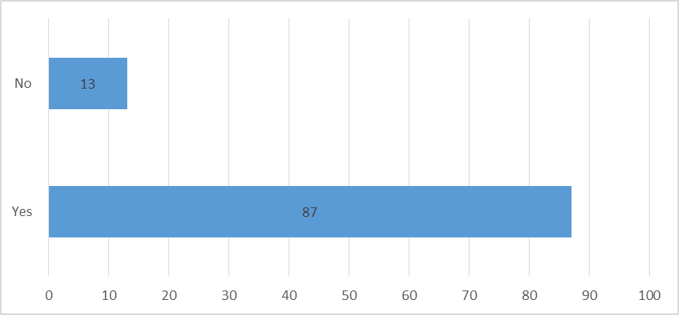

The table and graph No 4.11 shows that 87% of the respondents worked other places before joining Kudumbhashree. 13% of the respondents never worked anywhere before joining Kudumbhashree.

Table No 4.12
Take loan from Kudumbhashree
RESPONSES | NO. OF RESPONDENTS | PERCENTAGE
Yes | 100 | 100
No | 0 | 0
TOTAL | 100 | 100
Source: Primary Data
Figure No4.12
Take loan from Kudumbhashree

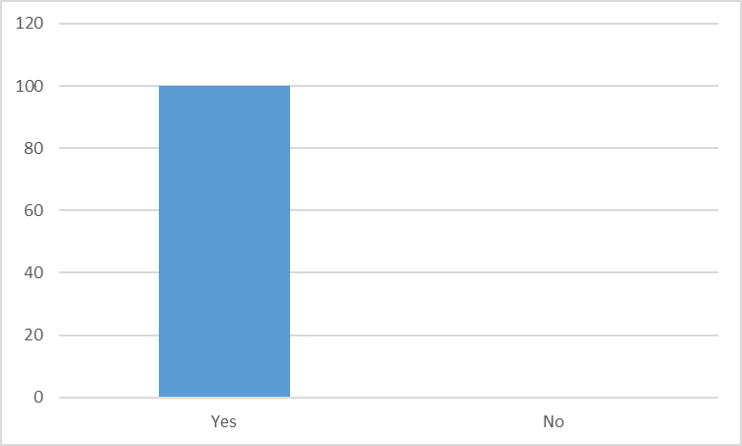
The table and graph No 4.12 shows that 100% of the respondents taken loan from Kudumbhashree.

Table No 4.13
Motive behind to joining Kudumbhashree
RESPONSES | NO. OF RESPONDENTS | PERCENTAGE
Savings | 12 | 12
Self-employed | 60 | 60
To ensure in social group | 20 | 20
Others | 8 | 8
TOTAL | 100 | 100
Source: Primary Data
Figure No4.13
Motive behind to joining Kudumbhashree
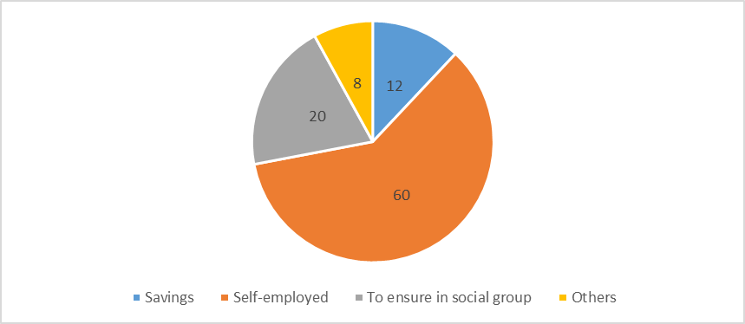

The table and graph 3.13 shows that 60% of the respondents opined that their motive behind to joining Kudumbhashree is self-employment. 20% of the respondents said that their motive behind to joining Kudumbhashree is to ensure in social group while 12% said that savings is their motive behind to joining Kudumbhashree. 8% choose other options.

Table No 4.14
Purpose of loan borrowed
RESPONSES | NO. OF RESPONDENTS | PERCENTAGE
Buying of live stocks | 15 | 15
Marriage | 38 | 38
Housing | 45 | 45
Others | 2 | 2
TOTAL | 100 | 100
Source: Primary Data
Figure No4.14
Purpose of loan borrowed
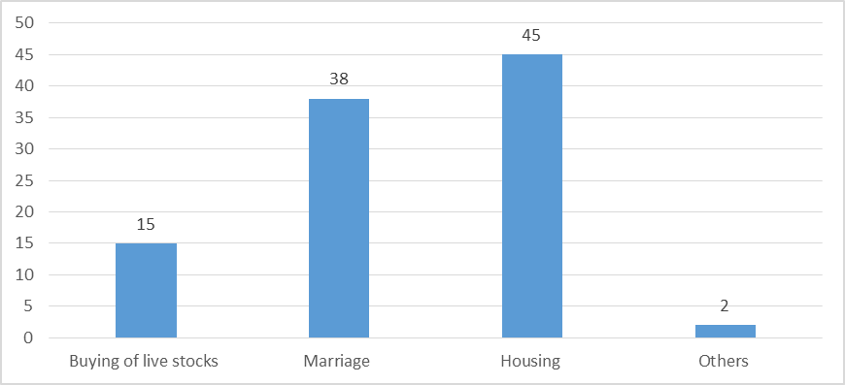
The table and graph No 4.14 shows that 45% of the respondents said housing is the purpose of loan borrowing. 38% said marriage is their purpose of taking loan. 15% said that buying of live stocks is their purpose and 2% said that they have other purposes of loan borrowing.

Table No 4.15
Loan amount
RESPONSES | NO. OF RESPONDENTS | PERCENTAGE
Upto 20000 | 17 | 17
20000-40000 | 43 | 43
40000-60000 | 32 | 32
60000 & above | 8 | 8
TOTAL | 100 | 100
Source: Primary Data
Figure No4.15
Loan amount
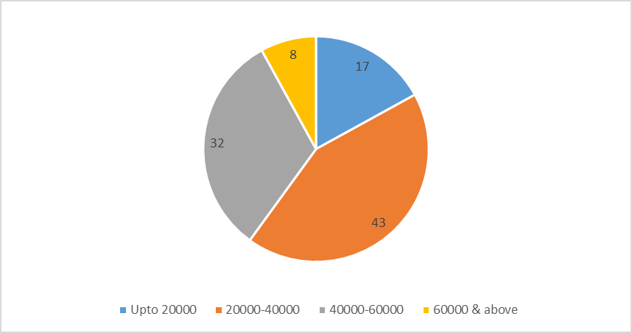
The table and graph No 4.15 shows that 43% of the respondents said that 20000-40000 is their loan amount. 32% of the respondents said that 40000-60000 is their loan amount. 17% of the respondents said that their loan amount is up to 20000. 8% of the respondents said that 60000 & above is their loan amount.

Table No 4.16
Get any subsidy or grant
RESPONSES | NO. OF RESPONDENTS | PERCENTAGE
Yes | 78 | 78
No | 22 | 22
TOTAL | 100 | 100
Source: Primary Data
Figure No4.16
Get any subsidy or grant
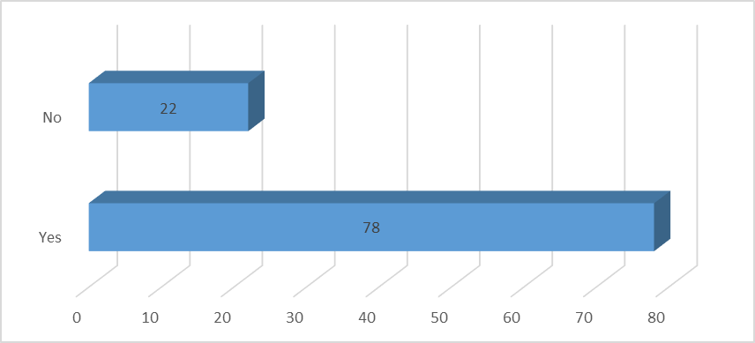

The table and graph No 4.17 shows that 78% of the respondents got subsidy and grant while 22% of them never got it.

Table No 4.17
Your economic status
RESPONSES | NO. OF RESPONDENTS | PERCENTAGE
APL | 45 | 45
BPL | 55 | 55
TOTAL | 100 | 100.
Source: Primary Data
Figure No4.17
Your economic status
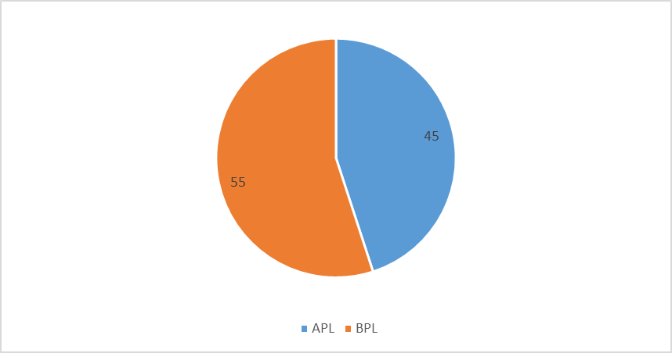
The table and graph No 4.17 shows that 55% of the respondents are BPL. 45% of them are APL.

Table No 4.18
Effect of Kudumbhashree member’s income on family income
RESPONSES | NO. OF RESPONDENTS | PERCENTAGE
Improved | 90 | 90
Not improved | 10 | 10
TOTAL | 100 | 100
Source: Primary Data
Figure No4.18
Effect of Kudumbhashree member’s income on family income
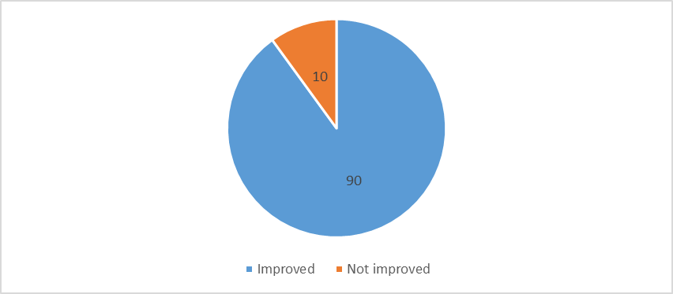
The table and graph No 4.18 graph shows that 90% of the respondents opined that their family income improved because of Kudumbhashree. 10% of the respondents said that their family income is not improved.

Table No 4.19
Status of repayment of loan by Kudumbhashree members
RESPONSES | NO. OF RESPONDENTS | PERCENTAGE
Fully repaid | 12 | 12
Being repaid | 40 | 40
Not yet repaid | 13 | 13
Partially paid | 35 | 35
TOTAL | 100 | 100
Source: Primary Data
Figure No4.19
Status of repayment of loan by Kudumbhashree members
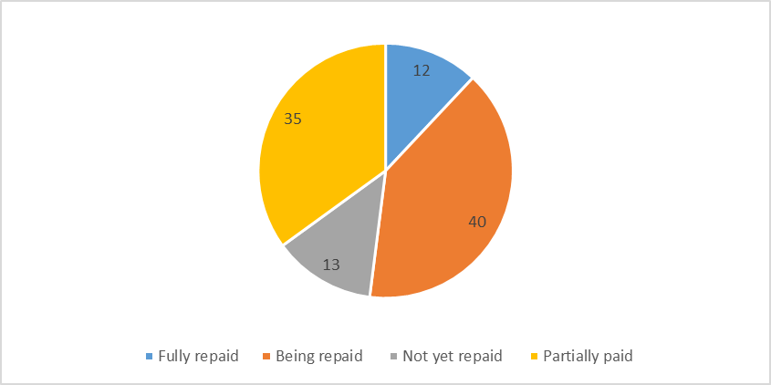
The table and graph No 4.19 shows that 40% of the respondents opined that their loan is being repaid. 35% of the respondents said partially paid, 13% of them said not yet repaid and 12% of the respondents said that their loan is fully repaid.

Table No 4.20
Income source far thrift of Kudumbhashree members
RESPONSES | NO. OF RESPONDENTS | PERCENTAGE
Own labour | 32 | 32
Husbands wage | 40 | 40
Live stock | 12 | 12
Others | 16 | 16
TOTAL | 100 | 100
Source: Primary Data
Figure No4.20
Income source far thrift of Kudumbhashree members
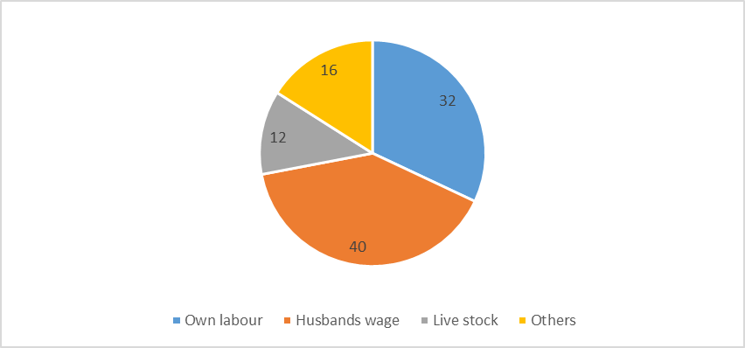
The table and graph No 20 shows that 40% of the respondent’s income source is husband’s wage. 32% said their own labour is their income source while 16% said others and 12% said live stock.

CHAPTER 5
FINDINGS, SUGGESTIONS AND CONCLUSION

5.1 FINDINGS
- 45% of the respondents are from the age group of 30 to 40.
- 46% of the respondents are married.
- 56% of the respondents rate good for the income generating activities of Kudumbhashree.
- 35 percent of the respondents are graduates.
- 60% of the respondents said that there are 10 to 15 members in their Kudumbhashree.
- 43% of the respondents opined that hotel is their income generating activity of Kudumbhashree.
- 50% of the respondents opined that 5 to 10 members engaged in the income generating activities of Kudumbhashree
- 88% of the respondents got training.
- 65% of the respondents monthly income is 5000-10000.
- 50% of the respondents have below 5000 rupees as monthly income before joining Kudumbhashree.
- 87% of the respondents worked other places before joining Kudumbhashree.
- 100% of the respondents taken loan from Kudumbhashree.
- 60% of the respondents opined that their motive behind to joining Kudumbhashree is self-employment.
- 45% of the respondents said housing is the purpose of loan borrowing.
- 43% of the respondents said that 20000-40000 is their loan amount.
- 78% of the respondents got subsidy and grant
- 55% of the respondents are BPL.
- 90% of the respondents opined that their family income improved because of Kudumbhashree.
- 40% of the respondents opined that their loan is being repaid.
- 40% of the respondent’s income source is husband’s wage.
5.2 SUGGESTIONS
- The awareness class, camps and financial assistance should give to eligible women.
- Authorities should conduct awareness classes to women those who don’t know about their empowerment.
- There should be an appropriate strategy for promoting women entrepreneurship.
- Government should introduce pension scheme for Kudumbhashree workers.
- Proper method should be taken to make sure that financial assistance provided is properly utilized.
- The CDS should at least visit each NHG once in a month / to evaluate the activities of each group and also to identify needs of each member.
- Motivate members to take up new ventures and activities
- There should be a close monitoring and follow up on the income generation activities of Kudumbhashree.
- To improve the participation of women whose age between 20-40, it can introduce new innovative schemes. Because now majority of members are from the age group at 30-40.
- The activities of ADS and should be improved to identify the weaker sections in women.

5.3 CONCLUSION
The study provides valuable insights into the factors influencing women's participation in the Kudumbhashree Units in Kerala. Urban areas, particularly in the South region, tend to have a more supportive environment for women's empowerment. While the interaction between Region and Area of Group showed some significance, the overall impact of the independent variables on the dependent variables was limited. Further research is needed to better understand the complex dynamics and identify additional factors that may contribute to women's empowerment within the Kudumbhashree Units. “Kudumbhashree “, the state poverty eradication mission initiated by the Government at Kerala, India can be seen as a strong “women population in Kerala is more than men. It women actively participate in various programmes; it will result in overall development and thus development of the family. Kudumbhashree identifies the poor and provides micro credit programmes.
Kudumbhashree is supposed to enables the rural women who are below the poverty line to be self-sufficient and self-reliant in social, economic and political spheres. There is increasing recognition that economically empowering women is essential both to realize women’s rights and to achieve broaden development goals such as economic growth, poverty reduction, health, education and welfare. Economically empowering women is a win –win that can benefit both only women, but society more broadly. It promotes women’s ability to achieve their rights and well-being while also reducing house hold poverty, increasing economic growth and productivity and increasing efficiency.

BIBLIOGRAPHY
BOOKS
- C.R Kothari, “Research methodology- method & techniques”, new age international (p) publisher, New Delhi (2009)
- Sudhansu Kumar Das, “micro finance & india’s Rural Economy”, New Century publishers (2010).
- Muhammed Yunus, “Bankers to the poor”, public affairs publishers (2003).
JOURNALS & MAGAZINES
- Devaria TS, “ Micro finance in Indis- a tool for poverty reduction” may 2010
- Kudumbhashree annual administration report 2013-2014
- Author Muncipality Development report 2014.
- Mathew P, “poverty education & human resources development august 2010
- Kenneth Kalyani & Seena PC “socio economic changes of women through kudumbhashree,” oct 2012
- Sid Net research Briefing NO. 3, “ poverty alleviation: & participating citizenship for women in Kerala, India,” March 2011
WEBSITES
- http://www.kudumbhasree.org
- http://www.Kerala.gov.in
- http://www.google.com
- http://www.cdit.org

APPENDIX
QUESTIONNAIRE
Name:
- Age

  - Below 20
  - 20-30
  - 30-40
  - 40 & above

- Marital status

  - Married
  - Unmarried
  - Separated
  - Widow

- Educational qualifications?

  - Illiterate
  - Primary & UP level
  - High school or HSE
  - Graduate
  - Others ( specify)

- What is your opinion about income generating activities of kudumbhashree?

  - Good
  - Excellent
  - Satisfactory
  - Neutral

- Number of members

- 10-15
- 15-20
- 20-25
- 25 & above

- Income generating activities of Kudumbhashree?

  - Caw rearing
  - Hotel
  - Cottage industry
  - Tailoring
  - Others ( specify)

- No of members engaged in the income generating activities of Kudumbhashree?

  - 0-5
  - 5-10
  - 10-15
  - 15 & above

- Have you got any training?

  - Yes
  - No

- What is your monthly income from Kudumbhashree Unit?

  - Below 5000
  - 5000-10000
  - 10000-15000
  - 15000 & above

- How much was your monthly income before joining Kudumbhashree?

  - Below 5000
  - 5000-10000
  - 10000-15000
  - 15000 & above

- Did you work any where before joining Kudumbhashree?

  - Yes
  - No

- Have you take loan from Kudumbhashree?

  - Yes
  - No

- Motive behind to joining Kudumbhashree?

  - Savings
  - Self-employed
  - To ensure in social group
  - Others ( specify)

- Purpose of loan borrowed?

  - Buying of live stocks
  - Marriage
  - Housing
  - Others

- Loan amount, if any?

  - Upto 20,000
  - 20,000-40,000
  - 40,000-60,000
  - 60,000 & above

- Did you get any subsidy or grant?

  - Yes
  - No

- Your economic status

  - APL
  - BPL

- Effect of Kudumbhashree member’s income on family income?

  - Improved
  - Not improved

- Status of repayment of loan by kudumbhashree members

- Fully repaid
- Being repaid
- Not yet repaid
- Partially paid

- Income source far thrift of Kudumbhashree members?

  - Own labour
  - Husbands wage
  - Live stock
  - Others

