CHAPTER I
EXECUTIVE SUMMARY
INTRODUCTION
Kudumbashree is a unique programme at poverty alleviation with full participation at women, especially poor women. It seeks to bring the poor women falk together to forms grass roof organizations to helps & to enhance their economic security. The concept of Kudumbashree sought to match the energy of self help group movement with the need for a community plat form to interface with local self govt. the literacy meaning of the word Kudumbashree is prosperity at the family.
Kudumbashree a female- oriented, community based, poverty reduction project at govt of Kerala. Kerala is an Indian state Iying in the south-west part at Indian subcontinent, where many development experiments are beings tested, retined & implemental. Kudumbashree Ayalkoottam, Kudumbashree ward samithy, Kudumbashree panchayath smithy. The paradigm shift in the Approach is that any women who is residing in the Grama panchayath can become a member of the Kudumbashree Ayalkoottam irrespective at whether she is a below poverty line (BPL) family. Since this aspect gives an opening for the above poverty line (APL) families to enter in to the community structure envisaged by Kudumbashree. It is further ensured that majority of the office bearers should belong to BPL families. These structure give added importance to women empowerment both social and Economic.
Kudumbashree means prosperity of the family, is the state poverty eradication mission initiated by the govt. of Kerala for devoting the absolute poverty from the state. It is a holistic, participatory, women oriented innovative poverty reduction approach implemented through local self govt’s. the mission follows a process approach rather than a project approach. Kudumbashree envisages prosperity of the poor families in the state with multiple programmes that will provide them information, create awareness, buildup their capability and capacity, enhance their confidence and show them opportunity for better social security and empower them physically, socially, economically and politically.
The overall development of a nation depends to a great extent, on the inclusion of women in the entire nation building process. Unfortunately woman rarely enjoys the wide spectrum of freedom in her life because of the ‘subordination’ imposed her by a mail dominated society. This naturally hinders her decision making capacity leading to a state of disempowerment, reflected not only in her own life, but also in the family where she has a pivotal role in moulding the children – the next generation – as well as the judicious management of the family budget even though they are not at all recognized and accounted by anybody. The late recognition of the above facts by the government and policy makers lead to the creation of the concept of women empowerment. Women empowerment is a process where women recognize their rights and freedom guaranteed by the Constitution and Law (Judiciary system) which enable them to become ‘demanders’ rather than ‘beneficiaries’ of various schemes and programmes designed by the authorities for the development/ welfare of women.
In our country, for the well-being and the empowerment of women, different schemes and models are practiced producing mixed results. In Kerala, an innovative model of women empowerment, focusing the empowerment of women at grass root level is implemented through Local Self Government Bodies (LSGBs) with the collaboration of NABARD in the year 1999 and has its operations in each and every district in the state.
Under Kudumbashree, women have organized themselves under a three – tier community based organization. The bottom of the KDMS programme is formed by the Neighborhood Groups (NHGs) comprising of 20-40 women members selected from poor families. Area Development Society (ADS) is formed at the level of ward of local government by federating 8-10 NHGs. The Community Development Society (CDS) formed at the village Panchayath level or at the municipality (town) or corporation (city) is a federation of ADSs. CDS, the highest tier, is the federation of all the ADSs in the respective Panchayath (rural) or municipality (town) or corporation (city).The KDMS system works in close association with both the urbanand rural local governments through a network of Community Based Organizations working with women.
As on March 2008, KDMS has covered 36, 53,655 families through 1, 85,309 NHGs, 16,950 ADSs and 1058 CDSs. It also plays an important role as a nodal agency for anti-poverty programs sponsored by central, state and local governments with focus on micro enterprise development. It has become a conduit for a variety of government programs. This poor women-oriented self-help group programme strives to tackle poverty in an integrated manner through an effective convergence of resources and actions.
Micro finance, especially provision of thrift and credit services using bank linkage appears to have proved its viability. Thrift and Credit activities at the level of NHGs promote saving habit among the poor and help them access loans for both consumption and investment purposes. These Thrift and Credit Societies play a significant role in channelizing rural savings for the poverty eradication programme of Kudumbashree. It has developed training modules for micro-enterprise management and conducted several training programs. Kudumbashreemission is implementing the projects for the destitute. Various development activities in the state of Kerala are being brought together through the group dynamics developed under the Kudumbashreeprogramme. This has resulted in convergence of resources leading to poverty reduction.

CHAPTER II
PROBLEM STATEMENT

STATEMENT OF THE PROBLEM
The emergence of Kudumbashree among rural women for their over all development is at recent origin and their increase in no is rapid. Women population in India constitute around half of the country’s population. Hence they are regarded as the “Better half of the society”. Kudumbashree is supposed to enables the rural women who are below the poverty line to be self-sufficient & self reliant in social, economic & political spheres.
The Kudumbashree & it’s financial policies are considered as significant & emerging trend in the present scenario for the economic empowerment of women. Micro finance programme are promoted as an important strategy for women’s empowerment. Micro finance builds mutual trust & confidence between bankers & rural poor to encourage banking in a segment of population where formal financial institutions usually find it difficult to reach. The present project examine the economic impact of micro finance & whether it contributes to their financial management Dharmadam Panchayathin Kannur District is selected for the study.
OBJECTIVES OF THE STUDY
- To study the role of Kudumbashree in Economic Empowerment at women.
- To study the economic condition Kudumbashree members.
- To evaluate the economic empowerment utilization by Kudumbashree members.
- To study the economic impact of Kudumbashree self help group members.
- Improving incomes of the poor through up gradation at vocational & managerial skills & creations of opportunities for self employment & wage empowerment.
- Empowering the poor women to improve the productivity & managerial capabilities at the community by organizing them into community based organizations.
SCOPE OF THE STUDY
Kudumbashree being a very powerful tool initiated by govt to solve the problems by poor particularly the women. Kudumbashree programme was designed to provide employment, generate income & make women self- reliant. A society where in women are empowered & financially self- sufficient the process at planning implementation at policies could be easier. Since 33 percent reservation is given to women in local bodies, empowered women could make decisions systematically & scenically financial policies at Kudubmshree like micro finance can make a significant contribution to women’s financial management. It is quite significant to note micro enterprises can play a vital role in socio-Economic like at communities even in this age of growing globalization. Hence the study is highly significant from the socio economic point at view for the purpose of this study, data were collected from 50 Kudumbashree members from various wards in Dharmadam Panchayath.
METHODOLOGY OF THE STUDY
SOURCES OF DATA
For the successful completion at the present study the data required for analysis had been collected from two sources, namely.
- Primary sources
- Secondary sources
- Primary data

The sources of primary data are
- Direct observations
- Schedule
- Personal interview with Kudumbashree members
- Informal talk with Kudumbashree members primary data were collected from the 50 respondents. (Kudumbashree members) from various wards of Dharmadam Panchayath. Mainly through observations, direct interview & schedules.
- Secondary data
The secondary data
- Kudumbashree annual report, municipality developmental reports etc.
- Magazines & journals etc
- Internet
Sample Size
In this project 50 samples were selected.
Sample Technique
The samples are chosen by the method of simple random sampling without sample replacement.
Tools and technique used for data collection
Questionnaire
Personnel Interview
Tools for analysis
- Bar diagram
- Pie Diagram
PERIOD OF THE STUDY
The study was conducted during 21 days
LIMITATIONS OF THE STUDY
- The topic selected for the study was vast & requires much more time for the study. There fore time was a major limiting factor.
- Kudumbashree was spread Across the country & the pattern of growth at Kundumbashree is not uniform since the study confined to 50 samples, result may not be completely Accurate.
- The respondents unwillingness to disclose all the details about the Kudumbashree & the personal information limits the scope of the study.
REVIEW OF LITERATURE
Manjusha (2010) assessed the level of empowerment achieved by the womenfolk of Ulladan Tribe of the North Paravur Taluk in Ernakulam District of Kerala. The study is an attempt through Kudumbshree units. The findings show that a significant change has come about in the socio-economic life of the women folk in the Taluk. Change was also observed in the political avenues as well as the general skills of the respondents through the Kudumbshree Units. The study suggested that for future development, training and awareness programmes should be conducted for empowering the poor women in that area.
Kenneth and Seena (2012) studied the impact of various programmes that were introduced in order to raise the women from below poverty line in Puthanvelikkara Grama Panchayat of Ernakulum, Kerala. The Questionnaire method was adopted in this study for collecting primary data. The results of the study show that economic development is the base for other developments and Kudumbshree units drastically changed economic independence of the women and their living status.
Beevi and Devi(2011) conducted a study with an aim to assess the role of Self Help Groups in empowering rural women and to identify the major constraints faced by women in Kollam District of Kerala. The study revealed that micro-enterprises are a practicable pathway for improving the economic status. Some factors like education, income and mass media contact were positively and significantly related to the role of the SHGs. The effectiveness of the SHGs in promoting women empowerment was found to be limited by only factors like hesitation to take up innovative scheme; difficulty in playing dual roles by women; lack of confidence, team spirit, effective leadership, managerial skills, working capital and transportation. These thus were found to be the major constraints faced by SHGs.
Jaya (2004) evaluated the functioning of SHGs and identified the factors contributing to the successful functioning and sustainability of groups in Kerala. This was achieved through an exploratory study of selected SHGs in the district of Malappuram in Kerala. The findings of the study show that SHG intervention has indeed improved the living standards. Interestingly, it also inculcated saving and loan repayment habits and brought about a positive change in attitudes and social skills of 52% of the respondent women folk thereby leading to empowerment.
Contrastingly, Shylendra (1998) assessed performances of eight women SHGs in Vidaj village of Gujarat. The SHGs, it was found, failed to enable members realize their potential benefits. The failure was attributed to wrong approaches followed in the SHG formation, lack of clarity about the SHG goals and concept among the members. The study brought to light the need to constitute SHGs with clear understanding of the concept from the beginning itself.
Minimol and Makesh (2012) did a study to identify the level of personal, social, economic and financial empowerment achieved by the members through SHGs. The data was collected from a sample of 200 members of 18 SHGs located within three villages of Cherthala Taluk of Alappuzha, Kerala. Primary data were collected by employing a structured interview schedule, through participant observation, and direct personal discussions with the members of various SHGs. The study concluded that the concept of SHGs for rural women empowerment has not yet run its full course in attaining its objective.
Kavitha et.al (2011) conducted a study on the general acumen of effectiveness of group functioning by the members of women self-help groups (SHGs) in goat farming, operating under Kudumbashree, in Thrissur district, Kerala. The findings of the study showed that majority of the respondents (76%) perceived the effectiveness of their group functioning as medium. The functioning of the group in terms of official procedures (mean score 1.96) was perceived most effective by the members, followed by that of interpersonal relationships (mean score 1.93) and entrepreneurial activities (mean score 1.76). The study brought to light the need for entrepreneurial training in goat farming along with provision of resources like good quality breeds, grazing land, feed, market and veterinary care for success of the group’s functioning.
Kudumbasree is a unique poverty eradication mission of the state of Kerala. Many studies have so far conducted in relation with Kudumbasree and self help groups in different parts of our country. A brief view of the studies so far conducted is given below.
Gurumoorthy (2000)reveals that empowering women contributes to social development. Economic progress in any country whether developed or underdeveloped could be achieved through social development.
The self-help group disburses micro-credit to the rural women for the purpose of making them enterprising women and encouraging them to enter into entrepreneurial activities. Credit needs of the rural women are fulfilled totally through the self-help groups. SHGs enhance equality of status of women as participants, decision makers and beneficiaries in the democratic economic, social and cultural spheres of life. SHGs also encourage women to take active part in socio-economic progress of our nation.
Puhazhendhi and Satyasai (2001) in their study attempted to evaluate the performance of SHGs with special reference to social and economic empowerment. Primary data collected with the help of structured questionnaire from 560 sample households in 223 SHGs functioning in 11 states representing four different regions across the country have formed the basis of the study. The findings of the study reveal that the SHGs as institutional arrangement could positively contribute to the economic and social empowerment of rural poor.
The impact on the later is more pronounced than on the former. Though there has been no specific pattern in the performance of SHGs among different regions, the southern region could edge out other regions. The SHGs programme has been found more popular in the southern region and its progress in other regions is quite low, thus signifying an uneven achievement among the regions. Older groups had relatively more positive features like better performance than younger groups.
Sakuntala Narasimhan (2001) , focuses specifically on rural Scheduled Caste and Scheduled Tribe women, who are disadvantaged as women, as members of the rural section of the laypeople and because of their low caste status. The book compares the effectiveness of State initiatives with the motivation – and conscientisation strategy advocated by Action for Welfare and Awakening in Rural Environment (AWARE), a non-governmental development organization working in 6000 villages spread over 7 States in India. It analyses
the success of AWARE’s work among women through various case studies and concludes that, besides monetary resources, it is the mindset of the policy makers, bureaucrats and particularly the women concerned that must change in order to assist the empowerment of women.
Jaya S. Anand (2002)10, in her discussion paper titled “Self-Help Groups in Empowering Women: Case Study of Selected SHGs and NHGs”, gives a review of progress of Self Help Groups. She has attempted to examine the performance of selected SHGs and NHGs and to assess its impact, especially the impact of micro credit programme on empowering women. It has been clearly established that delivering credit alone may not produce the desired impact. The supporting services and structures through which credit is delivered, ranging from group formation and training to awareness-raising and a wide range of other supporting measures are critical to make the impact of group activity strong and sustainable.
Meenakshi Malhotra (2004) , in her work entitled, “Empowerment of Women” (in 3 volumes), deals with the issues leading to empowerment of women with particular reference to rural women. Volume one deals with issues like gender inequalities in labour market and in entrepreneurship. Volume two focuses on micro finance options for women empowerment. It looks into micro credit schemes for rural women and micro finance movement in India. Third volume describes the various programmes introduced to empower women and bring them into the orbit of development network.
J. Bhagyalakshmi (2004) , in the article, “Women’s Empowerment - Miles to Go”, points out that India as a signatory to the UN Convention has taken several measures to ensure full development and advancement of women. The women specific programmes are showing positive results in empowering women, until now, one feels, there are miles to go and promises to keep. All forms of violence against women, physical and mental, whether at familial or communal level shall be dealt with great care. She states that all forms of discrimination against girl child and violation of her rights shall be eliminated by undertaking strong measures both preventive and disciplinary within and outside the family. Though women play a major role in agriculture and allied sectors, their contribution is hardly recognized. Intensive efforts are needed to ensure that benefits of training, extension and various programmes will reach them to make them more effective in their own area of operation.
Sri.V.P.Ragavan (2009)13, in his article stated that the poor women of the State have become active participants in the planning and implementation process of various ant-poverty programmes. By participating in various income generating –cum-developmental activities, the morale and confidence of women became very high. Capacity of the poor women of the State in several areas has gone up considerably. Status of women in families and community has also improved. Kudumbashree has gained national and international acclaim as an ideal and workable model of participatory development for eradicating poverty. He further stated that women empowerment is the best strategy for poverty eradication.

CHAPTER III
THE STUDY

3.1 INTRODUCTION
For the sustained economic development and social justice, socio economic status of women should be improved along with that at men socio economic freedom gives the right to determine the course of their lives. Entrepreneurship enhances the women’s social standing the entrepreneurial activity is depended on several complex economic, social and psychological factors. Thus, for any attempt made to understand the entrepreneurial . Activity among women, on analyzing of their socio-economic origins is necessary.
Kudumbasree , a female- oriented , community- based, poverty reduction project of govt. of Kerala. Kerala is an Indian State lying in the south-west part of Indian – sub continent, where many development experiments are being tested, refined and implemented. The mission aims of the empowerment of women, through farming self- help groups and encouraging their entrepreneurial or other wide range of activities. The purpose at the mission is to ensure that the women should no longer remain as passive recipients of public assistance, but active leaders in women involved development initiatives. Kudumbasree movement was launched by farmer prime minister A P Vajpayee at a function chaired by then local administration minister Paloli Mohammed Kutty at Kottakkunnu in Malappuram on May 17, 1998.
Kudumbasree is a female- oriented, community based, poverty reduction project of the govt. of Kerala. Kerala is an Indian State lying in the south- west part of the Indian subcontinent where many development experiments are being tested, refined and implemented.
STRUCTURE OF KUDUMBASHREE
Kudumbashree has three tiers community based organization (CBO) for its effective administration and decentralized operations. Neighborhood group (NHG ) -This is the lowest tier consisting of 15 to 40 women members from poor families. Meetings are arranged on a weekly basis, in the house of one of the NHG members. The Area Development Society (ADS) is the second tier. ADS are formed at ward level- panchayat, municipality or a corporation by joining 10-15 NHGs. The Community Development Society (CDS) is the highest tier formed by union of all the ADSs in the respective panchayat, in ‘rural’ or municipality and in ‘town’ or corporation in city areas. It monitors the thrift and credit activities of NHGs at these levels ie. panchayat or municipality or corporation level.
HISTORY AND BACKGROUND OF KUDUMBASREE
Kerala has a tradition of special forms of micro thrift and micro finance practices like kurikalyanam, Azhcha chitty, kettuthengu etc.which are different forms of informal banking of olden days. These systems made the community as a whole giving a helping hand to the needy and also helped the poor overcome many social and economic challenges. The mission aims at the empowerment of women, through farming self- help groups and encouraging their entrepreneurial or other wide range of activities.
Kudumbasree, which means “ prosperity of the family”, is the name of the women oriented, community based, and empowerment programme of the State Poverty Eradication Mission (SPEM) of govt. of Kerala. The mission aims at the empowerment of women , by forming self help groups (SHG)s and encouraging their entrepreneurial or other wide range of activities. The purpose of mission is to ensure that the women should no longer remain as passive receipients of public assistance, but active leaders in women involved development initiatives. Kudumbasree was conceived as a joint programme of the Govt. of Kerala and NABARD, implemented through CDSs of poor women, serving as the community wing of local govt. It is formally registered as the SPEM, a society registered under the Travancore Kochi literacy, scientific and charitable societies act 1955.
Kudumbasree perceives poverty not just as the deprivation of money, but also as the deprivation at basic rights. The poor need to find a connective voice to help claim these rights. The grass roots of Kudumbasree are neighbourhood groups(NHG)s that send representatives to the ward level area development societies (ADS)s. The ADSs sends it’s representatives to the community development societies(CDS)s, which completes the three tier structure of Kudumbasree to day there are 1.94 lakhs NHGs, over 17000 ADSs and 1061 CDSs in Kudumbasree.
It is this network that brings women to the Grama Sabhas and helps them brings the needs of the poor to the attention at the local govt. The CDSs are also very active in givt. Programmes and play significant roles. Development activities ranging from socio economic surveys and enterprise development to community management and social audit. Kudumbasree is the inevitable off spring at the collective experience derived from the bleak plight of the anti- poverty programmes at the past most at the well conceived antipoverty programmes at the central and state govt. failed to bring about the desired result. The centrally planned, rigid, individual oriented poverty eradication programmes of the past did not give a room for the involvement and commitment of poor and viewed poor only as resources less “ receivers of benefit”.
The decentralization process in Kerala results in transfer at powers to local govt’s. First in October 1995 when the decision to transfer most of the development institutions to local govt. along with staff and the second in august 1996 by the decision to transfer about a third of state plan resources to local govt when the peoples plan campaign was launched. The concept of Kudumbasree sought to match the energy of SHG movement with the need for a community platform to interface with LSG.
The anti- poverty programme had evolved through a long phase of experimentation. The urban basic services for the poor(UBSP) implemented in Alappuzha municipality in 1992 focused on a community based participatory approach to planning and implementing poverty reduction programme. The formal launch at Kudumbasree network was on 18th May 1998. The kudumbasree network developed across the state in 3 phases. By March 2002, the entire state was brought under the kudumbasree network for the first 14 years, activities have been focused towards making . Economic independence as the first step towards women empowerment, but to ensure sustainable economic independence, Gender equality and justice need to the established. To make women capable of understanding these issues, this pts programmes gender self learning programmes(GSLP) has been envisaged.
The strategy of process of this programme is unique and distinct as it looks at creating a community women aware of their rights. GSLP encourages women to examine one’s life and experiences, recognize, understand and analyse the ways of exploitation. The learning modules co-relates the issues of employment, health, with the life experiences of women, while reports are created after discussion of the same within the neighbourhood groups. The community learning, helps women discuss and find a solution to the various problems faced by them.
There is a dynamic group of resources persons who work towards making 2 lakhs neighbourhood groups a parts of this process and leading the study process. Sreesakthi portal has been initiated to make gender self learning programme a productive and successing issues, creation of study guides, collating programme reports, along with clearing of doubts, discussion of ideas, and most importantly, help women become computer and technology savvy.
KERALA KUDUMBASREE PROGRAMMES
Launched by the govt. of Kerala in 1998 for wiping out absolute poverty from the state through concerted community action under the leadership at self govts, kudumbasree is to day one of the largest women- empowering projects in the country. The programme has 41 lakhs members and covers more than 50% at the house holds in Kerala. Built around 3 critical components, micro credit entreneurship and empowerment, the kudumbasree initiative has today succeeded in addressing the basic needs of the less privileged women, thus providing them a more dignitied life and a better future. Literal meaning at kudumbasree is prosperity of family.
Kudumbasree have been working on a programme that aims at getting women to discuss the gender dimension at their issues for this we had to break the mould of thrift and credit based discussions which alone were taking place in the NHG, apart from the odd health or other dissemination.
Locally contextualized modules on issues such as women and work women and health, women and mobility, women and entertainment are developed and deliberated in neighbourhood group meetings. The different voices of women and their perceptions about the topics of discussions will be captured on a web- based portal accessible at the level at the local self govt. The portal is being developed with the support of the minister of information technology, govt. of India.
Awareness building programmes seems not to leave any sustained impact. It was felt therefore that a learning process in which the women felt them selves to have a stake and would be delivered not through trainings, but through discussions focusing on some other formate- press cuttings, poems, skit etc. had to be the mode of delivery. State level constitutions help identify the themes of the “ learnings modules.” The content for the learning modules are prepared by local womens resources persons.
Kudumbashree links participatory governance initiative to poverty alleviation with the explicit intention of creating “ empowered” female citizens. The programme operate through women- only neighbor hood groups( NHG)s, which focus on three main day – today activities. Who sources the stories out of their own experiences for further contextualization and development. One of the modules are developed. They are consolidated and disseminated by resource persons in the neighbourhood groups. Women are encouraged to ask questions about themes ranging from work and environment to health, power and power structure. This programme is expected to directly touch the lives of over 35 lakhs women of the state. Not only will these discussions and debates be documented, but also shared with a larger community through a special Sthree Saksthi Web based portal being developed by CDAC with financial support from the ministry of information technology govt. of India.
- To act as active thrift and credit society.
- To support micro- enterprise and provide women with new income- earnings opportunities.
- To support women’s participation in local governance by providing the means by which poor women’s voice can influence the practical of the local state.
Each NHG consist of around 10-20 women, the majority of women are living below poverty line. The NHGs are federated at the electoral ward level in to area development society(ADS)s and at the municipality or panchayath level; ADS s are grouped into a community development society (CDS s) . The groups are there fare structured to present poor women within strong, federated and autonomous structure. The formation of NHG s is actively supported by the state and subsidized credit and other state benefits are channeled to NHG members. Even given this strong governmental support, the roll out of kudumbasree has been impressive the programme has also been successful in relation to its function as network of credit and thrift groups, with members making regular contributions and gaining access to formal credit in addition to their savings.
THE MISSION OF KUDUMBASHREE
The mission of kudumbasree is:
“ To eradicate absolute poverty in ten years through concerted community action under the leadership of local govts, by combining self- help with demandled convergence of available services and resources to tackle the multiple dimensions and manitestations of poverty, holistically”.Kudumbasree is not only envisaged as a mission, but also as a process, a project and a delivery mechanism for the poor. “ Kudumbasree “, through concerted and continuous action, had created sustainable livelihood options to the poorest of the poor in the society.
Kudumbasree has been continuously evolving and today has moved on from micro finance to local economic development from seeking to provide welfare to the poor, we are enabling the poor to claim entitlements. The search has also been one of transforming participation to citizenship.

OBJECTIVES OF KUDUMBASHREE
- Ensuring a minimum of 5 years of primary education for all children, belonging to risk families.
- Ensuring better health and nutrition for all families.
- Ensuring basic amenities like safe drinking water, sanitary latrines improved shelter and healthy environment.
- Ensuring zero drop out in school for children belong to poor families.
- Identification of poor families through risk indices- based surveys, with the active participations of the poor and the communities to which they belong.
- Promoting functional literacy among the poor and supporting continuing education.
- To ensure adequate, qualitative, preventive and curative health care to people at the state.
- To ensure health care services to all particularly to the disadvantaged groups like scheduled tribes, scheduled caste and backward closes.
- Facilitating self- identification of the poor families through transparent risk idex composed of socially accepted indicators of poverty through a particular survey.
- To gather, people’s reactions to the programmes and policies of the govt and their implementation and to report them back for appropriate action and course corrective measures.
- Improving incomes of the poor through improved skills and investment for self- employment.

STRATEGIES OF KUDUMBASHREE
- Formation of women collectives:
The poor women from families identified will be organized into neighbor hood groups (NHG) representing 15to 40 families. A five member team elected from the NHG s will be the cutting edge of the programme. NHG s will be the cutting edge of the programme. NHG s will be the cutting edge of the programme. NHG s will be federated democratically into area development societies(ADS) at the panchayath/ municipality ward level and then into community development societies (CDS) at the panchayath / Municipal level. Their organizational structure will provide opportunities for collective public action.
- More information and training:
weekly meetings of NHG s, sharing of experiences, discussions, organized training etc. will broaden their out look on better health, better education, better social and economic status.
- Skill up grade training:
To facilitate economic development, suitable skill upgrades training will be given to women.
- The ultimate goal:
Reaching out family through women, and community through family, is the ultimate largest of Kudumbasree.
- Leadership:
Decision making power interaction in women collectives will help them to have a better under standing. Which will lead to the emergence of leadership. This will help to ensure efficient women leadership to elected govt’s in future.

- More information and training:
Weekly meetings of NHG s, sharing of experiences, discussions, organized trainings etc. will broaden their out look on better health, better education, better social and economic status.
- Thrift:
Credit operations and 24 hours banking system = small savings generated at the families are pooled at various levels as thrift and used to attract credit from banks, which will operate as 24 hours bank for the poor, acting as a sub- system at the formal bank.
- Better living condition-
infrastructural facilities = The needs identified at NHG level are shaped as micro plan which are integrated into mini plans at area development society(ADS) level and action plan at CDS level. A common infrastructural facility in the community strengthness them further.
- Power to the people especially the women = The skill for identification of needs, fixing priorities, availing resources, bridging gab between needs and resources in a cost effective manner etc. are taught to the poor women groups in various phases in the decentralization of power to the local bodies and common man, kudumbasree can act as a healthy sub system facilitating participation of poor women in the planning implementation and monitoring of the programme.
STRUCTURE OF KUDUMBASREE
The community based organization kudumbasree, conceived at poverty as a basket of relative deprevations and vulnerabilities and has developed an innovative methodology to identify the poor using no economic parameters. The poor thus identified identification of the underprivileged.
The kudumbasree community organization is a three tiered structure with its apex tier anchored in the local self govts. The 3 tieres are:
- Neighbour Hood Groups(NHG s) :
Groups of 10-20 women from the same neighbor form the foundation of the structure.
- Area Development Society(ADS) :
Federation of NHG s within a ward of the LSG.
- Community development society (CDS) :
Registered society as the federation of ADS within the LSG.
1)NEIGHBOUR HOOD GROUPS (NHG s)
To restore the defined or deprived entitlements of the poor the capability of the poor has to improve first, capability deprivation is the root cause of poverty and to make them aware of their entitlements the first and foremost step adopted by the mission is to build an organization structure of the poor. The community based organization ( CBO) of poor set up by the mission under the leadership of local self govt.’s play vital role in eradication of absolute poverty. The organization of poor built up by the mission give them an opportunity to realize the cause of poverty, different variables of poverty and the magnitude of poverty. It enables them to identify their entitlements and utilize the common platform to achieve it together. The community based organization, which encompasses all sections of poor, is organized into a three- tier structure. The neighbour hood group at grass roots level consists of 10 to 20 members, each member representing a family forms the building block of the organization. In each neighbourhood group from among it’s members, five volunteers are elected for undertaking various functional activities. The positive of a volunteer is the first stepping stone towards leadership for a women from poor family in each neighbour hood group from among the poor women five office bearers are selected for undertaking various functional activities.
- Community Health Volunteer:
She look after the various health related aspects of the group members including children, women and the aged convergence of various programmes indertaken by health and social welfare departments are also carried out under the leadership at the community health volunteer in each neighbour hood, the mission has plans to build a unique health care system for which the health volunteer will have a pivotal role. The new system has already been piloted in select municipality and it proved to be a success.
- Income generation activities volunteer:
The collection, consolidation and maintenance of books of accounts and registers in connection with thrift mobilization is looked after by his volunteer. The IGA volunteer in fact acts as local micro enterprises consultant(MEC). She persuades and motivates the members of NHG s to take up micro enterprises, livelihood activities using the thrift loan and the linkage banking loans at present, each neighbourhood groups has minimum one micro enterprise. The mission imparts necessary training to these volunteers in enterprises development , accounting etc.
- Infrastructure volunteer:
Infrastructural backwardness of the group is tackled with the help of various ongoing governmental programmes under the leadership of this volunteer. It is proposed to take micro contracting as an income generating activity by “ the group after sharpening their functional skills through a series of training programmes. She will guide and promote the micro plan preparation of the NHG and liaison with the local bodies and acts as a catalyst for local development.
- Secretary:
The secretary records the proceedings of the meeting and necessary follow up including motivation and team building it’s responsibility of the secretary.
- President:
She will preside over the weekly meetings and will impart necessary leadership and guidelines to the group members.
2)AREA DEVELOPMENT SOCIETY (ADS)
The second tier is the area development society, which is formed at ward level by federating all the NHG s in the ward. The activities and the decision in the ADS are decided by the representatives of the women elected from various NHGs. The area development society consist of :
- General body:
Consists of all presidents , secretaries and three sectoral volunteers of the federated NHG s.
- Governing Body:
Consists of seven member governing body elected from the general body. The seven member governing body consists of ADS chairperson, ADS vice chairperson and ADS secretary.
- Monitaring and Advisory Committee:
The streamline their activity with the activities at local self govt., a ward level monitoring and advisory committee is formed under the chairmanship of ward member of the local body. The salien feature of this arrangement is the fixation of priorities by the poor; in tane with the policy framework of local self govts.
3)Community Development Society (CDS)
At the panchayath / Municipal level a community development society(CDS), a registered body under the Travancore – Cochin literacy scientific and charitable societies act, is formed by federating all ADS s in the local bodies.
- General body:
It consist of all ADS chairpersons and ADS governing body members with representatives of resources persons, officers of the local body who are involved in implementing various poverty alleviation and women empowerment programmes.
- Governing Body:
The governing body consists at president, member secretary and five committee members. The president will be elected where as the member secretary is the project officer of UPA programmes. Other Govt. officer of UPA programmes.Other govt. officials and representatives of resources persons will be nominated to the governing body.
- Monitoring and Advisory Committee:
Municipal chairperson / president of the panchayath will be the chairman at the monitoring and advisory committee which is convened by municipal secretary / panchayath secretary as convener. In urban areas the urban poverty alleviation (UPA) project officer will be the joint convener. The advantage of this system is that it is managed wholly by the representatives of the poor and has the leverage of a non governmental organization which helps in channeling additional resources from various sources both internal and external . The CDS at local body level facilitate both autonomy and effective linkage with local self govts.
ROLE OF COMMUNITY DEVELOPMENTSOCIETY (CDS)
The CDS is the representative structure of the vast network of NHG s in the Grama Panchayath / Municipal areas. It works in close liaison with the LSG and serves as both dissemination organ for govt programmes and as enunciation of community needs in governance issues. Listing of its range of functions is attempted below.
- LSG Liaison
- Linkage Banking co-ordination
- Information Dissemination
- Community network strengthening activity
- Facilitating income generating activity
- Facilitating identification of poor for the purpose of LSG led development programmes.
- Articulation of community demand for development
- Leadership of NHG s
- LSG plan intervention
- Anti poverty sub plan
- Women component plan
- Local economic development
- Legal Literacy
- Facilitation of centrally sponsored scheme.
ACTIVITIES OFDIFFERENT LEVELS
NHG: Formation of activity groups, support to enterprises
ADS: Formation of activity groups. Spanning more than one NHG; support to enterprises.
CDS: Formation of activity groups spanning more than one ADS; financial assistance to me ; liaison with LSG for financial and infrastructural support monitoring of enterprises: organizing daily /weekly / monthly markets.
District Mission:
Forwarding application for subsidy; training and capacity building of enterprises monitoring of enterprises. Formation and support of special enterprises; support for marketing.
State Mission:
Sanction of subsidy; design of schemes and capacity building programmes; support for marketing initiative; feasibility assessment and trouble shooting for samagra projects.
ORGANISATIONAL AND WORKING STRUCTURE
Institutional Arrangements
Kudumbasree is an interdepartmental initiative, making it more conductive for various govt. department to collaborate with one another and address the multiple causes and consequences of poverty in a coherent fashion. The following are the main collaborations / partnerships:
- UNICEF in the initial stages
- State govt and the LGBs
- Various line departments
- Central govt.
- NABARD and the commercial banks.
INFORMAL BANKING SYSTEM
The three tier cos system , envisaged for poverty alleviation in kudumbasree approach, will take up the informal banking responsibility also. The poor women should be able to approach the informal banks whenever necessity occurs. The doors of the banks are formed with the active involvement of every members belonging to the self help group. An informal bank doesn’t need an office building furniture and other paraphernalia we normally relate with a formal bank. The strength of an informal bank is the intimate relationship between the members of the self help group. The members know each others potentials weakness and a problems. The members can deposit even trifle amt in the thrift scheme of the banks. In formal bank always tried to encourage saving habit among poor women. An informal bank can provide collateral free loans with the terms and conditions decided by the group . The self help group behind the informal bank is free to fix market driven rates of interest for advances. Every operation of an informal bank takes places in the group level, including depositing of thrift amount and sanctioning of thrift loans. The groups it self decided the eligibility of a members to get assistance from the bank . After discussions and assessment of the need and repayment capacity. Once the informal banks of the NHGs, ADS s and CDS reach a certain level of maturity; they can grant loans to the members for several purposes, failing under four major categories. The poor women will begin to enjoy the unique pleasure of doing things with their status in their own families and societies. Naturally, their confidence will increase above all internal banks provide loans to the poor women at their own door steps without any hassle.
ROLE OF LOCAL GOVT IN KUDUMBASREE PROGRAMME
Kudumbasree a further step to strengthen the decentralization process Kerala, as a front running state in devoluation of powers and funds to local govt. has taken a few initiatives in democratic decentralization that have resulted in several innovative practices. It is one among the states where the implementation of the panchayati raj act has been successfully done. Kerala’s local govt. system has been working within a clearly defined legal framework for decentralized governance. In 1994, the Kerala govt. enacted the panchayati Raj Act 1994, in conformity with 73 rd and 74 th . Amendment of the Indian constitution govt of Kerala through peoples planning programme revamped its decentralization process with a series of path breaking measures in 1996. There is a three tier panchayath raj system in Kerala with municipality of village level, block panchayath at intermediate level and district panchayat at district level. Functions are clearly demarcated among all the three tiers of local govt. The elected bodies are the executive authority and officials are their secretaries . Full control over staff is given to PRI and absolute right to information is given to the general public. Kudumbasree is considered oa innovative practice in the field of poverty alleviation and women empowerment. The decentralized planning process in Kerala provided kudumbasree a positive environment. Kudumbasree , an agency carrying out several activities at the cutting edge level, is considered as a further step to strengthen the decentralization process. Unlike many Indian states where SHG networks functions parallel to the local govt, inclusive and empowered community- based organizations of kons work in partnership with the local self govt in planning and implementing the poverty reduction programme. The allocation of nearly one- third of state plan funds to local govt as a grant is significant steps in the decentralization process of Kerala. This has supported and speeded up the process of convergence of series of various dept. and agencies. Local govt. support the self help initiatives of poor women through the three tier community based organizations in fact, local govt. implement the programme with the facilitation by the state poverty eradication mission.
WOMEN EMPOWERMENT- INTRODUCTION
The topic on “woman empowerment” is a burning issue all over the world. “Women empowerment” & “women equality with men” is a universal issue.
Women empowerment refers to the Creation of an environment for women where they can make decisions of their own for their personal benefits as well as for the society. Women empowerment refers to increasing & improving the social, economic, political & legal strength of women & to make them continent enough to claim their right, such as-

- Freely live their life with a sense o self-worth, respect & dignity.
- Have complete control of their life, both within & out side of their home & work place.
- To make their own choices& decisions.
- Have equal rights to participate in social, religious & public activities.
- Have equal social status in the society.
- Have equal rights for social & economic justice.
Women are equally competent, nowadays, women are even ahead of men in many socio economic activities. Women empowerment also reduces poverty. Sometimes, the money earned by the male members of the family is not sufficient to meet the demand of the family. The added earnings of women helps the family to come out the poverty trap. Women are increasingly participating in the national development process. they are making the nation proud by their out standing performance almost every spheres including medical science, services, engineering etc.
Women empowerment is also advantageous in case of corruption. Women empowerment helps women to get educate & know their rights & duties & hence can stop corruption. Women empowerment leads to decrease in domestic violence. Uneducated women are at higher risk for domestic violence than can educated women. Women empowerment also leads to more economic benefits not to the individuals but to the society as well. Unlike earlier days when they stayed at home only & do only kitchen stuffs, nowadays, they roam outside & also earns money like the male members of the society. Women empowerment helps women to stand on their own legs, become independent & also to earn for their family which grows country’s economy. Women population constitutes around 50% of the world are unemployed. The world economy suffers a lot because of the unequal opportunity for women at work places.
Women empowerment is the empowerment of women which helps them to take their own decisions by breaking all personal limitations of the society & family. Students are generally get this topic to discuss or write some paragraphs or complete essay in their schools & colleges. In order to make the country fully developed country, women empowerment is an essential tools to get the goal of development. Women faces many social challenges today whether it be making soaps & incence in order to secure an income for her family to raising children amidst the harsh income crisis. A women is dynamic in the many roles she plays. In the village of warwar here in Maharashtra 400 women stood up & raised their voices to ban alcohol & drugs. Women have withstood perennial health problems due to the lack of toilet facilities & are forced to use fields & open spaces for detecation. The art of living empowers women to face the pe\resent challenges by providing tool & techniques that help to eliminate individual stress. A sense of community spirit is created that allows for women to face these similar challenges as team rather than individually. The art of living encourages women to find practical solutions to their challenges so that each one becomes self dependent in their own rights.
Empower yourself with happiness as you take on life daily challenges. Fill in the form below to learn how to embrace like with a renewed enthusiasm every day. In the simplest of words it is basically the creation of an environment where women can make independent decisions on their personnel development as well as shine as equals in society. Women want to be treated as equals so much sonic that if a women rises to the top of her field it should be a common place occurrence that draws. This nothing more than a raised eyebrow at the gender. This can only happen it there is a channelized route for the empowerment of women.
Thus it is no real surprise that women empowerment in India is a hotly discussed topic with no real solution looming in the horizon except to doubly redouble our efforts & continue to forget the sources of all the violence & ill-will towards women.
WOMEN EMPOWERMENT AND KUDUMBASHREE
Real empowerment occurs only when rights can be legitimately claimed and are university acknowledged. It is the endeavour of kudumbashree to bring the discussion in women’s rights and issues into the heart of the development debate. The organizational structure and capacity building programmes of kudumbashree attempt to develop the leadership capabilities and opportunities for intervention in development activities. The gender self learning programme is a unique experiment to consolidate women’s voices and discuss gender disparities. Recently, women empowerment has acquired a very important place in govt development programmes. Seemingly most of the targeted group programmes of the central and state govt are using self help Group as an instrument for effectively implementing and to make the benefit of tricking down to it destitute. In Kerala, right from the mid eighties of the post century, micro finance has become a key strategy for poverty alleviation and empowerment. In a sense this is blindly accepted as an effective instrument for the govt scheme and solution for women empowerment. In Kerala the catalyst behind this venture mission called Kudumbashree a large no of studies have Analyzed he many facts and issue of micro credit groups under varying levels and themes of focus. Women empowerment in pre and post joining of the group attracted much scholarly analysis most of them use simple quantitative exercise of to find out whether the empowerment indicators have succeeded in achieving the target with a push from enhanced capabilities. Gender equality and empowerment of women is accented universally as an important aspect of development it is obvious that there is a high gender gap in literally, high dropout rate in girl students, high incence of crime against women, high negligence in economic freedom, law involvement in decision making and very low recognition for their efforts and contributions in agriculture and allied section in India.
KUDUMBASREE OF SELF EMPLOYMENT
Coming to self employment it is possible to look at enterprises from three one, of poverty alleviation, two, of local economic development, of three, of enhancing productivity. The perspective that is brought into the plan will influence the focus of he interventiosn proposed. For instance, a focus on technical aspects of production alone may not address commercial aspects or marketability of produce, 2 a b3 angle may over look the poverty dimensions that can make seemingly viable enterprise opportunities non starters. The challenge in an integrated approach would beb to bring in all three perspectives in adequates measures. This is where the samagra approach adopted by Kudumbasree becomes relevant. This approach is product or occupation shree becomes relevant. This approach is product or occupation specific, in that it looks to bring in all backward at specific, in that it looks to bring in all backward at forward linkages related to technical components, B5 planning of support together on one part for mas an integrated project, Kudumbashree devel;oped its form almost simultaneously with the peoples plan campaign, which saw the placement of the organization in the heart of the decentralized governance systems. Kudumbashree has a direct stake in most of these sectoral plans, at least an indirect interest as manifestation of the community need of weaker sections of society.
The major objectives of the scheme is as follows : focuses on providing assistance to individual urban poor beneficiaries for setting up gainful employment ventures micro enterprises. Urban women self help programme encourage under employment of umemployed urban poor to set up small enterprises reality to manufacturing, servicing of petty B5 for which there is a lot of potential in urban areas. Local skills and local crafts should be encouraged for this ppurpose, the mission aims at the empowerment of women through forming self help groups and encouraging their entrepreneurs or other wide range of activities. The purpose of the mission is to ensure that the women should no longer remain as passive receipients of public assistances, but active learners in women, involved development initiative. “self – employment of poverty eradication were set as the goals of Kudumbashree when it was launched. Since then it has been able elevate the rose of women in society and made them the controllers and managerss of money in the family. While engaging women, majority of them drawn from working class background with the burden of looking after their families of children on their shoulders, the organizers ensured that they would not fall into the clutches at private money lenders for raising capital for their small ventures.
KUDUMBASREE AND LOCAL ECONOMIC DEVELOPMENT
It is the mission of the Kudumbasree programme to strengthen both local governments of the women’s community network to take on the challenges in developing their own unique, sustaining models of local economic development. This madel involves community participation through the woman’s network in micro level planning of development. It also involves convergence of resources of programmes at the level of local govt. The responsible tourism programmes, the special urban livelihood projects and samgra are some of the Kudumbasree units who perform all the tasks related to rice cultivation of they are able to reap a reasonable income by joining hands with the RT programme. They also contribute to the ecological upliftment of the area by turning the follow land into cultivable land
The relevance of local to economic development needs of a community has increased in recent times, what with climate change and issues of food and water security developing hitherto unexpected dimensions. A local community which through its governance and participation structures is able to generate employment, stimulate local production and ensure the well being of the most vulnerable of its people would become a role model of inclusive growth. The confluence of Kudumbasree’s community structure with local governance provide the ingredients for the development of just such a model of local economic development. From reaching out to the poorest of the poor to empowering tribal groups, from caring for the disabled to open up a new world of opportunity to children from poor families, from enabling women find their voice, to empowering them to become the social conscience of the community, Kudumbashree’s space in social development has been multifaced and challenging. While care of comparision are one end of the social frame work, claiming of upholding rights from the other end.
Kudumbashree has a role to play in facilitating local economic development that pertains to identification of the constraints and challenges facing a particular micro enterprise, resolution of interpersonal issues that crop up in group enterprises, facilitation of bank linkages, following repayment patterns, assessing training needs etc. This is not a role that can be played out in isolation. It requires constant support of redressed on the part of the LSG for effective facilitation. The strength of the community based organization is the strength of its network. The lakh of women who meet weekly to disburse thrift and credit. It is already seen that less than 10% of these women are taken up with economic activity beyond thrift and credit. Mobilizing them at their families into viable economic activity would first require strengthening of the thrift and credit mechanism. It is through the network that the clarion call for enhanced economic participation is to reach community. It is this network that has to develop the necessary gender ‘muscle’ to be able to fake gender dimension into the care of policy planning and governance at the local level. There has to be a reworking of roles at the local level. There has to be a reworking of roles and responsibilities all round for the LSGs to be able to meaningfully take on myriad functions pertaining to local economic development and for formulating and executing projects that will make a sizable contribution to improving the quality of the life of the people they serve. The evaluation committee of CDs under the leadership of the municipal chairman is envisaged as the forum where this convergence can be brought about.
Though its efforts to engage women in civil society in development issues and opportunities Kudumbasree in Association with the local self govt. of Kerala is charting out new meaning of possibilities for local economic development of citizen centric governance.
KUDUMBASHREE ACTIVITIES OF MADHOOR MUNCIPALITY
Kudumbashree, one of the largest women – empowering projects in the country, has 37 lakh members and covers more than 50 percent households in Kerala. It is built around three critical components micro-credit, entreprenurship and empowerment. There is a defininte organizational hierarchy followed under this programme. Each unit, called Kudumbashree Ayalkkoottam or neighbor hood groups (NHGs), comprises more than 10-15 local women. These NHGs, comprises more than 10-15 local women. These NHGs are federated democratically in to the area development society.
It is possible to look at enterprises from three angles – one, at poverty alleviation, two of local economic development and three of enhancing productivity. The perspective that is brought into the plan will influence the focus of the interventions proposed. For instance, a focus on technical aspects of production alone may not address commercial aspects of marketability of produce, and a B5 angle may overlook the poverty dimensions that can make seemingly viable enterprise opportunities non starters. The challenge in an integrated approach would be to bring in all three perspectives in adequate measures. This is where the samagra approach adopted by Kudumbashree becomes relevant. This approach is product or occupation specific, in that it looks to bring in all backward and forward linkages related to technical componenets, B5 planning and support together on one platform as an integrated project. Activities include identification of available land, selection of beneficiaries, clustering them into groups, giving training, distribution of inputs and release of incentives. The land identified may be govt. land lying follow, or private land taken up for cultivation. Two types of incentives viz, area and production are given by Kudumbashre to women beneficiaries belonging to NHGs doing lease land farming area incentives is given for bringing the follow land under cultivation and production incentives is for achieving the inherent productivity of the crop selected for cultivation.

WOMEN IN KERALA
Kerala is a state with several achievements in the social development of women and in the balance of gender status has stabilized in many fronts. Kerala has a high female literacy rate at 86.2% a low instant mortality rate (1MR) of 13 (against the national avg of 80). A favorable sex ration of 1032 female/1000 male, low maternal mortality rate (mmR) 0.8 1/100 and a high life expectancy of 74 female / 70 male. However, the absence of women in the public domain remains as a paradox of the Kerala model of development.
The economic marginalization of women in the development process has drawn considerable attention during recent years. While the female work participation rate in India increased from 19.7% to 22.7% between 1981 and 1991 in Kerala the ratio declined from 16.6% to 15.9% during the same period. the incidence of unemployment among females in the states is higher than that among makes by 5 times in rural areas and 3 times in urban areas. Unemployment in Kerala is severe and is estimated to be 3 times larger than of India. The gender – oriented diviosn of labour has resulted in the concentration of women in law paying un organized sectors such as agricultural labour cottge and traditional industries and selected service sectors. Despite the powerful trade union movements, equal wages for equal work still remains a mirage and gender discrimination of the work place is widely prevalent. The marginalization of women in the economic process lack of control over resources have been major impediments. In improving the status at women. The violence against women and incidence of sexual harassment continue to increase (No of registered crimes increased from 1862 to 1991 to 1937 in 1996)
Despite the general progressive political environment in the state active involvement of women in various leadership level is low.
WOMEN'S EMPOWERMENT
In many discussions and studies it is found that women have been treated as second class citizens of all across the globe. It is a fact that almost common everywhere, irrespective of the development index of a country, women have always been subjected to denied rights and support systems for their adequate functional growth. This situation is caused due to loss of women’s self-dignity as human beings over time under such conditions. Women are not independent entities. Especially in Kerala, they are found to be fully associated and dependent on men particularly in addition to other aspects in the context of intellectual and professional capabilities.
One of the remedies then, is to improve the women status in society which has consequently become the goal of various Women empowerment schemes. Empowerment has been considered an effective tool to bring about changes in the socio-economic conditions of women. A nation, society as well as the individual himself or herself, cannot progress adequately until the status of women in the region is improved, in the very least. Gandhi (1930) written about the role of women in society that “to call woman the weaker sex is a libel; it is man's injustice to woman. If by strength is meant brute strength, then, indeed, is woman less brute than man. If by strength is meant moral power, then woman is immeasurably man's superior. Has she not greater intuition, is she not more self-sacrificing, has she not greater powers of endurance, has she not greater courage? Without her, man could not be. If nonviolence is the law of our being, the future is with woman. Who can make a more effective appeal to the heart than woman?"
According to United Nations, Women’s empowerment definition has five major components:
- women's sense of self-worth;
- their right to have and to determine choices;
- their right to have access to opportunities and resources;
- their right to have the power to control their own lives, both within and outside the home;
- Their ability to influence the direction of social change to create a more just, social and economic order, both nationally and internationally.\

Economic Empowerment
Economic empowerment, along with social empowerment and women empowerment is one of the central themes of Kudumbashree Mission. The Mission’s strategy is to promote economic empowerment of the poor and contribute to local economic development. The Mission has several programmes for economic empowerment targeting women and youth from the Kudumbashree family network. Major Kudumbashree programmes are collective farming, livestock farming, and enterprises. However, micro finance, which helps the poor in accessing institutional finance, has been the first initiative in local economic development.
CHALLENGES FACED BY WOMEN ENTREPRENEUR
Conflicts between Work and Domestic Commitments
Women's family Obligations also bar them from becoming successful entrepreneurs in both Developed and developing nations. "Having primary responsibility for children, Home and older dependent family members, few women can devote all their Time and energies to their business" (Starcher, 1996)
Gender gaps in education
While women are making major strides in educational attainment at primary and secondary levels, they often lack the combination of education, vocational and technical skills, and work experience needed to support the development of highly productive businesses.
Lack of finance
Access to finance is one of the most common challenges that entrepreneurs face and this is especially true for women who are further impeded by lack of personal identification, lack of property in their own name and the need for their husband's countersignature on many documents.

Legal constraints in family law
The institutional and legal environment is critical to the growth of female-owned enterprises. Laws regulating the private sphere specifically those regarding marriage, inheritance and land can hinder women's access to assets that can be used as collateral when securing a loan.
Heavy household responsibilities
Leave a demand on women especially those in rural areas who have more children. They are required to perform their traditional role as housewives and therefore, they have fewer hours of free time than men, both during the weekend and weekdays. An ILO report on women entrepreneurship identifies the following problems faced by women entrepreneurs.
Lack of family support
Sometimes the family may make the women feel guilty of neglecting household duties in her pursuit of business obligations. Cultural traditions may hold back a woman from venturing into her own business.
Lack of capital
Traditional sources of finance like banks are reluctant to lend to women entrepreneurs especially if they do not have any male or family backing. This is especially true of lower income females. Women do not have adequate finance or legal knowledge to start an enterprise.
Lack of confidence and faith
Lack of role models undermines the self confidence of women entrepreneurs. The activity of selling is considered abhorrent to the female gender.
Lack of right public/ private institutions
Most public and private incentives are misused and do not reach the woman unless she is backed by a man. Also many trade associations like ministries, chambers of commerce do not cater to women expecting women’s organizations to do the necessary thing.
ORGANISATIONS OF KUDUMBASREE
The following are the community structures suggested for the rural side:
- Kudumbasree Ayalkoottam (NHG)
- Kudumbasree Ward Samithy (ADS)
- Kudumbasree Panchayat Samithy (CDS)
The paradigm shift in the approach is that any woman who is residing in the Grama Panchayat can become a member of the Kudumbasree Ayalkoottam irrespective of whether she is in a below poverty line (BPL) family. Since this aspect gives an opening for the above poverty line (APL) families to enter into the community structures envisaged by Kudumbasree, it is further ensured that majority of the office bearers should belong to BPL families. These structures give added importance to women empowerment both social and economic.

CHAPTER IV
DATA ANALYSIS & INTERPRETATION
TABLE 4.1
AGE GROUP KUDUMBASHREE MEMBERS
Age | No of members | Percentage
Below 20 | 2 | 4
20-30 | 14 | 28
30 – 40 | 21 | 42
Above 40 | 13 | 25
Total | 50 | 100
(Source of primary data)
FIGURE 4.1
AGE GROUP KUDUMBASHREE MEMBERS
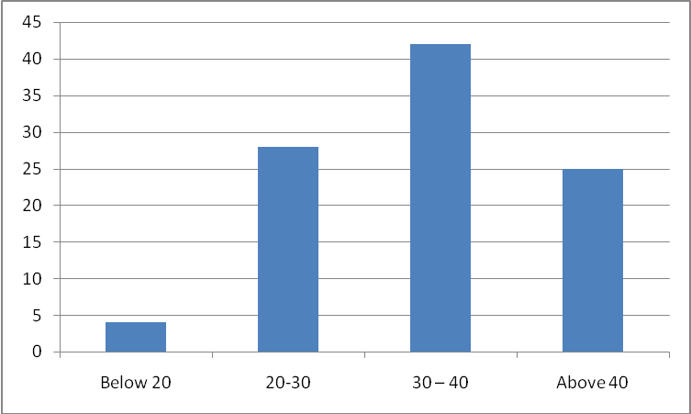
INTERPRETATION
Above table and figure indicates that out of the total no of respondents, the women below the age of 20 years are only 4 percent. 28 percent of the respondents come in the category of age group between 20-30 years. 42 percent of respondents were in above 40 years. It shows that majority of the women members belongs to age grup 30-40 years (42%).
TABLE 4.2
MARITAL STATUS OF KUDUMBASHREE MEMBERS
Marital status | No of members | Percentage
Married | 33 | 66
Unmarried | 11 | 22
Separated | 0 | 0
Widow | 6 | 12
Total | 50 | 100
(Source of primary data)
FIGURE 4.2
MARITAL STATUS OF KUDUMBASHREE MEMBERS
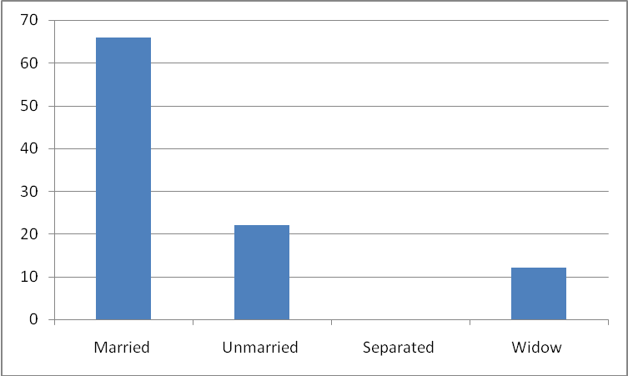
INTERPRETATION
From table 4.2 and from its corresponding groups, it is clear that 66 percent at the kudumbashree has members of Dharmadam Panchayath are married. The percentage of unmarried women is 22 percent, and that of separated women is nill and widow is 12 percentage.
TABLE 4.3
EDUCATIONAL QUALIFICATION OF KUDUMBASHREE MEMBERS
Opinion | No of members | Percentage
Illiterate | 0 | 0
Primary level | 14 | 28
Upper primary | 19 | 38
High school | 17 | 34
Total | 50 | 100
(Source of primary data)
FIGURE 4.3
EDUCATIONAL QUALIFICATION OF KUDUMBASHREE MEMBERS
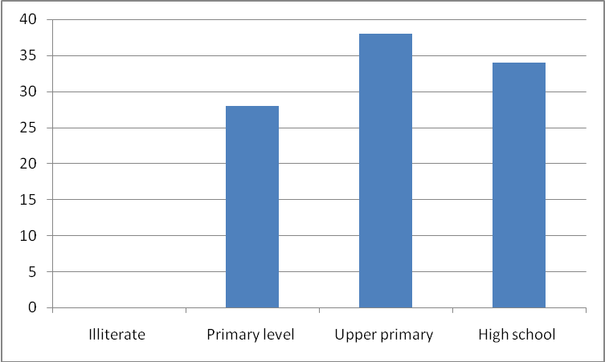
INTERPRETATION
From the table 4.3 and from its figure it seems that out of 50 respondents no one is illiterate. The no of members with primary level education was 14 (28%) upper primary education is 19 (38%). 17 members had completed the high school education which is 34% of the total.
TABLE 4.4
PURPOSE OF LOAN BORROWED BY KUDUMBASHREE
Opinion | No of members | Percentage
Purchse of mil animals | 4 | 8
B^{s} | 1 | 2
Marriage | 12 | 24
Hosing | 8 | 16
Total | 50 | 100
(Source of primary data)
FIGURE 4.4
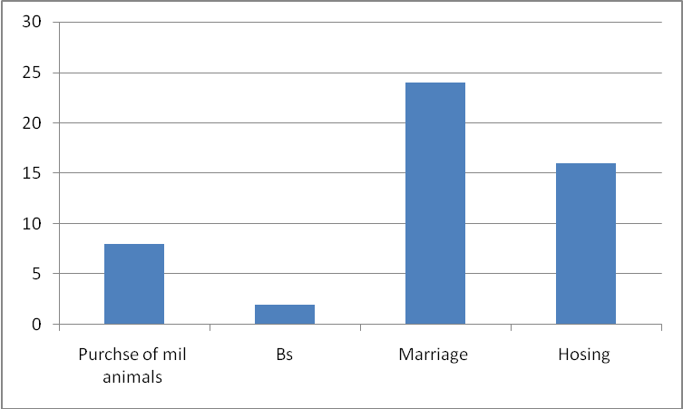

INTERPRETATION
From the above table and charts it is clear that kudumbashree members takes loan mainly for the purpose of wither for marriage, housing or for B^{s} purpose, 16% for housing purposes and 24% for marriage purposes any 8% members are avail loans from purchasing milk animals.

TABLE 4.5
INCOME GERATING ACTIVITIES OF KUDUMBASHREE MEMBERS
Activity | No of members | Percentage
caw rearing | 12 | 24
Hotel | 10 | 20
Cottage industry | 7 | 14
Tailoring | 21 | 42
Total | 50 | 100
(Source: primary data)
FIGURE 4.5
INCOME GERATING ACTIVITIES OF KUDUMBASHREE MEMBERS
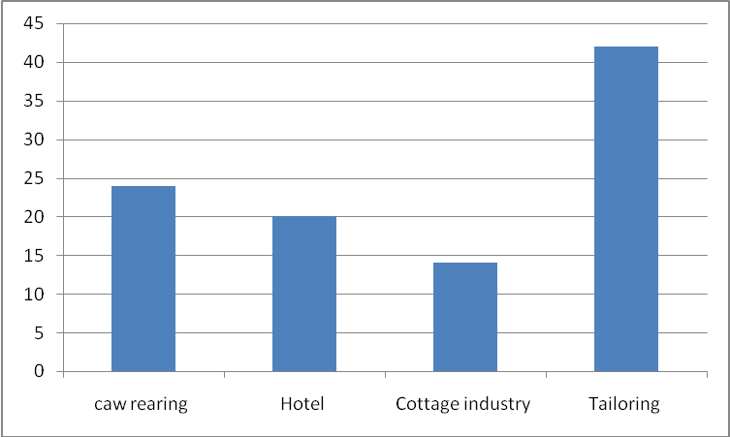
INTERPRETATION
Table 4.5 that income generation activities such as 12 members are working in a caw rearing activity (24%). 10 members are (20%) hotel working activity. Cottage industry activities are carried by 7 members (14%) and training activities by 21 members (42%) and overall total respondents out of 50 respondents. Majority of members are interest in caw rearing and tailoring activity. The women members are interest in tailoring (42%).
TABLE 4.6
MONTHLY INCOME FROM KUDUMBASHREE ACTIVITY
Income | No of members | Percentage
Below RS 800 | 13 | 26
800-110 | 18 | 36
110-1400 | 9 | 18
Above 1400 | 10 | 20
Total | 50 | 100
(Source of primary data)
FIGURE 4.6
MONTHLY INCOME FROM KUDUMBASHREE ACTIVITY
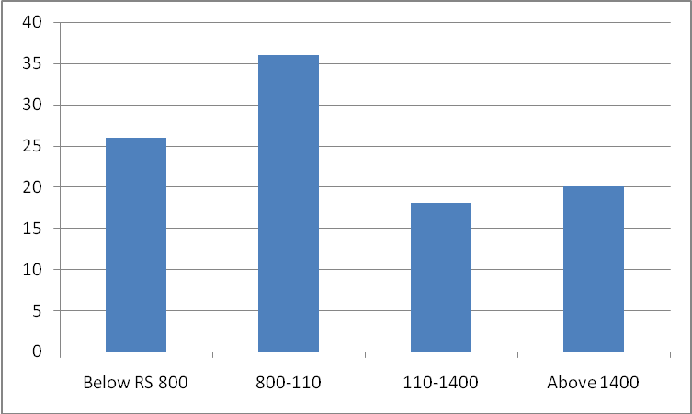
INTERPRETATION
Table 4.6 and its corresponding figure shows that out of the total 50 members selected, the no of members who earns income from kudumbashree activity between RS 800 and Rs 1100 monthly were 18(36%) and those having income in the range between Rs 1100 and Rs 1400 were 9 (18%) 10 members earns above Rs. 1400 monthly which is 20% of the total.
TABLE 4.7
AVERAGE MONTHLY INCOME BEFORE JOINING KUDUMBASHREE
Income | No of members | Percentage
Below Rs 1000 | 10 | 20
Rs 1000 – 1500 | 23 | 46
Rs 1500 – 2000 | 13 | 26
Above Rs 2000 | 4 | 8
Total | 50 | 100
(Source of primary data)
FIGURE 4.7
AVERAGE MONTHLY INCOME BEFORE JOINING KUDUMBASHREE
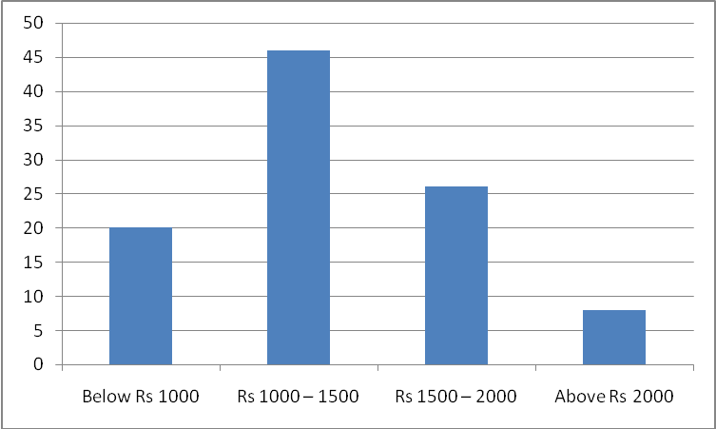
INTERPRETATION
Table 4.7shows that before joining the Kudumbashree unit 1, 23 members (46%) out of 50 members had their monthly income between Rs 1000 and Rs 1500. The no of members earning below Rs 1000 monthly is 10 which constitute 20% of total. 13 kudumbashree members (26%) earns between Rs1500 and Rs 2000. Monthly and 4 members (8%) comes in the category of earnings above Rs 2000.
TABLE 4.8
AVERAGE MONTHLY INCOME AFTER JOINING KUDUMBASHREE
Monthly income | No of members | Percentage
Below Rs 1000 | 24 | 48
Rs 1000 – 1500 | 18 | 36
Rs 1500 – 2000 | 5 | 10
Above Rs 2000 | 3 | 6
Total | 50 | 100
(Source of primary data)
FIGURE 4.8
AVERAGE MONTHLY INCOME AFTER JOINING KUDUMBASHREE
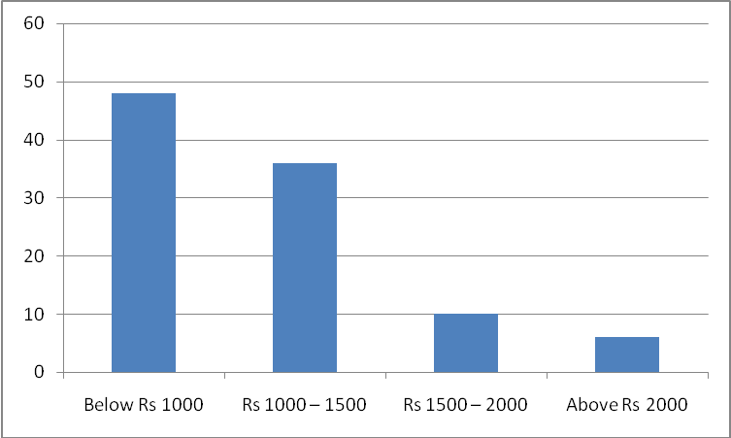
INTERPRETATION
From the table 4.8 shows that after joining the kudumbashree unit 1, 18 members (36%) out of 50memebrs had their monthly income between Rs 100 and Rs 1500. The no of members earning below Rs 1000 monthly is 24 which constitute 48% of the total. 5 kudumbashree members (10%) earns between Rs 1500 and Rs 2000 monthly and 3 members (6%) comes in the category of earnings above Rs 2000.
TABLE 4.9
ECONOMIC STATUS OF KUDUMBASHREE MEMBERS
Economic Category | No of members | Percentage
APL | 21 | 42
BPL | 29 | 58
Total | 50 | 100
(Source of primary data)
FIGURE 4.9
ECONOMIC STATUS OF KUDUMBASHREE MEMBERS
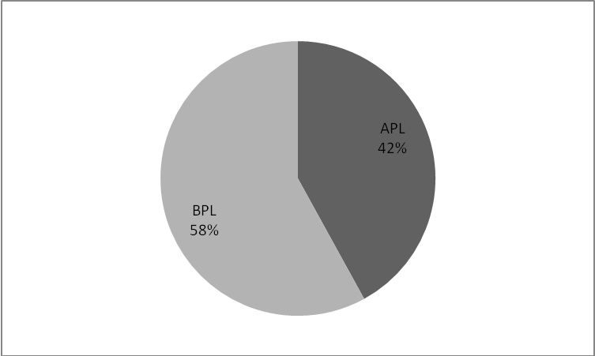

INTERPRETATION
From the above table and graph, it is clear that out of 50 respondents, 29 women members (58%) belongs to BPL category and the no of members include under APL category was 21 (42%). The percentage of BPL members is more than that of the APL members.
TABLE 4.10
MOTIVE BEHIND JOINING KUDUMBASHREE
Motive | No of members | Percentage
Savings | 12 | 24
Self development | 16 | 32
To be active in social group | 15 | 30
Above Rs 2000 | 3 | 6
Total | 50 | 100
(Source of primary data)
FIGURE 4.10
MOTIVE BEHIND JOINING KUDUMBASHREE
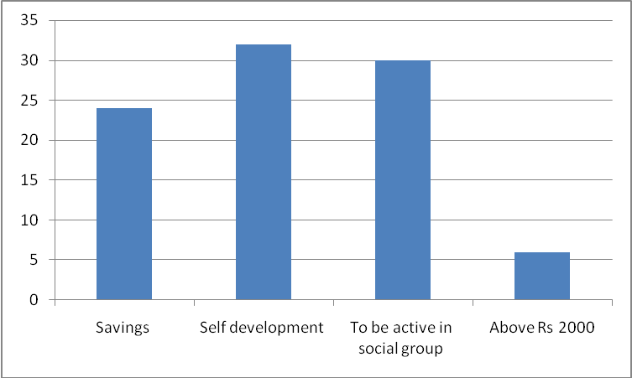
INTERPRETATION
From table 4.2 and from its corresponding graph, it is clear that 24% of the 12 kudumbashree members are savings. The 16 (32%) are motived in self development and 15 (30%) members re to be active in social group and the no of members with others 7(14%).
TABLE 4.11
STATUS OF REPAYMENT OF LOAN BY KUDUMBASHREE MEMBERS
Status of repayment | No of members | Percentage
Fully repaid | 8 | 16
Being repaid | 31 | 62
Not yet repaid | 11 | 22
Total | 50 | 100
(Source of primary data)
FIGURE 4.11
STATUS OF REPAYMENT OF LOAN BY KUDUMBASHREE MEMBERS
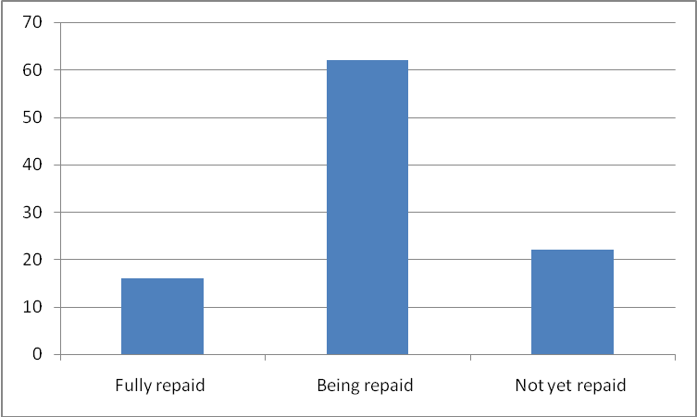

INTERPRETATION
Above table and figure shows that, out of 50 kudubashree members, 8 members (16%) repaid the loan in full, 31 members (62%) are being repaying the loan & the remaining 11 members (22%) are not yet started to repay the loan.
TABLE 4.12
AFFECT OF KUDUMBASHREE MEMBERS INCOME ON FAMILY INCOME
Affect of members | No of members | Percentage
Improved | 23 | 23
Not improved | 27 | 54
Total | 50 | 100
(Source of primary data)
FIGURE 4.12
AFFECT OF KUDUMBASHREE MEMBERS INCOME ON FAMILY INCOME
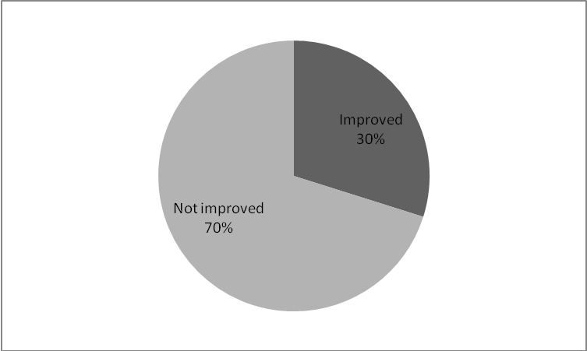
INTERPRETATION
Table 4.12 clearly shows that out of 50 kudumbashree members 23 (46%) are of the opinion that their income from kudumbashree has improved. The family income either marginally or significantly the remaining 27 (54%) members of the respondents are of the pinion that the income has not improved the family income.
TABLE 4.13
INCOME SOURCE FOR THEFT OF KUDUMABSREE MEMBERS
Income source | No of members | Percentage
Own labour | 24 | 48
Husband wage | 18 | 36
Live stock | 5 | 10
Others | 3 | 6
Total | 50 | 100
(Source of primary data)
FIGURE 4.13
INCOME SOURCE FOR THEFT OF KUDUMABSREE MEMBERS
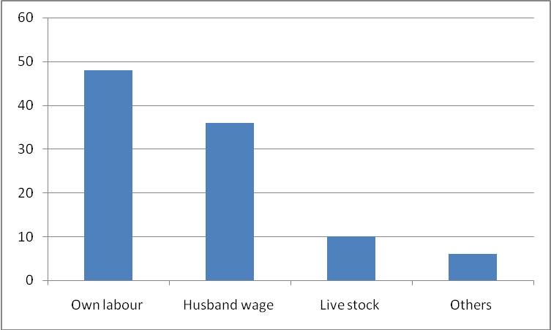
INTERPRETATION
It is clear from the table 4.5 that income from own labour 24(48%) was the major sources towards thrift contribution followed by husband wage 18 (36%) and live stock 5 (10% apart from the above sources donations or relatives is also used for the thrift.
TABLE 4.14
IMPROVEMENT IN CHANGE OF GETTING LOAN AFTER JOINING KUDUMBASHREE
Improvement | No of members | Percentage
Improved | 35 | 70
Not improved | 10 | 20
No opinion | 5 | 10
Total | 50 | 100
(Source of primary data)
FIGURE 4.14
IMPROVEMENT IN CHANGE OF GETTING LOAN AFTER JOINING KUDUMBASHREE
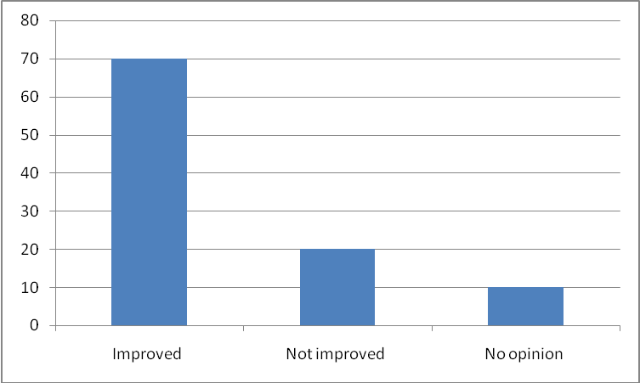
INTERPRETATION
Analyzing the table 4.14 it is found that 35 members (70%) are of the opinion that the joining of kudumbashree has improved their chance of getting loans. 10 (20%) members are of the view that the joining has not improved any such chance. 5 members constituting 10% has no opinion regarding the same.
TABLE 4.15
WHAT IS YOUR OPINION ABOUT INCOME GENERATING ACTIVITIES
Opinion | No of members | Percentage
Good | 22 | 44
Excellent | 15 | 30
Satisfactory | 7 | 14
No opinion | 6 | 12
Total | 50 | 100
(Source of primary data)
FIGURE 4.15
WHAT IS YOUR OPINION ABOUT INCOME GENERATING ACTIVITIES
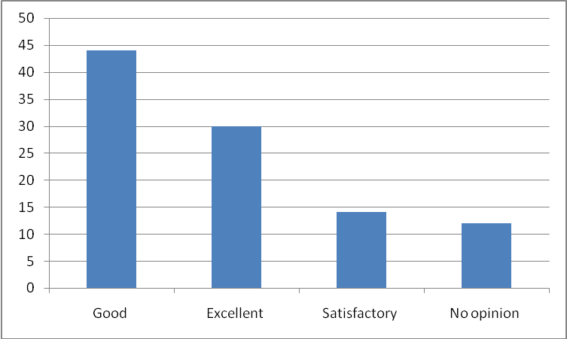
INTERPRETATION
From the above table and chart is clear that kudumbashree members opinions. The 22 (44%) members opnion was Good and other 15 (30%) members opnion was excellent. 7 (14%) members were as satisfactory and other 6 (12%) women mmebrs are in a no opinion about income generating activities of kudumbashree.
CHAPTER V
FINDINGS, SUGGESTIONS & CONCLUSION
5.1 FINDINGS
- Majority of the kudumbasree members 21(12%) are from the age group between 30-40 years.
- Regarding the marital status of the Kudumbasree members, 33(66%) women are married. Un married women constitute 11(22%) of the total and widow members constitute 6(12%).
- Considering the educational qualification of the kudumbasree members, no one is illiterate. All the members have basic formal education.
- Regarding the economic status of the kudumbasree members is majority 29( 58%) are from BPL families.
- The main sources of income for thrift for kudumbasree members is from their own labour followed by husband wages as sources of income for thrift.
- Kudumbasree members take loan mainly for the purpose of marriage and housing or B s.Members take loan not for their own purposes but for the whole family.
- Cow rearing, hotel, cottage industry, tailoring are the main income generation activities of the kudumbasree members.
- Even through the monthly income generated by kudumbasree is low, the monthly income of kudumbasree member primarily range between Rs 800-1100. Through the income generation activities either jointly or individually, with the aid of kudumbasree, members are earning a regular income.
- Before joining Kudumbasree, the average monthly income of kudumbasree members primarily range between Rs 1000 & Rs 1500.
- After joining kudumbasree members got financial and other assistances which in turn help them in widening the income generating activities and thus increasing the income.
- Members income from kudumbasree activities or from their own activities has greatly improved the family income.
- The members are of the opinion that their chance of getting either the bank loan or the kudumbasree loan has been increased.
- Loans are given to members by changing an interest rate not exceeding 12%.
- Pooled savings at the members was used for giving loans to members on priority basis.
- Members are keeping aside a pts amount of income as savings.
- The decision regarding the spending of kudumbasree members income is decided by members them selves in consultation with other family members.

5.2 SUGGESTIONS
- There should be a close monitoring and follow up on the income generation activities of kudumbasree.
- To improve the participation of women whose age between 20-40 , it can introduce new innovative schemes. Because now majority of members are from the age group at 30-40.
- The activities of ADS and should be improved to identify the weaker sections in women.
- The awareness class, camps and financial assistance should give to eligible women.
- Authorities should conduct awareness classes to women those who don’t know about their empowerment.
- There should be an appropriate strategy for promoting women entrepreneurship.
- Govt. should introduce pension scheme for kudumbasree workers.
- Proper method should be taken to make sure that financial assistance provided is properly utilized.
- The CDS should at least visit each NHG once in a month / to evaluate the activities of each group and also to identify needs of each members.
- Motivate members to take up new ventures and activities

5.3 CONCLUSIONS
“ Kudumbasree “, the state poverty eradication mission initiated by the govt at Kerala, India can be seen as a strong “ women population in Kerala is more than men. It women actively participate in various programmes, it will result in over all development and thus development of the family. Kudumbasree identifies the poor and provides micro credit programmes.
Kudumbasree is supposed to enables the rural women who are below the poverty line to be self sufficient and self reliant in social, economic and political spheres. There is increasing recognition that economically empowering women is essential both to realize women’s rights and to achieve broaden development goals such as economic growth , poverty reduction, health, education and welfare. Economically empowering women is a win –win that can benefit both only women, but society more broadly. It promotes women’s ability to achieve their rights and well being while also reducing house hold poverty, increasing economic growth and productivity and increasing efficiency.

BIBLIOGRAPHY
Books
- C.R Kothari, “ Research methodology- method & techniques” (2009), new age international (p) publisher, New Delhi
- Sudhansu Kumar Das, “ micro finance & india’s Rural Economy” (2010), New Century publishers.
- Muhammed Yunus, “ Bankers to the poor” (2003), public affairs publishers.
Journals & magazines
- Devaria TS, “ Micro finance in Indis- a tool for poverty reduction” may 2010
- Kudumbasree annual administration report 2013-2014
- Author Muncipality Development report 2014.
- Mathew P, “poverty education & human resources development august 2010
- Kenneth Kalyani & Seena PC “socio economic changes of women through kudumbasree,” oct 2012
- Sid Net research Briefing NO. 3, “ poverty alleviation: & participating citizenship for women in Kerala, India,” March 2011
URLS
http://www.kudumbasree.Org
http://www.Kerala.gov.in
http://www.wikipedia.org
http://www.google.com
http://www.cdit.org

APPENDIX
QUESTIONNAIRE
Topic : the role of kudumbasree in economic empowerment of when with special reference to Andoor Muncipality
- Basic details:
Name
Address
- Age

  - Below 20
  - b. 20-30
  - 30-40
  - above 40

- Marital status

  - Married
  - Unmarried
  - Separated
  - Widow

- What is your opinion about income generating activities of kudumbasree?

  - Good
  - Excellent
  - Satisfactory
  - No opinion

- How much is your monthly income after joining kudumbasree?

  - Below Rs 1000
  - Rs 1000-1500
  - RS. 1500-2000
  - Above Rs 2000

- Educational qualifications?

  - Illiterate
  - Primary level
  - Upper primary
  - High school

- Name of Kudumbasree you belong to :
- Ward no :
- No of member :
- No of BPL members in kudumbasree :

- How often you are a members of the kudumbasree?

  - One year
  - Two year
  - Three year
  - More than four year

- Have you take loan from kudumbasree?

  - Yes
  - No

- Motive behind to joining kudumbasree?

  - Savings
  - Self employment
  - To be active in social group
  - Others

- Purpose of loan borrowed?

  - Purchase of milk animals
  - Marriage
  - B⁵
  - housing

- income generating activities of kudumbasree?

  - Caw rearing
  - Hotel
  - Cottage industry
  - Tailoring

- No of people engaged in the income generating activities?

  - ne
  - Two
  - Five
  - More than five

- Have you got any training?

  - Yes
  - No

- Total cost of project
- Loan amt, if any
- Amt of subsidy or grant
- What is your monthly income from kudumbasree activity?

  - Below RS 800
  - 800-1100
  - Rs 1100-1400
  - Above 1400

- How much was your monthly income before joining kudumbasree?

  - Below RS 1000
  - Rs 1000-1500
  - Rs 1500-2000
  - Above Rs 2000

- Economic status of kudumbasree member?

  - APL
  - BPL

- Affect of kudumbasree members income on family income?

  - Improved
  - Not improved

- Improvement in chance of getting loan after joining kudumbasree?

  - Improved
  - Not improved
  - No opinion

- Status of repayment of loan by kudumbasree members?

  - Fully repaid
  - Being repaid
  - Not yet repaid

- Income source far thrift of kudumbasree members?

  - Own labour
  - Husbands wage
  - Live stock
  - Others

