CHAPTER I
EXECUTIVE SUMMARY
1.1 INTRODUCTION
Public Distribution System (PDS) is a social safety net ensuring the provision of essential commodities to the targeted population at subsidized prices. The PDS at its very inception as an important welfare policy of the government was meant for managing food scarcity and ensuring the affordability of the food grains. The primary objectives of PDS from its origin have been to ensure price stability, food security, rationing in times of scarcity and keep a check on the private trade. PDS policies have been dealt within the successive five-year plans in India. The Twelfth Five Year Plan (2012-17) emphasized expansion of Aadhaar numbers and opening of the bank accounts which allow the possibility of transferring benefits directly to the beneficiaries.
Indian food security system, established by the Government of India under Ministry of Consumer Affairs, Food and Public Distribution is to distribute subsidized food and non-food items to India’s poor. The items under the Public Distribution System include flour, rice, kerosene, sugar and other necessities of life at reasonable and fixed prices. The Government distributes these items through network of ration shops (fair price shops). There is different distribution mechanisms used under the scheme. These are based on the categorization of people below and above property line. To enable this facility, ration card is provided to the beneficiaries. By holding this ration card, the beneficiaries will be available with their monthly gains from the ration shops and this was a traditionalsystem.
These ration shops are likely to become a permanent feature of our social life. They are the best and the most successful means to curb unsocial elements and to keep the price within reasonable limits. These shops are gone a long way to stabilise price of articles of daily consumption. However, Public Distribution System has been criticized for its urban bias and failure to save the poorer sections of the population effectively. The targeted Public Distribution System is costly and gives rise to much corruption in the process of extricating the poor from those who are less needy. The ration shop dealers resort to malpractices. They divert the grains of the open market to get better margin. Some dealers sell poor quality grains to ration shops. Still others open their shops irregularly, and some dealers weigh less and cheat illiterate customers.
Kerala State has the privilege of having the best system of Public Distribution in the whole country. The system is evenly spread over the whole state without any distinction between urban or rural to ensure equitable distribution of the food grains at a fairly low cost to all people especially to the weaker sections of the population. There isaverygoodnetworkofwholesaleand retail outlets for the distribution of rationed articles under the Public Distribution System.
In order to make the Rationing system high tech the government implemented e-PoS machine in Ration Shops in Kerala. With this, the public distribution mechanism in the state will move into the Aadhaar-enabled PDS (AePDS) mode. As part of enforcing the National Food Security Act (NFSA), the e-PoS machines are expected to bring in transparency in the distribution of the food grain quota and check the corruption that has been rampant in PDS. Under the new system, ration goods will be distributed to beneficiaries after validation of biometric identification.
From April 10 onwards, ration will be supplied using this system. With this, people cannot buy ration using other’s ration cards. Presently, the details of the remaining stock in the shops is being linked to the new system.
As per the new scheme, the card holder will be correctly identified and the allotted quantity of supply will be distributed. The consumers will be recognized by cross checking their fingerprint in Aadhar using the biometric system in the machine. The name and details of all the members will be displayed on the screen, when the card number is entered. As the finger is touched on the machine, the ration supply allotted for each card and it price also will be displayed and the bill be printed.
The authorities expect the ration system will become transparent with the implementation of the new system. 21 ration shops in the district distribute ration using E – pos machines since March and it was found to be completely successfully.
The machine was designed by Vision Tech in Andra. Its battery is durable for 10 hours, so that the power shortage will not affect the functioning of the machine. Since it works on all SIM cards, network range also does not affect it. Experts have been appointed to resolve the technical errors. The biggest advantage of Supply co Chain Management System is that all the information will be known right from the products taken from the godown. The remaining stock detail will alos be available accurately if the excess stock can be added to the share of APL and state subsidy categories. The machines has facility or connect with Adhar, so that those who do not have Aaadhar can by products with the OTP sent to their registered phone number. The consumers who cannot come in person to buy the ration due to physical incapable may get their support at home in future.

CHAPTER II
PROBLEM STATEMENT
SIGNIFICANCE OF THE STUDY
This project work attempts to draw light on the impact of e-PoS machines introduced in ration shops of Kumbla village from the view point of beneficiaries and the objectives of the paper is to analyse the level of satisfaction of the beneficiaries regarding the performance of ration shops and to highlight the major obstacles associated with the performance of ration shops after introduction of e-PoS machines. It also analyse the awareness of people about e-PoS system.
STATEMENT OF THE PROBLEM
Purchase in ration shops are mainly made by the common people, due to the fact that they do not earn much income to buy costly items. They also get food items like rice, wheat etc and non-food item like kerosene with minimum cost. They feel relieved by this fact. Traditional system was replaced by e-PoS system for the efficient purchase in ration shops. Main reason for this is to eliminate malpractices that are made in ration shops. It was introduced recently. So it is very essential to study the impact of e-PoS system.
SCOPE OF THE STUDY
The study area is limited to Kumbla village. The study covers a survey among the ration beneficiaries within the Kumbla village 50 respondents were selected for the study. Questionnaire was used for the data collection.
OBJECTIVES OF THE STUDY
- To analyse the awareness of e-PoS system amongrespondents
- To examine the satisfaction level of the respondents regarding the rationing system after the implementation of e-PoSsystem
- To examine the major problems associated with the implementation of e-PoS system
RESERCH METHODOLOGY
Research methodology is a method that can be used to solve the research problems. It helps in studying how research is done scientifically. Research methodology provides various steps that can be adopted by the researcher in studying his research problems.
Sources of Data
The study uses both primary data and secondary data.
Primary Data
For the purpose of collection of data, interview schedule has been prepared and data was collected from the consumers who have purchased products through online. Adequate care has been exercised to collect unbiased data from the respondents.
Secondary Data
Secondary data for the study was collected from websites, journals, magazines and newspapers.
Population Size
RATION SHOPS IN PAPPINISSERY GRAMA PANCHAYATH | TOTAL NUMBER OF RATION CARD HOLDERS
Mangadavu | 814
Aroli | 1100
Keecheri | 1300
Velapuram | 813
Pappinisserychungam | 926
Pappinissery gate, Near Railway station | 759
Pappinissery gate, Nr. Railway Station | 833
karikkankulam | 921
Puthiyakavu | 1030
Total | 8496

From the above population 20 samples selected from Pappinisseri and 10 samples from each of the other ration shops in Kumbla village.
Sampling
Sampling zsize
The sample size was limited to 100 ration beneficiaries from Kumbla village.
Sampling technique
The sampling technique followed for the study is convenience sampling.
Tools for Data collection
a structure of interview schedule consisting of 20 questions covering personal and opinion factors was prepared. The respondents were asked to fill-up the questionnaire and their opinions were consolidated
Tools for Analysis
• Tables were used for presenting thedata
• To analyse and interpret the collected data, percentage analysis and bar diagram were applied whereverrequired

LIMITATIONS OF THE STUDY:

- Availability of time and resources are important limiting factor for the study
- Reliability of the study depends on the reliability of the information given by the respondents
- Inherent limitations of sampling technique have affected the study to a certainextent.
REVIEW OF LITERATURE
Agro-Economic Research Centre (AERC-I3 (1957) Madras, has examined the impact of Government's food control measures on the agrarian economy of the erstwhile-Madras Presidency for the period 1938 to 1954. In general, it perceived the food control measures as "necessary evils" and the rationing of food as a positive service, especially when food availability remained very low and food prices rules very high.
Agro-Economic Research Centre, (1965) Madras, has examined the actual working of the Fair Price Shops in the Southern Region, covering thethree States of Tamil Nadu, Kerala and Andhra Pradesh. The study could not identify the really poor among the consumer households since income statements were not available. It was found that the open market prices could not be brought down by Fair Price Shops operations as at the Fair Price Shops supplies of food grains were only limited.
Uma and Leles(1973) in the study pointed out the significance of the relationship between the private trading activities and the Government's food policies. It confirmed that the grain trade in India operated efficiently within the technological and policy confines. It concluded that if Government's policies could be made to facilitate investment in the new storage and transport sectors and could be made to encourage technological improvement, the traditional market structure will be able to function economically and still more efficiently. This study did not examine the question of how to solve the food problem of the weaker sections under the free market system, given the real problem of extreme economic inequality in the society.
Ramamurthy (1974) in his study, he examined the levels of poverty and destitution in Tamil Nadu vis-a-visthe trends in the production and distribution of wage goods (cereals, pulses, sugar, tea and cotton) for the period 1960-61 to 1970-71. Ramamurthy emphasized the significant role that the Public Distribution System could play in the eradication of poverty and destitution in Tamil Nadu after establishing that the Public Distribution System is superior to all other anti-poverty measures.
Rajapurohit (1978) in his study, he stated the segments of the population who consumed less than the state average quantity of cereals were treated as the target group. The study suggested the exchange of superior cereals like Rice and Wheat with coarse cereals like Jowar, RagiandBajra through open market operation and distribution of coarse grains through the Public Distribution System.
AmartyaSens (1982) in his study, he concentrated on the three serious conflicts encountered (or battles persistently waged) by the Economically Vulnerable Sections even during the non-famine situations. Sen remarked thus "India's so-called self-sufficiency in food goes hand in hand with a quarter- perhaps a third of the rural population as persistent losers in food battles, suffering from regular hunger and systematic malnourishment.
Indian Institute of Public Administration (1987) in its study presented a "Status Report" on the Public Distribution System in India, covering the period upto 1986-87. The papers of BhabatoshDatta, Kamal NayanKabraand Anil ChandyIttyerah and of Barbara Hams discussed the problems and issues of the Public Distribution System and offered certain alternative strategies to be adopted for achieving the maximum effectiveness of the Public Distribution System.
Ittyerah and Kabra(1990) in their study, they analyzed the utilization of and access to the Public Distribution System in India. They found the utilization index for rice was very low and that for sugar was very high. According to them about 80 per cent of the sample households were generally satisfied with the Public Distribution System while 20 per cent were not.
Singh (1991) in his study, he analyzed the Public Distribution System in Bihar. He stated a number of serious deficiencies in the system. He prescribed a package of 27 measures to improve the working of the system. He emphasized the important contribution of the Public Distribution System towards poverty alleviation in rural areas.
Government of India (1992 1993) indicated that, the several weaknesses emerged in the public distribution system which diluted the essence of the system to benefit the vulnerable section. The financial liabilities of the state government in maintaining this system have increased. Leakage and black marketing in PDS items have also increased the full impact of PDSin containing inflation. Government of India (1992 1993) reported that the PDS as a social safety net has to be understood in the sense of this limited perspective. The perspective as announced by the government of India is that essential commodities such as rice, wheat, imported edible oils, sugar and kerosene are distributed at prices below the market prices through a network of fair price shops. The government accepts this as an essential element of governments’ safety net for the poor.
Geetha, and Suryanarayan, (1993) in their study, they have reviewed the objectives of food policy pursued in different, five year plans. They examined interstate PDS disparities, and their implications for the current ongoing PDS reform. Their study confirms the general impression that there have been significant disparities in the state wise PDS quantities, be it with respect to total population or population covered by the PDS. This is largely in conformity with the objects of global coverage as enunciated in the sixth plan. Part of the reason seems to be the lack of proper infrastructure for the PDS in some states and hence their inability to lift their allotted quota, by the Centre. Thus PDS revamping is not merely a question of targeting but also involves the creation of the necessary infrastructure.
Government of India in the tenth plan (1995) the document admits that there is overflowing stock of food grains in the country. This means that the distribution of food grains is not managed properly and the areas of food shortage are still unable to receive support from the Government overflowing stocks.
Rao (1995) says "the persistent weaknesses observed in FCI operations are a clear symptom of over centralization. While efforts to tone up the personnel and working of the corporation need to be undertaken, the more fundamental task is to reorganize the food security system itself on a decentralized basis. In the event of such reorganization, FCI with its specialized experience and expertise would be in a position to play a major supporting role to help the decentralized food security system to become operational.
Indrakanth (2000) using data collected in 1994-95 in five villages in Andhra Pradesh with diverse socio economic characteristics, shows that in several cases households that were to a ration card did not have one. Instead, contrary to what seems to happen in other Indian states, in the selected villages complains about low quality of PDS supplies were not frequent.
ReetikaKhera [2001]in her work entitled “India’s public Distribution system: utilization and Impact”, studied the effectiveness of India’s public distribution system (PDS) as a food security intervention, using field survey data collected by the author in Rajasthan, utilization is low, and many households purchase wheat from the market at higher prices before exhausting PDS quotas.
Ranjana Singh (2010) in his paper on “Impact of the Public Distribution System on Poverty and Food Security” opined that there is need to shift from the exiting expensive inefficient and corruption ridden institutional arrangements to those that will ensure cheap delivery of requisite quality grains in a transparent manner and are self-targeting.
Chandra Kant Singh and Rakesh Kumar Singh (2010) in the study of “Role of Public Distribution System in Food Security” observed that there is need to amend law to ban controls and restrictions on trade between states. There should be free movement of all kinds of commodities including agricultural produce.
RatanLalBasu (2011) in the study of “Public Distribution System in India and Food Security” observed that the basic causes of food security in India lie not in supply failure but in declining income and employment intheunorganized sector and failure of the TPDS that excludes a large segment of the poor because of definitions and methods of implementation. So far as policy of introducing the TPDS is concerned, it may be said that the policy as such is not unsound but the real problem lies in the way it is implemented.
Anju Singh, Kalanand Singh and AshaDubey (2011) in their study on “Management of Public Distribution System in India – An Arrangement for Food Security” observed that 70 Per cent of people living in village’s and40 Per cent of landless labourers, beside this 20 crores of the poor people are rural agricultural labourers. Food problems can be solved by the integration of the PDS with other anti-poverty programme like Antyodaya and other programmes. The public distribution system is a vital programme to ensure distributive justice to the weaker sections of the community. Lastly, it maybe quote the line of Mother Theresa, “if we have no peace, it is because we have forgotten that we belong to eachother”.

CHAPTER III
THE STUDY

PUBLIC DISTRIBUTION SYSTEM IN KERALA
Public distribution system is primarily a social welfare and antipoverty programme of the government of India. Essential commodities like rice, wheat, sugar, Kerosene are supplied to the people under the public distribution system at subsidized prices. It has been one of the most important elements in India’s safety net systems for almost 50 years. Public distribution system provides rationed amounts of basic food items and other non-food products at below market prices to consumers through a network of fair price shops disseminated in the country. With a network of more than 400,000 fair price shops (FPS) under the PDS in India is perhaps the largest distribution machinery of the world. The PDS distribute the commodities with more than Rs. 15,000 crores to about 16 crores families each year. The success of this huge network is dependent on its ability to translate a macro level self-sufficiency to a micro level by ensuring availability of food grains for poor households. The public distribution system is considered as the principal instrument in the hands of government for providing a safety net to the poor and the down trodden. The system serves triple objectives namely protecting the poor, enhancing the nutritional status and generating a moderate influence on market price. Thus the main objective of public distribution system can be summarized as maintaining price stability, raising the welfare of the poor, rationing during situations of scarcity of keeping a check on private trade.
In 1991, around 95 percent of all households were covered by the public distribution system and possessed a ration card. Though the number of ration cards issued alone does not necessarily translate to mean that all these cardholders are using the ration cards. This is the measure used by most studies to calculate the reach and coverage of the public distribution system. At the same time, Kerala’s public distribution system was internationally acclaimed as being a model system worth emulating by the other states in the country. The quantity of food grains purchased from the public distribution system has been higher than in most other states, making a significant contribution to household nutrition. The annual purchase of grain from the public distribution system in Kerala provides about one half of the cereal requirements of a person. The monthly entitlement of food grain per adult was 14.8Kg and satisfying the minimum requirement of 370 Grams of cereals per person per day in Kerala recommended by the Indian 99 Council of Medical Research. The functioning of ration shops and the delivery system has been better than in other parts of the country and this is reflected in consumer surveys. Given the scale and effectiveness of the public distribution system, it has been noted that the public distribution system has contributed to an improvement in consumption and nutrition in Kerala.
REFORMS AND PERFORMANCE OF FAIR PRICE SHOPS IN KERALA
The Fair Price Shop (FPS) or ration shop is an important link that connects the government to the beneficiaries for the distribution of essential commodities through PDS. The previous chapter was about the demand side of PDS, based on the feedback on PDS utilization and preference analysis between PDS and cash transfer scheme from the beneficiary households who are the ration card holders. An efficient working of the PDS needs to have a perfect understanding of beneficiary part and the service delivery mechanism through PDS outlets. As a crucial step for analyzing the functioning and reforms of the fair price shop, a primary survey was conducted among the ration shops in the study area of the household survey in rural, urban and tribal regions of Thiruvananthapuram and Malappuram districts.
e-PoSSYSTEM
Information and communication technologies in public administration and social welfare initiatives are increasingly being used by various countries with intent to augment transparency and provide better services to citizens. However, lack of infrastructure, education, technology literacy, and training keeps a major proportion of target population deprived of the benefits of these initiatives in various developing countries. Hence services of technology intermediaries are utilized to bridge this gap between the benefits of e- government technologies and citizens.
e-Government aims to improve the relationship between people and their government by making public services more effective, accessible, and responsive to people’s needs as well as by increasing the transparency of public institutions. Effective implementation, adoption, utilization, and maintenance of Information and Communication Technologies (ICTs) to provide services to their constituents is a major challenge faced by governments of various nations. This challenge is increased in developing countries due to lack of technology literacy, limited infrastructure, improper training, and social, cultural and gender disparities. This compels the government institutions to utilize the services of technology intermediaries who are often the primary users of ICTs in e-governance. Services of intermediaries are widely used in India to provide a better access of e- governance initiatives to general population. One such program that utilizes the services of technology intermediaries is the public distribution system (PDS), specifically in the state of Kerala,India.
Food insecurity is a serious challenge worldwide. India accounts for one-fourth of the 795 million undernourished in the world and therefore any global impact on world hunger requires progress in food and nutrition security in the country. The Public Distribution System (PDS) is the biggest poverty alleviation program under which the federal and state governments provide food grains and other essential commodities (like sugar, salt, kerosene, etc.) to below poverty line households through the world’s largest food distribution network of fair price shops. However, a major portion of available grain is lost in distribution due to leakages, diversion and black marketing. Distribution of entitlements is the responsibility of state governments who lift the grains from federal warehouses and allocate them to beneficiaries through fair price shops. The government of India aims to computerize the fair price shops for efficient commodity distribution.
The state of has been proactive in implementing various administrative and technological reforms to empower end-beneficiaries of the PDS supply chain, increase transparency, extend coverage of PDS and improve delivery of entitlements. Two major technological advances introduced in Kerala were the overall computerization of PDS supply chain in and implementation Centralized Online Real-time Electronic Public Distribution System(COREPDS).
Prior to the implementation of COREPDS, each beneficiary was linked to one fair price shop and had no option but to buy entitlements from that shop. This created a forced monopoly of fair price owners leading to exploitation of beneficiaries. COREPDS aimed at empowering beneficiaries by providing them the right to choose the fair price shop from which they could purchase their entitlements. Since each fair price shop owner receives commission based on the quantity of commodities sold, therefore the fear of losing beneficiaries forced them to provide better services. In addition to this, all fair price shops were equipped with electronic point of sale (e-PoS) devices for easier commodity tracking, increased transparency, efficient beneficiary identification and real-time transaction recording. Fair price shop salespersons are the primary users of e-PoS devices and therefore, act as intermediaries between government agencies and beneficiaries.
In this system, only authentic person can be recovered ration materials from ration shops based on the amount available in the database. The traditional PDS is used to distribute grocery items to India's poor people who are valid ration card holders. The validity and the allocation of the ration cards are monitored by the state governments. It contains separate record for each family which includes details like number of members in family, names of the members, head of the family, permanent address, present living address, and phone number. The main reason for using this Biometric system and making this process computerized is to remove the drawbacks of the present way of issuing products based on ration card. The main drawback in the current system is that the PDS has been criticised for its urban bias and its failure to serve the poorer sections of the population effectively. The targeted PDS is costly and gives rise to much corruption in the process of extricating the poor from those who are less needy. Also many retail shopkeepers have large number of bogus cards to sell food grains in the open market. Many FPS dealers resort to malpractice since they acquire less salary. Most of the times users do not get their rightful entitlement in terms of quantity what's meant for them or the farm produce procured by the FPS's is diverted to the open market. So in order to avoid all these drawbacks we are going to use the Biometric base Smart ration card which will help us to avoid the corruption in PDS if not eradicateit.
Electronic Point Of Sale (POS) Device:Components
1. Stylus
The Stylus will be used to operate the software on the POS Device, as the POS device has touch screen facility. It is recommended to use the stylus for operating the software as use of stylus will help in minimizing operational software errors and reducing risk of damaging the touch screen of the POS device.
2. Antenna
The antenna provided ensures better signal receptivity to the POS devices.
4. POSCharger
The charger is used to charge the battery regularly.
4. POSBattery
The battery provided enables to run the POS device.
5. Paperroll
A Paper roll is available in the POS device box. This will be used for printing bills, reports etc. at retailer end.

CHAPTER IV
DATA ANALYSIS AND INTERPRETATION
TABLE NO: 4.1
AGE-WISE DISTRIBUTION OF RESPONDENTS

Age | No. of respondents | Percentage
Up to 25 | 36 | 36
26-35 | 8 | 8
36-45 | 12 | 12
Above 45 | 44 | 44
Total | 100 | 100
Source: Primary Data
CHART NO: 4.1
AGE-WISE DISTRIBUTION OF RESPONDENTS

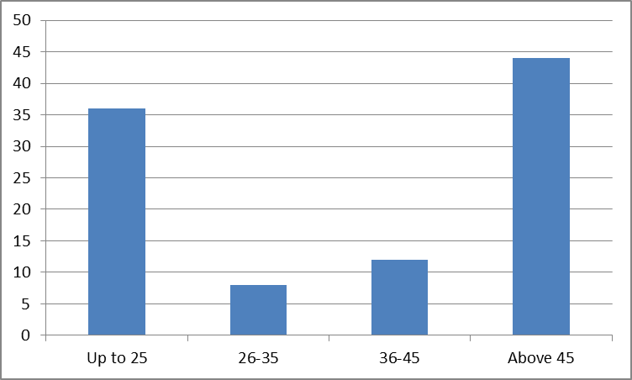

INTERPRETATION

The table showing the distribution of ration beneficiaries according to age shows that majority (44%) belonged to above 45 years age group, followed by (36%) age group up to 25 years. 12% were between 36 – 45 years of age and 8% were between 26 to 35 years.
TABLE NO: 4.2
GENDER-WISE DISTRIBUTION OF RESPONDENTS

Gender | No. of respondents | Percentage
Male | 62 | 62
Female | 38 | 38
Total | 100 | 100
Source: Primary Data

CHART NO: 4.2
GENDER-WISE DISTRIBUTION OF RESPONDENTS

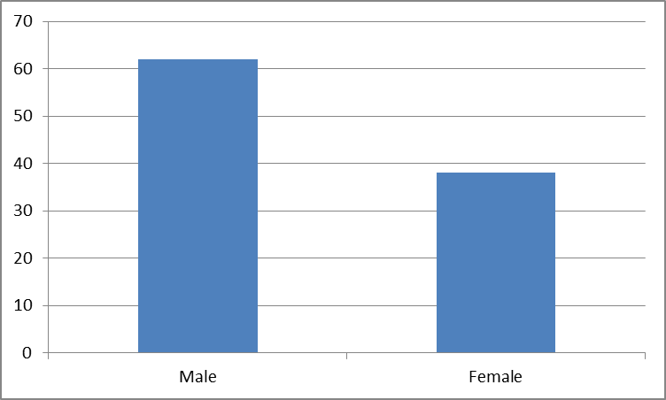

INTERPRETATION

The distribution of ration customers according to gender shows that, 62% were male and 38% were female.
TABLE NO: 4.3
EDUCATIONAL STATUS OF THE RESPONDENTS

Course | No. of respondents | Percentage
Illiterate | 4 | 4
Primary studies | 10 | 10
SSLC | 26 | 26
Graduate | 60 | 60
Total | 100 | 100
Source: Primary Data
CHART NO: 4.3
EDUCATIONAL STATUS OF THE RESPONDENTS
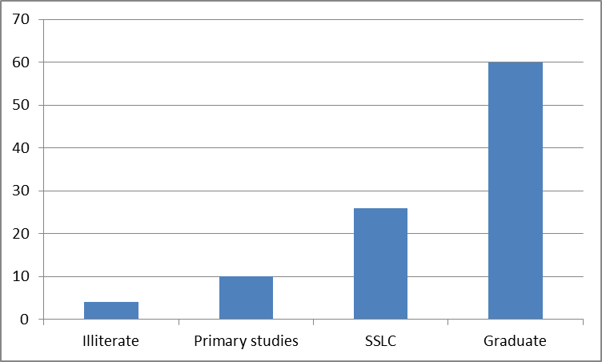

INTERPRETATION
Education wise distribution of respondents reveals that, out of the total ration beneficiaries, majority (60%) were graduates, 26 % of them have passed SSLC and 10% of them have only primary qualifications and the rest 4% were illiterates.
.
TABLE NO: 4.4
STATUS OF THE RESPONDENTS

Status of respondent | No. of respondents | Percentage
Daily wage employee | 40 | 40
Government employee | 6 | 6
Student | 24 | 24
House wife | 20 | 20
Others | 10 | 10
Total | 100 | 100
Source: Primary Data
CHART NO: 4.4
STATUS OF THE RESPONDENTS

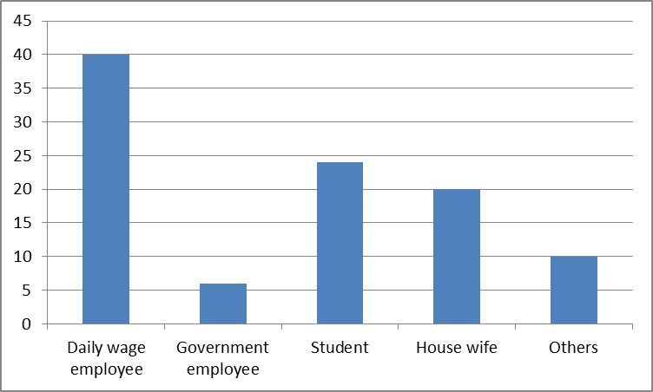
INTERPRETATION
Status wise distribution of respondents reveals that majority (40%) were daily wage employees, 24% are students, 20% were housewives, 10% were others and 6% were Government employees.
TABLE NO: 4.5
MONTHLY FAMILY INCOME OF THE RESPONDENTS

Monthly Income | No. of respondents | Percentage
Below 10000 | 18 | 18
10000-20000 | 36 | 36
20000-30000 | 20 | 20
Above 30000 | 26 | 26
Total | 100 | 100
Source: Primary Data

CHART NO: 4.5
MONTHLY FAMILY INCOME OF THE RESPONDENTS
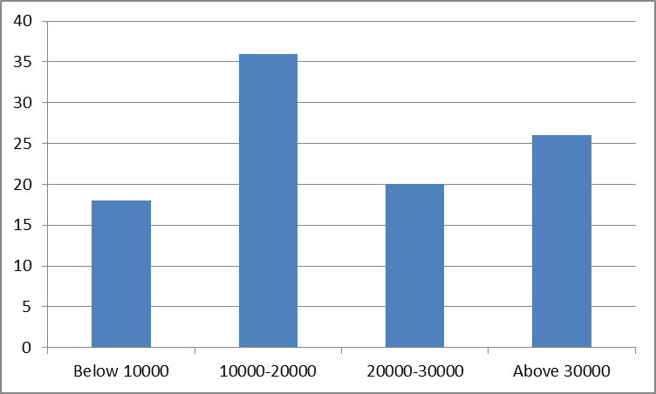
INTERPRETATION
The table showing monthly family income of ration customers indicates that majority (36%) of respondents have income between Rs.10000 to Rs.20000. 26% of the respondents were included in the family income level above Rs.30000. 20% of the respondents lies between the income level of Rs.20000 to Rs.30000. Minority of the respondents (18%) had family income below Rs.10000.
TABLE NO: 4.6
CATEGORY WISE DISTRIBUTION OF RESPONDENTS

Category | No. of respondents | Percentage
APL | 60 | 60
BPL | 40 | 40
Total | 100 | 100
Source: Primary Data
CHART NO: 4.6
CATEGORY WISE DISTRIBUTION OF RESPONDENTS
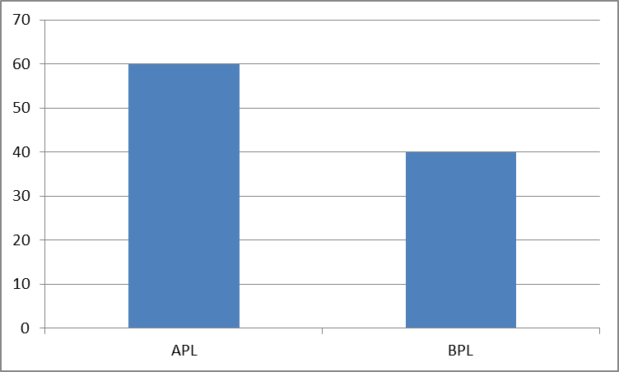
INTERPRETATION
The table showing category of ration customers shows that 60% of them belongs to APL category and 40 % were BPL category.
TABLE NO: 4.7
DISTRIBUTION SHOWING AWARENESS ABOUT E- POS SYSTEM

Option | No. of respondents | Percentage
Yes | 86 | 86
No | 14 | 14
Total | 100 | 100
Source: Primary Data

CHART NO: 4.7
DISTRIBUTION SHOWING AWARENESS ABOUT E- POS SYSTEM
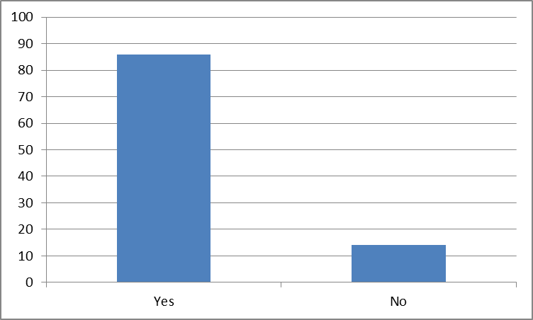
INTERPRETATION
The table about the awareness level of e-PoS system shows that 86% were aware about e-PoS system and 14 % were not.
TABLE NO: 4.8
SOURCE OF INFORMATION ABOUT E-POS SYSTEM

Option | No. of respondents | Percentage
Ration shopkeeper | 56 | 56
Newspaper | 32 | 32
Television | 2 | 2
Internet | 8 | 8
Radio | 0 | 0
Friends | 2 | 2
Total | 100 | 100
Source: Primary Data
CHART NO: 4.8
SOURCE OF INFORMATION ABOUT E-POS SYSTEM
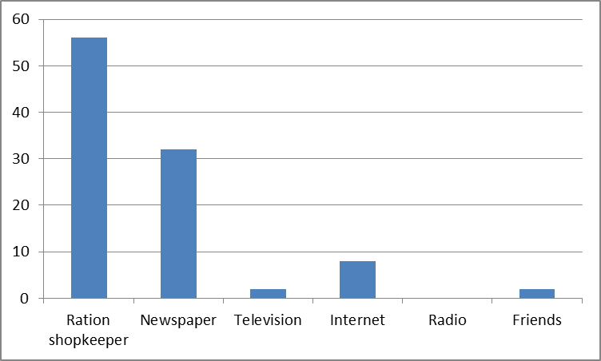
INTERPRETATION
The table showing source of information about e-PoS system shows that 32 % of them had received information from the newspaper. Another 56% of them have had heard about this new system from ration shopkeeper. Internet had helped to make 8% of the respondents to know about the new system. 2% of respondents were received information from television. And another 2 % received information from friends.
TABLE NO: 4.9
KNOWLEDGE ABOUT THE FEATURES OF E-POS SYSTEM
Features | Respondents |  | Percentage
Features | Yes | No | Yes | No
There is information regarding the eligible  items in the website | 34 | 16 | 68 | 32
You can check whether the ration shop is  active or not | 18 | 32 | 36 | 64
If there is a lag in recognizing thumb, OTP  would be an additional option | 15 | 35 | 30 | 70
Manual billing option is available for  bedridden people | 17 | 33 | 34 | 66
You can buy your ration items from any ration  shop within Kerala state | 36 | 14 | 72 | 28
CHART NO: 4.9
KNOWLEDGE ABOUT THE FEATURES OF E-POS SYSTEM
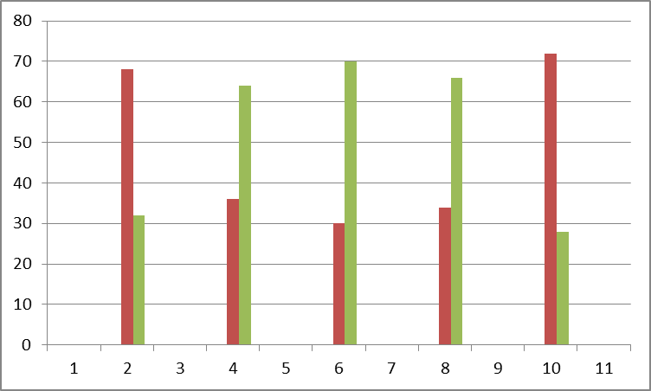
INTERPRETATION
The above table shows the knowledge of the respondents about the features of e- PoS system. It can be interpreted that 68% of the respondents have knew that there is enough information regarding eligible items in the website. Rest of the 32% was not aware about thatfeature.
36% of the respondents know about the feature that there is a facility to check whether the ration shop is active or not. And majority (64%) was unaware about thisfacility.
Majority (70%) of the respondents were unaware that there is an OTP option when there is lag in recognizing the thumb. And 30% were aware of it.
Only 34% of the respondents knew that there is a manual billing option for bedridden people. Rest of the 66% of respondents is unaware ofit.
Majority (72%) of the respondents were aware of the facility to buy their ration items from any ration shops within Kerala after the implementation of e-PoS system. Remaining 28% didn’t know about the new facility.
TABLE NO: 4.10
OPINION ABOUT USER-FRIENDLINESS OF E-POS SYSTEM
Option | No. of respondents | Percentage
Yes | 82 | 82
No | 18 | 18
Total | 100 | 100
Source: Primary Data
CHART NO: 4.10
OPINION ABOUT USER-FRIENDLINESS OF E-POS SYSTEM
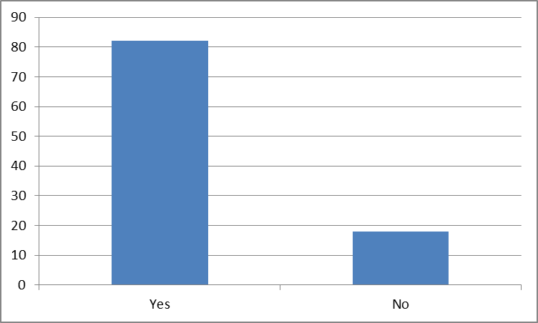
INTERPRETATION
The table showing opinion about the user-friendliness of e-PoS system shows that 82% of respondents find the new system user-friendly while 18% do not.
TABLE NO 4.11
SATISFACTION WITH THE OLD SYSTEM
Option | No. of respondents | Percentage
Highly satisfied | 0 | 0
Satisfied | 12 | 12
Neutral | 20 | 20
Dissatisfied | 40 | 40
Highly Dissatisfied | 28 | 28
Total | 100 | 100
Source: Primary Data
CHART NO: 4.11
SATISFACTION WITH THE OLD SYSTEM
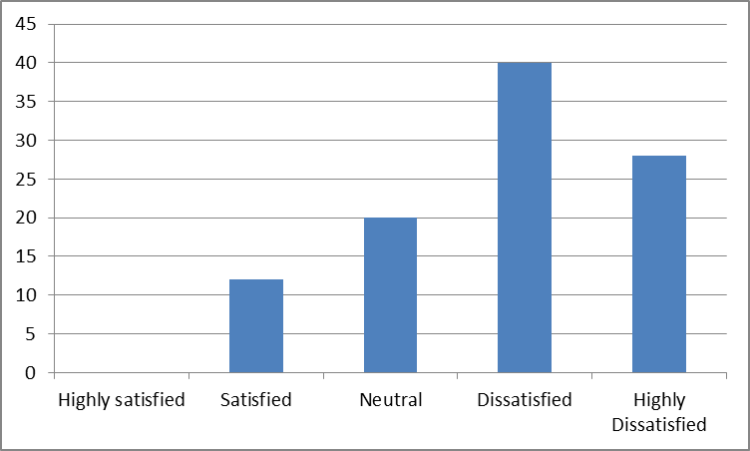
INTERPRETATION
The table shows the satisfaction level with the information received from the old system. Majority (40%) are dissatisfied with the information received from the old system, none of the respondents were highly satisfied, 12% respondents are satisfied, 20% have neutral opinion and the rest of the respondents (28%) are highly dissatisfied with the information received from the oldsystem.
TABLE NO: 4.12
SATISFACTION WITH THE NEW SYSTEM
Option | No. of respondents | Percentage
Highly satisfied | 36 | 36
Satisfied | 50 | 50
Neutral | 14 | 14
Dissatisfied | 0 | 0
Highly dissatisfied | 0 | 0
Total | 100 | 100
Source: Primary Data
CHART NO: 4.12
SATISFACTION WITH THE NEW SYSTEM
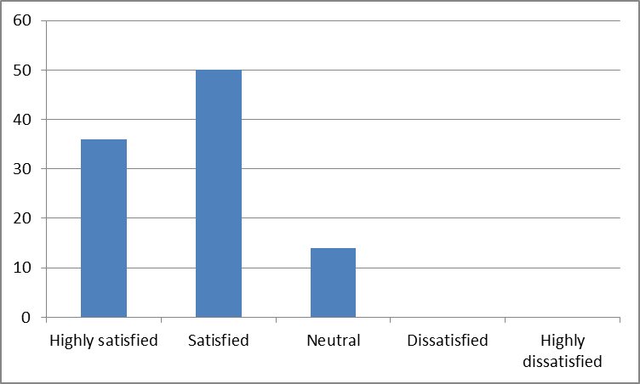
INTERPRETATION
The table shows the satisfaction with the new system. Majority (50%) are satisfied. 14% respondents have neutral opinion and the rest of the respondents (36%) are highly satisfied with the information received from the new system.
TABLE NO: 4.13
OPINION ABOUT RECEIVING OF MORE INFORMATION

Option | No. of respondents | Percentage
Yes | 84 | 84
No | 16 | 16
Total | 100 | 100
Source: Primary Data
CHART NO: 4.13
OPINION ABOUT RECEIVING OF MORE INFORMATION
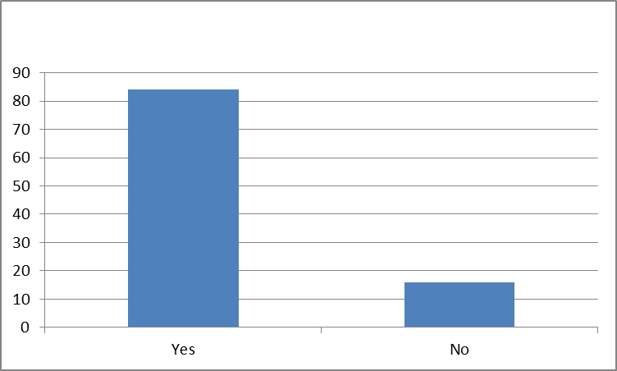
INTERPRETATION
The table shows the opinion about receiving of more information through e-PoS system compared to the earlier system. In this regard, majority (84%) received more information compared to the earlier system. Only 16% believed that they do not get any additional information compared to old system.
TABLE NO: 4.14
OCCURANCE OF HINDRANCE

Option | No. of respondents | Percentage
Often | 12 | 12
Sometimes | 46 | 46
Rarely | 18 | 18
Never | 24 | 24
Total | 100 | 100

Source: Primary Data

CHART NO: 4.14
OCCURANCE OF HINDRANCE

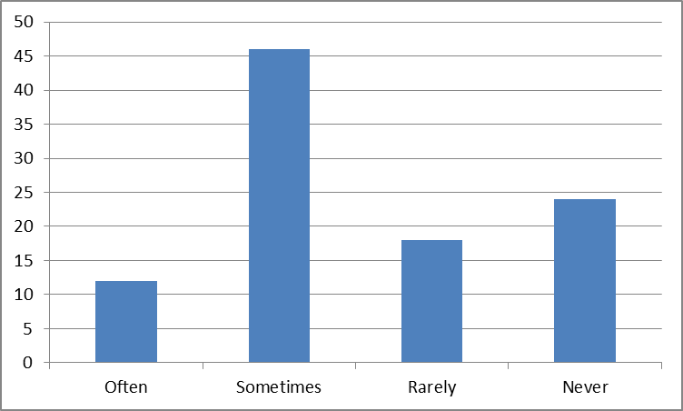
INTERPRETATION
The table shows the occurrence of hindrance due to the e-PoS system adopted in the ration shop. Majority of the respondents (46%) faced hindrance sometimes. 24% of the respondents never faced any hindrance with the new system. 18% faced problems rarely and 12% faces problems often.

TABLE NO: 4.15
FREQUENT PROBLEM FACED THROUGH E-POS SYSTEM

Option | No. of respondents | Percentage
Technical problem | 22 | 22
Fingerprint delay | 46 | 46
Low network coverage | 22 | 22
Inadequate knowledge of  operator | 8 | 8
Nothing faced | 2 | 2
Total | 100 | 100
Source: Primary Data
CHART NO: 4.15
FREQUENT PROBLEM FACED THROUGH E-POS SYSTEM
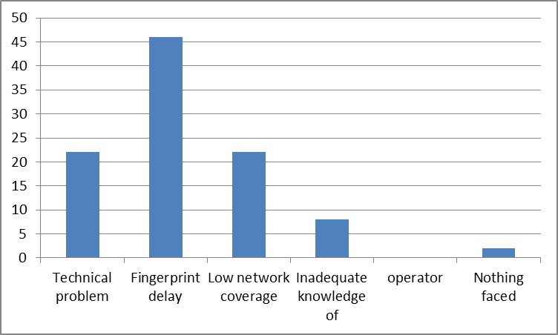
INTERPRETATION
The table shows the frequent problem faced through e-PoS system. Majority of the respondents (46%) faced the problem of finger print delay. 22% of the respondents faced the problem of low network coverage and another 22% faced technical problem. Only 8% of the respondents faced the problem of inadequate knowledge of the operator. Minority of the respondents (2%) did not face any problem.

TABLE NO: 4.16
AWARENESS ABOUT PDS WEBSITE

Option | No. of respondents | Percentage
Yes | 20 | 20
No | 80 | 80
Total | 100 | 100
Source: Primary Data
CHART NO: 4.16
AWARENESS ABOUT PDS WEBSITE
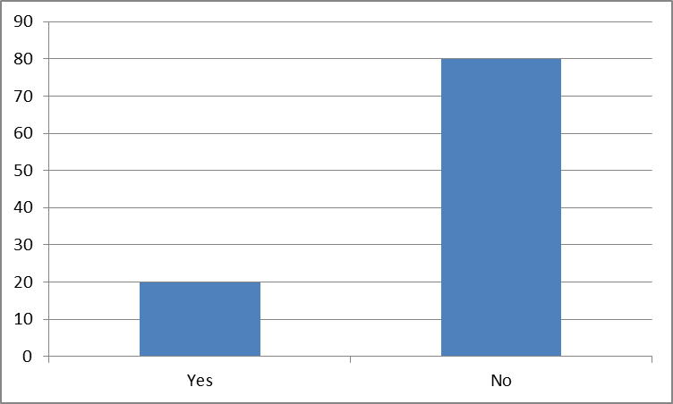

INTERPRETATION
The table showing awareness of respondents about the website of PDS reveals that 80% of respondents were not aware of the website of PDS. And 20% were aware of the website of PDS.
TABLE NO: 4.17
STATUS OF WEBSITE VISIT

Option | No. of respondents | Percentage
Often | 0 | 0
Sometimes | 4 | 4
Rarely | 20 | 20
Never | 76 | 76
Total | 100 | 100

Source: Primary Data

CHART NO: 4.17
STATUS OF WEBSITE VISIT

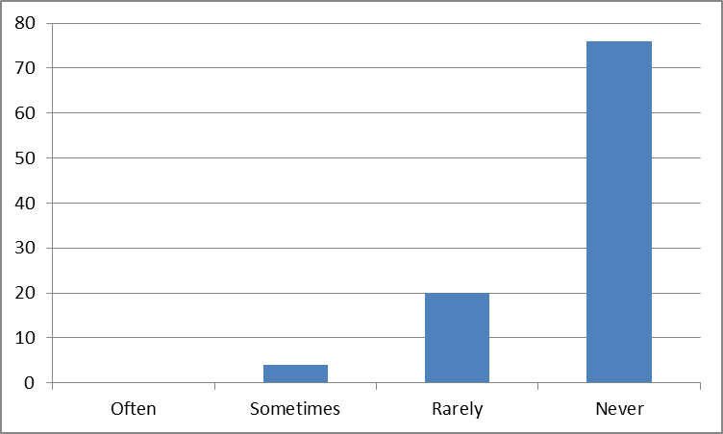
INTERPRETATION
The table showing s2tatus of website visit of PDS shows that majority (76%) never visited the website of PDS. 20% of respondents rarely visits the website and 4% visits sometimes.

TABLE NO: 4.18
USEFUL TO REDUCE THE DISPUTE
Option | New system is useful to reduce dispute among the customers and ration shopkeeper | Percentage
Highly Agree | 28 | 28
Agree | 44 | 44
Neutral | 22 | 22
Disagree | 2 | 2
Highly Disagree | 4 | 4
Total | 100 | 100
Source: Primary Data
CHART NO: 4.18
USEFUL TO REDUCE THE DISPUTE
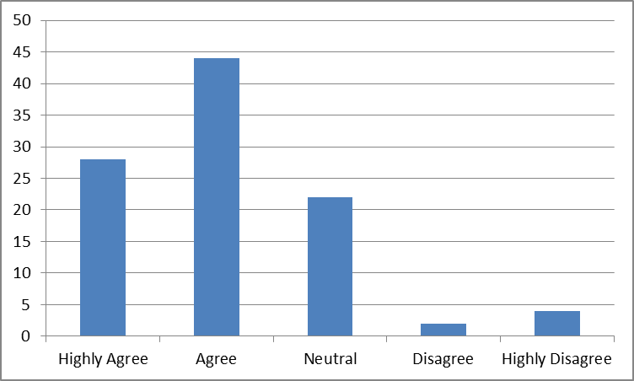
INTERPRETATION
The above table shows whether the new system is useful to reduce dispute among the customers and ration shopkeeper. Majority of the respondents (44%) agreed with the statement and 28% highly agreed. 22% of them had neutral opinion regarding the statement. Minority of the respondents (2%) disagreed and 4% of the respondents disagreed highly.
TABLE NO: 4.19
REDUCTION IN CORRUPTION

Option | Corruption will be reduced | Percentage
Highly Agree | 34 | 34
Agree | 38 | 38
Neutral | 18 | 18
Disagree | 10 | 10
Highly Disagree | 0 | 0
Total | 100 | 100
Source: Primary Data
CHART NO: 4.19
REDUCTION IN CORRUPTION
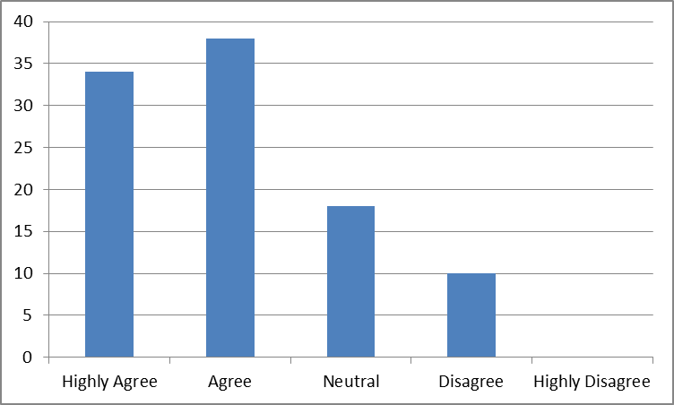
INTERPRETATION
The above table shows whether the new system is useful to reduce corruption in PDS. Majority of the respondents (38%) agreed with the statement and 34% highly agreed. 18% of them had a neutral opinion with the statement. None of the respondents (0%) disagreed highly and 10% of them disagreed with thestatement.
TABLE NO: 4.20
ELIMINATION OF BOGUS AND INELIGIBLE CARD HOLDERS

Option | New system will eliminate bogus and ineligible  card holders | Percentage
Highly Agree | 34 | 34
Agree | 44 | 44
Neutral | 16 | 16
Disagree | 4 | 4
Highly Disagree | 2 | 2
Total | 100 | 100
Source: Primary Data
CHART NO: 4.20
ELIMINATION OF BOGUS AND INELIGIBLE CARD HOLDERS
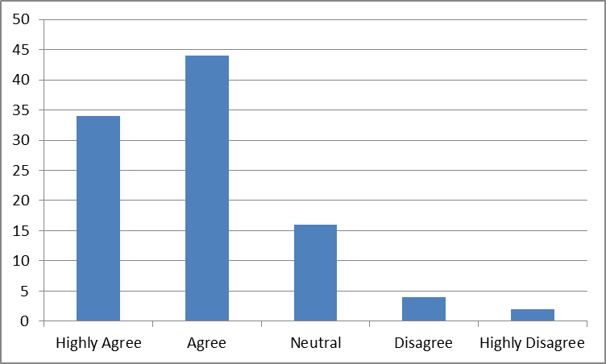
INTERPRETATION
The above table shows the opinion of respondents whether the new system is useful to eliminate bogus and ineligible card holders. Majority of the respondents (44%) agreed with the statement and 34% highly agree. 16% of them had a neutral opinion with the statement. Minority of the respondents (2%) highly disagreed and 4% of the respondents disagreed with thestatement.
TABLE NO: 4.21
OPINION ABOUT CURBING PILFERAGE OF FOOD GRAINS

Option | E-POS system helps to curb pilferage of food grains | Percentage
Highly Agree | 20 | 20
Agree | 40 | 40
Neutral | 32 | 32
Disagree | 6 | 6
Highly Disagree | 2 | 2
Total | 100 | 100
Source: Primary Data
CHART NO: 4.21
OPINION ABOUT CURBING PILFERAGE OF FOOD GRAINS
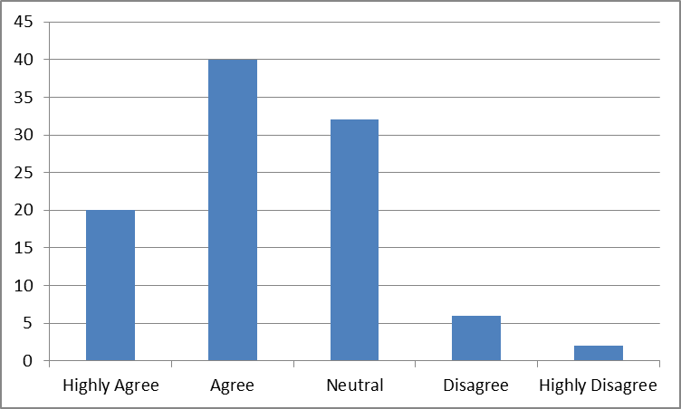
INTERPRETATION
The above table shows whether the new system is useful to curb pilferage of food grains. Majority of the respondents (40%) agreed with the statement and 20% highly agreed. 32% of them had a neutral opinion with the statement. Minority of the respondents (2%) highly disagreed and 6% of the respondents had disagreed with the statement.

TABLE NO. 4.22
BRINGING TRANSPARENCY AND ACCOUNTABILITY
Option | E-POS system will bring transparency and accountability in the PDS | Percentage
Highly Agree | 24 | 24
Agree | 56 | 56
Neutral | 18 | 18
Disagree | 2 | 2
Highly Disagree | 0 | 0
Total | 100 | 100
Source: Primary Data
CHART NO: 4.22
BRINGING TRANSPARENCY AND ACCOUNTABILITY
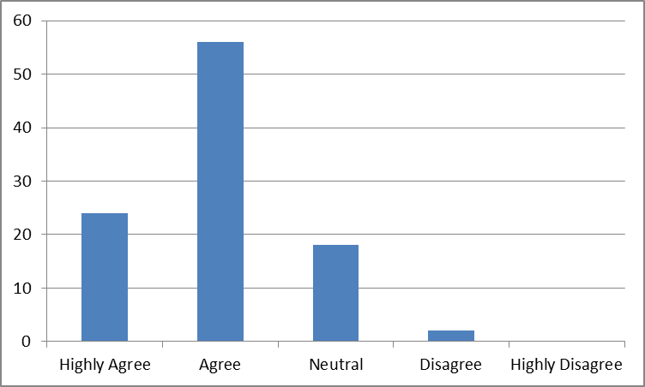
INTERPRETATION
The above table shows whether the new system is useful to bring transparency and accountability in the PDS. Majority of the respondents (56%) agreed with the statement. 18% respondents had neutral opinion, 24% highly agreed with the statement. None of the respondents (0%) highly disagreed and 2% of the respondentsdisagreed.
TABLE NO: 4.23
RECEIVING BENEFITS FROM GOVERNMENT
SCHEMES CORRECTLY
Option | Through the new system only genuine beneficiary will get the benefit of government schemes | Percentage
Highly Agree | 28 | 28
Agree | 42 | 42
Neutral | 20 | 20
Disagree | 8 | 8
Highly Disagree | 2 | 2
Total | 100 | 100
Source: Primary Data
CHART NO: 4.23
RECEIVING BENEFITS FROM GOVERNMENT
SCHEMES CORRECTLY
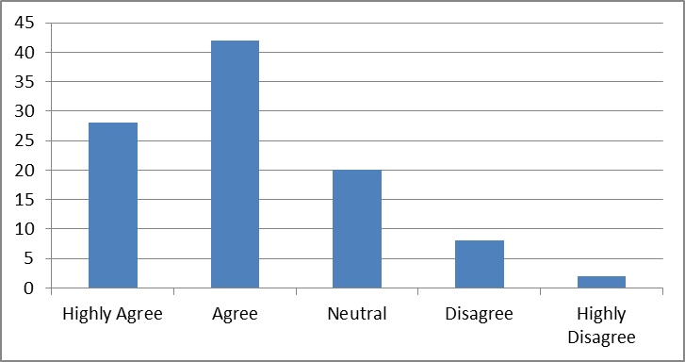
INTERPRETATION
The above table shows the opinion of respondents whether through the new system, only genuine beneficiary gets the benefit of government schemes. Majority of the respondents (42%) agreed with the statement and 28% highly agreed. (20%) of them had a neutral opinion with the statement. 2% of the respondents highly disagreed and 8% of the respondents disagreed.
TABLE NO: 4.24
OPINION ABOUT ILLITERATE PEOPLE FACE PROBLEM WITH E-POS SYSTEM
Option | No. of respondents | Percentage
Yes | 30 | 30
No | 70 | 70
Total | 100 | 100
Source: Primary Data
CHART NO: 4.24
OPINION ABOUT ILLITERATE PEOPLE FACE PROBLEM WITH E- POS SYSTEM
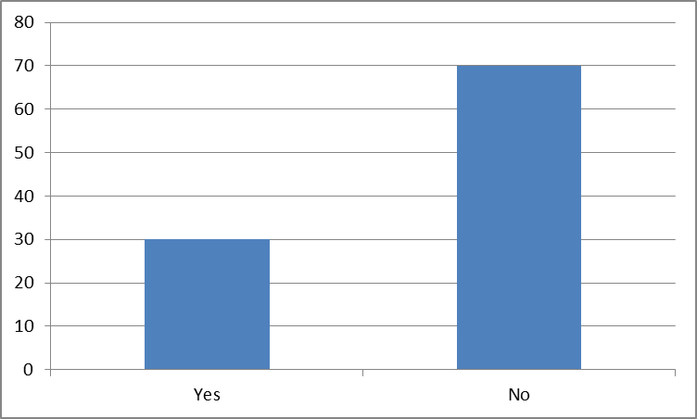
INTERPRETATION
The above table shows the opinion of the respondents whether the illiterate people faced problem with E-PoS system. Majority (70%) of the respondents reveals that there was no problem for illiterate people with the E-PoS system. 30% of respondents believed that illiterate people faced problem with the E-PoS system.
TABLE NO: 4.25
KNOWLEDGE ABOUT THE REAL PURPOSE BEHIND THE
IMPLEMENTATION OF E-POS SYSTEM
Option | No. of respondents | Percentage
Yes | 28 | 28
No | 72 | 72
Total | 100 | 100
Source: Primary Data
CHART NO: 4.25
KNOWLEDGE ABOUT THE REAL PURPOSE BEHIND THE
IMPLEMENTATION OF E-POS SYSTEM
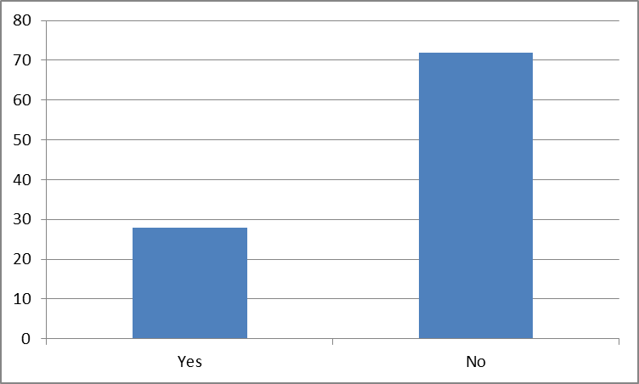

INTERPRETATION
The above table shows the knowledge of respondents about the real purpose behind the implementation of the e-PoS system. Majority (72%) were not aware about the real purpose behind the implementation of the e-PoS system in ration shops. 28% of respondents were aware about the real purpose behind the implementation.
TABLE NO: 4.26
REDUCTION OF MALPRACTICES
Option | No. of respondents | Percentage
Strongly Agree | 60 | 60
Agree | 30 | 30
Neutral | 10 | 10
Disagree | 0 | 0
Strongly Disagree | 0 | 0
Total | 100 | 100
Source: Primary Data
CHART NO: 4.26
REDUCTION OF MALPRACTICES
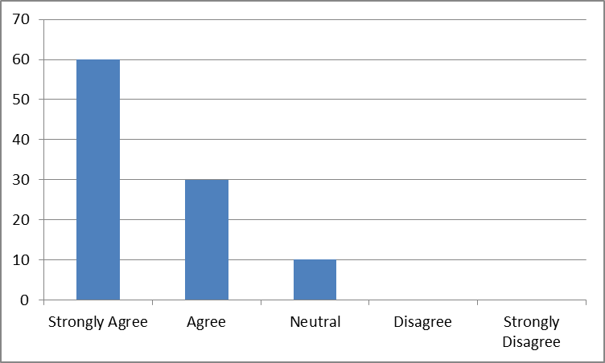
INTERPRETATION
The above table shows the agreement of the reduction of malpractices in ration shops. Majority (60%) of the respondents strongly agreed with the statement that the new system would help to reduce the malpractices in ration shops. 10% respondents were neutral in opinion with the statement. The rest of the respondents (30%) agreed with thestatement.
TABLE NO: 4.27
OPINION ABOUT BETTER SYSTEM

Option | No. of respondents | Percentage
Old | 12 | 12
New | 88 | 88
Total | 100 | 100
Source: Primary Data
CHART NO: 4.27
OPINION ABOUT BETTER SYSTEM
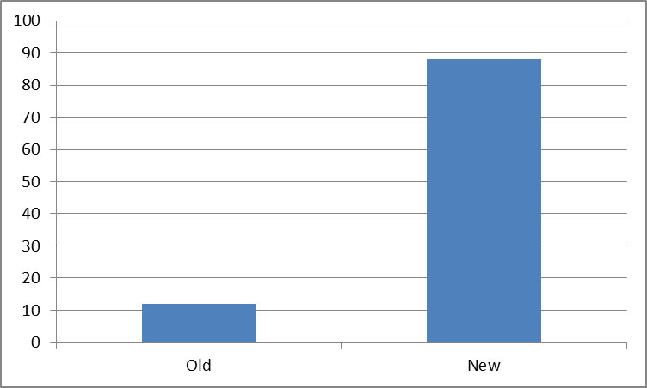
INTERPRETATION
The table shows the opinion of respondents to the query of which system being the best one. Majority of the respondents (88%) supported the new system and rest of the 12% supported the oldsystem.
TABLE NO: 4.28
OPINION ABOUT THE BENEFICIALITY OF THE NEW SYSTEM

Option | No. of respondents | Percentage
Strongly Agree | 16 | 16
Agree | 56 | 56
Neutral | 28 | 28
Disagree | 0 | 0
Strongly Disagree | 0 | 0
Total | 100 | 100
Source: Primary Data
CHART NO: 4.28
OPINION ABOUT THE BENEFICIALITY OF THE NEW SYSTEM
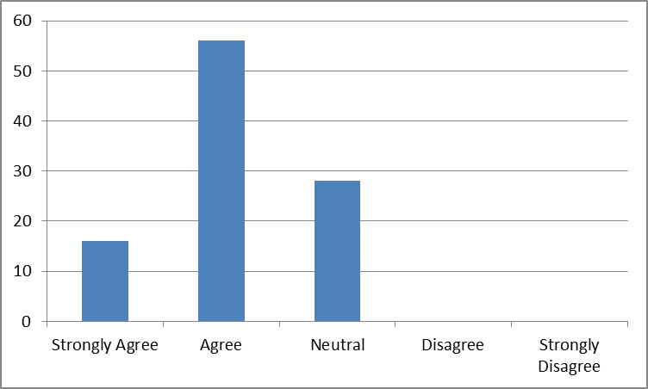
INTERPRETATION
The above table shows whether the new system is beneficial for ration customers. Majority of the respondents (56%) agree with the statement and 16% strongly agreed. 28% of them had a neutral opinion with the statement. None of the respondents disagreed with the statement.
TABLE NO: 4.29
SATISFACTION WITH THE ADOPTION OF E-POS MACHINE IN RATION SHOP
Option | No. of respondents | Percentage
Highly satisfied | 10 | 10
Satisfied | 66 | 66
Neutral | 22 | 22
Dissatisfied | 2 | 2
Highly Dissatisfied | 0 | 0
Total | 100 | 100
Source: Primary Data
CHART NO: 4.29
SATISFACTION WITH THE ADOPTION OF E-POS MACHINE IN RATION SHOP
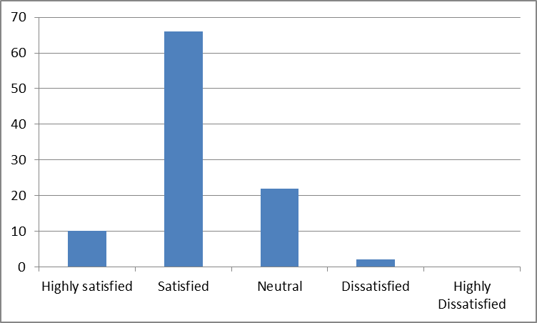
INTERPRETATION
The table showing satisfaction with the adoption of e-PoS machine in ration shop reveals that majority (66%) are satisfied with the new system. 10% of ration customers were highly satisfied with the adoption of new system. 22% belongs to neutral category and 2% were dissatisfied with the new system. None of the respondents were highly dissatisfied.
CHAPTER V
FINDINGS,SUGGESTIONS AND CONCLUSION
5.1 FINDINGS

- The study reveals that most (86%) of the respondents were aware of the e-PoS system implemented in ration shops.
- Greater number of the respondents received information about e-PoS system through ration shop keeper.
- More than half (68%) of the respondents had knowledge regarding available items in the website.
- Only 36% of the respondents were aware of the facility to check whether the ration shop is active or not.
- Most of the respondents (70%) were unaware that there is an OTP option available when there is lag in recognizing the thumb impression.
- Only 34% of the respondents were aware of the manual billing option devised for bedridden people.
- Majority of the respondents (72%) were aware of the fact that they can purchase the ration item from any ration shop within Kerala.
- A best part of the respondents had the opinion that the e-PoS system is user-friendly.
- Almost all of the respondents were dissatisfied regarding the information received through the old system.
- Half of the (50%) of the respondents were satisfied with the information received from the new system.
- It is clear from the study that new system helped to receive more information than the old system.
- Finger print delay was the frequent problem faced by the respondents.
- The study found out that a dominant number of respondents was unaware about the website of PDS.
- It is found that a best part of the respondents had never visited the website.
- Majority of the respondents agreed that the e-PoS system helped to reduce dispute between customers and ration shop keeper.
- The study found that majority of the respondents agreed with the fact that thee -PoS system helped to reduce corruption.
- 44% of the respondents agreed that thee-PoS system would help to eliminate bogus and ineligible card holders.
- Majority of the respondents believed that thee-PoS system would help to curb pilferage of food grains.
- Majority of the respondents (42%) agreed that only genuine beneficiary would get the benefits of government schemes after the implementation of the e-PoS system.
- Most of the respondents believed that illiterate people did not face any problem with thee-PoS system.
- Majority of the respondents (72%) had knowledge about the real purpose behind the implementation of thee-PoS system.
- The study revealed that majority of the respondents (60%) strongly agreed that the e-PoS system would help to reduce malpractices in ration shops.
- Majority of the respondents (88%) had an opinion that the new system is better than the old system.
- Majority of the respondents (56%) agreed that new system is beneficial for them
- The study revealed that majority of the respondents (66%) was satisfied with the adoption of the e-PoS system in ration shops.
5.2 SUGGESTIONS
- The present e-PoS machines should be checked and improved for eliminating technical problems.
- Finger print delay is a main problem, thus it is essential to take actions for eliminating the problem.
- Authorities should take initiative to give customers guidelines for using the e-PoS system.
- Person with physical ailment are unable to purchase through the e-PoS system. So government should find solution for this problem.

5.3 CONCLUSION

The e-PoS system was introduced to eliminate the drawbacks of the traditional system. Now every ration shop is working under thee-PoS system in Kerala. Implementation of thee-PoS machines increases transparency in transactions. Malpractices have almost vanished from ration shops. By introducing this system, people became more aware of their allotted ration items. It became very convenient to the people that they can purchase ration items from any of the ration shop in Kerala. It is found that most people did not have much idea about the e-PoS system.
The study revealed that people are satisfied with the e-PoS system than the traditional system. No one had the opinion to change thee-PoS system, but they needed improvement in this system. Most frequent problem seen in thee-PoS system are technical ones.
At times due to technical and finger recognition problems, customers are unable to make their purchase. Even though there is an option to make purchase from other ration shops, people found this difficult. However, no customers had the opinion to change the e-PoS system.
To conclude, the government should take steps to improve the e-PoS system and give sufficient information about the working of the e-PoS system to everyone, and also they should find solution for the technical problems.

BIBLIOGRAPHY

Books Referred:

- Gerardus Blokdyk , E-POS – A Complete Guide, 2019 Edition.
- N. Krishnaji and T.N Krishnan, Public Support for Food Security.
- Manu Gautam, Public Distribution System and Tribal Development.

Websites:

- www.wikipedia.com
- www.indiafilings.com
- www.epos.kerala.gov.in
- www.civilsupplieskerala.gov.in

QUESTIONNAIRE
PERSONAL DETAILS
(i) Name ______________________________________
(ii) Age
 Up to 25
 26-35
 36-45
 Above 45
(iii) Gender
 Male
 Female
(iv) Education
 Illiterate
 Primary studies
 SSLC
 Graduate
(v) Status of the respondent
 Daily wage employee
 House wife
 Student
 Government employee
(vi) Family Income level (monthly)
 Below 10000
 10000-20000
 20000-30000
 Above 30000
1.Category
 APL
 BPL

2.Are you aware about e-PoS system?
 Yes
 No
3.How do you get information about e-PoS system?
 Ration shopkeeper
 Newspaper
 Television
 Internet
 Radio
 Friends
4.Mark your knowledge about the features of the e- PoS system?
 | Yes | No
There is information regarding the eligible items in the website
You can check whether the ration shop is active or not
If there is a lag in recognising thumb, OTP would be an additional option
Manual billing option is available for bedridden people
You can buy your ration items from any ration shop within Kerala state

5.Do you find the new system user-friendly?
 Yes
 No
6.Rate your satisfaction regarding the old system.
 Highly satisfied
 Satisfied
 Neutral
 Dissatisfied
 Highly Dissatisfied
7.Rate your satisfaction regarding the new system
 Highly satisfied
 Satisfied
 Neutral
 Dissatisfied
 Highly Dissatisfied
8.Do you think you receive more information through e- PoS system compared to theearlier system?
 Yes
 No
9.Have you ever faced any hindrance due to the e- PoS system adopted in the rationshop?
 Often
 Sometimes
 Rarely
 Never
10.Which of the most frequent problem you have faced through e- PoS system?
 Technical problem
 Fingerprint delay
 Low network coverage
 Inadequate knowledge of operator
 Others
11.Are you aware of the website of PDS?
 Yes  No
12.Have you ever visited the website?
 Often
 Sometimes
 Rarely
 Never

Rate the following with regard to the adoption of e-PoS system in ration shop
5- Highly Agree 4- Agree 3- Neutral 2- Disagree 1- Highly disagree
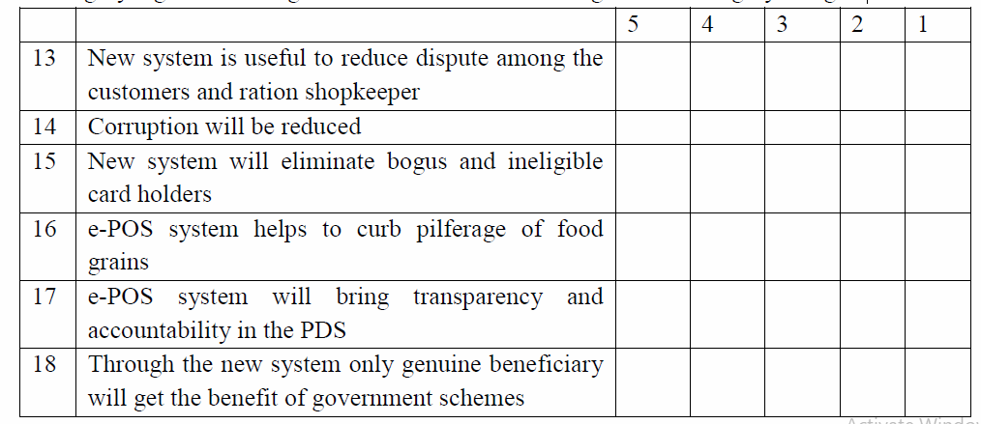
19.Do you think that illiterate people feel problem with e-PoS system?
 Yes  No
20.Do you know the real purpose behind the implementation of e-PoS machine?
 Yes  No
21.Do you agree that the new system can reduce malpractices in the ration shop?
 Strongly Agree
 Agree
 Neutral
 Disagree
 Strongly Disagree
22.Which system is better?
 Old
 New
23.Do you think this system is beneficial for you?
 Strongly Agree
 Agree
 Neutral
 Disagree
 Strongly Disagree
24.Rate your level of satisfaction with the adoption of e- PoS machine in ration shop
 Highly satisfied
 Satisfied
 Neutral
 Dissatisfied
 Highly Dissatisfied
25.What would be your suggestion to improve the operations of e- PoS system?
______________________________________________________________________________________________________________________________________
___________________________________________________________________

