**CHAPTER-I**

**INTRODUCTION**

**INTRODUCTION**

With the advent of globalization and culture of consumerism, people begin to travel to make use of wide variety of alternatives that bring satisfaction and healthy living. Now a day’s people are more aware of the importance of health. They are conscious in maintaining a healthy body, mind and soul. People visit tourism destinations normally for leisure and recreation. The purpose of visiting a tourism destination may vary depending up on the nature and interests of tourists. Hence tourism destinations design variety of tourism products so as to cater the needs of tourists having different interests. Health tourism is a niche tourism developed by the competing tourism promoting countries in order to attract people travelling with the prime purpose of getting healthcare.

Ayurveda is a holistic system of healing that has a tradition of 3000 years old. Kerala and Ayurveda are synonymous to each other, as it is the only place on earth where Ayurveda is practised with absolute authenticity and dedication. This ancient Indian system of medicine has proved to be not only the cure for illness but also the 100 percent natural way to prefect health. The methods of Ayurveda are unique and universal. Instead of treating the symptoms of a disease, it treats the individual and caring is given for the entire body. Ayurveda medicines are purely natural and absolutely free of side effects.

Kerala is not only a beautiful destination in Southern India known for its scenic beaches and scenic backwaters but also, of late, Kerala has gained international attention for medical tourism and is becoming a popular international medical tourism destination. Tourists have also identified that Kerala has a pool of trained doctors and nurses, and an excellent network of hospitals that offer international standards at very affordable prices. Previously Indians working abroad such as residents of Kerala working in the Persian Gulf countries, would return to India for medical treatment. Now, other international travelers have also realised the advantages of travelling to Kerala and the medical tourism industry has begun to take off in big way in the state. Kerala is famous for its alternative medical therapies such as ayurveda which helps to rejuvenate and revitalise the body

**1.1 IMPORTANCE OF THE STUDY**

Medical tourism has emerged as a critical component of tourism in India. Medical tourism, a subset of health tourism, is an emerging segment of tourism industry and there are only a few serious studies conducted on the topic. With the growing importance of medical tourism and the thrust given by central and state governments to promote tourism, the paper explores the potential role of Ayurveda in medical tourism sector

**1.2 OBJECTIVES OF THE STUDY**

* To study the importance of Ayurveda tourism in Kerala tourism industry.
* To make an awareness about important Ayurveda treatments.
* To study about the concept of health tourism.
* To study the health tourism industry of Kerala and India.
* To make valuable suggestions based on the findings of the study.

**1.3 RESEARCH METHODOLGY**

The present study is theoretical in nature. Primary data is collected through interactions with various personnel through .The data analysis has been done through secondary review and content analysis has been performed to arrive at conclusions and discussion.

The secondary sources of the dataincludes books, journals, newspapers, published and unpublished research work, various search engines, etc.

**1.4 LIMITATIONS OF THE STUDY**

* Time constrain was the major limitation of the study
* This study depends only on secondary data
* Lack of information relate with this topic
* Lack of authorities and institutes to provide data

**CHAPTER-II**

**TOURISM INDUSTRY IN INDIA**

**TOURISM IN INDIA**

India‟s glorious traditions and rich cultural heritage are closely related with the development of tourism. Its magnificent monuments attract a large number of tourists from all over the world. The natural surroundings, the architectural masterpieces, the music, dance, paintings, customs and languages all these go to make India as tourist paradise. In ancient India, there were no travel formalities for travelling in the period of Chandragupta - II, and that time the famous Chinese pilgrim FaHien travelled between A.D. 401 and 410 without a passport. But in the 3rd century B.C. a passport or mudra was essential, according toKautilya‟sArthashastra, for all travelers. During the Vedic period, the tourists were accommodated at „dhams‟ or holy place of the country.

There was a remarkable increase in the traveler coming to India, as a result of the discovery of the new sea route by Vasco - de - Gama. When Alexander the Great reached in India, he found well maintained roads lined with trees and wells, and rest houses. Along with the royal highway which is 1920 km long and 19 meters wide, men travelled in Chariots, palanquins, bullock- carts, on donkeys, horses, camels and elephants. During the British period, tourism in India becomes more organized. They built Dak Bungalows on the road side for the convenience of dak traveler.

The finest of India‟s cuisines is as rich and diverse as its civilization. In Sanskrit literature the three famous words “AththiDevoBhava” means „the guest is truly god‟ are a dictum of hospitality in India. India is a storehouse of art, paintings; crafts appeared on pots found in the Indus valley civilization as early as the 3rd century B.C. The cave paintings of Ajanta and Ellora date back to the 1st to 5th century A.D. The British setup the Archaeological survey of India in the 19th century to document the wealth of material available in the country. Viewing Indian art and culture as an integral part of the century‟s heritage.

**TOURISM POLICY OF INDIA**

Tourism emerged as the largest global industry of the 20th century and is projected to grow even faster in the 21st century. India has immense possibilities of growth in the tourism sector with vast cultural and religious heritage, varied natural attractions, but comparatively small role in the world tourism scenario. The government of India announced the first tourism policy in November 1982, but new initiatives towards making tourism as the catalysts in employment generation, environmental re-generation. It would lead to larger foreign investment. After ten years government has feels the need to improve first policy, then newly introduced by the name the National Action Plan for Tourism in 1992. The report of the National Committee on Tourism was submitted in 1988, in this report two five-year plans provided basic perspective framework for operational initiatives.

The tourism policy, 1982 was more aggressive statement in marketing than a perspective plan for development. Following measures were suggested by the policy-

1) To take full advantage of the national heritage for attracting tourists.

2) To increase tourist resorts.

3) The status of an export industry to tourism

4) To adopt the approach to develop few tourist circuits.

5) To invite private sector.

In the National Action Plan for Tourism, seven objectives are given theyare as follows-

1. Socio - economic development of region.

2) Increasing employment opportunities.

3) Development of domestic tourism.

4) Preserving national heritage and environment.

5) Development of international tourism.

6) Diversification of the tourism products.

7) Increase in India‟s share in world tourism

**HEALTH TOURISM IN INDIA**

Health tourism is gaining momentum in developing countries. It is perceived as one of the fastest growing segments in marketing ‘Destination India’. India has become a heaven for medical tourists because of the provision of cost effective high quality treatment and overhead costs liketraveling, lodging, sightseeing, food and shopping are very affordable in India. From less than 10000 patients visiting India for medical treatment five years ago, the medical tourism market in India is worth US$ 333 million, with about 100000 foreign patients coming every year.

The medical care infrastructure in India includes over 500000 doctors, 15000 hospitals and 875000 beds. In addition, semi urban and rural regions have over 23000 primary health centres and 132000 sub centres. Despite an extensive public healthcare infrastructure, private sector now dominates the market. Health administration of India is governed by the Ministry of Health and Family Welfare (MOHFW), which has three departments such as Department of Health, Department of Family welfare, Department of AYUSH (Ayurveda, Unani, Siddha and Homeopathy).

High quality treatment at a fraction of the cost, in comparison to western countries, makes India an ideal healthcare destination for highly specialized medical care. The potentials of India in the area of health tourism are identified by evaluating the health tourism products and providers of the country and the competitive advantage of India over other countries in attracting health tourists.

**Health Tourism Providers**

Health tourism providers are organisations involved in the process of health tourism include healthcare providers, travel agencies, tour guides, hotels and resorts. Services of health tourism providers include consultation with the relevant medical specialist prior to arrival by email, telephone and if needed by video conference, flight arrangements & extensions / visa assistance, airport pick-up including an ambulance if needed, hotel accommodation, appointments with medical specialists, clinical tests, scheduling of all medical appointments, coordination of the admissions process, cost estimates for anticipated treatment, special dietary needs / religious arrangements, providing news & information of patient's relatives back home, remote consultations via telemedicine, local sightseeing, foreign exchange, insurance services, financial services, travel advice for local conditions, ticketing, spa, shopping, yoga, and beauty treatment .

Major medical tourism providers in India are Apollo Hospitals, Escorts Heart Institute & Research Centre, Wockhardt Hospitals, Fortis Healthcare, Tata Memorial Cancer Hospital, Leelawati Hospital and Manipal Hospital.

**Health Tourism Products**

Health Tourism Products can be classified as medical tourism- surgery etc., eye care, dental care, cosmetic treatment, Ayurveda, yoga, siddha, unani and homoeopathy.

Indian corporate hospitals excel in Cardiology and Cardiothoracic surgery, Joint replacement, Orthopedic surgery, Gastroenterology, Ophthalmology, Transplants and Urology to name a few. The various specialties covered are Neurology, Neurosurgery, Oncology, Ophthalmology, Rheumatology, Endocrinology, ENT, Pediatrics, Pediatric Surgery, Pediatric

Neurology, Urology, Nephrology, Dermatology, Dentistry, Plastic Surgery, Gynecology, Psychiatry, and General Medicine & General Surgery

Some of the facilities offered by the dental clinics are Dental Scanning - Intra mouth, Surgical Intervention under general anesthesia, Whitening of teeth, Ceramic caps without gold under microscopic control, Prosthesis on the implant, Vertical and horizontal bone grafting, Gum Grafting, Palatal orthodontics, Fluoride treatment for children and Maxillary surgery etc.

**Cosmetic Treatment includes:**

Breast Enhancement - Breast reshaping procedures include: surgical breast enlargement, breast enhancement, breast augmentation, breast lift and breast reduction.

**Liposuction**

Liposuction is not a substitute for weight reduction. Liposuction is a method of removing localised fat that does not respond to diet and exercise. It can enhance one’s appearance and one’s self-confidence. It can be carried out on the tummy, hips, thighs, buttocks and in fact, anywhere on the body where localised fat can be removed

**Varicose Veins**

Varicose Veins can be very uncomfortable because of poor circulation and it is advisable to have the varicose veins surgically removed to improve the circulation of blood in the effected areas. Varicose vein removal is an increasingly popular procedure for cosmetic surgery Varicose Veins.

**Face-Lifts**

As one grow older one’s facial skin has a tendency to wrinkle and dry, a face lift around the eyes, mouth and chin can take years off ones appearance. With modern Cosmetic surgery, face lifts and Rhinoplasty techniques can dramatically alter facial structures to give that renewed confidence.

**Rhinoplasty**

Modern techniques have dramatically improved the possibilities for Nose re-modeling and re-sculpturing.

**Eye Lid Lifts**

Cataract removal, Glaucoma Surgery, Laser correction or Lens implants

**Siddha System of Medicine**

Siddha System is one of the oldest systems of medicine in India. The term 'Siddha' means achievements and 'Siddhas' were saintly figures who achieved results in medicine through the practice of Yoga. Eighteen 'Siddha' are said to have contributed towards the development of this medical system. Siddha literature is in Tamil and it is practiced in Tamil speaking parts of India. The Siddha System is largely therapeutic in nature.

The Siddha system of Medicine emphasizes that medical treatment is oriented not merely to disease but has to take into account the patient, his environment, the meteorological consideration, age, sex, race, habits, mental frame, habitat, diet, appetite, physical conditions, physiological constitution etc. This means the treatment has to be individualistic which ensures lesser chance of committing mistakes in diagnosis or treatment.

**Unani System of Medicine (USM)**

Unani system of Medicine is originated in Greece. It is based on the teaching of Hippocrates (462-377 B.C.). Gallon during 13 1-2230 A.D.develop it into elaborated medical science. The medicines used in this system are of plant, animal, mineral and marine origins which also have their own temperament.

**Homoeopathy**

Homoeopathy is a specialised method of drug therapy of curing natural disease by administration of drugs which have been experimentally proved to possess the power of producing similar artificial symptoms on healthy human beings.

**Naturopathy**

Naturopathy is not only a system of treatment but also a way of life. It is often referred to as a drugless treatment of diseases. It is based mainly on the ancient practice of the application of the simple laws of nature. The system is closely allied to Ayurveda as far as its fundamental principles are concerned.

**Yoga & Meditation**

Yoga increases the efficiency of the heart and slows the respiratory rate, improves fitness, lowers blood pressure, promotes relaxation, reduces stress and allays anxiety. It also serves to improve coordination, posture, flexibility, and range of motion, concentration, sleep and digestion. It can also be used as supplementary therapy for conditions as diverse as cancer, diabetes, arthritis, asthma, migraine etc., and help to combat addictions such as smoking. It is not, in itself, a cure for any medical ailment.

The practice of Yoga, or unification, re-establishes the connection between the individual and the universal field of pure consciousness. Yoga removes the attachment to external objects and false knowledge and corrects psychological trauma by merging the mind with the real, the virtuous, and the wellspring of harmony. It really is true. Since the mind plays such an important role in creating health, Yoga plays a vital role in Ayurvedic medicine Patanjali, the compiler of the original Yoga Sutras, lived approximately between 900-800 B.C. at a time when Ayurveda was flourishing.

The original teaching of Patanjali's system of yoga describes a consecutive sequence of eight stages, ashtanga yoga, to achieve unification with pure consciousness (ashta = eight).

**HEALTH TOURISM IN KERALA**

Kerala, God’s Own Country is one of the most sought after tourist destinations in Asia. It is the only Indian state having all types of tourism products. Secluded beaches, palm fringed back waters, mist clad hill stations, lush tropical forests, water falls, exotic wildlife, monuments, art forms and festivals give it a distinctive charm. Apart from being a tourist destination, Kerala is India’s number one state with 100 percent literate people, world-class healthcare systems, lowest infant mortality and highest life expectancy rates, highest physical quality of life and best law and order conditions. It is India’s most affluent, peaceful and cleanest state also.

Kerala is located on the south western tip of India with the Arabian Sea in the west and Western Ghats towering 500- 2700m in the east, covered under an area of 38863 square kilometer having a population size of3,18,38,619 (as per 2001 census) people. The state is divided into three regions – the costal low lands, the fertile midlands and the high lands. The low lands of Kerala are networked by endless backwaters and the deltas of forty –four rivers. The midlands are rich with cashew, coconut, tapioca, banana, rice, ginger, pepper, sugar cane and vegetable plantations. The forested highlands abound in tea, rubber, coffee and spice plantations and wildlife reserves. Kerala has a moderate climate: Summer: February – May, Monsoon: June – September, and Winter: October – January. For administrative purposes, Kerala is divided into 14 districts and they are the revenue divisions of the State. The districts are further divided into taluks and villages. Each district has head quarters where the administrative offices function. On the basis of geographical, historical and cultural similarities, the districts are generally grouped into:

North Kerala: (Kasaragod, Kannur, Wayanad, Kozhikkode, Malappuram) Central Kerala: (Palakkad, Thrissur, Eranakulam, Idukki)

South Kerala: (Thiruvananthapuram, Kollam, Alappuzha, Pathanamthitta, Kottayam).

Kerala has wide variety of tourism resources which is capable of attracting large number of tourists. It can become one of the world’s best tourism destinations by highlighting its natural beauty. Its small area allows a tourist to enjoy back waters, beaches, hill stations, wild life, performing arts etc within a short span of time. Every district in Kerala has much potential to develop in tourism by exploring unexplored tourism resources. People choosing medical travel will prefer to travel to Kerala if Kerala’s natural beauty is highlighted. Kerala can attract tourists of varying interest by adopting niche tourism strategy that enables optimum utilisation of tourism resources. Different forms of tourism can also be linked. People who decide to visit Kerala to enjoy beaches may also be interested in taking Ayurveda and vice versa

Ayurvedic resorts, spas, massaging centres, hospitals and clinics are plenty in Kerala. In order to thwart the mushrooming of fraudulent centres, Government of Kerala has two types of certifications for standardizing the level of services, namely **Green Leaf** and **Olive Leaf**. The certifications are given in view of the type of facilities, quality of medicine and health programme, the expertise of physicians, masseurs and supervising personnel etc.

Some of the Green Leaf certified AyurvedicCentres include [SomatheeramAyurvedic Hospital and Yoga Centre](http://www.somatheeram.in), [ManaltheeramAyurvedic Hospital & Research Centre](http://www.manaltheeram.com) etc. Somatheeram and Manaltheeram are located in Thiruvananthapuram, the capital city of Kerala.

Be it for rejuvenation, treatment or learning, Kerala is one of the best places to experience Ayurveda in the purest form.

**CHAPTER – III**

**CONCEPT OF HEALTH TOURISM**

Health tourism comprises of two terms healthcare and tourism and it involves a combination of resources of healthcare and tourism. A health tourism destination highlights its healthcare resources that give wellness and cure and tourism attractions that give peace of mind and relaxation. Health tourism is becoming a preferred form of vacationing as its covers a broad spectrum of medical services and mixes leisure, fun and relaxation together with wellness and healthcare. Health tourism is also known as medical tourism, wellness tourism, healthcare travel or medical value travel.

Medical tourism often refers to travelling to other countries to obtain medical, dental and surgical treatment. It denotes the increasing tendency among people to travel in search of more affordable health options often packaged with tourist attractions. Wellness tourism is the sum of all the relationships and phenomena resulting from a journey and residence by people whose main motive is to preserve or promote their health. They stay in a specialized hotel which provides the appropriate professional know how and individual care. They require a comprehensive service package comprising physical fitness/beauty care, healthy nutrition/ diet, relaxation/meditation and mental activity/ education1.

Medical tourism is highly promoted by big corporate hospitals in developing countries by providing high quality medical services at cheaper prices to patients from industrialized nations. Health tourism is projected as a new segment in travel and healthcare business. Globally, medical tourism is said to be US $ 40 billion industry. The main attractions of health tourism are cost effectiveness and a chance to enjoy the tourist products of health tourism destination during recuperative period.

**HISTORY OF HEALTH TOURISM**

Health tourism has become a common form of vacationing, and covers a broad spectrum of medical services. It mixes leisure, fun and relaxation together with wellness and healthcare. Medical tourism is actually thousands of years old. In ancient Greece, pilgrims and patients came from all over the Mediterranean to the sanctuary of the healing god, Asklepios, at Epidaurus. In Roman Britain, patients took the waters at a shrine at Bath, a practice that continued for 2,000 years. From the 18th century wealthy Europeans travelled to spas from Germany to the Nile. In the 21st century, relatively low-cost jet travel has taken the industry beyond the wealthy and desperate.

With many of the earliest civilizations, medical tourism manifested as trips to sacred temple baths and hot springs. Written historical accounts of Mesopotamian, Indian, Egyptian, and Chinese cultures clearly document bathing and healing complexes erected around therapeutic springs. As far back as the Bronze Age (2000 B.C.), hill tribes near present-day St. Moritz, Switzerland gathered around to drink and bathe in the iron-rich mineral springs of the region. Bronze Age implements, including votive drinking cups, have also been found around thermal springs in France and Germany, as well as in Celtic mineral wells. In 4000 B.C., the Sumerians constructed the earliest known health complexes alongside mineral water springs that included elevated temples and flowing pools. Although many post-Sumerian civilizations probably understood and appreciated the healing effects of mineral-rich water, it was the Greeks who first laid the foundation for comprehensive health care systems and medical tourism networks

**Earliest Health Tourism Centres**

Earliest medical tourism centres are built by Greeks, ancient Romans, Persians, Arabs, Europeans and Indians.

**Greek Medical Tourism**

The Asclepia Temples (built in honor of the Greek god, Asclepius) were some of the earliest healing centers where patients from around the region congregated for therapeutic purposes.

The numerous Asclepia Temples that were constructed during this time were usually established in prime “healthful” locations, often near mineral springs. Most temple complexes also included snake nurseries where serpents were farmed for mystic, healing rituals.

At Epidaurus, the longest preserved of the Asclepia Temples, the complex included bathing springs, a dream temple, gymnasium, palaestra (exercise area), and a snake farm large enough to supply nearby villages. Patients at the temple were attended to by a retinue of priests, stretcher carriers, and caretakers, before finally being granted an “appointment” with the mighty head priest.

The Asclepia Temples flourished well into the fourth century AD until treatments began to be less ritualistic and more clinical. However, even at the height of alchemy and herbal medicine, the old “sleep and dream” formula was still popular in certain parts of the Mediterranean. Other temple spas, like the Sanctuary of Zeus at Olympia and the spa multiplex at the Temple of Delphi, flourished throughout ancient Greece, although not on the same scale as the Asclepia Temples.

**Ancient Roman Medical Tourism**

In ancient Rome, hot water baths (called thermae) were not only used for their obvious medicinal benefits, but they also served as important social networking venues for some of the Empire’s most privileged elite. The Romans were definitely not believers in Spartan healing, and those who could afford to do so spend lavish amounts of money at the numerous baths and hot springs that surfaced. Much like the swank health care centers of 21st century medical tourism hotspots, these elaborate Roman complexes were posh establishments. Some treatment centers actually included theaters, lounges, art galleries, conference halls, brothels, and even the occasional sports stadium. Some of the larger complexes could reportedly house as many as 3,000 patients and patrons at a time.

During the early days of the Roman Empire, these thermae could hardly have been considered medical tourism spots since most visitors were within one day’s journey. But as the Empire slowly expanded during its 1,000 year reign, pilgrims, diplomats, beggars, and kings from all corners of the "known" world flocked to the Mediterranean to seek medical counsel and health treatments. And as a result of active trade with many parts of Persia, Africa, and Asia, these Roman baths necessarily expanded the healing arts. Ayurvedic massage, Chinese medicine, and various aspects of Buddhist spiritual healing became common features at some Roman thermae.

**Persian, Arabian, and Islamic Medical Tourism**

Early Islamic civilization, known for its many contributions in the fields of medicine and healing, had a well established health care system in place for foreigners. Probably the most famous medical tourism facility was Mansuri Hospital in Cairo (erected: 1248 AD). With a total in-patient capacity of 8,000 people, Mansuri Hospital was not only the largest hospital of the time, but it was also the most advanced health care facility that the world had ever seen. The complex included separate wards for women, a pharmacy, a library, and numerous lecture halls. There were also facilities for surgery and separate departments for eye diseases. No patient was to be turned away on account of race or religion, and no limits were imposed on a patient’s stay in the hospital.

**European Medical Tourism**

Although pilgrimages have remained central throughout much of Europe’s history, leisure travel, recreational vacations, and medical tourism didn't really come about until the 16th century when Europeans rediscovered the Roman baths. Entire communities sprung up around spa towns like Baden Baden, Aachen, and most notably, Bath. The emergence of Bath or AquaeSulis (Sulis derived from the water goddess, Sulis Minerva) as a major medical tourism destination can be attributed to the heavy royal patronage and involvement that the city enjoyed. With heavy endorsements from members of the ruling class, it wasn’t long before Bath became anointed as a fashionable wellness and recreation playground for the rich and famous. By the 1720s, aristocrats and gentlemen of leisure from other parts of Europe were swarming to Bath for cleansing and healing, while rubbing elbows with some of the continent’s elite.

**Trends in Demand for Health Tourism**

Customers of health tourism are known as health tourists who travel to health tourism destinations with the prime purpose of obtaining medical care and wellness for maintaining a healthy body, mind and soul. Health tourist is a person who travels to another country with the dual purpose of getting medical treatment, which is more affordable in the other country and enjoying a vacation as well. Medical tourists can be classified into two, leisure tourists who take minor treatment for his wellness as part of vacation and tourists travelling specifically for medical treatments. They are generally residents of the industrialized nations of the world such as United States, Canada, Great Britain, Western Europe, Australia and The Middle East.

**Reasons for the Development of Health Tourism**

A combination of several factors has led to the recent increase in popularity of medical tourism. People from industrialized nations seek health tourism because of high costs of treatment in their home country. Health tourism destinations provide high quality treatment at low cost, that is the health tourist gets treatment at a fraction of cost that he has to spend for the same procedure in his home country. So person’s having limited health insurance and uninsured persons choose treatment outside their home country. More over they get an opportunity to visit a new country and enjoy its tourism products during the recuperative period.

In UK medical treatment is free under National Health Service, but patients have to wait for a long time to get their turn. The waiting period may vary from 18 to 24 months. So they choose health tourism an option to get treated within weeks. Wealthy patients from third world countries also choose for health tourism as they get better service and care from the health tourism provider.

Some health tourism destinations provide alternative medicines and traditional form of treatments. Patients wish to take alternative medicines like Ayurveda opt for health tourism. Health insurance agencies and big corporates of developed countries also choose health tourism for their clients and employees so as to reduce the cost of treatment.

In nutshell following are the reasons that prompt people to choose health tourism:

High cost of treatment in home country and high quality low cost treatment offered by health tourism destination.

* Long waiting lists in home country and opportunity to get medical treatment within a week at health tourism destination.
* To make use of highly sophisticated equipments and technology provided by the health tourism destination.
* To reduce stress and rejuvenate body, mind and soul by taking alternative forms of medicines which have no side effects.
* Taking the advantage of tourism while treatment as the patients can forget about their illness and can relax in a health tourism destination.
* Ease and affordability of international travel and favourable exchange rates.
* Better hospitality services provided by the health tourism destination. Patients feel like they are at home even if they are treated for a serious disease.
* Availability of the services of highly skilled doctors and high standards of care.

**AYURVEDA & ITS IMPORTANCE IN KERALA TOURISM**

**AYURVEDA**

Ayurveda is a holistic system of healing which evolved among the Brahmin sages of ancient India some 3 000-5000 years ago. There are several aspects of this system of medicine which distinguish it from other approaches to health care:

* It focuses on establishing and maintaining balance of the life energies within us, rather than focusing on individual symptoms.
* It recognizes the unique constitutional differences of all individuals and therefore recommends different regimens for different types of people. Although two people may appear to have the same outward symptoms, their energetic constitutions may be very different and therefore call for very different remedies.
* Ayurveda is a complete medical system, which recognizes that ultimately all intelligence and wisdom, flows from one Absolute source (Paramatman). Health manifests by the grace of the Absolute acting through the laws of Nature (Prakriti). Ayurveda assists Nature by promoting harmony between the individual and Nature by living a life of balance according to her laws.
* Ayurveda describes three fundamental universal energies that regulate all natural processes on both the macrocosmic and microcosmic levels. That is, the same energies that produce effects in the various galaxies and star systems are operating at the level of the human physiology--in your own physiology. These three universal energies are known as the Tridosha.
* Finally, the ancient Ayurvedic physicians realized the need for preserving the alliance of the mind and body and offer mankind tools for remembering and nurturing the subtler aspects of our humanity. Ayurveda seeks to heal the fragmentation and disorder of the mind-body complex and restore wholeness and harmony to all people.

**CLASSIFICATION OF A YUR VEDA CENTRES**

The ayurvedic system of medication has become an extremely important and popular attraction for tourism in Kerala. In the state, it is virtually a way of life and perhaps the only place in the country, where it is

practised in its true and authentic form. A number of centres have come up and they are spread through out the state. The Government recognised the need to evaluate the safety and service standards of these ayurvediccentres and classify them properly, to ensure that the efficacy and the genuineness of this system of medicine does not get affected, which would have a direct impact on the number of tourists visiting the state. Those centres that fulfil the essential conditions prescribed by the Department of Tourism would be classified as the Olive Leaf status.

Those centres that fulfil the optional conditions also, in addition to the essential conditions, are accorded the Green Leaf status of classification. Some of the important features of these are given below:

**Essential conditions for ‘OLIVE LEAF’**

**Personnel:**

* Treatment / therapy should be done only under the supervision of a qualified physician with a recognised degree in Ayurveda.
* Separate Masseurs for male and female patients should be present – with at least one male and one female masseur.
* The masseurs must have training from recognized Ayurveda institutions
* Quality of medicine:
* Only those programmes approved by the Approval Committee shall be offered
* Health programmes shall be clearly displayed along with the time taken for massages and treatments.
* The approved time limit for a massage is 45 minutes.
* Medicines and material shall be clearly labelled, displayed and acquired from an approved and reputed firm

**Equipment:**

* The massage table shall confirm to a minimum size (7ft x 3 ft), made of good quality wood or fibreglass.
* A Gas or electric stove shall be operational and medicated hot water facility for bathing and other purposes shall be provided for.
* Sterilization facilities shall be provided.
* All equipment, areas, apparatus shall be clean and hygienic.

**Facilities:**

Separate treatment rooms – at least one each, separately for male and female shall be provided. These should be well ventilated and should be at least of 100 sqft of area (width not less than 8 ft). Toilets should have proper sanitary fittings and floors and the walls should be furnished with tiles.

One Consultation room shall be provided for a minimum size of 100ft (width not less than 8 ft). The rooms should be well equipped with medical instruments like BP apparatus, stethoscope, examination couch, weighing machine, etc.

A separate rest room (minimum size of 100ft with width not less than 8 ft), should be provided, in case the centre is not attached to a hotel/resort/hospital

General infrastructure should be good. Locality and ambience, including accessibility should be suitable. Furnishing should be of good quality. The centre and surrounding premises should be kept clean and hygienic.

**Optional conditions for ‘GREEN LEAF’**

In addition to the above essential requirements, centres having some additional / optional features, would be accorded the Green Leaf certification.

High standards of construction of the building, architectural features etc. with excellent furnishings, curtains etc. in superior quality materials

* Adequate parking facility in the premises.
* Bathrooms facilities for steam bath.
* Separate halls for meditation and yoga.
* Location of the centre in picturesque surroundings with a quiet ambience.
* Herbal garden attached to the Centre.

Ayurvediccentres that are provided with a licence or classification would be eligible for claiming a 10% state investment subsidy or electric tariff concession, offered by the Department of Tourism.

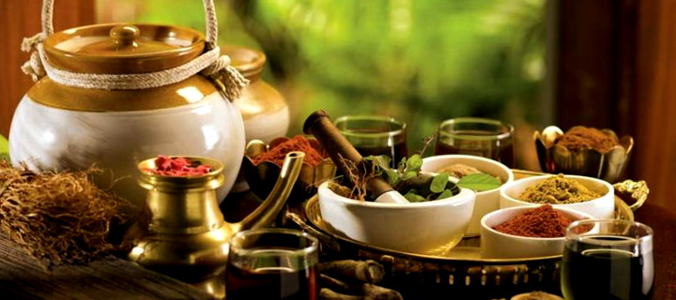**AYURVEDIC THERAPIES IN KERALA**

Ayurvedic Therapies can be used to treat ailments like Anxiety, Arthralgia, Asthma, Back pain, Diabetes, Disc Prolapse, Diseases of the eye, Dislocation, Dystonia, Hemiplegia, Hypertension, Impotence, Infertility, Miscarriage, Motor diseases, Multiple Sclerosis, Obesity, Peptic Ulcer, Peripheral Neuritis, Psoriasis and other skin diseases, Rheumatic Joint pains, Rheumatoid Arthritis etc.

Apart from treatment for these diseases it also offers therapy that rejuvenates the body and mind from the ills arising out of the frictions of everyday life.

General Ayurvedic Therapies offered in India

**Uzhichil**

This is a special Kerala type of massage done by two persons using medicated warm oils. Improves blood circulation, strengthens muscles and joints, provides good sleep, improves the skin texture and sheen and nourishes the nerves. This treatment is not only for people who are ailing, but for anyone who wants to rejuvenate the entire system.

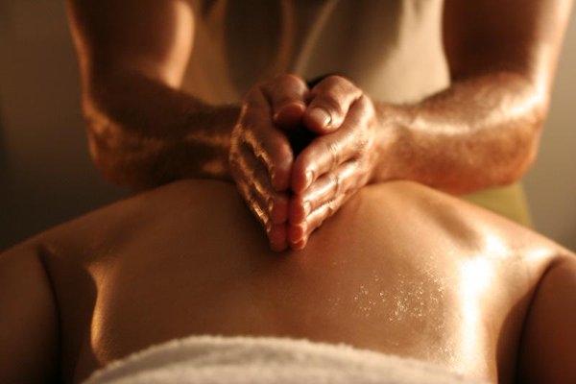

**Elakizhi**

This is a process of massaging the body with heated cloth bag filled with fried medicinal leaves like ricinus, calatropis, tamarind and more. This massage is normally done by three people. It helps in stimulating thenerves and helps in reducing pain. This is done in cases of Rheumatism, arthritis, paralysis, sciatica, spondylosis and nervous disorders.

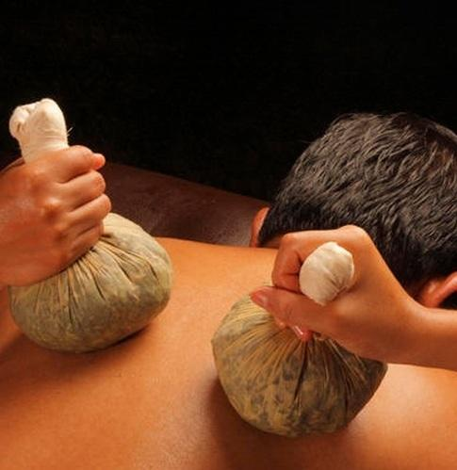

Navarakizhi

The body is massaged with linen bags filled with cooked Navara rice, frequently warming it in a mixture ofdecoction and milk. This massage is normally done by three people. It is acardinal treatment for diseases affecting the nervous system. Pain, rheumatism, emaciation of limbs, stroke, hypertension, sciatica, spondylosis etc. are the indications.

Podikizhi

This is a special type of massage done with cloth bags filled with herbal powder, which will be warmed frequently. This massage is normally done by three people. This is massage has been seen to be very effective for inflammatory joint problems and primary stages of hemiplegia.

Udvarthanam

This is the process of massaging the body with herbal powders in a reverse order. The massage is done from the bottom up. The treatment is mainly for obesity, cholesterol and certain rheumatic complaints.

Thalapothichil

Under this procedure, the head is covered with Amla (Indian gooseberry) paste prepared in buttermilk or some decoctions suitable for the condition. Then, the head is covered with a banana leaf. This procedure has been seen to be very effective for dealing with stress, anxiety, sinusitis, chronic headache, sleep disorders and hair loss.

Dhanyamladhara

This procedure will be done by four people using special pots to pour a warm acidic herbal fluid (Dhanyamlam) all over patient's body. Helps to reduce inflammation and pain in many cases and is a method of sweating without using oils. This is done for people with cases of arthritis, stroke, rheumatism etc.

Pizhichil

This is also done using special pots, pouring warm medicated oil all over the body along with gentle massage by two people and three assisting them in collecting and warming the oil. This procedure has been seen to be very helpful in many types of multi joint problems and hemiplegia. It is strictly done for specific illnesses.

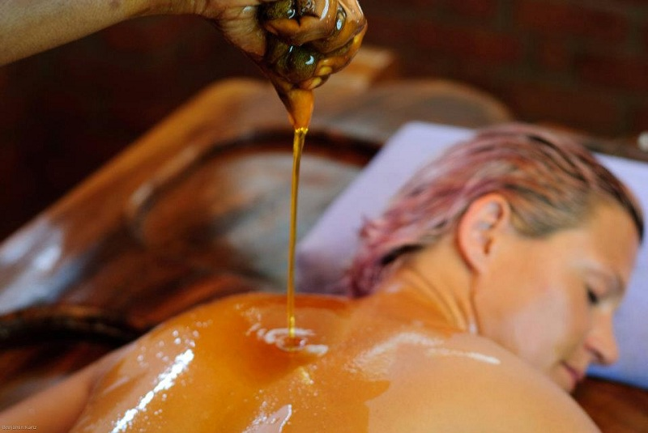

**Sirodhara**

Sirodhara means pouring of a liquid on the forehead in a continuous stream. According to the type of liquid used, Sirodhara can be classified into three types:

* Thailadhara - Sirodara with medicated oil.
* Thakradhara – Sirodhara with medicated buttermilk.
* Ksheeradhara – Sirodhara with medicated milk.

According to the liquid used, the effect will be different. Thailadhara is good for various types of nervous disorders like hemiplegia, facial palsy etc. Thakaradhara is good for various skin diseases, sleeplessness, stress and insanity. And Ksheeradhara is good for cooling the head, which helps immensely for people suffering from insomnia.

**Sirovasthy**

Under this, warm oils are kept on the head inside a leather cap for a long duration which depends on case to case. This is highly effective in cases of facial paralysis, headaches, spondylosis, hemiplegia etc.

**Snehapanam**

This involves internal administration of medicated ghee in daily increasing doses and strict restrictions on diet and activities. This is the primary preparation for all the panchakarmas. This is an internal Shehana (Oleation) procedure. It is helpful in many cases like allergic asthma, psoriasis, eczema, low immunity, hyper acidity, peptic ulcer, digestive disorders and in all kinds of mental illnesses.

**Kadeevasthy**

A particular type of oil is kept over the affected part (usually the lower back) inside a boundary made of some herbal pastes. This is particularly effective in all kinds of back pains and spinal disorders. The same procedure when done on the chest is called Urovasthy.

**Thalam**

Oils or pastes are applied on the middle of the head and kept for one hour. This has been seen to be helpful in alleviating insomnia, high blood pressure, stress and vatha conditions.

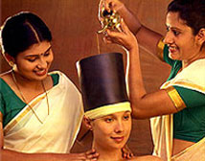

**Lepanam**

Herbal pastes are applied over the affected parts. This is usually done to reduce swelling, pain or inflammation of the joints. And this is also used to treat some skin diseases.

**Pichu**

Cotton pieces soaked in warm medicated oils are applied on the affected parts. This cotton will be soaked with warm oil frequently. This is very effective in relieving pain for muscles and joints. This is also performed on the head for some types of headaches and problems of sensory organs.

**Avagaham**

After some oil applications, the patient will be seated in a tub full of hot herbal decoction suitable for patient's condition. For the diseases of spinal cord, hip and lower back. This is very helpful for gynecological conditions.

**Upanaham**

A concoction of herbal pastes and some acidic liquids will be applied on the affected parts. This will be covered with leaves of calotropis, ricinus etc. and a cotton cloth on the top. This will be retained in place for at least 12 hours. This is highly effective for inflammatory joint pains and helps in reducing stiffness of joints and improves mobility of joints.

**NethraTharpanam**

Well melted and strained medicated ghee will be collected in a ridge made around the eyes with black gram paste. This is very effective for refractive errors and degenerative diseases of the eyes.

**Putapakam**

Herbal juice mixed with goat's milk is collected around the eyes similarly as in NethraTharpanam. This helps in relieving tiredness of the eyes helps in clearing the vision.

**Nethradhara**

This is an eye wash with special herbal decoctions, done by two persons. This has been seen to be very effective for eye infections and helps in refreshing the eyes.

**Aschyothanam**

This is nothing but application of eye drops. This has been found to be helpful in conditions like various eye infections, cataract etc.

**Mukhalepam**

A herbal powder is mixed with cow's milk and applied on the face. It is kept for one hour and then washed. This is a herbal face pack. This helps to remove wrinkles and black marks, improve the skin tone and imparts a special glow to the face. The powder is a special of the Rajah Ayurvedic hospitals under which Rajah Islands falls.

**Ksheeradhoomam**

Under this, the patients face and neck is steamed with medicated milk. This is very effective in treating facial paralysis and diseases of the sensory organs.

**Panchakarma Treatments**

**Vamanam**

This is medically induced vomiting. This is the cleansing process for the upper respiratory tract and upper digestive tract. Effective in Kapharogas and some skin diseases like leukoderma.

**Virechanam**

This is a medically induced purgation which cleanses the lower digestive tract. Almost all types of skin diseases and chronic rheumatic problems will be relieved by this.

**Nasyam**

It involves the administration of medicines through the nose in the form of drops or powders. It is one of the Panchakarmas. Highly effective for all kinds of headaches, paralysis, depression, stress, pain around the neck and shoulders, eye diseases etc.

**SnehaVasthy**

Medicated oil mixed with some herbal paste and salt, is administered through the anus. The quantity of material will be decided according to the strength of the patient and disease. One with the lowest dose of oil is called MathraVasthy. This is beneficial in chronic nervous disorders, joint problems and skin diseases.

**KashayaVasthy**

This is enema done with a mixture of honey, salt, herbal paste, herbal decoction and medicated oils. This will be preceded by one or two rounds of SnehaVasthy according to the condition of the patient. Combination of Sneha and Kashayavasthys are helpful in some chronic rheumatic problems. This is very effective for Urinary stones, nervous disorders and in some gynecological problems.

**CHAPTER-IV**

**AYURVEDA TOURISM IN KERALA**

#### AYURVEDA

Ayurveda is not just about good physical health. It is a therapy that promises holistic wellness. The natural herbs and oils used in the therapy are of great medicinal value as is said in the Vedic literature on Ayurveda. The history of Ayurveda which can be traced back to the Vedic Ages clearly lays out instructions to maintain health as well as fighting illnesses through therapies such as massages, herbal medicines, diet control and exercise.

Elimination of toxic elements from the body is the primary function of this curing remedy. The system gets purified when the poisonous elements are removed from the body. As a result, the chances of falling ill are largely zeroed down which makes one feel tension-free. It rejuvenates the mind, body and soul.

CharakaSamhitha (Treatise on Medicine), SusruthaSamhitha (Treatise on Surgery) and AshtangaSamgraha (Treatise on the basic principles) are the three major treatises in Ayurveda. These treatises tell us that every individual has a unique constitution. Every organ or system has an energy related to it and there has to be equilibrium between them. The balance generally gets affected when we fall ill. The objective of Ayurveda is to reestablish this equilibrium in order to maintain good health.

Kerala has a number of Ayurveda treatment centres which offer various packages. From treatments like uzhichil and pizhichil to curing illnesses like arthritis to beauty massages for the skin and hair; there is no place better than Kerala to seek the benefits of Ayurveda. Kerala has a number of natural herbs such as Aswagandha, Amalki, Katphal, Brahmi, Bharangi, Yashtimadhu, Shankhupusham to name a few. Turmeric, Cinnamon, Keezharnelli (PhylantusAmarus), Kilukillapa (Crotalaria Retusa Linn), Koduveli (PlumbagoZeylanica Linn) and many more herbs with medicinal values are found in Kerala.

The rainy season, from June to September, is the ideal time for Ayurvedic treatments because the atmosphere remains cool, moist, and dust free. This opens up the body’s pores, making it receptive to herbal oils and therapy. The places offering the best packages in Ayurveda in Kerala are :SomatheeramAyruveda Resort near Kovalam, KottakkalAryaVaidyaShala which is a hospital, Beach and Lake Ayurveda Resort and Surya Samudra Spa Niraamaya at Tivandrum, KeralyeemAyurvedic resort near Allepey and Ayurkshethra at Kumarakom.

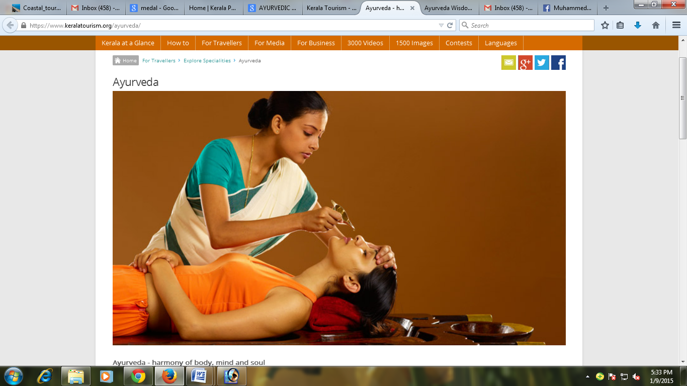

**Ayurveda Principles**

In Ayurveda a person is viewed as a unique individual made up of five primary elements. The elements are ether (space), air, fire, water, and earth. Just as in nature, we too have these five elements in us. When any of these elements are present in the environment, they will in turn have an influence on us. The foods we eat and the weather are just two examples of the presence of these elements. While we are a composite of these five primary elements, certain elements are seen to have an ability to combine to create variousphysiological functions. Ether and air combine to form what is known in Ayurveda as the Vatadosha. Vata governs the principle of movement and therefore can be seen as the force that directs nerve impulses, circulation, respiration, and elimination. Fire and water are the elements that combine to form the Pitta dosha.

The Pitta dosha is the process of transformation or metabolism. The transformation of foods into nutrients that our bodies can assimilate is an example of a pitta function. Pitta is also responsible for metabolism in the organ and tissue systems as well as cellular metabolism. Finally, it is predominantly the water and earth elements, which combine to form the Kaphadosha. Kapha is what is responsible for growth, adding structure unit by unit. Another function of the Kaphadosha is to offer protection. Cerebral-spinal fluid protects the brain and spinal column and is a type of Kapha found in the body. Also, the mucous lining of the stomach is another example of the Kaphadosha protecting the tissues. We are all made up of unique proportions of Vata, Pitta and Kapha. These ratios of the doshas vary in each individual; and because of this, Ayurveda sees each person as a special mixture that accounts for our diversity.

Ayurveda gives us a model to look at each individual as a unique makeup of the three doshas and to thereby design treatment protocols that specifically address a person’s health challenges. When any of the doshas (Vata, Pitta or Kapha) become accumulated, Ayurveda will suggest specific lifestyle and nutritional guidelines to assist the individual in reducing the dosha that has become excessive. We may also suggest certain herbal supplements to hasten the healing process. If toxins in the body are abundant, then a cleansing process known as Pancha Karma is recommended to eliminate these unwanted toxins.

Ayurveda treatments can be classified into two types2.

1. Rejuvenative: aims at total well – being and

2. Therapeutic: ailment – specific.

**Following are the rejuvenation treatments:**

Rejuvenation Therapy (RasayanaChikista): Tones up the skin and rejuvenates and strengthens all the tissues, so as to achieve ideal health and longevity. Increases 'Ojas' (primary vitality) and improves 'Sattva' (mental clarity) and thereby increases the resistance of the body. Includes head andface massage with medicated oils and creams, body massage with herbal oil or powder, by hand and foot, internal rejuvenative medicines and medicated steam bath. Herbal baths are also used.

Body Immunisation and Longevity Treatment (KayakalpaChikitsa): Prime treatment for retarding the ageing process, arresting the degeneration of body cells and immunisation of the system. It includes intake of Rasayana (special Ayurvedic medicines and diet) and comprehensive body care programmes. It is very effective for either sex, if undertaken before the age of 50.

Body Sudation (Sweda Karma): Medicated steam baths eliminate impurities from the body, improve the tone and complexion of the skin, reduce fat and are recommended for certain rheumatic diseases, particularly for pain. Precious herbs and herbal leaves are boiled and the steam is passed over the entire body for 10 to 20 minutes daily. Hand massage with herbal oils or herbal powder improves blood circulation and tones up the muscles.

Body Slimming: Medicated herbal powder and medicated herbal oil massages and an Ayuvedic diet of herbal juices are part of the programme.

Beauty Care: Beauty care programmes include herbal face pack, intake of herbal tea, herbal oil massage etc for improving the complexion and beautifies the body.

Mental And Physical Well Being (Meditation and Yoga) : Mental and physical exercises meant to isolate the ego from the body and mind - designed to hone your concentration, improve health and help attain peace of mind through eight stages of training:

* Disciplined behaviour (yama).
* Self purification (niyama).
* Bodily postures such as the lotus position (padmasana).
* Control of breathing (pranayama).
* Control of the senses (pratyahara).
* Fixing of the mind on a chosen object (dharana).
* Meditation (dhyana) and
* Samadhi - a state of being, where you experience absolute tranquillity and well –being.

7. Overall Fitness (Panchakarama Treatment): A five fold treatment for mental and physical well being - tunes the body, organs, mind, breath, nerves and purifies the blood.

**Following are the therapeutic treatments:**

Treatment for chronic headaches, insomnia, mental tension and cases of hysteria, hallucination and insanity (Dhara): Herbal oils, medicated milk or butter milk and decoctions are poured on the forehead/whole body in a special manner. Variations include OordhwangaDhara (good for diseases of the eyes, ears and skin), TakraDhara (for those suffering from memory loss, severe headache or insanity) and SarvangaDhara (for both head and body).

Treatment to alleviate osteoarthritis, leukemia etc. (Snehapanam): Medicated ghee is given internally in a gradually increased quantity for specific periods.

Treatment of dryness of nostrils, mouth and throat, severe headaches, facial paralysis and burning sensatin in the head (Sirovasti): Lukewarm herbal oils are poured into a leather cap fitted on the head for specific durations as per physician's recommendation.

Treatment for spondilosis, rheumatic diseases like arthritis, paralysis, hemiplegia, nervous weaknesses and nervous disorfers (Pizhichil): Lukewarm herbal oil applied with fresh linen all over the body by trainedmasseurs in a rhythmic manner for a period of 1 to 1.5 hrs daily for 7 to 21 days.

Treatment for musculo-skeletal ailments due to trauma or accidents (MarmaChikitsa): Treatment that works on the extremely sensitive vital points of the body (the 107 marmas).

Treatment for nasal ailments (Nasyam): Inhalation of mediated herbal preparations, decoction oils and ghee to eliminate the morbid factors from the head and neck area.

Treatment for ear ailments (Karnapooranam): Medicated oils are applied to the ear for 5 to 10 minutes daily to clean as well as treat specific ailments.

Preventing cataract and strengthening vision (Tharpanam): A treatment for the eyes, effective in preventing cataract and strengthening the optic nerve.

Treatment for wasting of muscles, rheumatism, sports injuries, pain in the joints, emaciation of the body or parts of the body and certain kinds of skin diseases (Njavarakizhi): The whole body is made to perspire by the external application of medicated rice packs in the form of boluses tied bags.

**Ayurveda Treatment Providers**

Ayurveda treatment centres can be mainly classified into two: Ayurveda hospitals and hotels and health resorts providing the services of ayurvedic treatment and spa. Among the Ayurveda hospitals Kottakal Ayurveda Sala is famous for its excellent treatment services.

**Kottakal Ayurveda Sala**

Kottakal Ayurveda sala is situated in a village called Kottakal in Malappuram district which was founded by VaidyaRatnam P.S Varrier of Kottakkal. Ayurveda owes its present status to him as he made arrangements, to organise treatment under the Ayurvedic system and prepare and supply medicines on modern times by strictly following the ancient Ayurveda texts. The Ayurveda PataSala (School for Ayurveda) was set up in 1917 and the Ayurveda chikitsasala (Hospital) in 1924.

KottakkalPooram is the annual festival at the SreeVishwambara Temple dedicated to Lord Vishnu in his incarnation as Dhanvanthiri. Dhanvanthiri, in Indian mythology, is the patron god of medicine and health. During the festival, masters of music, art, culture and literature from all over the country participate in the cultural function organised by the P. S.Warrier Trust. The Trust is run by the renowned Ayurvedic research, treatment and study centreKottakkalAryaVaidyasala.

KottakkalAryaVaidyasala is famous among foreigners. Patients from various countries are coming here to take treatments even before the concept of health tourism emerges. This hospital is dedicated to the promotion of Ayurveda and wanted to propagate the healing effect of Ayurveda. Many travel agents and multi speciality hospitals have made arrangements for tourists who want to get rejuvenated their body and mind to take treatments in KottakkalAryaVaidyasala.

**Ayurveda - harmony of body, mind and soul**

Sprouted in the pristine land of India some 5000 years ago, Ayurveda, the science of life and longevity, is the oldest healthcare system in the world and it combines the profound thoughts of medicine and philosophy. Since then Ayurveda has stood for the wholesome physical, mental and spiritual growth of humanity around the world. Today, it's a unique, indispensable branch of medicine, a complete naturalistic system that depends on the diagnosis of your body's humours - vata, pitta and kapha - to achieve the right balance.

**Kerala, the Land of Ayurveda**

Kerala possesses an unbroken tradition of Ayurveda that has surpassed the many invasions and intrusions both foreign and native. For hundreds of years the Ayurveda Vaidyas (traditional practitioners of Ayurveda) were almost the only access for people seeking healing from every kind of disease in Kerala. The legendary eight families of Vaidyas (Ashtavaidyas) and their successors treated the entire state for centuries. Unlike the other Indian states the status of Ayurveda in Kerala is not alternative but mainstream. In fact, today, Kerala is the only State in India which practices this system of medicine with absolute dedication.

Being the only resort of treatment for the people, the Vaidyars of Kerala were challenged to interpret the theories of Ayurveda and adapt them actively into effective healing systems in everyday life. Thus almost all the contemporary procedures and protocols of Ayurveda have evolved in and around Kerala.

**The Boons of Nature**

Its equable climate, natural abundance of forests and the cool monsoon season are best suited for Ayurveda's curative and restorative packages. Kerala is perhaps one of the few places on earth where a temperature of 24-28 degrees is maintained during a period of continuous rain. This prevalence of moisture in the air and on the surface of the skin makes it the ideal place for natural medicines to work at their highest levels of potency. The land is also blessed with innumerous medicinal plants and provides the continuity and consistency of Ayurveda medicines needed for effective treatment procedures. The same herbs with the same potency are available year after year across every season. The rich alkaloid content of the soil enhances the intensity and potency of many Ayurvedic medicines when compared to places with different soil constitution.

**The Advantages of Ayurveda in Kerala**

*Ashtangahridayam*, the practical, user friendly interpretation of Ayurveda, compiled by the great Vagbata is seldom used anywhere in the world as it is extensively done in Kerala. The Vaidyars of Kerala are proficient in this most contemporary treatise of Ayurveda which many scholars consider an advancement over the earlier samhitas of Charaka and Sushruta, the pioneers of Ayurveda. It is in Kerala that KashayaChikitsa (treatment with concoction) has become a standardised protocol involving hundreds of Kashayams that were scientifically classified and organised according to various treatment needs. KeraliteVaidyars where the first to focus on the anti oxidant properties of *Abayangam* leading to the profusion of *kizhis*. The largest number of Ayurveda colleges and the largest number of practitioners in comparison to any place in the world has led to a tradition of Ayurveda research in a scientific manner in Kerala.

**Ayurveda as a lifestyle**

In Kerala Ayurveda is not just a healthcare system but it is a part and parcel of every aspect of life, in fact it is a lifestyle in Kerala so to speak. The miracles like paralysed people walk, incurable diseases cured etc. that happen even today inspires respect and awe for the vaidyars of Kerala.

**WHAT IS INDIA OFFERING:**

**AYURVEDA:**

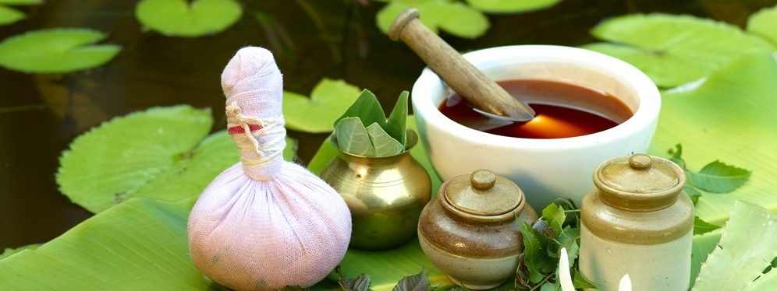India has a rich heritage in the areas of traditional and natural medicines. The earliest mention of Indian medical practices can be found in theVedas and Samhitas of Charaka, Bhela and Shusruta. A systematic and scientific approach was adopted by the sages of the time leading to the development of a system that is relevant even today.India is the land of Ayurveda. It believes in removing the cause of illness andnot just curing the disease itself. It is based on herbals and herbal components without having side effects.

Ayurveda considers that the base of life lies in the five primary elements; ether (space), air, fire, water and earth. And the individual is made up of a unique proportion of the five elements in unique combinations to form threedoshas (vata, pita and kapha). When any of these dashes become acute, a person falls ill. Ayurveda recommends a special life style and nutritional guidelines supplemented with herbal medicines. If toxins are abundant, then a cleaning process known as Panchkarma is recommended to eliminate those unwanted toxins and revitalize both mind and body. Ayurveda offers treatments for ailments such as arthritis, paralysis, obesity, sinusitis, migraine, premature aging and general health care. Kerala is a world tourist destination and part of the reasons lies with the well- known stress-releasing therapies of famedAyurvedic research centers. The climate along with the blessing of nature has turned Kerala into the ideal place for ayurvedic, curative and rejuvenating treatments.

**YOGA:**

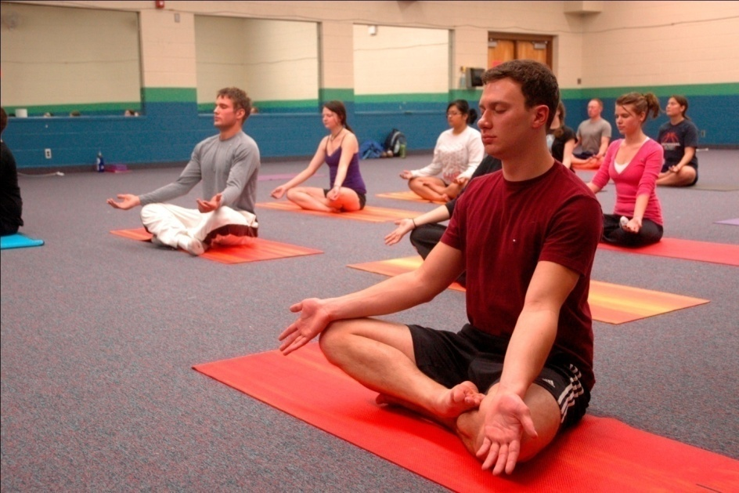

If Ayurveda is the science of body, yoga is the science of the mind. Practiced together they can go a long way in making an individual fit. The word yoga means to join together. The ultimate aim of yoga is to unite the human soul with the universal spirit. Yoga was developed 5000 years ago and the base of yoga is described in the Yoga Sutra of Patanjali.This describes eight stages of yoga. These are Yam (universal moral commands), Niyam (self purification), Asana (posture), Pranayama (breathing control), Prathyahara (withdrawal of mind from external objects), Dharana(concentration), Dhyana (meditation), and Samadhi (state of super consciousness). To get the benefits of yoga, one has to practice Asana,Pranayama and Yoganidra. With the regular practice of asanas one can 327control cholesterol level, reduce weight, normalize blood pressure and improve cardiac performance.Pranayama helps to release tensions, develop relaxed state of mind andYoganidra is a form of meditation that relaxes both physiological and psychological systems. Today, yoga has become popular in India and abroad and in a number of places including urban and rural areas yoga is taught and practiced.

**SPA TREATMENT:**

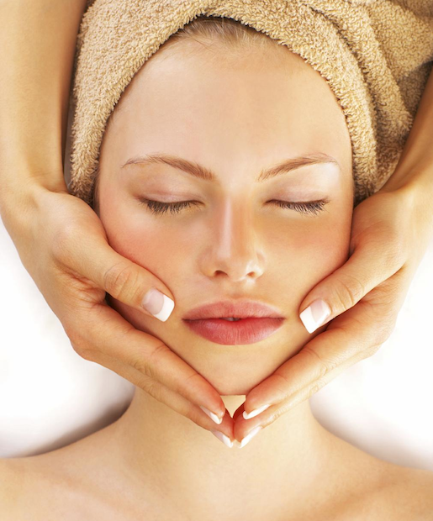

Most of the other parts of the world have their own therapies and treatment that are no doubt effective in restoring wellness and beauty. Newkinds of health tours that are gaining popularity in India are spa tours. Spasoffer the unique advantages of taking the best from the west and the east combining them with the indigenous system and offering best of the twoworlds. In hydropath, Swedish massages work with the Javanese Mandy, lulur,aromatherapy, reflexology and traditional ayurveda procedures to help keep the tourist healthy and enhance beauty. Combining these therapies with meditation, yoga and pranayama make the spa experience in India a new destination for medical tourism. The spas are very useful for controlling blood pressure, insomnia, cure tension, depression, paralysis and number of other deadlydiseases. Ananda Resort in Rishikesh, Angsana Resort, Golden Palm Spa andAyurgram in Bangalore offer ayurveda, naturopathy, yoga and meditation packages. (Gaur Kanchilal) Allopathy India has made rapid strides in advanced health care systems, which provides worldclass allopathic treatment. This has become possible because of the emergence of the private sector in a big way in this field. More and more foreign tourists are realizing that India is an ideal place for stopover treatment. Indian Multi-specialty hospitals are providingworldclass treatment at an amazingly economical cost as compared to the west.Quality services and low price factor primarily go in favour of India. The cardiocare, bone marrow transplantation, dialysis, kidney transplant, neuronsurgery, joint replacement surgery, urology, osteoporosis and numerous diseases are treated at Indian hospitals with full professional expertise. Apollo hospital group, Escorts in Delhi, Jason Hospital, Global Hospital, and Max Health Careare catering to medical care for international patients in the areas of diagnostic,disease management, preventive health care and incisive surgeries.The tourism department has devised websites in order to provide information. Many Ayurveda health resorts that are owned by traditionalAyurveda Institutes have come up. Ayurgram is a novel concept that not only offers heritage accommodation but also offers a whole range of Ayurvedictreatments and rejuvenating packages.

**HEALTH CARE POTENTIALS OF KERALA**

Health care resources of Kerala include holistic systems of medicine such as Ayurveda, Unani, Siddha, Naturopathy, Yoga and Meditation and modern medicines like Allopathy – surgery, plastic surgery, dental treatment and eye care treatment.

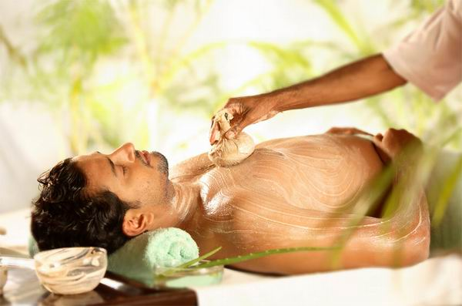**Ayurveda**

Ayurveda is a holistic system of healing that has a tradition of 3000 years old. Kerala and Ayurveda are synonymous to each other, as it is the only place on earth where Ayurveda is practised with absolute authenticity and dedication. This ancient Indian system of medicine has proved to be not only the cure for illness but also the 100 percent natural way to prefect health. The methods of Ayurveda are unique and universal. Instead of treating the symptoms of a disease, it treats the individual and caring is given for the entire body. Ayurveda medicines are purely natural and absolutely free of side effects.

**Ayurveda treatments can be classified into two types2.**

1.Rejuvenative: aims at total well – being and

2. Therapeutic: ailment – specific.

Following are the rejuvenation treatments:

1. Rejuvenation Therapy (RasayanaChikista): Tones up the skin and rejuvenates and strengthens all the tissues, so as to achieve ideal health and longevity. Increases 'Ojas' (primary vitality) and improves 'Sattva' (mental clarity) and thereby increases the resistance of the body. Includes head andface massage with medicated oils and creams, body massage with herbal oil or powder, by hand and foot, internal rejuvenative medicines and medicated steam bath. Herbal baths are also used.

2. Body Immunisation and Longevity Treatment (KayakalpaChikitsa): Prime treatment for retarding the ageing process, arresting the degeneration of body cells and immunisation of the system. It includes intake of Rasayana (special Ayurvedic medicines and diet) and comprehensive body care programmes. It is very effective for either sex, if undertaken before the age of 50.

3. Body Sudation (Sweda Karma): Medicated steam baths eliminate impurities from the body, improve the tone and complexion of the skin, reduce fat and are recommended for certain rheumatic diseases, particularly for pain. Precious herbs and herbal leaves are boiled and the steam is passed over the entire body for 10 to 20 minutes daily. Hand massage with herbal oils or herbal powder improves blood circulation and tones up the muscles.

4. Body Slimming: Medicated herbal powder and medicated herbal oil massages and an Ayuvedic diet of herbal juices are part of the programme.

5. Beauty Care: Beauty care programmes include herbal face pack, intake of herbal tea, herbal oil massage etc for improving the complexion and beautifies the body.

6. Mental And Physical Well Being (Meditation and Yoga) : Mental and physical exercises meant to isolate the ego from the body and mind - designed to hone your concentration, improve health and help attain peace of mind through eight stages of training:

1. Disciplined behaviour (yama).
2. Self purification (niyama).
3. Bodily postures such as the lotus position (padmasana).
4. Control of breathing (pranayama).
5. Control of the senses (pratyahara).
6. Fixing of the mind on a chosen object (dharana).
7. Meditation (dhyana) and
8. Samadhi - a state of being, where you experience absolute tranquility`and well –being.
9. Overall Fitness (Panchakarama Treatment): A five fold treatment for mental and physical well being - tunes the body, organs, mind, breath, nerves and purifies the blood.

**Following are the therapeutic treatments:**

1. Treatment for chronic headaches, insomnia, mental tension and cases of hysteria, hallucination and insanity (Dhara): Herbal oils, medicated milk or butter milk and decoctions are poured on the forehead/whole body in a special manner. Variations include OordhwangaDhara (good for diseases of the eyes, ears and skin), TakraDhara (for those suffering from memory loss, severe headache or insanity) and SarvangaDhara (for both head and body).

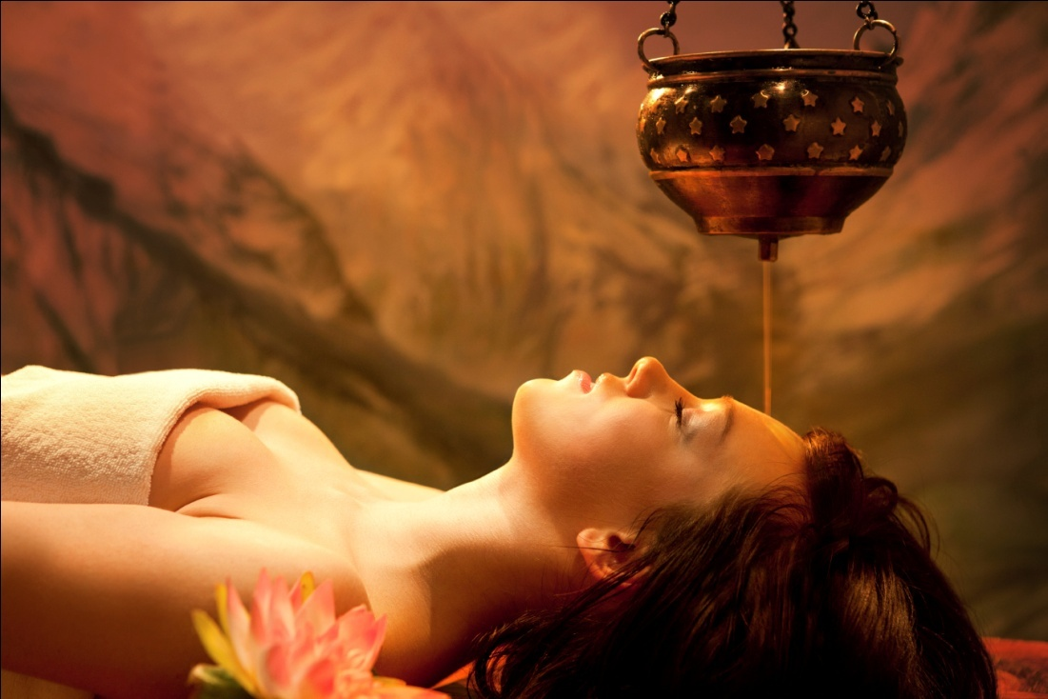

2. Treatment to alleviate osteoarthritis, leukemia etc. (Snehapanam): Medicated ghee is given internally in a gradually increased quantity for specific periods.

3. Treatment of dryness of nostrils, mouth and throat, severe headaches, facial paralysis and burning sensatin in the head (Sirovasti): Lukewarm herbal oils are poured into a leather cap fitted on the head for specific durations as per physician's recommendation.

4. Treatment for spondilosis, rheumatic diseases like arthritis, paralysis, hemiplegia, nervous weaknesses and nervous disorfers (Pizhichil): Lukewarm herbal oil applied with fresh linen all over the body by trained masseurs in a rhythmic manner for a period of 1 to 1.5 hrs daily for 7 to 21 days.

5. Treatment for musculo-skeletal ailments due to trauma or accidents (Marma Chikitsa): Treatment that works on the extremely sensitive vital points of the body (the 107 marmas).

6. Treatment for nasal ailments (Nasyam): Inhalation of mediated herbal preparations, decoction oils and ghee to eliminate the morbid factors from the head and neck area.

7. Treatment for ear ailments (Karnapooranam): Medicated oils are applied to the ear for 5 to 10 minutes daily to clean as well as treat specific ailments.

8. Preventing cataract and strengthening vision (Tharpanam): A treatment for the eyes, effective in preventing cataract and strengthening the optic nerve.

9. Treatment for wasting of muscles, rheumatism, sports injuries, pain in the joints, emaciation of the body or parts of the body and certain kinds of skin diseases (Njavarakizhi): The whole body is made to perspire by the external application of medicated rice packs in the form of boluses tied bags.

**Ayurveda Treatment Providers**

Ayurveda treatment centres can be mainly classified into two: Ayurveda hospitals and hotels and health resorts providing the services of ayurvedic treatment and spa. Among the Ayurveda hospitals Kottakal Ayurveda Sala is famous for its excellent treatment services.

**Kottakal Ayurveda Sala**

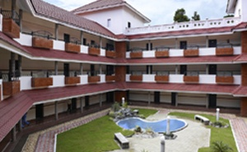

Kottakal Ayurveda sala is situated in a village called Kottakal in Malappuram district which was founded by VaidyaRatnam P.S Varrier of Kottakkal. Ayurveda owes its present status to him as he made arrangements, to organise treatment under the Ayurvedic system and prepare and supply medicines on modern times by strictly following the ancient Ayurveda texts. The Ayurveda PataSala (School for Ayurveda) was set up in 1917 and the Ayurveda chikitsasala (Hospital) in 1924.

KottakkalPooram is the annual festival at the SreeVishwambara Temple dedicated to Lord Vishnu in his incarnation as Dhanvanthiri. Dhanvanthiri, in Indian mythology, is the patron god of medicine and health. During the festival, masters of music, art, culture and literature from all over the country participate in the cultural function organised by the P. S.Warrier Trust. The Trust is run by the renowned Ayurvedic research, treatment and study centreKottakkalAryaVaidyasala.

KottakkalAryaVaidyasala is famous among foreigners. Patients from various countries are coming here to take treatments even before the concept of health tourism emerges. This hospital is dedicated to the promotion of Ayurveda and wanted to propagate the healing effect of Ayurveda. Many travel agents and multi speciality hospitals have made arrangements for tourists who want to get rejuvenated their body and mind to take treatments in KottakkalAryaVaidyasala.

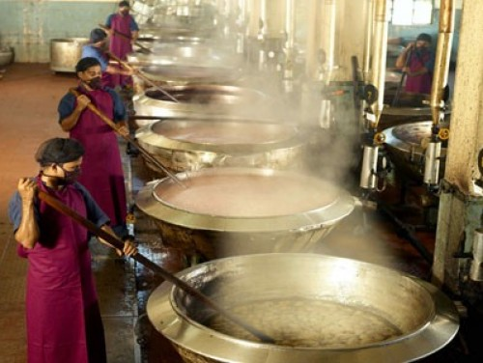

Preparation of Ayurvedic Medicine

**CLASSIFICATION OF AYUR VEDA CENTRES3**

The ayurvedic system of medication has become an extremely important and popular attraction for tourism in Kerala. In the state, it is virtually a way of life and perhaps the only place in the country, where it is practised in its true and authentic form. A number of centres have come up and they are spread through out the state. The Government recognised the need to evaluate the safety and service standards of these ayurvediccentres and classify them properly, to ensure that the efficacy and the genuineness of this system of medicine does not get affected, which would have a direct impact on the number of tourists visiting the state. Those centres that fulfil the essential conditions prescribed by the Department of Tourism would be classified as the Olive Leaf status.

Those centres that fulfil the optional conditions also, in addition to the essential conditions, are accorded the Green Leaf status of classification. Some of the important features of these are given below:

**Essential conditions for ‘OLIVE LEAF’**

Personnel:

• Treatment / therapy should be done only under the supervision of a qualified physician with a recognised degree in Ayurveda.

• Separate Masseurs for male and female patients should be present – with at least one male and one female masseur.

• The masseurs must have training from recognized Ayurveda institutions

Quality of medicine:

• Only those programmes approved by the Approval Committee shall be offered

• Health programmes shall be clearly displayed along with the time taken for massages and treatments.

• The approved time limit for a massage is 45 minutes.

• Medicines and material shall be clearly labelled, displayed and acquired from an approved and reputed firm

Equipment:

• The massage table shall confirm to a minimum size (7ft x 3 ft), made of good quality wood or fibreglass.

• A Gas or electric stove shall be operational and medicated hot water facility for bathing and other purposes shall be provided for.

• Sterilization facilities shall be provided.

• All equipment, areas, apparatus shall be clean and hygienic.

Facilities:

• Separate treatment rooms – at least one each, separately for male and female shall be provided. These should be well ventilated and should be at least of 100 sqft of area (width not less than 8 ft). Toilets should have proper sanitary fittings and floors and the walls should be furnished with tiles.

• One Consultation room shall be provided for a minimum size of 100ft (width not less than 8 ft). The rooms should be well equipped with medical instruments like BP apparatus, stethoscope, examination couch, weighing machine, etc.

• A separate rest room (minimum size of 100ft with width not less than 8 ft), should be provided, in case the centre is not attached to a hotel/resort/hospital

• General infrastructure should be good. Locality and ambience, including accessibility should be suitable. Furnishing should be of good quality. The centre and surrounding premises should be kept clean and hygienic.

Optional conditions for ‘GREEN LEAF’

In addition to the above essential requirements, centres having some additional / optional features, would be accorded the Green Leaf certification.

• High standards of construction of the building, architectural features etc. with excellent furnishings, curtains etc. in superior quality materials

• Adequate parking facility in the premises.

• Bathrooms facilities for steam bath.

• Separate halls for meditation and yoga.

• Location of the centre in picturesque surroundings with a quiet ambience.

• Herbal garden attached to the Centre.

Ayurvediccentres that are provided with a licence or classification would be eligible for claiming a 10% state investment subsidy or electric tariff concession, offered by the Department of Tourism. Details of classified Ayurveda health centres in Kerala is given in Appendix V

**Role of Ayurveda in Health Tourism**

Ayurveda is one of the components of health tourism and it is the main contributor to Kerala’s health tourism. Ayurveda and Kerala are synonymous to each other. It is the trade mark of Kerala’s health tourism. It is a holistic treatment that has no side effects and hence it is very popular among health care travelers. The treatment under Ayurveda helps to rejuvenate body and mind. One can take holiday and rejuvenate his body and mind undergoing Ayurveda treatment. Not only health tourists but also tourists coming with some other specific purposes are also interested in Ayurveda. Following table shows details regarding the tourists interested in Ayurveda.

**Yoga and Meditation**

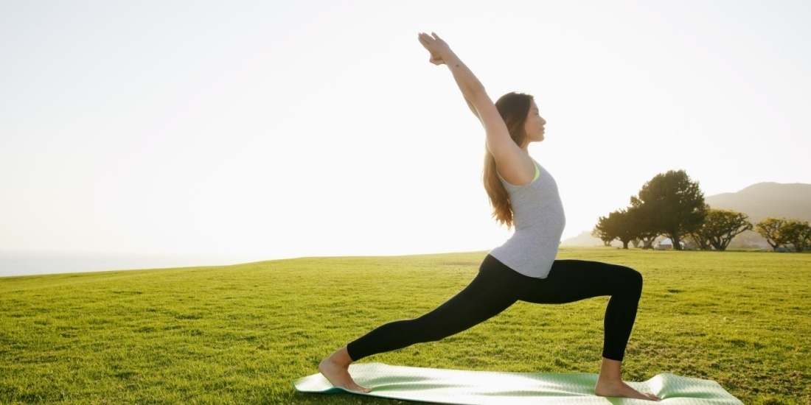

Yoga, the science of man, based on ancient Indian wisdom and culture, is an art of living a healthy, balanced, peaceful and contented life. Yoga, being a total integrated system, studies man in his wholeness - body, mind and spirit and is integrated to certain principles, ideas, values, attitudes and a way of life for personal and social benefits. Conceived by the great sages in their quest for self-realization, it has come to be recognized during its long travails from the hermitages to the cities - as the science of man, a philosophy of old life, a code of conduct, an attitude and an approach, as well as an art of living which is capable not only of ensuring physical well-being, mental peace harmony, moral elevation and spiritual uplift of man but also of transforming man from his gross animal existence to the sublime heights of divinity.

Yoga had recognized and accepted the importance of the mind and the subconscious over the total human personality much earlier than modern psychology did in its present form. Yoga is a stepwise, stage wise eight-fold path to final liberation from pain and suffering. These steps progressively take us to the highest state of creativity, of discriminative knowledge and towards attaining the desired perfection.

The eight steps are:

1. Yama : Conditional yoga behaviour, personal and social
2. Niyama : Attitude sublimate to yoga norms
3. Asana : Discipline of the physical body
4. Pranayama : Control over bio energy through respiratory action
5. Pratyahara : Withdrawal of the senses inwards through abstraction
6. Dharna : Concentration
7. Dhyana : Meditation
8. Samadhi : Trans consciousness

Of these, the first five, which border on the Psychosomatic Approach, are referred to as External (Bahiranga) yoga, popularly known as Hatha Yoga, while the latter three, which directly affect the psyche are known as internal (Antaranga) yoga, popularly known as Raja Yoga. It is almost impossible to try internal yoga (Raja Yoga) for the average man before accomplishing the external one (Hatha Yoga). The respective sequence of the eight steps is the standard methodology of yoga. Yoga is based on a deep understanding of man and his position in this world and was the first system evolved in the world to recognize the connection and the interaction between body and mind. It studies in depth the very structure of the human personality, through analysis the psychological complexities and the cause of human pain, sorrow and suffering. It has laid down psychosomatic means through its various psycho-physiological processes for dealing with the body mind complex and tries to harmonize and integrate the human personality at all levels and stages of life.

Yoga is basically a way of Life, which has been evolved as a system to go beyond the personality - complex and achieving absolute freedom-liberation of the spirit from the matter

**Unani and Siddha**

Unani

Unani, the system of medicine originated in Greece and flourished in Asia, especially India bears similarities with Ayurveda. Practiced mostly by Muslims, Unani practitioners are found in all parts of India, and a large number of them in Kerala. Unani is an Arabic word which means Greek. Unani principles are so close to that of Ayurveda. According to Unani, the basic elements of nature are earth, water, air and fire. These four elements are known as ARKAN. Each element has its own properties and goes into the making of everything in the universe.

**Siddha**

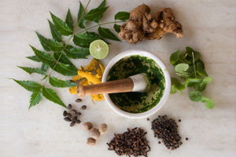

Herbs and minerals found in the nature are used in the production of Siddha medicine. The medicines are simple, yet effective. All types of diseases have medicine in Siddha. The materials used in the production of Siddha medicines include leaves, bark, root and other parts of plants and trees, metals like silver, gold, iron and mercury. It is to be noted the metals are not used as such, but prepared through vigorous purification processes that lasts over several days. After purification, the metal is called bhasma (ash), which the body can use.

The ultimate aim of Siddha medicine is moksha or salvation from the cycle of the pangs of births and deaths by strengthening the body. The goal is similar to that of yoga. Siddha medicine tries to reach this stage by giving immortality to body.

Out of 370 health tourists only 7(1.89%) persons of them has given first priority to Siddha and Unani treatment.

**Naturopathy**

Naturopathy is a system of healing science stimulating the body’s inherent power to regain health with the help of five great elements of nature – Earth, Water, Air, Fire and Ether. Naturopathy is a call to "Return to Nature" and to resort to simple way of living in harmony with the self, society and environment. Naturopathy provides not only a simple practical approach to the management of diseases, but a firm theoretical basis which is applicable to all the holistic medical care and by giving attention to the foundations of health; also offers a more economical frame work for the medicine of future generation.

The methods applied for cure in Naturopathy are the following: -

1. Water Therapy: Water is the most ancient of all the remedial agents. It is employed in different forms in treatment and produces several types of physiological effects depending upon temperature and duration. Hydrotherapy is employed in almost all types of disease conditions.

2. Air Therapy: Fresh air is essential for good health. Air therapy is employed in different pressures and temperatures in variety of disease conditions.

3. Fire Therapy: Existence of all the creatures and forms depends upon “Agni” (Fire). In Nature Cure treatment, different temperatures are employed through different heating techniques to produce different specific effects.

4. Space Therapy: Congestion causes disease. Fasting is the best therapy to relieve congestion of body and mind.

5. Mud Therapy: Mud absorbs, dissolves and eliminates the toxins and rejuvenates the body. It is employed in treatment of various diseases like constipation, skin diseases etc.

6. Food Therapy: Most of the diseases are amenable through food therapy. As you eat so will you be physically as well as mentally. Your food is your medicine. These are the main slogans of Nature Cure.

7. Massage Therapy: Massage is generally employed for tonic, stimulant and sedative effects. It is an effective substitute for exercise.

8. Acupressure: There are different points on hands, feet & body which are associated with different organs. By applying pressure on theseselected points, related organs can be influenced for getting rid of their ailments.

9. Magneto Therapy: Magnets influence health. South and North poles of different powers and shapes are employed in treatment, by applying directly on different parts of the body or through charged up water or oil.

10. Chromo Therapy: Sun rays have seven colours – violet, indigo, blue, green, yellow, orange and red. These colours are employed through irradiation or body or by administering charged water, oil and pills for treatment6.

**Kalari Treatment**

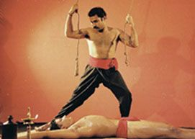

Marmachikilsa in Kerala is centuries old. Marma is "Vital spots" and Chikilsa means "Treatment". It emerged as a treatment system for warriors or soldiers who fought in wars and conflicts and suffered physical injuries. Several treatment techniques were used for treating different kinds of injuries like wound, fractures etc. Siddha system of treatment gives emphasis to marmachikilsa. MarmaChikilsa is mainly performed by specialists who know well about the vital (marma) spots on human body. There are total 108 Marma points in the body in which 64 are considered as deadly points. These points could be used to heel or to harm. If these points are pierced hard, it could result in trauma or even death. A Kalari masseur uses the Marma points to heal. Kalarimarma treatment is as sophisticated as the uzhichil treatment of Ayurveda.

Kalari massage is a traditional massage, performed by the therapist using his hand and feet by applying appropriate pressure on vital parts of the human body. It is a full body massage with medicated oil to stimulate the Marma points on the body. Kalari massage helps the body in attaining ahealthy constitution with flexibility, nimbleness and suppleness. It also enables proper blood circulation and easy maneuverability of the body for twisting and turning. Kalari massage relieves various aches like back pain, stiffness, dislocations, injuries and also stimulates various bodily organs and systems7.

Kalarippayattu, evolved as a physical cum material art of Kerala during the early centuries of the Christian era, had been enlarged in the later years with the addiction of physiotherapy, bone setting and marmachikitsa systems. Institutions practisingkalarippayattu developed in to treatment centres for marma disorders and rheumatic ailments. Medicated oils were widely being used for kalari exercise. Massage or Uzhichil was considered to be one of the essential parts of this exercise to attain flexibility for different parts of human body. It could be learent that the kalari masters have been influenced by the knowledge assimilated from the flok medical systems of Ayurveda. The exercise and therapy attached to kalarippayattu have paved the foundation for the health of the people of the state through centuries8.

**Allopathy**

The term "allopathy" was coined in 1842 by C.F.S. Hahnemann to designate the usual practice of medicine (allopathy) as opposed to homeopathy, the system of therapy that he founded based on the concept that disease can be treated with drugs (in minute doses) thought capable of producing the same symptoms in healthy people as the disease itself. This system of medical practice treats disease by the use of remedies which produce effects different from those produced by the disease under treatment.

Treatment packages under allopathy system of medicine are:

a. Orthopaedics

• Minimally invasive surgery for total knee, hip replacement

• Revision of Joint Replacement

• Shoulder Replacement

• Treatment for all types of sports injuries

**Basic elements of Ayurvedic medicine**

**Diabetes Treatment**

Ayurvedic medicine with its roots in India, originated during the Vedic period. As a medicinal theory that complements the concept of allopathic medicine; Ayurvedic medicine is geared to the principle of five elements. According to its basic premise not only the universe but the human body which is a part of the universe is constituted by five essential elements of earth, air, water, fire and ether.

The medicinal theory of Ayurveda, which has human body in its prime focus, enshrines the composing units of human body in the following manner. According to it human body is constituted by

Similar to the Elizabethan concept of 'humors' as necessary tools of balance in the human body, Ayurvedic medicine dwells on the proper balance of wind, bile and phlegm. According to the century's ancient Oriental medical practice, imbalance in the mentioned elements of wind, bile and phlegm; gave rise to defects or 'dosas' in human body and that a healthy metabolic system rests on a rightful balance of these elements which existed in equal measures in the human body.

In keeping with the concept that there are twenty essential qualities or 'guna' typical of each and every substance of the universe, Ayurvedic medicine upholds the application of the remedial measures when any of the fundamental qualities are disturbed on account of the imbalance in the 'vatas' of wind or air; bile or pitta and 'khapa' or phlegm. Its therapeutic regimen rests on the devices of exercise, meditation and massage. It dwells on the belief that by way of the mentioned regimens of exercise, meditation and massage imbalance in the physiological system can be rectified. Besides that, a healthy system striking the right balance between its composing humors; thrives on healthy digestion and required excretion of toxic elements.

Ever since the later Vedic age; the medicinal system of Ayurveda was classified into eight separate disciplines. Involving different regimens of treatments seeking to cater to different organic system of human physiology, there are areas catering to internal medication, pediatric, psychiatry, surgery, toxicology, child bearing capacities, revitalization of the immunity, and that serving to rectify the disorders in eye, ear, nose and throat.

**Ayurveda Diet and Ayurvedic Diet Tips**

As a medicinal concept holistic in purpose; it not only upholds the maintenance of proper balance; but also emphasizes a moderate expression of instinctive urges and desire with sleep, food consumption, sexual and other activities being carried out in proportional measures. 'CharakaSamhita' throws significant light on the diagnostic procedures of Ayurvedic medicine. The tenfold method of disease diagnoses involves the examination of patient's build up or constitution with accurate measurement of his height, weight and structure, assessing the nature and essence of his abnormality; recognition of factors which may lead to stability. It also involves an assessment of his diet peculiarities and necessary correction to be made therein. The vital factors of his age, stamina, digestive and psychiatric capabilities are also kept in mind while deducing the cause, origin and the nature of disease.

Similar to the allopathic mode of treatment, another of the fundamental tenets of Ayurvedic medicine involves the study and analysis of symptoms and pathogenic development of a disease. The therapeutic measure also bears in mind the factors of effects and side effects; whether it has been able to get rid of the original factor and the symptomatic factors exhibited by the disease it seeks to rectify.

**Cancer Treatment in Ayurveda**

The medicines used as part of Ayurvedic therapy are made of herbs and various aspects of the natural flora. For the remedial procedure of certain diseases animal and alcoholic elements are also made use of. Extracts of plants and animals are used in forms of tar, oil and paste meant for topical application. Emphasizing basically on external application and massage, there are those meant for oral consumption as well.

**CHAPTER-V**

**FINDINGS, SUGGESTIONS AND CONCLUSION**

**FINDINGS**

* Ayurvedic tourism is a craze for the tourists visiting Kerala and it has become the major element of tourism in the state
* Ayurveda plays a major role in Kerala’s round the year tourism. The tourism season in Kerala is from October to March. But Ayurvedic treatments are mainly offered during monsoon months of June, July, and August. Moreover ayurvedic treatments done in Kerala are more famous than other locations due to its equable climate.
* Increase foreign investment through Ayurveda tourism.
* Different treatments of Ayurveda is more better for human health.
* Ayurveda tourism helps to the effective use of natural resources.
* Ayurveda treatment is more effective then compare to other types of treatment.
* Ayurveda tourism helps to economic development
* No side effects is Ayurveda treatments.
* Ayurveda tourism provide a mental and physical satisfaction to tourist.

**SUGGESTIONS**

* Domestic tourists for Ayurveda treatment is low than foreign tourists. Govt. should give more advertisement in other states of the country.
* Strategic management must be implemented for the large scale growth of tourism in Kerala.
* Conduct special tourism fairs and festivals in rural areas for knowing the social and cultural life, interaction, with people, knowing the local arts, music, dance and crafts
* Kerala has to promote privatization on a bigger scale to create more and more tourism infrastructure and employment opportunities.
* Govt should provide a special fund for Ayurveda tourism
* Start more Ayurveda resorts in Kerala.
* Provide awareness classes for the public to understand the benefits of ayuverda treatments
* Utilize natural resources in optimum manner for Ayurveda tourism.
* Attract foreigners our culture and tradition.

**CONCLUSION**

Health tourism is not a new concept and it is thousands of years old. Earliest health tourism centres were run by Greeks, ancient Romans, Persians, Arabs, Europeans and Indians. In the current scenario, health tourism is gaining popularity as more people prefer healthcare travel in search of getting high quality treatment at low cost. Health tourism destinations take it as a golden chance to explore their healthcare and tourism resources and thereby gain economic growth. India also can use this opportunity to excel in health tourism by highlighting its holistic treatments and sophisticated multi speciality hospitals in addition to tourism attractions. This study tries to examine the potentials of Kerala to become one of the world’s best health tourism destinations.

Kerala has enormous potential to emerge as one of the world’s best health tourism destinations. Its splendid flora and fauna, beaches, back waters; festivals etc. have the ability to lure more and more tourists. It is capable of becoming a heaven for wellness tourists by highlighting holistic treatments such as Ayurveda, spa, yoga, meditation, naturopathy etc. Emergence of accredited multi speciality hospitals gives boost to medical tourism. Health tourism is not a one time business. Satisfied health tourists will recommend Kerala as a health tourism destination to their nearby. Hence health tourism providers should try to maintain service quality.

Ayurveda is one of the components of health tourism and it is the main contributor to Kerala’s health tourism. Ayurveda and Kerala are synonymous to each other. It is the trade mark of Kerala’s health tourism. It is a holistictreatment that has no side effects and hence it is very popular among health care travelers. The treatment under Ayurveda helps to rejuvenate body and mind. One can take holiday and rejuvenate his body and mind undergoing Ayurveda treatment. Not only health tourists but also tourists coming with some other specific purposes are also interested in Ayurveda.

**REFERENCES**

1. Tourism Brochure.Retrieved.from. Department of Tourism Kerala
2. Menck, K. W. Medical tourism _ a new market for developing countries. Retrieved June 28, 2006
3. http://indianmedicine .nic.in/html/nature/nature.htm
4. http://www.anjane¬yam.com/marma.htm
5. <http://en.wikipedia.org/wiki/Health_tourism_provider>