**CHAPTER I**

**INTRODUCTION**

**1.1 INTRODUCTION**

Kudumbashree, the poverty eradication mission of the state of Kerala is a community based self-help initiative involving poor women. It has been envisaged as an approach to poverty alleviation focusing primarily on micro finance and micro-enterprise development, and integrally linked to local self-government institutions. National Bank of Agriculture and Rural Development (NABARD) initiated women Self Help Groups (SHGs) in India with the support of local NGOs. The formation of SHGs led to the implementation of Swarnajayanti Gram SwarozgarYojana(SGSY), launched by the Ministry of Rural Development. In a similar line Kudumbashreeis sponsored by local self-government institutions in Kerala. Though local government institutions are not organically linked to Kudumbashree, they are active partners in the programme.

Under Kudumbashree, women have organized themselves under a three – tier community based organization. The bottom of the KDMS programme is formed by the Neighborhood Groups (NHGs) comprising of 20-40 women members selected from poor families. Area Development Society (ADS) is formed at the level of ward of local government by federating 8-10 NHGs. The Community Development Society (CDS) formed at the village Panchayath level or at the municipality (town) or corporation (city) is a federation of ADSs. CDS, the highest tier, is the federation of all the ADSs in the respective Panchayath (rural) or municipality (town) or corporation (city).The KDMS system works in close association with both the urbanand rural local governments through a network of Community Based Organizations working with women.

As on March 2008, KDMS has covered 36, 53,655 families through 1, 85,309 NHGs, 16,950 ADSs and 1058 CDSs. It also plays an important role as a nodal agency for anti-poverty programs sponsored by central, state and local governments with focus on micro enterprise development. It has become a conduit for a variety of government programs. This poor women-oriented self-help group programme strives to tackle poverty in an integrated manner through an effective convergence of resources and actions.

Micro finance, especially provision of thrift and credit services using bank linkage appears to have proved its viability. Thrift and Credit activities at the level of NHGs promote saving habit among the poor and help them access loans for both consumption and investment purposes. These Thrift and Credit Societies play a significant role in channelizing rural savings for the poverty eradication programme of Kudumbashree. It has developed training modules for micro-enterprise management and conducted several training programs. Kudumbashreemission is implementing the projects for the destitute. Various development activities in the state of Kerala are being brought together through the group dynamics developed under the Kudumbashreeprogramme. This has resulted in convergence of resources leading to poverty reduction.

It is significant to examine the functioning of KDMS programme in the state of Kerala which has caught the attention world-wide, due to high social and equitable development in the backdrop of limited economic growth. Kerala, despite having a relatively low GNP, has achieved life expectancies comparable to industrially advanced countries. Among various Indian states it has an impressive Human Development Index (HDI). From the gender perspective also, it has made impressive performance. The sex ratio in Kerala state is 1,058 females per 1, 000 males compared to all India ratio of only 933 females per 1,000 males. In terms of HDI Kerala has consistently held the top position among the major states for 1981, 1991 and 2001 (Planning Commission 2002). The gender gap in literacy rates is much smaller in Kerala, compared to other regions in India. Education of women has been linked to the low fertility rates, which together are key indications of the emancipation of women. Infant mortality rates stand impressive in Kerala at one fifth of India’s rate.

Kudumbashree was conceived as a joint programme of the Government of Kerala and NABRD implemented through Community Development Societies (CDSs) of Poor Women, serving as the community wing of Local Governments. Kudumbashree is formally registered as the "State Poverty Eradication Mission" (SPEM), a society registered under the Travancore Kochi Literary, Scientific and Charitable Societies Act 1955. It has a governing body chaired by the State Minister of LSG. There is a state mission with a field officer in each district. This official structure supports and facilitates the activities of the community network across the state.

Kudumbashree differs from conventional programs in that it perceives poverty not just as the deprivation of money, but also as the deprivation of basic rights. The poor need to find a collective voice to help claim these rights. The grassroots of Kudumbashree are Neighbor Hood Groups (NHG in short) that send representatives to the ward level Area Development Societies (ADS). The ADS sends its representatives to the Community Development Society (CDS), which completes the unique three-tier structure of Kudumbashree. Today, there are 4.58 lakhs NHGs, over 19,700 ADSs and CDSs in Kudumbashree. It is this network that brings women to the GramaSabhas and helps them bring the needs of the poor to the attention of the local governments. The Community Development Societies are also very active in Government programs and play significant roles in development activities ranging from socio-economic surveys and enterprise development to community management and social audit. Though its efforts to engage women in civil society in development issues and opportunities, Kudumbashree in association with the local self-government of Kerala is charting out new meaning and possibilities for local economic development and citizen centric governance.

Kudumbashree, the State Poverty Eradication Mission was launched in 1998, with the objective of eradicating poverty with focus on micro credit and self-help groups, thereby enhancing living standards of poor women in the State. This self-help group programme, through its 13 years of concerted and continuous action, has created sustainable living options for the under privileged sections of the society.

**1.2 STATEMENT OF THE PROBLEM**

Kudumbashree plays a very significant role in the development of rural area by means of providing number of benefits such as providing loans, giving self-employment opportunities, social welfare programs and construction of roads etc. All the studies undertaken with respect to kudumbashree units are women empowerment through kudumbashree but kudumbashree gives number of benefits to rural community and helps in the development of that area that is notable achievement. So this aspect is examined in this study.

**1.3 SIGNIFICANCE OF THE STUDY**

Rural development is an important element of economic development of a nation. Many studies were conducted with respect to kudumbashree units in general but no serious study has been conducted with respect to benefits given by kudumbashree towards rural community for their development. Hence it is believed that this study is meaningful and relevant.

**1.4 SCOPE OF THE STUDY**

The study is conducted to evaluate the benefits given by kudumbashree towards rural community. The findings and conclusion from this study are based on response of kudumbashree members. The study will be helpful to the society and its members.

**1.5 OBJECTIVES OF THE STUDY**

The study has the following objectives;

1. To evaluate the women empowerment through kudumbashree.

4. To evaluate the satisfaction level of kudumbashree members.

4. To understand the role of kudumbashree in the development of rural area.

4. To analyze the problem faced by kudumbashree members.

**1.6 METHODOLOGY**

In common words research means to search for knowledge. One can also define research as a scientific and systematic search for information on specific topic. In fact research is an art of scientific investigation.

Research methodology is the way to systematically solve the research problems. It describes the procedure which has been used in the research.

The present study title ‘Benefits given by kudumbashree towards rural community” has been designed as an analytical and descriptive study. The study has been undertaken to identify services provided by the units, developments and women empowerment etc.

**1..1 RESEARCH DESIGN**

Research design is the arrangement of condition for collection and analysis of data in a manner that to combine relevance to the research purpose. The research design refers to pre-planning of what a researcher does in this study. The study designed as an analytical one based on the survey method. The collected data were presented in tables and these tables were analysed systematically.

**1.6.2 AREA OF STUDY**

The Azhikode Panchayathwas purposely selected for the area of study.

**1.6.3 SOURCES OF DATA**

Both primary and secondary data were collected for the purpose of study.

**Primary Data:**

Data that has been collected from first-hand-experience is known as primary data. Primary data has not been published yet and is more reliable, authentic and objective. Here primary data is collected from 50 respondents in Azhikode Grama Panchayath by a pre-standard questionnaire.

**Secondary Data:**

Data collected from a source that has already been published in any form is called as secondary data. These secondary data is collected from various books, journals, magazines, internet, periodicals, etc.

**1.6.4 POPULATION**

The population selected for the study is people from Azhikode Panchayath

**1.6.5 SAMPLE SIZE**

In this project 50 samples were selected from Azhikode Panchayath

**1.6.6 SAMPLING TECHNIQUE**

The sampling technique used in this study is convenient sampling. A convenient sampling is one in which the only criterion for selecting the sampling units which is convenience of the sampler.

Commonly used convenience samples are associates, friends, and family members. The method of convenience samplings also called chunk. The chunk refers to that fraction of population being investigated neither by probability nor by judgment but by convenient.

**1.6.7 TOOLS FOR DATA ANALYSIS**

In this study questionnaire is used to collect data from kudumbashree members. The questionnaire contains multiple choice questions, rating scale questions and ranking scale questions, etc.

a) PERCENTAGE METHOD

The tool which is used for the data analysis is percentage. Percentage is a number or ratio expressed as a fraction of 100. It is often denoted using the per cent sign “%”. Percentage is used to express how large or small one quantity is relative to another quantity. The formula used to calculate percentage is

Percentage = amount/total* 100

**1.8 LIMITATIONS OF THE STUDY**

Certain limitations were encountered during the course of study which is as follows;

1. The study depends entirely on the response of kudumbashree members.

4. The sample size is very small. Hence the accuracy of the results obtained may be less.

4. The conclusions and interference are drawn on the basis of the data received through questionnaires and interviews, it may be coloured by personal bias.

4. The collected data are based on current factors and experiences of the respondents and is not based on any quantitative facts or tracked data.

**CHAPTER II**

**REVIEW OF LITERATURE & THEORETICAL FRAME WORK OF THE STUDY**

**2.1 REVIEW OF LITERATURE**

A literature review is an evaluative report of information found in the literature related to selected area of study. The review should describe, summarise, evaluate and clarify this literature. It should give a theoretical base for the research and help to determine the nature of research. Works which are irrelevant should be discarded and those which are peripheral should be looked at critically.

Kudumbashree, the poverty eradication mission of the state of Kerala is a community based self-help initiative involving poor women. It has been envisaged as an approach to poverty alleviation focusing primarily on micro finance and micro-enterprise development, and integrally linked to local self-government institutions

**T K Jose, Executive Director of Kudumbashree (2006)** Commented that Kudumbashree views Micro Enterprise Development as an opportunity for providing gainful employment to the people below poverty line and thereby improving their income and living standard**.** In setting up of Micro enterprises for the poor and enabling to take up livelihood activities Kudumbashree has developed its own methodology. So far 27477 women from urban area and 4.07 lakh women from rural areas were given the sustainable self-employment opportunities with reasonable income. There is a need for changing the mind-set towards women so as to give equal rights as enshrined in the constitution. The progress towards gender equality is slow and is partly due to the failure to attach money to policy commitments. In the words of president APJ Abdul Kalam "Empowering women is a pre-requisite for creating a good nation, when women are empowered, society with stability is assured. Empowerment of women is essential as their thoughts and their value systems lead to the development of a good family, good society and ultimately a good nation." 24

**Mohammed Seik (2004)** Suggested that in the rural context women’s control over ownership of land can play an important role not only in economic betterment but also in terms of social and political empowerment as land is the symbol of political power and social status. Micro credit programmes have to be visualized in the context of new global economic order in liberalization, globalization and privatization policies which have led to job losses in the formal sector decline in social sector spending and growing unemployment. In this scenario the last option left for poor women is self-employment, which micro credit aims to promote. He concluded that since the efficiency of micro credit programmes is not independent of other developmental interventions, it could at best be one of the components of wider developmental agenda.

**Gurumoorthy (2000)** Reveals that empowering women contributes to social development. Economic progress in any country whether developed or under developed could be achieved through social development. The self-help group disburses micro-credit to the rural women for the purpose of making them enterprising women and encouraging them to enter into entrepreneurial activities. Credit needs of the rural women are fulfilled totally through the self-help groups. SHGs enhance equality of status of women as participants, decision makers and beneficiaries in the democratic economic, social and cultural spheres of life. SHGs also encourage women to take active part in socio-economic progress of our nation.

**Puhazhendhi and Satyasai (2001)** In their study attempted to evaluate the performance of SHGs with special reference to social and economic empowerment. Primary data collected with the help of structured questionnaire from 560 sample households in 223 SHGs functioning in 11 states representing four different regions across the country have formed the basis of the study. The findings of the study reveal that the SHGs as institutional arrangement could positively contribute to the economic and social empowerment of rural poor. The impact on the latter is more pronounced than on the former.

**NarasimhanSakuntala (2001)**Focuses specifically on rural Scheduled Caste and Scheduled Tribe women, who are disadvantaged as women, as members of the rural section of the lay people and because of their low caste status. The book compares the effectiveness of State initiatives with the motivation – and conscientisation strategy advocated by Action for Welfare and Awakening in Rural Environment (AWARE), a non-governmental development organization working in 6000 villages spread over 7 States in India. It analyses the success of AWARE’s work among women through various case studies and concludes that, besides monetary resources, it is the mind-set of the policy makers, bureaucrats and particularly the women concerned that must change in order to assist the empowerment of women.

**Anand S Jaya (2002)**, In her discussion paper titled “Self-Help Groups in Empowering Women: Case Study of Selected SHGs and NHGs”, gives a review of progress of Self Help Groups. She has attempted to examine the performance of selected SHGs and NHGs and to assess its impact, especially the impact of micro credit programme on empowering women. It has been clearly established that delivering credit alone may not produce the desired impact. The supporting services and structures through which credit is delivered, ranging from group formation and training to awareness-raising and a wide range of other supporting measures are critical to make the impact of group activity strong and sustainable.

**2.2 THEORETICAL FRAMEWORK**

Kudumbashree, a female-oriented, community-based poverty reduction project of Government of Kerala is an Indian state lying in the south-west part of Indian subcontinent, where many development experiments are being tested, refined and implemented. The mission aims at the empowerment of women, through forming self-help groups and encouraging their entrepreneurial or other wide range of activities. The purpose of the mission is to ensure that the women should no longer remain as passive recipients of public assistance, but active leaders in women-involved development initiatives. Kudumbashree movement was launched by former Prime Minister A B Vajpayee at a function chaired by the Local Administration Minister Paloli Mohammed Kutty at Kottakkunnu in Malappuram on May 17, 1998.

**WOMEN IN KERALA**

Kerala is a state with several achievements in the social development of women and in the balance of gender status has established in many fronts, the details of which are available from the government website on Kerala Women. Kerala has a female literacy rate of 86.2 per cent, a low infant mortality rate (IMR) of 13 (against the national average of 80) a favourable sex ratio of 1032 female/1000 male, low maternal mortality rate (MMR) 0.8/1000 and a high life expectancy of 74 female/70 male. However, the absence of women in the public domain remains as a paradox of the Kerala model of development. The economic marginalisation of women in the development process has drawn considerable attention during recent years. While the female work participation rate in India increased from 19.7 per cent to 24.7 per cent between 1981 and 1991, in Kerala the ratio declined from 16.6 per cent to 15.9 per cent during the same period. The incidence of unemployment among females in the State is higher than that among males by 5 times in rural areas and 3 times in urban areas. Unemployment in Kerala is severe and is estimated to be 3 times larger than of India.

The gender-oriented division of labour has resulted in the concentration of women in low paying unorganized sectors such as agricultural labour, cottage and traditional industries and selected service sectors. Despite the powerful trade union movements, equal wages for equal work still remains a mirage and gender discrimination at the work place is widely prevalent. The marginalisation of women in the economic process and lack of control over resources have been major impediments in improving the status of women. The violence against women and incidence of sexual harassment continue to increase. Despite the general progressive political environment in the state, active involvement of women in various leadership levels is low.

**THE MISSION**

The mission of Kudumbashree is “to eradicate absolute poverty in ten years through concerted community action under the leadership of local governments, by facilitating organization of the poor for combining self-help with demand-led convergence of available services and resources to tackle the multiple dimensions and manifestations of poverty, holistically”.

**OBJECTIVES**

The specific objectives are:

* Identification of poor families through risk indices-based surveys, with the active participation of the poor and the communities to which they belong.
* Ensuring a minimum of 5 years of primary education for all children, belonging to risk families.
* Enabling the poor to participate in the decentralization process through the Community Based Society (CDSs), as it is a subsystem of the local government, under which it works.
* To achieve the specific objectives of the mission, several auxiliary objectives are pursued methodically.
* Improving incomes of the poor through improved skills and investment for self-employment.
* Ensuring better health and nutrition for all.
* Ensuring basic amenities like safe drinking water, sanitary latrines improved shelter and healthy environment.
* Empowering the poor women to improve the productivity and managerial capabilities of the community by organizing them into community based organizations (CBOs). Encouraging thrift and investment through credit by developing CDSs to work as informal bank of the poor.

**HISTORY**

Kudumbashree, a female-oriented, community-based poverty reduction project of Government of Kerala is an Indian state lying in the south-west part of Indian subcontinent, where many development experiments are being tested, refined and implemented. The mission aims at the empowerment of women, through forming self-help groups and encouraging their entrepreneurial or other wide range of activities. The purpose of the mission is to ensure that the women should no longer remain as passive recipients of public assistance, but active leaders in women-involved development initiatives. Kudumbashree movement was launched by former Prime Minister A B Vajpayee at a function chaired by the Local Administration Minister Paloli Mohammed Kutty at Kottakkunnu in Malappuram on May 17, 1998.

**ORGANISATION**

The following are the community structures suggested for the rural side:

KudumbashreeAyalkoottam (NHG)

Kudumbashree Ward Samithy (ADS)

KudumbashreePanchayathSamithy (CDS)

The paradigm shift in the approach is that any woman who is residing in the GramaPanchayath can become a member of the KudumbashreeAyalkoottam irrespective of whether she is in a Below Poverty Line (BPL) family. Since this aspect gives an opening for the Above Poverty Line (APL) families to enter into the community structures envisaged by kudumbashree, it is further ensured that majority of the office bearers should belong to BPL families. These structures give added importance to women empowerment both social and economic.

**STRATEGIES**

The auction plan charted out for kudumbashree is:

**FORMATION OF WOMEN COLLECTIVES**

The poor women from families identified will be organised into Neighbourhood Groups (NHG) representing 15 to 40 families. A five-member team elected from the NHGs will be the cutting edge of the programme. NHGs will be federated democratically into Area Development Societies (ADS) at the Panchayath /municipality Ward level and then into Community Development Societies (CDS) at the Panchayath/municipal level. Their organizational structures will provide opportunities for collective public action.

**MORE INFORMATION AND TRAINING**

Weekly meetings of NHGs, sharing of experiences, discussions, organised trainings, etc., will broaden their outlook on better health, better education, better social and economic status.

**SKILLS UPGRADE TRAINING**

To facilitate economic development, suitable skill upgrades training will be given to women.

**THRIFT-CREDIT OPERATIONS AND 24 HOUR BANKING SYSTEM**

Enabling women to realize their latent potential, strengthening them through self-help are the main objectives of kudumbashree.

**MICRO-ENTERPRISE DEVELOPMENT**

Supporting and sustaining micro enterprises has always been a challenge for development administration. Problems of scale, capability, market and vulnerability do not offer easy solutions. In the recent past kudumbashree has been attempting to analyse and resolve these problems specifically and jointly, both by increasing the interface with the LSG and the entrepreneur regarding existing programmes, and by bringing new strategies and new programmes that help converge resources and address arising issues pro-actively and creatively.

**MILESTONES AT A GLANCE**

In contrast with the previous poverty eradication programmes there are no specific financial and physical targets set for kudumbashree. Kudumbashree practices a process approach and not a project approach. Milestones of the Mission, at a glance, are as follows:

The largest women movement in Asia with a membership of 41 lakhs representing equal number of families. 41 lakh poor families brought under the community-based organisations (CBOs) consisting of 4.61 lakh NHG, 19773 ADS and 1072 CDS-rural & urban. Mobilised a sum of Rs. 2073 crores as thrift and disbursed loans amounting to Rs.8539.55 crores to the members of NHG. 1, 50,755 NHGs graded under Linkage Banking Programme, out of which 1, 28,425 NHGs linked with banks and an amount of Rs.2712 croresmobilised as credit. 25050 individual enterprises and 1757 group enterprises of women developed in urban areas. 3516 individual enterprises and 47611 groups for collective farming. 376 group enterprises and 319 individual enterprises started under the Special Employment Programme (Yuvashree).

Ashraya-Destitute identification and rehabilitation project implemented in 745 Local Self Governments and 58,389 destitute identified. 44,586 houses constructed under the Bhavanashree housing loan scheme for the poor in rural areas. 248 entrepreneur groups formed for the municipal solid waste management in urban areas. ‘Buds’-55 special schools for physically and mentally challenged children set up under the leadership of the Local Self Government. 40,162 Balasabhas with 4.25 lakh children formed in urban and rural areas.

**PROGRAMME IMPLENTATION TEAM**

The activity of kudumbashree mission is controlled by a state level office, headed by an IAS officer and at district level a District Mission Team. At the Panchayath level a charge officer is given the responsibility of the administration along with the CDS governing committee. The officials are government employees working on deputation with the mission. Besides, part-time consultants and experts are also engaged for specific tasks.

**EVOLUTION**

Kudumbashree launched by the Government of Kerala in 1998 for wiping out absolute poverty from the State through concerted community action under the leadership of Local Self Governments, kudumbashree is today one of the largest women-empowering projects in the country. The programme has 41 lakh members and covers more than half of the households in Kerala, is built around three critical components micro credit, entrepreneurship and empowerment, and has succeeded in addressing the basic needs of the less privileged women, providing them a more dignified and independent life. The Community Based Organization is the lifeblood of “Kudumbashree”. Literal meaning of kudumbashree is prosperity (shree) of family (kudumbam). Kudumbashree was conceived as a joint programme of the Government of Kerala and NABARD implemented through Community Development Societies (CDSs) of Poor Women, serving as the community wing of Local Governments. Kudumbashree is formally registered as the “State Poverty Eradication Mission” (SPEM), a society registered under the Travancore Kochi Literary, Scientific and Charitable Societies Act 1955. It has a governing body chaired by the State Minister of LSG. There is a state mission with a field officer in each district. This official structure supports and facilitates the activities of the community network across the state.

Kudumbashree differs from conventional programmes in that it perceives poverty not just as the deprivation of money, but also as the deprivation of basic rights. The poor need to find a collective voice to help claim these rights. The grassroots of Kudumbashree are Neighbourhood Groups (NHG) that sends representatives to the ward level Area Development Societies (AADS). The ADS sends its representatives to the Community Development Society (CDS), which complete the unique three-tier structure of kudumbashree. Today, there are 4.58 lakhs NHGs, over 19700 ADSs and 1072 CDSs in kudumbashree. It is this network that brings women to GramaSabhas and helps them bring the needs of the poor to the attention of the local governments.

The Community Development Societies are also very active in Government programmes and play significant roles in development activities ranging from socio-economic surveys and enterprise development to community management and social audit. Though its efforts to engage women in civil society in development issues and opportunities, kudumbashree in association with the local self-government of Kerala is charting out new meaning and possibilities for local economic development and citizen centric governance.

The NHG members used to meet once in a week in one of the member’s house. The members, who meet together, discuss their problems and make joint effort to find solutions to their grievances with the support of the functional volunteers. This would bring up inter-personal feelings among the members and would generate supportive attitude to build confidence among them. Apart from this, they practice small savings through thrift which should be used to create productive assets. The ‘micro-plans’ are prepared at the NHG meetings and the formulated plans would be sent to ADS for scrutiny and finalization to form the ‘mini-plan’. After consolidating the ‘mini-plans’ by judicious prioritization at the CDS meeting a ‘sub-plan ‘is formed to become the anti-poverty programme of the Local Self Government. The important Programmes of Kudumbashree are:

1. Identification of poor families through risk indices based surveys, with the active participation of the poor and the communities to which they belong.

4. Empowering poor women to improve the productivity and managerial capabilities of the community by organizing them into Community Based Organizations (CBOs).

4. Encouraging thrift and investment through credit by developing Community Development Society (CDSs) to work as informal bank of the poor (these banks operate round-the-clock, throughout the year; advise on savings by assessing weaknesses of individuals, and lack office building, furniture and other appurtenance we relate with a formal bank).

4. Improving incomes of the poor through improved skills and investment for self-employment; this would also help in micro-entrepreneurship among poor women.

5. Kudumbashree is a multi-faceted women based participatory poverty eradication programme jointly initiated by Government of Kerala and NABARD. It is implemented by community based organizations (CBOs) of poor women in co-operation with Local Self Government Institutions.

Evolution kudumbashree, a unique programme of poverty alleviation with full participation of women, especially poor women, was launched formally by Government of Kerala on 17th May 1998. KDMS is a Malayalam word, which means prosperity to the family. KDMS is a Mission working for the fulfilment of a shared vision. Its Mission Statement is "to eradicate absolute poverty in ten years through concerted community action under the leadership of Local Self Governments, by facilitating organisation of the poor, combining self-help with demand led convergence of available services and resources to tackle the multiple dimensions and manifestations of poverty, holistically." KDMS is women-oriented participatory approach for community development and poverty reduction. It aims at the prosperity of the economically backward families in the state of Kerala with various programmes. These programmes are mainly related to creation of opportunity for their social security and empowerment: physical, social, economic and political. Information dissemination, awareness creation, capacity and confidence building are also included in these programmes.

KDMS aims at eradicating absolute poverty within a definite time frame of 10 years under the leadership of Local Self Governments formed and empowered by the 73rd and 74th Amendments of the Constitution of India. The KDMS Mission was launched by the State Government with the active support of Government of India. However, NABARD has adopted a different methodology in wiping out absolute poverty by organizing the poor in to community-based organisations. Unlike many other similar programmes, it follows a process approach rather than a project approach. The slogan of the mission is “reaching out to families through women and reaching out to community through families”.

UNICEF and Government of India initiated Urban Basic Services (UBS) as a poverty alleviation programme. This programme which involved community based organisations (CBOs) was renamed as Urban Basic Services for the Poor (UBSP). With a financial contribution of Government of India, UNICEF and government of Kerala in the ratio of 40:40:20. This programme was implemented in eight towns in Ernakulum and five towns in Alappuzha districts of Kerala. UNICEF started the Community Based Nutrition Programme (CBNP) which focused on improving the nutritional and health levels of the poor women and children. It was under this programme, a survey of over five thousand households in Alappuzha town was conducted to identify nine factors that characterize poverty which can be used in targeting the genuine poor.

In 1992 by using the platform provided by the erstwhile- Urban Based Services for the Poor (UBSP) of Government of India, a community development society (CDS) system was introduced in seven wards of Alappuzha Municipality with the support of UNICEF using a specific methodology to identify the poor and study the nature and causes of poverty. The following mentioned 9 point poverty index was used in this system: A community based nutrition programme and poverty alleviation project (CBNP & PAP) started functioning in November 1994 under UNICEF assistance with community participation in the entire area of Malappuram, the most backward district of Kerala. A total of 4448 neighbourhood groups (NHGs) of poor women were formed which mobilized thrift (savings) which touched Rs. 4.68 crores in August 2000. Around 700 NHGs were linked to various commercial banks under the Linkage Banking Programme of NABARD and implementation of government sponsored programmes for improving health and sanitation in the district were carried out through these NHGs.

In view of the success of the Alappuzha and Malappuram models, the Government extended the CDS system to rest of the 57 towns of Kerala. The bye-laws of the CDS were approved by the State Government signifying official recognition of the CDS as a legitimate body of poor women to implement poverty eradication programmes and mobilise resources, including loans from financial institutions and other agencies. The State Government initiated actions for further strengthening and expansion of the women oriented participatory approach for community development and poverty eradication. A Special Urban Poverty Alleviation Cell was set up at the state capital to co-ordinate this work.

State UPA Cell, Kerala State Planning Board and the Thiruvananthapuram regional office of NABARD jointly prepared a comprehensive project report to eradicate the poverty prevailing in Kerala within ten years. The State Government expedited the formalities and gave approval to the Project. The inclusion of KDMS programme in the state budget for the year 1997-98 was a land mark development. It was in November 1998, KDMS was registered as the State Poverty Eradication Mission which started its operations on 1st April 1999.

Activities of KDMS were confined to the urban areas of the state and urban and rural areas of Malappuram District. Subsequent to the positive outcome of the project, it was decided to cover the entire rural area of the State in a phased manner and at first in June 2000, 262 GramaPanchayath were covered. Subsequently in November 2001, 338 GramaPanchayath and in March 2002, the remaining 291 GramaPanchayath were brought under KDMS programme. Massive training programme were organised for the Panchayath functionaries, officials and activists in the rural area.

**NEIGHBOURHOOD GROUP (NHG)/AYALKOOTTAM**

The lowest tier constitutes the Neighbourhood Group (Ayalkoottam in Malayalam) consisting of 20-40 women members selected from the poor families. Meetings are convened on a weekly basis in the houses of NHG members. In the meeting, the various problems faced by the group members are discussed along with suggestions for improving the situation. Sometimes Government officials are invited to the meeting for explaining the schemes implemented by them.

Activities and Responsibilities; In the weekly meeting all members bring their thrift, which will be collected and recycled, to the system by way of sanctioning loans. Micro plans are also prepared after taking stock of the situation.

1. Community Health Volunteer looks after various health- related aspects of the group members including children, women and the aged. Convergence of various programmes undertaken by Health and Social Welfare Departments are also carried out under the leadership of the Community Health Volunteer.

4. Income generation activities volunteer carry out the collection, consolidation and maintenance of books of accounts and registers in connection with thrift mobilisation is looked after by this volunteer. Necessary training is imparted by NABARD for increasing their capability.

4. Infrastructure Volunteer takes the lead in tackling the infrastructural backwardness of the group with the help of various on-going governmental programmes.

4. Secretary records the proceedings of the meeting and makes necessary follow up including team building.

5. President chairs the weekly meetings and imparts necessary leadership and guidelines to the group members. 42

**CHAPTER III**

**DATA ANALYSIS AND INTERPRETATIONS**

This chapter attempts to analyze the role of kudumbashree in rural development. There were 50 respondents selected from Azhikode Panchayath Panchayath. Their responses about the role of kudumbashree in rural development were collected through personal interview. Well-structured interview schedule were used for collecting information. Percentage and rank test were used for analysis of data.

**4.1 AGE WISE CLASSIFICATION**

The table 4.1 shows that 24 percentage of the respondents are below 25 years old , 50 percentage of the respondents are of 25-35 years old, 26 percentage of the respondents are of above the age of 35.

**TABLE 4.1**

**AGE WISE CLASSIFICATION**

|  |  |  |
| --- | --- | --- |
| **Age class** | **No of respondents** | **Percentage** |
| Below 25 | 12 | 24 |
| 25 -35 | 25 | 50 |
| Above 35 | 13 | 26 |
| **Total** | **50** | **100** |

**Source : Field Survey**

The survey data can be represented in figure 4.1

**Age wise classification**

**Figure 4.1**

**4.2 MARITAL STATUS WISE CLASSIFICATION**

From the table 4.2, 76 percentage of the respondents are married , 16 percentage are single , 8 are widows.

**TABLE 4.2**

**MARITAL STATUS WISE CLASSIFICATION**

|  |  |  |
| --- | --- | --- |
| **Marital status** | **No of respondents** | **Percentage** |
| Married | 38 | 76 |
| Single | 8 | 16 |
| Widow | 4 | 8 |
| **Total** | **50** | **100** |

**Source :Field Survey**

**4.3 EDUCATION WISE CLASSIFICATION**

The table 4.3 shows that 4 percentage respondents are illiterate and 28 percentage are 1-10 , 50 are PDC and 18 are above PDC.

**TABLE 4.3**

**EDUCATION WISE CLASSIFICATION**

|  |  |  |
| --- | --- | --- |
| **Education** | **No of respondents** | **Percentage** |
| Illiterate | 2 | 4 |
| 1-5 | 5 | 10 |
| 6-10 | 9 | 18 |
| PDC | 25 | 50 |
| Above PDC | 9 | 18 |
| **Total** | **50** | **100** |

**Source : Field Survey**

**4.4 OCCUPATION WISE CLASSIFICATION**

Based on occupation 56 percentage of respondents are agricultures , 24

percentage are salaried and 6 are doing business and 14 percentage responders are

under the category of others.

**TABLE 4.4**

**OCCUPATION WISE CLASSIFICATION**

|  |  |  |
| --- | --- | --- |
| **Occupation** | **No of respondents** | **Percentage** |
| Agriculture | 28 | 56 |
| Salaried | 12 | 24 |
| Business | 3 | 6 |
| Others | 7 | 14 |
| **Total** | **50** | **100** |

**Source : Field Survey**

**4.5 DURATION OF MEMBERS IN KUDUMBASHREE**

The study reveals that 60 per cent of the members serve kudumbashree for more than two years, 32 per cent serve kudumbashree for two years and the remaining 8 per cent serve for one year. So the majority of members serve kudumbashree for more than two years. The survey results are shown in table 4.5

**TABLE 4.5**

**DURATION OF MEMBERS IN KUDUMBASHREE**

|  |  |  |
| --- | --- | --- |
| **Year** | **No of respondents** | **Percentage** |
| 1 year | 4 | 8 |
| 2 year | 16 | 32 |
| Above 2 year | 30 | 60 |
| **Total** | **50** | **100** |

**Source : Field Survey**

The survey data can be represented in figure 4.2

|  |  |  |  |  |  |  |  |  |  |
| --- | --- | --- | --- | --- | --- | --- | --- | --- | --- |
| 0 |  |  |  |  | 60 | |  |  |  |
|  |  |  |  |  |  |  |
| 60 |  |  |  |  |  |  |  |
|  |  |  |  |  |  |  |  |  |
|  |  |  |  |  |  |  |  |  |
| 50 |  |  |  |  |  |  |  |  |  |
|  |  |  |  |  |  |  |  |  |
| 40 |  |  | 32 | |  |  |  |  |  |
|  |  |  |  |  |  |  |
| 30 |  |  |  |  |  |  |  |  |  |
|  |  |  |  |  |  |  |  |  |
| 20 |  | 8 |  |  |  |  |  |  |  |
|  |  |  |  |  |  |  |  |
| 10 |  |  |  |  |  |  |  |  |
|  |  |  |  |  |  |  |  |  |
| 0 |  |  |  |  |  |  |  |  |  |
|  |  | One year |  | Two year |  | Above two year | |  |  |
|  |  |  |  |  |  |  |  |  |  |

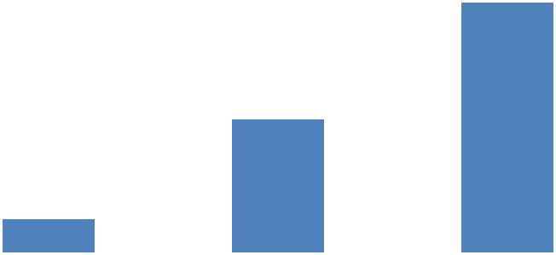

**Duration of members in kudumbashree**

**Figure 4.2**

**4.6 CLASSIFICATION ON THE BASIS OF SAVINGS THROUGH KUDUMBASHREE**

The study reveals that all the members have savings through kudumbashree. The survey results are shown in table 4.6

**TABLE 4.6**

**CLASSIFICATION ON THE BASIS OF SAVINGS THROUGH**

**KUDUMBASHREE**

|  |  |  |
| --- | --- | --- |
| **Response** | **No of respondents** | **Percentage** |
| Yes | 50 | 100 |
| No | 0 | 0 |
| **Total** | **50** | **100** |

**Source : Field Survey**

The survey data can be represented in figure 4.3

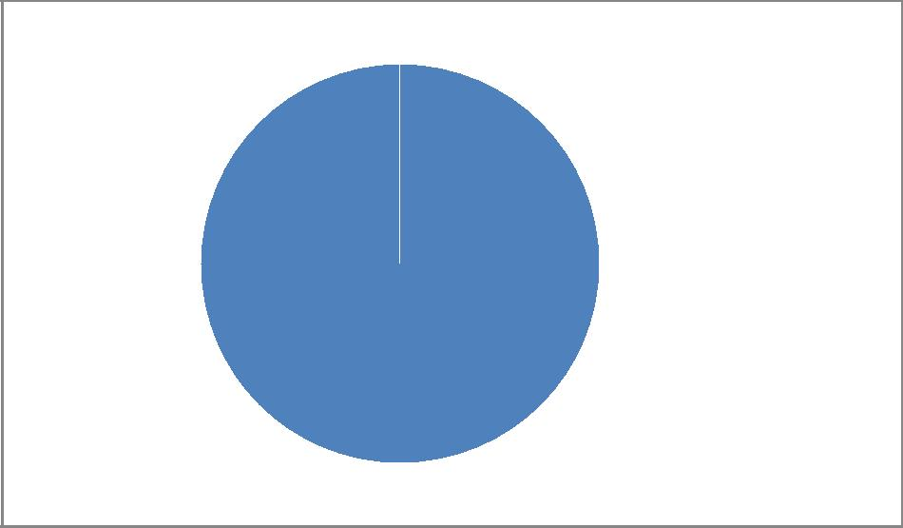

 Yes

100%

**Classification on the basis of savings through kudumbashree**

**Figure 4.3**

**4.7 OPINION ABOUT LOAN TAKEN FROM KUDUMBASHREE**

In the study reveals that 98 per cent of the members take loans from kudumbashree and 2 per cent are not taking any loan from kudumbashree. So the majority of members take loans from kudumbashree. The survey results are shown in table 4.7

**TABLE 4.7**

**OPINION ABOUT LOAN TAKEN FROM KUDUMBASHREE**

|  |  |  |
| --- | --- | --- |
| **Response** | **No of respondents** | **Percentage** |
| Yes | 49 | 98 |
| No | 1 | 2 |
| **Total** | **50** | **100** |

**Source : Field Survey**

The survey data can be represented in figure 4.4

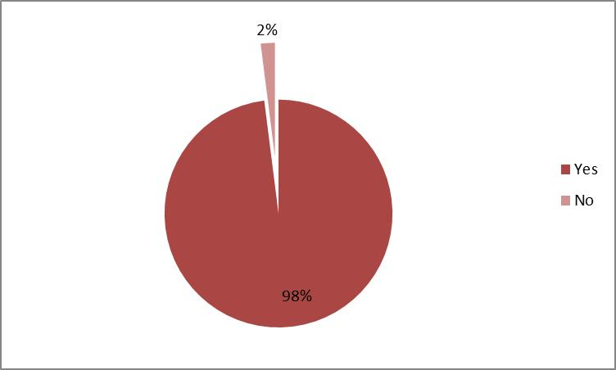

**Opinion about loan taken from kudumbashree**

**Figure 4.4**

**4.8 OPINION ABOUT THE FACTORS FORCED TO TAKE LOAN FROM KUDUMBASHREE**

The study reveals that 36 per cent take loan for educational purpose of their children, 30 per cent take loan for medical purposes, 18 per cent take loan for purchase of some articles, 12 per cent take loan for household consumption and the remaining 4 per cent take loans for the setting up of micro enterprises. So majority take loans for educational purpose of their children. The survey results are shown in table 4.8

**TABLE 4.8**

**OPINION ABOUT THE FACTORS FORCED TO TAKE LOAN FROM**

**KUDUMBASHREE**

|  |  |  |
| --- | --- | --- |
| **Factors** | **No of respondents** | **Percentage** |
| Medical purpose | 15 | 30 |
| Educational purpose of children | 18 | 36 |
| To start micro enterprise | 2 | 4 |
| For house hold consumption | 6 | 12 |
| For purchase | 9 | 18 |
| **Total** | **50** | **100** |

**Source : Field Survey**

**4.9 DURATION OF LOAN REPAYMENT**

The study shows that 46 per cent repay the loan on the basis of instruction given by kudumbashree units, 36 per cent repay loan with in a period of 36 months, and 18 per cent repay within 12 months. The majority repay the loan on the basis of instruction given by kudumbashree units. The survey results are shown in table 4.9

**TABLE 4.9**

**DURATION OF LOAN REPAYMENT**

|  |  |  |
| --- | --- | --- |
| **Duration** | **No of respondents** | **Percentage** |
| 36 months | 18 | 36 |
| 12 months | 9 | 18 |
| As per kudumbashree decision | 23 | 46 |
| **Total** | **50** | **100** |

**Source: Field Survey**

The survey data can be represented in figure 4.5

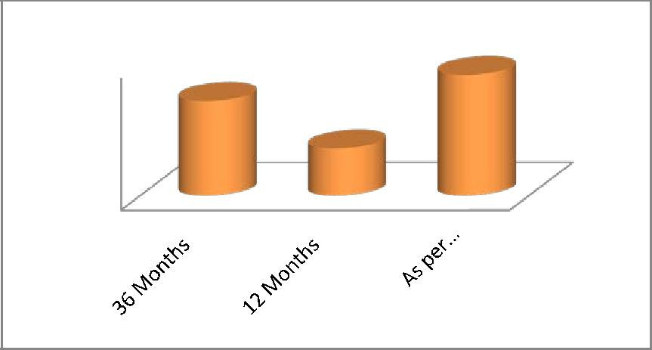

|  |  |  |
| --- | --- | --- |
|  |  |  |
|  |  |
|  |  |  |
|  |  |  |
|  |  |  |
|  |  |  |
|  |  |  |

**Duration of loan repayment**

**Figure 4.5**

**4.10 SATISFACTION WISE CLASSIFICATION OF RESPONDENTS ON THE BASIS OF LOAN AVAILABILITY**

The study shows that majority of members are satisfied with the loan availability. The survey results are shown in table 4.10

**TABLE 4.10**

**SATISFACTION WISE CLASSIFICATION OF RESPONDENTS ON THE**

**BASIS OF LOAN AVAILABILITY**

|  |  |  |
| --- | --- | --- |
| **Satisfaction** | **No of respondents** | **Percentage** |
| Very much satisfied | 1 | 2 |
| Satisfied | 26 | 52 |
| Neutral | 9 | 18 |
| Dissatisfied | 11 | 22 |
| Very much dissatisfied | 3 | 6 |
| **Total** | **50** | **100** |

**Source : Field Survey**

**4.11 OPINION ABOUT WHETHER THEIR KUDUMBASHREE UNITS STARTS ANY MICRO ENTERPRISES**

The study shows that 76 per cent kudumbashree units have micro enterprises and remaining 24 per cent kudumbashree units have no micro enterprises. So the majority of kudumbashree units have micro enterprises. The survey results are shown in table 4.11

**TABLE 4.11**

**OPINION ABOUT WHETHER THEIR KUDUMBASHREE UNITS START**

**ANY MICRO ENTERPRISES**

|  |  |  |
| --- | --- | --- |
| **Response** | **No of respondents** | **Percentage** |
| Yes | 38 | 76 |
| No | 12 | 24 |
| **Total** | **50** | **100** |

**Source : Field Survey**

The survey data can be represented in figure 4.6

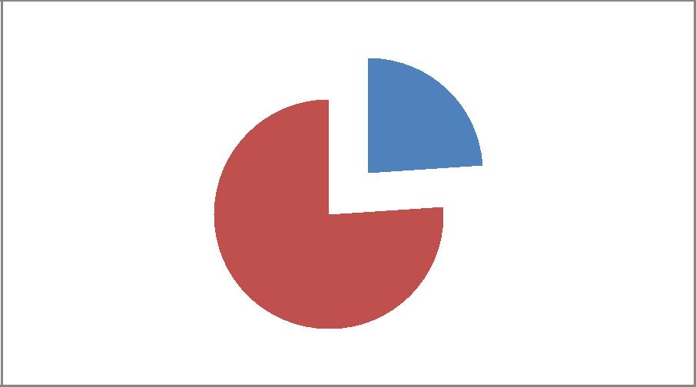

24

76

**Starting of micro enterprise wise classification of respondents**

**Figure 4.6**

**4.12 DURATION WISE CLASSIFICATION OF MICRO ENTERPRISES SET UP BY KUDUMBASHREE UNITS**

The study shows that 48 per cent of kudumbashree units brought up micro enterprises for more than 3 years, 26 per cent units brought up micro enterprises in between 2-3 years, and the remaining 26 per cent units brought up micro enterprises below 1 year duration. So the majority of kudumbashree units brought up micro enterprises for more than 3 years. The survey results are shown in table 4.12

**TABLE 4.12**

**DURATION WISE CLASSIFICATION OF MICRO ENTERPRISES SET UP**

**BY KUDUMBASHREE UNITS**

|  |  |  |
| --- | --- | --- |
| **Type** | **No of respondents** | **Percentage** |
| Below 1 year | 10 | 26 |
| 2-3 years | 10 | 26 |
| Above 3years | 18 | 48 |
| **Total** | **38** | **100** |

**Source : Field Survey**

**4.13 PROFITABILITY OF MICRO ENTERPRISES**

The study shows that 47 per cent units gets profit in between 50000-100000 in a year, 12 per cent get profit above 100000, and remaining 21 per cent get below 50000 profit. So the majority of units get profits in between 50000-100000. The survey data can be represented in figure 4.13

**TABLE 4.13**

**PROFITABILITY OF MICRO ENTERPRISES**

|  |  |  |
| --- | --- | --- |
| **Profit** | **No of respondents** | **Percentage** |
| Below 50000 | 8 | 21 |
| 50000-100000 | 18 | 47 |
| Above 100000 | 12 | 32 |
| **Total** | **38** | **100** |

**Source :Field Survey**

**4.14 OPINION ABOUT WHETHER THE KUDUMBASHREE UNITS GETS ANY TRAINING FOR THE SETTING UP OF MICRO ENTERPRISES**

The study states that 76 per cent kudumbashree units received training to start micro enterprises and the remaining 24 per cent units does not get any training to starting up of micro enterprises. So the majority of kudumbashree units received training to start micro enterprises. The survey results are shown in table 4.14

**TABLE 4.14**

**OPINION ABOUT WHETHER THE KUDUMBASHREE UNITS GETS ANY TRAINING FOR THE SETTING UP OF MICRO ENTERPRISES**

|  |  |  |
| --- | --- | --- |
| **Response** | **No of respondents** | **Percentage** |
| Yes | 38 | 76 |
| No | 12 | 24 |
| **Total** | **50** | **100** |

**Source : Field Survey**

**4.15 OPINION ABOUT WHETHER THE MICRO UNITS GETS INSURANCE COVERAGE**

The study reveals that 50 per cent of kudumbashree units rarely get insurance coverage for their micro enterprises, 26 per cent units does not get any insurance coverage and 24 per cent always get coverage for their enterprise. So the majority of kudumbashree units rarely get insurance coverage for their micro enterprises. The survey results are shown in table 4.15

**TABLE 4.15**

**OPINION ABOUT WHETHER THE MICRO UNITS GETS INSURANCE COVERAGE**

|  |  |  |
| --- | --- | --- |
| **Field** | **No of respondents** | **Percentage** |
| Always | 9 | 24 |
| Rarely | 19 | 50 |
| Never | 10 | 26 |
| **Total** | **38** | **100** |

**Source :Field Survey**

**4.16 OPINION ABOUT THE PARTICIPATION OF KUDUMBASHREE MEMBERS IN GRAMA SABHA**

The study shows that 50 per cent of members sometimes participate in GramaSabhas, 44 per cent members never participated in GramaSabhas and remaining 6 per cent always participate in GramaSabhas. The survey results are shown in table 4.16

**TABLE 4.16**

**OPINION ABOUT THE PARTICIPATION OF KUDUMBASHREE MEMBERS IN GRAMA SABHA**

|  |  |  |
| --- | --- | --- |
| **Response** | **No of respondents** | **Percentage** |
| Always | 3 | 6 |
| Some time | 25 | 50 |
| Never | 22 | 44 |
| **Total** | **50** | **100** |

**Source :Field Survey**

**4.17 OPINION ABOUT THE DIFFICULTY IN THE SETTING UP OF NEW MICRO ENTERPRISES**

The present study shows that 76 per cent does not face any difficulty while starting new enterprises and 24 per cent faces certain difficulties while starting new enterprises. So the majority of kudumbashree units do not face any difficulty while starting new enterprises. The survey results are shown in table 4.17

**TABLE 4.17**

**OPINION ABOUT THE DIFFICULTY IN THE SETTING UP OF NEW MICRO ENTERPRISES**

|  |  |  |
| --- | --- | --- |
| **Response** | **No of respondents** | **Percentage** |
| Yes | 12 | 24 |
| No | 38 | 76 |
| **Total** | **50** | **100** |

**Source: Field Survey**

The survey data can be represented in figure 4.7

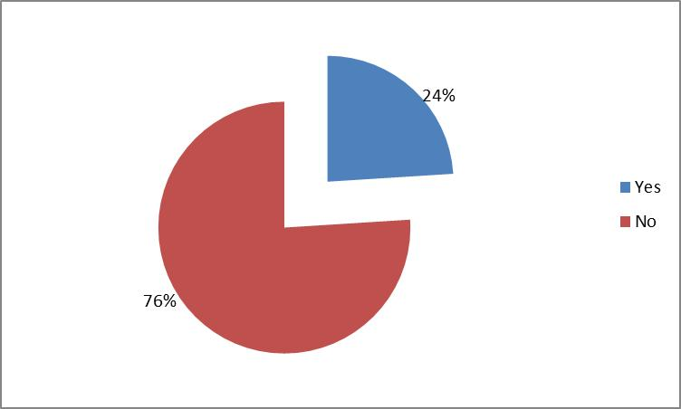

**Opinion about the difficulty in the setting up of new micro enterprises**

**Figure 4.7**

**4.18 RATING OF DIFFICULTIES FACED BY KUDUMBASHREE MEMBERS WHILE STARTING NEW MICRO ENTERPRISES**

The study reveals that procedural formalities are the most important difficulty faced by kudumbashree units while starting new micro units. The survey results are shown in table 4.18.1

**TABLE 4.18.1**

**RATING OF DIFFICULTIES FACED BY KUDUMBASHREE MEMBERS WHILE STARTING NEW MICRO ENTERPRISES**

|  |  |  |  |  |  |
| --- | --- | --- | --- | --- | --- |
| **Difficulties** | **Rank 1** | **Rank 2** | **Rank 3** | **Rank 4** | **Rank 5** |
| Lack of knowledge | 4 | 3 | 3 | 2 | 5 |
| Lack of money | 3 | 2 | 4 | 3 | 5 |
| Communication gap | 5 | 4 | 3 | 4 | 1 |
| Procedural formalities | 2 | 2 | 5 | 6 | 2 |
| Other problem | 3 | 6 | 2 | 2 | 4 |

**Source: Field Survey**

**TABLE 4.18.2**

**MARK**

|  |  |  |  |  |  |
| --- | --- | --- | --- | --- | --- |
| **Difficulties** | **Rank 1** | **Rank 2** | **Rank 3** | **Rank 4** | **Rank 5** |
| Lack of knowledge | 20 | 12 | 9 | 4 | 5 |
| Lack of money | 15 | 8 | 12 | 6 | 5 |
| Communication gap | 25 | 16 | 9 | 8 | 1 |
| Procedural formalities | 10 | 8 | 15 | 12 | 2 |
| Other problem | 15 | 24 | 6 | 4 | 4 |

**TABLE 4.18.3**

**AVERAGE**

|  |  |  |
| --- | --- | --- |
| **Difficulties** | **Total mark** | **Average** |
| Lack of knowledge | 50 | 4.94 |
| Lack of money | 46 | 4.70 |
| Communication gap | 47 | 4.76 |
| Procedural formalities | 59 | 4.47 |
| Other problem | 53 | 4.11 |

**4.19 AWARENESS OF FACILITIES PROVIDED BY**

**KUDUMBASHREE UNITS TO ITS MEMBERS**

The study states that 46 per cent are aware about the student scholarship, 40 per cent are aware about the insurance coverage, 10 per cent are aware about the joint liability group, 2 per cent are aware about the Agatha ashray programme and remaining 2 per cent are known about the kudumbashreebheemayojana provided by kudumbashree. So the majority of members are aware about the student scholarship. The survey results are shown in table 4.19

**TABLE 4.19**

**AWARENESS OF FACILITIES PROVIDED BY KUDUMBASHREE UNITS TO ITS MEMBERS**

|  |  |  |
| --- | --- | --- |
| **Type** | **No of respondents** | **Percentage** |
| Joint liability group | 5 | 10 |
| Insurance coverage | 20 | 40 |
| Agatha ashray program | 1 | 2 |
| Student scholarship | 23 | 46 |
| Kudumbashree bheema yojana | 1 | 2 |
| **Total** | **50** | **100** |

**Source : Field Survey**

**4.20 OPINION ABOUT WHETHER THE KUDUMBASHREE UNITS CONDUCT ANY AWARENESS PROGRAMME FOR THE RURAL PEOPLE**

The present study shows that 68 per cent units conduct awareness programs to rural people and remaining 32 per cent does not provide awareness programs. So the majority of kudumbashree units conduct awareness programs to rural people. The survey results are shown in table 4.20

**TABLE 4.20**

**OPINION ABOUT WHETHER THE KUDUMBASHREE UNITS CONDUCT ANY AWARENESS PROGRAMME FOR THE RURAL PEOPLE**

|  |  |  |
| --- | --- | --- |
| **Responses** | **No of respondents** | **Percentage** |
| Yes | 34 | 68 |
| No | 16 | 32 |
| **Total** | **50** | **100** |

**Source : Field Survey**

**4.21 OPINION ABOUT SOCIAL ACTIVITIES OF KUDUMBASHREE**

**T**he study reveals that, 48 per cent of the respondents argued that poverty eradication is the major social activity undertaken by the Kudumbashree. 28 per cent argued that cleaning program and 24 per cent opined other social activities. The survey results are given in Table 4.21.

**TABLE 4.21**

**OPINION ABOUT SOCIAL ACTIVITIES OF KUDUMBASHREE**

|  |  |  |
| --- | --- | --- |
| **Type** | **No of respondents** | **Percentage** |
| Poverty eradication | 24 | 48 |
| Cleaning program | 14 | 28 |
| Others | 12 | 24 |
| **Total** | **50** | **100** |

**Source : Field Survey**

**4.22 BENEFITS GIVEN BY KUDUMBASHREE UNITS TO ITS MEMBERS**

The study shows that improvement in savings is the major benefits given by kudumbashree units to its members. The survey results are shown in table 4.22

**TABLE 4.24.1**

**BENEFITS GIVEN BY KUDUMBASHREE UNITS TO ITS MEMBERS**

|  |  |  |  |  |  |
| --- | --- | --- | --- | --- | --- |
| **Benefits** | **Rank 1** | **Rank 2** | **Rank 3** | **Rank 4** | **Rank 5** |
| Improvement in confidence level | 3 | 9 | 12 | 17 | 9 |
| Improvement of social status | 4 | 10 | 19 | 7 | 10 |
| Decision making capacity | 2 | 15 | 9 | 10 | 14 |
| Communication skill | 4 | 15 | 10 | 16 | 5 |
| Improvement in savings | 37 | 1 | 0 | 0 | 12 |

**Source: Field Survey**

**TABLE 4.24.2**

**MARK**

|  |  |  |  |  |  |
| --- | --- | --- | --- | --- | --- |
| **Benefits** | **Rank 1** | **Rank 2** | **Rank 3** | **Rank 4** | **Rank 5** |
| Improvement in confidence level | 15 | 36 | 36 | 34 | 9 |
| Improvement of social status | 20 | 40 | 57 | 14 | 10 |
| Decision making capacity | 10 | 60 | 27 | 20 | 14 |
| Communication skill | 20 | 60 | 30 | 32 | 5 |
| Improvement in savings | 185 | 4 | 0 | 0 | 12 |

**TABLE 4.24.3**

**AVERAGE**

|  |  |  |
| --- | --- | --- |
| **Benefits** | **Total mark** | **Average** |
| Improvement in confidence level | 130 | 4.6 |
| Improvement of social status | 141 | 4.82 |
| Decision making capacity | 131 | 4.62 |
| Communication skill | 147 | 4.92 |
| Improvement in savings | 201 | 4.02 |

**4.23 OPINION ABOUT THE FULFILLMENT OF NEEDS THROUGH KUDUMBASHREE**

The study shows that 100 per cent members fulfill their needs through kudumbashree. The survey results are shown in table 4.23

**TABLE 4.23**

**OPINION ABOUT THE FULFILLMENT OF NEEDS THROUGH KUDUMBASHREE**

|  |  |  |
| --- | --- | --- |
| **Responses** | **No of respondents** | **Percentage** |
| Yes | 50 | 100 |
| No | 0 | 0 |
| **Total** | **50** | **100** |

**Source :Field Survey**

The survey data can be represented in figure 4.8



0

 Yes

 No

100

**Opinion about the fulfillment of needs through kudumbashree**

**Figure 4.8**

**4.24 RATING THE FULFILLMENT OF NEEDS THROUGH KUDUMBASHREE**

The study shows that family expenses are the major need fulfilled by the kudumbashree units to its members. The survey results are shown in table 4.24

**TABLE 4.24.1**

**RATING THE FULFILLMENT OF NEEDS THROUGH KUDUMBASHREE**

|  |  |  |  |  |  |
| --- | --- | --- | --- | --- | --- |
| **Type** | **Rank 1** | **Rank 2** | **Rank 3** | **Rank 4** | **Rank 5** |
| Repayment of loan | 25 | 26 | 25 | 9 | 15 |
| Educational purpose of children | 24 | 25 | 15 | 16 | 20 |
| Family expenses | 26 | 24 | 20 | 26 | 4 |
| Personal needs | 15 | 12 | 16 | 22 | 35 |
| Others | 10 | 13 | 24 | 27 | 26 |

**Source: Field Survey**

**TABLE 4.24.2**

**MARK**

|  |  |  |  |  |  |
| --- | --- | --- | --- | --- | --- |
| **Type** | **Rank 1** | **Rank 2** | **Rank 3** | **Rank 4** | **Rank 5** |
| Repayment of loan | 125 | 104 | 75 | 18 | 15 |
| Educational purpose of children | 120 | 100 | 45 | 32 | 20 |
| Family expenses | 130 | 96 | 60 | 52 | 4 |
| Personal needs | 75 | 48 | 48 | 44 | 35 |
| Others | 50 | 52 | 72 | 54 | 26 |

**TABLE 4.24.3**

**AVERAGE**

|  |  |  |
| --- | --- | --- |
| **Type** | **Total mark** | **Average** |
| Repayment of loan | 337 | 6.74 |
| Educational purpose of children | 317 | 6.34 |
| Family expenses | 342 | 6.84 |
| Personal needs | 250 | 5 |
| Others | 254 | 5.08 |

**Source : Field Survey**

**4.25 OPINION ABOUT WHETHER KUDUMBASHREE UNITS REDUCE THE MEMBERS STAGE FEAR**

The study reveals that 92 per cent of respondents can face the group without any difficulty after participating in kudumbashree and the remaining 8 per cent respondents does not face the group. So the majority of respondents can face the group without any difficulty after participating in kudumbashree. The survey results are shown in table 4.25

**TABLE 4.25**

**OPINION ABOUT WHETHER KUDUMBASHREE UNITS REDUCE THE MEMBERS STAGE FEAR**

|  |  |  |
| --- | --- | --- |
| **Opinion** | **No of respondents** | **Percentage** |
| Yes | 46 | 92 |
| No | 4 | 8 |
| **Total** | **50** | **100** |

**Source : Field Survey**

The survey data can be represented in figure 4.9

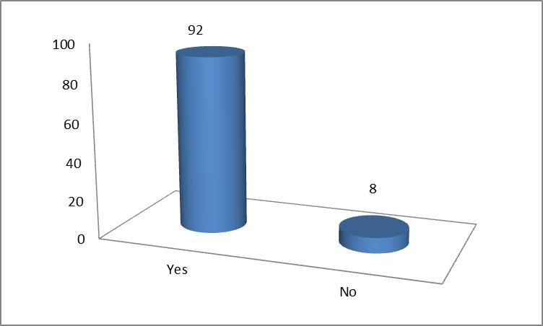

**Opinion about whether kudumbashree units reduce the members stage fear**

**Figure 4.9**

**4.26 OPINION ABOUT PARTICIPATION OF KUDUMBASHREE UNITS IN SOCIAL ISSUES**

The study shows that 54 per cent are responds against existing social problems and 46 per cent are not responding against the existing social problems. So the majority of kudumbashree units respond against existing social problems. The survey results are shown in table 4.26

**TABLE 4.26**

**OPINION ABOUT PARTICIPATION OF KUDUMBASHREE UNITS IN SOCIAL ISSUES**

|  |  |  |
| --- | --- | --- |
| **Responses** | **No of respondents** | **Percentage** |
| Yes | 27 | 54 |
| No | 23 | 46 |
| **Total** | **50** | **100** |

**Source: Field Survey**

**4.27 WHICH ARE THE SOCIAL ISSUES**

The study shows that 72 percentage social problems are alcoholism , 14 percentage are violation against women and 14 percentage problem are under the category of others.

**TABLE 4.27**

**WHICH ARE THE SOCIAL ISSUES**

|  |  |  |
| --- | --- | --- |
| **Type** | **No of respondents** | **Percentage** |
| Alcoholism | 36 | 72 |
| Violation against women | 7 | 14 |
| Others | 7 | 14 |
| **Total** | **50** | **100** |

**Source: Field Survey**

**4.28 OPINION ABOUT THE INTERNAL PROBLEMS IN KUDUMBASHREE**

The study reveals that 62 per cent respondents have no internal problems in kudumbashree and remaining 38 per cent face internal problems. The majority of respondents have no internal problems in kudumbashree. The survey results are shown in table 4.28

**TABLE 4.28**

**OPINION ABOUT THE INTERNAL PROBLEMS IN KUDUMBASHREE**

|  |  |  |
| --- | --- | --- |
| **Response** | **No of respondents** | **Percentage** |
| Yes | 19 | 38 |
| No | 31 | 62 |
| **Total** | **50** | **100** |

**Source: Field Survey**

The survey data can be represented in figure 4.10

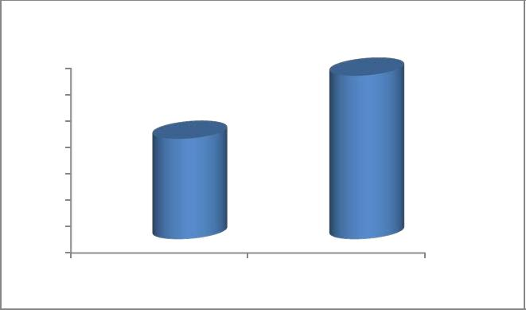

62

|  |  |  |  |
| --- | --- | --- | --- |
| 70 |  |  |  |
| 60 | 38 |  |  |
| 50 |  |  |
|  |  |  |
| 40 |  |  |  |
| 30 |  |  |  |
| 20 |  |  |  |
| 10 |  |  |  |
| 0 |  |  |  |
|  | Yes | No |  |

**Opinion about the internal problems in kudumbashree**

**Figure 4.10**

**4.29 OPINION ABOUT FACTORS THAT BLOCKS REGULAR THRIFT**

The study shows that 54 per cent blocks their regular thrift by economic conditions, 28 per cent are blocks their regular thrift by lack of interest and remaining 18 per cent blocks their regular thrift by group members. So the majority of members blocks their regular thrift by economic conditions. The survey data can be represented in figure 4.29

**TABLE 4.29**

**OPINION ABOUT FACTORS THAT BLOCKS REGULAR THRIFT**

|  |  |  |
| --- | --- | --- |
| **Type** | **No of respondents** | **Percentage** |
| Economical | 27 | 54 |
| Lack of interest | 14 | 28 |
| Group members | 9 | 18 |
| **Total** | **50** | **100** |

**Source: Field Survey**

The survey data can be represented in figure 4.11

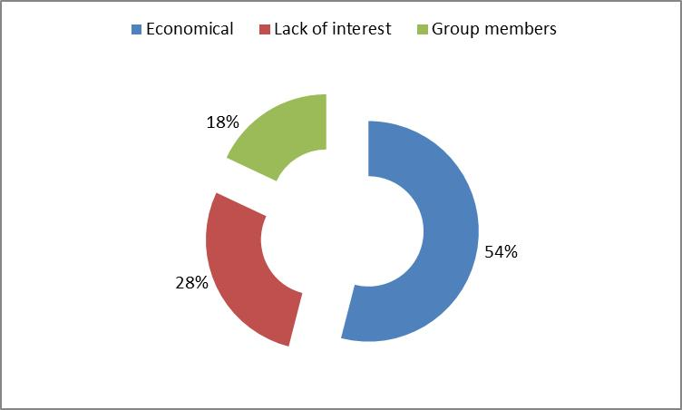

**Factors that blocks regular thrift**

**Figure 4.11**

**4.30 OPINION REGARDING CULTURAL DEVELOPMENT OF KUDUMBASHREE MEMBERS**

The study states that 80 per cent of members can improve their culture through kudumbashree and the remaining 20 per cent does not improve their culture through kudumbashree. So the majority of respondents can develop their culture through kudumbashree. The survey results are shown in table 4.30

**TABLE 4.30**

**OPINION REGARDING CULTURAL DEVELOPMENT OF KUDUMBASHREE MEMBERS**

|  |  |  |
| --- | --- | --- |
| **Total** | **No of respondents** | **Percentage** |
| Yes | 40 | 80 |
| No | 10 | 20 |
| **Total** | **50** | **100** |

**Source: Field Survey**

**4.31 OPINION ABOUT ECONOMIC STATUS AFTER JOINING IN KUDUMBASHREE**

The study reveals that 94 per cent members can improve their economic status after joining in kudumbashree and 6 per cent members does not improve their economic status. So the majority of members can improve their economic status through kudumbashree. The survey results are shown in table 4.31

**TABLE 4.31**

**OPINION ABOUT ECONOMIC STATUS AFTER JOINING IN KUDUMBASHREE**

|  |  |  |
| --- | --- | --- |
| **Response** | **No of respondents** | **Percentage** |
| Yes | 47 | 94 |
| No | 3 | 6 |
| **Total** | **50** | **100** |

**Source: Field Survey**

**CHAPTER IV**

**FINDINGS, CONCLUSION AND SUGGESTIONS**

**4.1 FINDINGS OF THE STUDY**

The study deals with role of kudumbashree in rural development. The major findings are:

1. Among 50 respondents majority of members serve kudumbashree for more than 2 years.
2. Majority of members have savings through kudumbashree
3. The study reveals that 98 per cent of the members take loans from kudumbashree.
4. Most of the respondents take loan for educational purpose of their children.

5. Among 50 respondents 46 per cent repay loan as per kudumbashree decision.

* 1. Majority of members are satisfied with the loan availability.
  2. Majority of kudumbashree units start micro enterprises.
  3. Most of the kudumbashree units brought up micro enterprises for more than 3 years.
  4. Majority of kudumbashree unit gets profit in between 50000-100000 in a year.
  5. Among 50 respondents 59 per cent of kudumbashree units rarely get insurance coverage for their micro enterprises.
  6. Majority of kudumbashree units received training to start micro enterprises.
  7. Majority of remaining kudumbashree units are ready to setting up micro enterprises in future.
  8. The study shows that 50 per cent of members sometimes participate in GramaSabhas.
  9. Among 50 respondents 76 per cent does not face any difficulty while starting new enterprises.
  10. Majority of respondents does not face any difficulty while starting new micro enterprises.

16. Majority of respondents are aware about the student scholarship.

* 1. Majority of rural people get awareness programs through kudumbashree.
  2. Among 50 respondents 92 per cent kudumbashree units done social activities.
  3. The study shows that improvement in savings is the major benefit given by kudumbashree units to its members.
  4. The study reveals that 100 per cent members fulfill their needs through kudumbashree.
  5. Majority of respondent can face the group without any difficulty after participating in kudumbashree.
  6. Among 50 respondents 54 per cent are responds against existing social problems.
  7. Most of the respondents have no internal problems in kudumbashree.
  8. 54 per cent members blocks their regular thrift by economic conditions.
  9. Majority of respondent that develop their culture through kudumbashree.
  10. Among 50 respondents 94 per cent members can improve their economic status after joining in kudumbashree.

**4.2 SUGGESTIONS**

1. To provide better facilities to kudumbashree members.
2. To boost up the members for starting micro enterprises.
3. Take action against current social issues faced by women.
4. Majority of the members are unaware about the new schemes. So Government should take necessary actions to inform the members about various schemes.
5. Encourage all the members to participate in GramaSabhas.

6. Majority of the members are interested in setting micro enterprises but they are discouraged by various formalities for the setting up. So assistance should be given by government to members and reduce the formalities.

1. Encourage kudumbashree units to participate in the welfare programs such as construction of roads, cleaning of ponds, wells etc. by means of means of providing incentives.

* 1. **CONCLUSION**

The study shows that numbers of benefits are given by kudumbashree towards rural community. It promotes saving habits among members, and it helps in the women empowerment, it helps in reducing social problem, it helps in generating self-employment opportunities etc. kudumbashree units undertake number of activities such as construction of roads, cleaning of ponds, wells, etc. all helps in the development of rural area. As far as rural female communities are concerned it is a great blessing.

**BIBLIOGRAPHY**

**BOOKS**

1. Roy Ashine , Women in power and decision making, Rajat Publications, New Delhi, 2003
2. Krishnaswamy O R, Himalaya Publications House, Mumbai,(2010), pp. 31-262
3. Majundar, Social Status of Women in India, Dominant publishers and distributers, New Delhi, 2004
4. Kapur Promila, Empowering the Indian women, Ministry of Information and Broadcasting, 2001
5. Ram Ahuja, Social problems in India, Rawat Publication, Jaipur, 2004

**JOURNALS**

1. Social welfare, Aravali publishers, New Delhi, September 2005, vol.

54.

1. Social welfare, Aravali publishers, New Delhi, April 2007, vol. 54
2. Sai Om journal of commerce and management, Sai Om publications, vol. 1, issue 9, September 2014

**WEBSITES**

1. www.google.com

* 1. www.wikipedia.org
  2. www.ask.com
  3. www.kudumbashree.org

**APPENDIX**

**QUESTIONNAIRE**

**A STUDY ON THE BENEFITS GIVEN BY KUDUMBASHREE TOWARDS RURAL COMMUNITY- WITH SPECIAL REFERENCE TO AZHIKODE PANCHAYATH**

**PERSONAL PROFILE**

1. Name:
2. Age : Below 25 25-35 Above 35
3. Marital status: Single Married Widow
4. Education: Illiterate 1-5 6-10 PDC Above PDC
5. Occupation: Agriculture Salaried Business Others

**TECHNICAL DATA**

1. Duration as a member of Kudumbashree.

One year Two year Above two year

1. Do you have savings in Kudumbashree?

Yes No

1. Do you take loan from Kudumbashree?

Yes No

1. If yes, the factors which forced you to take loan?

Medical purposes Educational purpose of children For festivals

To start micro enterprise For purchase

1. Duration of loan repayment?

36 months 12 months As per Kudumbashree decisions

1. Do you satisfied with amount of loan received?

Very much satisfied Satisfied neutral Dissatisfied

Very much dissatisfied

1. Have your Kudumbashree start any micro enterprises?

Yes No

1. If yes,how many years you have been started it?

Below 1 year 2-3 years Above 3 years

1. How much profit will you get from this enterprise?

Below 50000 50000-100000 Above 100000

1. Do you get any training class to start new micro enterprise?

Yes No

1. Do you get any insurance coverage to start a new enterprise?

Always Rarely Never

1. Are you participate in Grama Sabha?

Always Sometimes Never

1. Do you feel any difficulty in processing while starting a new enterprise?

Yes No

1. If yes, which are they? ( Rate the following from 5,4,3,2 and 1)

Lack of knowledge

Lack of money

Communication gap

Procedural formalities

Other problems

1. Are you aware about the following facilities provided by CDS through Kudumbashree?

Joint liability group

Insurance Coverage

Agatha ashray program

Student scholarship

Kudumbashree bheema yojana

1. Does your NHG give any awareness program to rural people?

Yes No

1. Which are the social activities done by the Kudumbashree?

Poverty eradication Cleaning programs Others

1. What are the benefit get from Kudumbashree while being as a member? Can you rate your preference? (5,4,3,2 and 1)

Improvement in confidence level improvement of social status

Decision making capacity communication skill Improvement in savings

1. Do you fulfil any of your needs through Kudumbashree?

Yes No

1. If yes, which are they?

Repayment of loan Educational purpose of children Family expenses Personal needs others

1. Can you face a group now without fear?

Yes No

1. Have you ever respond any existing social problem in your village?

Yes No

1. If yes, what are they?

Alcoholism Violation against women Others

1. Do you have any internal problem in your Kudumbashree unit?

Yes No

1. Factors that blocks in giving regular thrift?

Economical Lack of interest Group members

1. Does the Kudumbashree helpful for cultural developments?

Yes No

1. Is there any improvement in your economic status after joining in Kudumbashree?

Yes No