**CHAPTER -1**

**INTRODUCTION**

**1.1 Introduction of the study**

A freight forwarder is an entity that acts as an intermediary between the actual shipper and the carrier. Freight forwarder provides other logistics and legal services for shipper as value added service, nowadays it books Freight, prepares documentation, arranges Warehousing and aids to Custom Clearance on behalf of shippers or importer.

Traditionally, a freight forwarder is an entity that acts as an intermediary between the actual shipper or importer and the carrier. In broad sense, a freight forwarder or forwarding agent, also called as a non-vessel operating common carrier (NVOCC), is an individual or a company that aids to arrange shipments for individuals or corporations to get cargoes or goods from the producer or manufacturer to a customer or customers, a market, or final point of distribution for end users. Forwarders contract with a carrier or often multiple carriers to move the goods.

To move large quantities of goods across the country and around the world, Nations depend on their freight transportation system—a vast network of roads, bridges, rail tracks, airports, seaports, navigable waterways, pipelines, and equipment. A freight forwarder is an individual or company that dispatches shipments via asset based carriers and books or otherwise arranges space for those shipments. Common carrier types could include waterborne vessels, airplanes, trucks or railroads.The movement of international freight among nations relies on a complex array of long-distance transportation services. The process involves many participants, including shippers, commercial for-hire carriers, third-party logistics providers, and consignees. Moreover, global trade depends on seaport and airport services to move large volumes of merchandise over long distances via a variety of transportation modes. The interaction of these services and participants is vital to successful global trade. Freight forwarders typically arrange cargo movement to an international destination. Also referred to as international freight forwarders, they have the expertise that allows them to prepare and process the documentation and also perform related activities pertaining to international shipments. Some of the typical information reviewed by a freight forwarder is the commercial invoice, shipper's export declaration, bill of lading and other documents required by the carrier or country of export, import, or transshipment. Much of this information is now processed in a paperless environment.

As an analogy, freight forwarders have been called travel agents for freight. In the U.S., a freight forwarder involved with international ocean shipping is licensed by the Federal Maritime Commission as an Ocean Transportation Intermediary.

Export of goods take place when there is a change of proprietorship from a resident to a non-resident; this does not essentially infer that the goods in question physically crosses the border. However, in specific cases national accounts credit changes of ownership even though in legal terms no change of ownership takes place such as cross border financial leasing, cross border deliveries between affiliates of the same enterprise, goods crossing the border for significant processing to order or repair. Also smuggled goods must be included in the export measurement. Exporter has to submit ‘shipping bill’ for export by sea or air and ‘bill of export’ for export by road. Relevant documents i.e. copies of packing list, invoices, export contract, letter of credit are also to be succumbed.

For many companies, export begins in the sale or marketing department. That department may develop leads or identity clients located in other countries. Inquiries or orders may come from potential customers through company website where the destination is not identified. When such orders come in, sales person need to determine what steps are different from its domestic sale in order to fill those export orders.

The main task of the forwarding agent is the consolidation of consignments. Freight Forwarders do all procedural and documentation involved in the clearance on behalf of the exporters and importers. The forwarders use the latest technologies to solve the logistics challenges improvise the Forwarders strength and expertise in gaining customers. The Indian government had taken several initiatives to help the forwarders. Mainly the infrastructure has to be developed in India to meet up with the international standards. Service tax collected from freight forwarders is huge and none are happy with it. So they have to be very careful while handling the shipments.

Freight forwarders are thetravel agents for the freight. They are doing the best operations in India with the limited infrastructural facilities. The problems faced by forwarders is identified in a customs clearance perspective and it is very clear by the facts and figures that it is because of government regulations, the result of port authorities, insurance companies, customs clearance, infrastructural issues, payment issues etc. To overcome these problems the forwarders association have to be strongand they have to raise the voice mainly against the government so that the government will be forced to help the forwarder. The main problems India suffer in the shipping industry is because of infrastructure facilities. Technologies are improving now. Freight forwarders have to be very careful in accepting shipments from exporters and importers.

**1.2 Statement of the problem**

The need for the study was to assess the effectiveness of Logistics Management and the operations in freight forwarding in the KIFFAL, compared with other organization in the same industry. The organization also needs relevant data as to how it can improve its management policies in order to gain future market share.

**1.3 Industry Profile**

**History of Freight Forwarders**

The original function of the forwarder, or was to arrange for the carriage of his customers' good by contracting with various carriers. His responsibilities included advice on all documentation and customs requirements in the country of destination. His correspondent agent in far-away lands looked after his customers' interests and kept him informed about matters that would affect movement of goods.

In modern times the forwarder still carries out those same responsibilities for his client. He still operates either with a corresponding agent overseas or with his own company branch-office. In many instances, the freight forwarder also acts as a carrier for part of a movement it can happen that in a single transaction the forwarder may be acting either as a carrier (principal) or as an agent for his customer.

**Typical Job role of Freight Forwarder**

Freight forwarders process orders for the import and export of freight, compile documentation for clearance by customers, produce invoices, process stock transfers, check the contents, compile and check documents of freight goods. They also tally and record consignments and destination details of articles, containers and passengers, and make freight and transport bookings and related arrangements.

A freight forwarder may perform the following tasks:

* Check the number of articles or containers in consignments of goods received or dispatched.
* Make sure articles are in good condition and correspond to invoices, manifests or other records.
* Arrange internal distribution of goods received.
* Prepare and attach documentation to articles to be dispatched.
* Make sure clearance procedures (eg. payment of any customs entry fees or duties) are carried out, dispatch goods and arrange delivery promptly on arrival.
* Spend time in warehouses packing and unpacking goods.
* Drive between wharves, container terminals, airports and government departments.
* Weigh items.
* Contact senders to fix shortages and arrange replacement of damaged goods.
* Maintain records of receipts and dispatches.
* Undertake clerical work such as filing, accounting, updating customs records, preparing correspondence, and inputting and retrieving information from computers.

**Responsibility of freight forwarders**

Although freight forwarders have acted as respected professionals since the last century, the legal nature of their activities has only recently attracted real attention. This is because freight forwarders have become prominent links in modern transportation systems, due to the importance of containers, and multimodal transport.

In times of excess vessel capacity, too, freight forwarders have increased authority because it is they who are able to provide cargoes, thereby becoming influential participants in a buyer's market. It is for this reason that on occasion freight forwarders have voyage chartered and even time chartered ships.

The legal responsibility of freight forwarders often seems mysterious because freight forwarders have assumed two different legal roles - agents and principal contractors. Nor are the activities of freight forwarders directly regulated by any international convention, although their acts naturally bridge national borders. The result is that various national laws control their actions, giving rise to conflicts of law.

In the light of the foregoing - the emerging importance of freight forwarders, the often puzzling national laws, and the lack of international uniformity - it is apparent that an international convention is necessary. The Multimodal Transport Convention 19801 is just such a convention. Its adoption would give certainty to the law and protection to both the public and to freight forwarders themselves.

The Multimodal Transport Convention 1980 has the advantage of clarity and simplicity and is not encumbered with other maritime, albeit important, matters such as freight, liens and electronic commerce, which make the Convention less likely to be enacted.

**Freight Forwarder fundamental roles**

1. The freight forwarder ensures that your goods receive the priority it requires; your documentation is appropriately filled and your goods reach its destination in the specified time.
2. The increasing specialization on transportation of goods and decimations operations means that the exporter of products would prefer to leave these formalities to "freight forwarder" in order to concentrate on his own business.
3. An efficient "freight forwarder" can offer advice, on the special requirements of different countries as well as to offer a number (sea, air, rail etc.) of quotations for a particular consignment being sent from point A to B.
4. The "freight forwarder" role is often underestimated as one of the most important elements in shipping.
5. The "freight forwarder" is there to ensure that your goods receive the priority it requires; that your documentation is appropriately filled and most importantly, your goods reach its destination in order and in the specified time.
6. The next most important and effective function of the "forwarder" is to be an adviser and agent for the shipper, and that, is the "forwarder's" prime consideration.
7. The transportation of goods from one place to another over short or long distances, is a fundamental activity in materials handling with many complexities in international cross border transportation i.e. large number of documents are required to document the movement goods.
8. The [basic activities](http://www.malaysiaexports.com/inex13.1.transportation.htm) of a "freight forwarder" include booking cargo space on ship, airplane, train, or any other form of goods/cargo transportation, route planning, various documentation, export packing, insurance, warehouse, collection and delivery consignment.
9. And to provide service which involves establishing various inland depots and clearing offices so that customs clearance at the port of entry is done by the "forwarder" as well as delivery to consignee's doorstep, without actually involving the consignee.

**Freight Forwarder - Dual Role**

The freight forwarder traditionally acts as an agent who arranges for the shipment of goods belonging to his client/the shipper. The freight forwarder as agent typically arranges for transportation, pays freight charges, insurance, packing, customs duties, etc., and then charges a fee, usually a percentage of the total expenses. All the costs are (or should be) disclosed to the client. The specific scope of the forwarding agent’s duties, however, is determined primarily by its contract with the customer (ordinarily the shipper) who retains its services. At times, the freight forwarder has acted as principal contractor arranging the carriage in his own name. His fee, payable by the shipper, is a straight freight charge. He then arranges to pay lower freight rates to the carrier and obtains his profit from the difference between the two. Very often, the freight forwarder consolidates the cargoes of a number of clients into a single container, resulting in savings which benefit the freight forwarder and the clients. The forwarding carrier may also provide other services, such as packing, warehousing, cartage, lighter age and/or insurance. On these occasions the freight forwarders responsibility to the shipper is often that of a carrier.

Whether acting as agent or principal, the freight forwarder (as is normal in commerce) usually attempts to contract out of as much responsibility as possible. This has often resulted in very confusing standard trading conditions, where the two contradictory roles and kinds of responsibility - of the agent and of the principal - are set out.

The responsibility of the freight forwarder, as agent and as principal contractor, will be described in the light of the civil law, the common law and certain national laws.

**Freight forwarder plays integral part of transportation process.**

The freight forwarder plays an integral part in the transportation process. Freight forwarders act on behalf of the exporter in arranging ocean or air transport services. They are familiar with the import rules and regulations of foreign countries, methods of shipping, and documents connected with foreign trade.

Freight forwarders can provide a number of services. During the initial planning phases, they can help choose the carrier and the most economical shipment size. At the beginning of the sale, the freight forwarder can provide an exporter with quotations on a number of costs. This information can be used in preparing an accurate price quotation to foreign customers.

At the shipper's request, the freight forwarder can make the actual arrangements and provide the necessary services for expediting the shipment to its overseas destination. This can include:

1. Providing advice on foreign import regulations,
2. Arranging for inland transportation,
3. Booking space with the ocean or air carrier,
4. Completing export documentation,
5. Arranging for cargo insurance,
6. Providing guidance on packaging, marking and labelling,
7. Arranging for products to be packed and containerized,
8. Freight consolidation, but this is not a standard service.

Freight forwarders operate on a fee basis paid by the exporter. The fees consist of an agreed-upon amount, plus documentation charges. The cost for the services should be figured into the price charged to the customer. Freight forwarders also collect a percentage of the freight costs from the carrier.

**1.4 COMPANY PROFILE**

Established in 2005 , Kiffal Pvt. Ltd. has made a name for itself in the list of top service providers of in India. Kiffal Pvt. Ltd. is listed in Trade India's list of verified companies offering wide array of etc. Contact here for in Kannur, Kerala.

Name Kiffal Pvt. Ltd

Address Room no : XLVI 3088

Trade Center Building

Opp. Sub Registrar Office

Kannur, Kerala.

Country India

Contact Name Admin

Email Address info@kiffal.com.

Phone +91-497-2700099

Website www.kiffal.com

Category Freight Forwarders

**Dynamic Flexibility**

Kiffal strength is the ability to accept evolving technological advancements and implement to make the movement of goods (logistics) simple, precise and reliable. By integrating the core skills of logistics, data warehouse management, and supply chain Management functionality, we ensure the transportation requirements are fulfilled in every way.

Kiffal combine advanced technologies to effectively deal with all key business requirements including order management, receiving, location and warehouse management, quality control, picking, replenishment, shipping, counts, returns, and related warehouse task management.

**Service Driven**

Kiffal offer the highest quality of service emphasizing on-time services with exceptional customer care. Our workforces are dedicated, loyal and responsible individuals who recognize that our past and future success depends on our ability to provide a superior service to our worldwide clients on every shipment.

Kiffal focus is to strengthen the logistic services on all parts of the planet and help clients succeed. We provide up and down logistics services to all countries in the Middle East, Africa, China and other major destinations in the world.

**SERVICES**

**AIR FREIGHT SERVICES**

KIFFAL make the best use of Airfreight services to meet the rising global supply demands. Through our expertise, in-depth knowledge and honesty, we commit to delivering an exceptional experience to global clients who use our air freight services. Regardless of the logistic demands and what you have to transport, KIFFAL has the best air-freight solution designed for you.

Kiffal provide a wide range of air-freight options ranging from lightweight to heavyweight shipments around the world. Therefore with the full suite of air freight solutions, we have the capacity to optimize every requirement arising from the domestic and international market.

The dedicated commitment in the industry over the years, help us to achieve goals in an effective and timely manner.

**The Air Freight Expert**

On its pathway to a leading logistics company in Kerala, India we work hard to come with innovative solutions and ideas each time to get the job done in a timely and affordable manner. The tracking systems we use and the proactive approach we adopt sets the example for our commitment towards a professional service. These systems also keep real-time communication with the user making the tracking even simpler.

The enduring relationship we keep with the leading airlines and transportation companies makes it possible for the clients to enjoy reasonable pricing and a safe carriage. Having exposure to international carriers, professionals, and technology, we come along with worthy services that help you avoid many challenges in the logistics process.

**SEA FREIGHT SERVICES**

KIFFAL gives you altogether control and commands through sea freight services. KIFFAL has an indomitable place in the industry that offers up to date international transportation solutions to clients across the world. Our link to a range of extensive network of carriers makes enough space for the safe transport of goods via sea.

The close association with the world’s major airports enable us to effortlessly manage the international shipments with guaranteed moving time. With our comprehensive range of ocean freight solutions and services, we ensure an effortless flow of goods to the right place, at the right time and in an affordable way.

The sea freight services we offer are designed according to your needs

* Full Container Load Service (FCL)
* Less than Container Load Service (LCL)
* Multi modal Transport solutions
* Handle all types of cargo
* Conventional load services
* Cargo vessel charter
* and other prominent sea-freight services

Since the shipment is in terms of contractual an emergency basis with the leading carriers or vessels, customers are for sure they get the affordable pricing structure for their logistics order. Therefore, if you are in need of dependable sea-freight services in Kerala, KIFFAL is here to make your business flow.

**ROAD FREIGHT SERVICES**

Reliable, Fast and Precise. KIFFAL Road freight services are always on the move with a comprehensive transport solution throughout India, helping your business to grow and succeed. With an impeccable level of service, we ensure the deliveries go smoothly from the pick up till final delivery. Regardless of Full Truck Load or Less than Truck Load, you have the right shipment solution designed for you.

KIFFAL keep the association with selected carriers to have the improved level of services, quicker delivery, and reduced costs. By combining with the latest logistics solutions, we make certain that the shipment is delivered on time and reliably.

**Precise Solutions**

A comprehensive road network and the modern fleet of trucks allow us to provide the highest level of service. Properly scheduled services and the deployment of transportation technology ensure that the shipment is on the right path and right time.With KIFFAL Road Freight, you’ll enjoy the advantages of daily and weekly outbound deliveries regionally. Being a leader in the Road transportation in Kerala, you can simply depend on us to get the logistics work done. Connecting our comprehensive network services brilliantly we let you enjoy our logistics services completely, transparently and precisely.

**1.5 SCOPE OF THE STUDY**

Freight forwarding are the major services offered by KIFFAL. The study made on the topic of Freight Forwarding Documentation and Exim Procedures will reveal the major operation on this particular service. Also, this study helps to identify the future expectations of Kannur International Freight Forwarding & Logistics industry.

Working in the shipping or freight forwarding sector is of good scope as number of opportunities is waiting in future. While working in the freight forwarding industry we can understand the impact of government policy on the international market. • The foreign trade policy that changes after every five years also has the impact on the working of the export and import.

Here we can understand that how the freight forwarders, shipping line, CHA custom house agents, Co loaders and even local transport vendors are interrelated to each other. The work of the freight forwarding teaches us how the international market works as per the currency rates. Here we can understand the relations and work of the freight forwarders with the co loaders. Custom housing Agents of clearing agencies and beat vendors for the pickup and transportation

**1.6 OBJECTIVES OF THE STUDY**

**Primary Objective**

* To study about challenges and opportunities for freight forwarders in Kerala and exim procedures with reference to Kannur international freight forwarding & logistics (KIFFAL) “

**Secondary Objectives**

* To study sea and air cargo operations at KIFFAL
* To know opportunities and challenges for freight forwarders.
* To analyses the basic principles and Freight Forwarding Documentation and Exim Procedures
* To identify the role of freight forwarding operators in International sea an air Freight transportation.
* To identify major problems come across in both export and import procedures
* To know whether the customers are satisfied with the existing range of service pattern.

**CHAPTER-2**

**REVIEW OF LITERATURE**

**2.1 CONCEPTUAL REVIEW**

* **Application By: Ozsomer, A.; Mitri, M.; Tamer Cavusgil. (1993) International Journal of Physical Distribution & Logistics Management** The recent changes in the international forwarding environment have witnessed the emergence of `new forms' of forwarders incorporating a broad spectrum of services under one roof. Such total logistics companies are becoming a critical third party in obtaining acompetitive advantage in foreign markets. Hence, the evaluation and selection of an international freight forwarder is no longer a simple operational decision but a strategic one. Presents and explains an expert systems tool to assist decision makers in selecting the freight forwarder which fits their needs best. The system, called FREIGHT, brings together international marketing, logistics and artificial intelligence knowledge.
* **Akinyemi (1997)** that sustainable mobility requires, among other things, acceptable levels of environment impacts and costs of development and operation of transportation system etc. three main inferences can be made from these ideas. The first inference is that sustainable mobility is significantly transportation supply dependent. The better and more sustainable the supply characteristics of a transportation system, higher will be the level of mobility of peoples. The second inference is that current levels of people mobility in many developing cities can be said to be low and unsustainable largely because of inadequate transportation supply characteristics. The inadequacy of transportation supply in many countries manifests mainly through inadequate public transportation services, low productivity and level of ride ability of facilities and high level of transportation related environmental impacts. For example, in many cities, it is difficult to move around by any mode of transportation wit out physically and/or mentally exhausted in the process. Thousands of people wait for hours at public transportation stops while public.
* **A study on “Logistics of small-size deliveries” by Outi(2000)** A study on―Logistics of small-size deliveries has been carried at the Technical Research Center of Finland. Seventeen enterprises participated in this study. In this study a calculation model was developed and tested with the logistics costs of the participating companies. After calculating the costs, order structure as well as the working methods of the companies was examined. With this information the ABC simulation model was developed to explain and simulate the change in the logistics costs of a company.
* **Study on Influence of Logistics Firms in International Trade by Joseph (2001)** This study says that every trade is possible only with the help of logistics advisories because those people are very experienced and professionally trained in logistics activity. He concluded that all the logistics firms should facilitate as much as possible to the exporter and importer.
* **Study on Role of Clearing & Forwarding Agents by Eswari(2002)** Eswari conducted a study on, ―Role of Clearing & Forwarding Agents in Business. She explained the nature and role of the Clearing and Forwarding Agents in detail and the Documentation process is perfectly done by them. She concluded topic by providing the Quality Services to the International Traders.
* **Wang and Tyan (2003) - study on involvement of Global third-party logistics in e-commerce and globalization** An effective global supply chain(GSC) management seeking to secure market share. Global third-party logistics (3PL) has developed into an alternative for the needs of global collaboration. In this, the authors present a new application of collaboration in Global Supply Chain execution, namely collaborative transportation management (CTM) that can reduce delivery time and to improve delivery reliability. A case study is illustrated the application of CTM by a 3PL provider in a notebook computer GSC. The implementation results show that the delivery cycle time and the total cost are simultaneously reduced.
* **Larson and Halldorsson (2004) – Study on Relationship between Logistics and supply chain management** Larson and Halldorss on introduce by describing four unique perspectives on the relationship between logistics and Supply Chain Management. Results of an International survey of logistics/SCM experts are reported. 200 questionnaires were sent to leading logistics educators. Based on expert’s opinion, cluster analysis conducted and confirms that the existence of the four perspectives on logistics versus SCM re-labelling, traditionalist, unionist and intersections.
* **Lai et al. (2005) – Study on Quality Management in Hong Kong’s Logistics Industry**This study examines the factors that encourage firms in Hong Kong‘s logistics industry to implement quality management system to ensure quality in their work processes. A generic ten-step approach for Quality Management system (QMS)has been introduced and discussed the cost and service advantages achieved in the case firm. The approach offers Procedural guidelines for firms in the industry contemplating the implementation of Quality Managements.
* **Miguel (2006) –** International Journal of Performance Measurement system and Logistics management and control It indicates that performance measurement systems truly applicable in Logistics Management and control. The impact of using performance measurers on management style has been largely neglected. The author set sout to explore this gapu sing an approach based on Simons ‘diagnostic versus interactive modes of control. The author aimed at describes the changes in logistics management and control compared with the situation in the rest of the firm. A case study method was undertaken involving amediumsized ceramic tile manufacturer. The results show that a clear interactive use in the logistics area, while in non-logistics department‘s performance measures is used diagnostically.
* **Nandiraju and Regan, 2005; Caplice, 2007; Collignon, 2016** have classified FTSP mechanisms implemented in trading institutions into three major types: (a) Catalogs (posted prices), wherein carrier offers are posted and the sole choice of the shipper consists in picking the carrier that best fits its own needs. Several markets or platforms such as Iship, Freightquote, and Smartship use this mechanism. (b) Auctions, wherein one party (most often the shipper) posts its requirements and several players in the other party (most often the carriers) place bids. These automated on-line mechanisms such as Uship and Anyvan are widely used in transportation service procurement (TSP). (c) Negotiations, wherein players on both sides of the market, shippers and carriers, bargain over the conditions of an exchange. Several transportation procurement services such as DAT Load Boards, The Internet Truck Stop, and Getloaded use this mechanism.
* **Sajed and Gunilla (2008) - study on the „impact of logistics on environment‟**Environmentalimplicationsoflogisticssystemsisoneofthefuturechallengestologisticians. This paper explores the logistics and supply chain management (SCM) discipline to seehow the scientific community handles this challenge. The preliminary literature has revealed that there are weak ties between the logistics/SCM discipline and the environmental discipline. The analysis indicates that the literature seems to be unbalanced: knowledge about assessing impact of logistics on environment is missing, and most emphasis is on impact of environment on logistics‘. From the reverse logistics literature knowledge about implementation has been drawn, the same has been described by scholars as explanatory and anecdotal. When comparing the subject logistics/supply chain management and environment with other subjects in the logistics literature, less attention has been paid to “Logistics/Supply Chain and environ”
* **Factors Hindering Success of Freight Forwarders byDr. Marian Tukuta (The Open Transportation Journal, 2009)** The study sought to investigate the factors hindering the success of the freight forwarding firms in facilitating imports and exports. A descriptive survey design was used on freight forwarding firms. The researcher used purposive sampling to select firms for the study. Questionnaires and interview guides were used as data collection instruments. The study found out that; demurrage charges through delays, wars, loss from fire out breaks, piracy, damage and destruction of goods, sinking of vessels and fraud by employees in position of authority were the major factors hindering the success of this industry in facilitating imports and exports. The government should al so make use of the latest technologies so as to increase the speed of clearing goods such that they reach their final point of consumption within the shortest possible time
* **Export- Import Operation By: Tucker and Michael Jay. - Research Starters Business. (2014)**Export-Import Operations are the actions and decisions necessary to take a product or raw material from a source in on country to a market in another. This article will discuss export- import operations as a three-part process: pre-shipment, transport, and after-sale. Each of the three will be considered in turn from the perspective of business professionals attempting to expand their companies' interests across national boundaries. Export-import can be considerably more complex than doing business in a single, domestic market, but the realities of a globalizing economy are such that most companies and most people must increasingly deal across frontiers whether they wish to ornot.
* **VonderGracht and Lena Darkow (2015) - study on the future of the logistics services industry in the year2025**VonderGracht and Lena Darkow propose a scenario planning and present the findings ofan extensive Delphi-based scenario study on the future of the logistics services industry in the year 2025. The major contribution of this study is the development of probable and unforeseen scenarios of the future which may provide a valuable basis for strategy development in the logistics services industry. The logistics services industry will be significantly affected by future developments throughout the world. Therefore, developing future scenarios is an important basis for long-term strategy Development
* **Hawas et al., 2016,** **Saghapour et al., 2016** Since the lack of access to transportation leads to social exclusion, transport and land use policies focus on accessibility and aim at enabling people to reach destinations at reasonable costs and times. Therefore, providing efficient public transport in terms of accessibility is one of the main objectives of policy makers and planners in metropolitan areas throughout the world.
* **Murray, 200**3, **Jackiva) Yatskiv et al., 2017** Service access and urban public transport accessibility have always been a major service issue in urban public transport. In network design of transit services, researchers are often more focused on minimizing the user and operator cost rather than incorporating the issues of equity and access Availability of infrastructure, ease of information, reduced time and cost are imperative factors in providing an attractive public transport with door to door access as well as the long-distance travel .

**CHAPTER -3**

**RESEARCH METHODOLOGY**

**3.1 RESEARCH**

Research methodology is a way of systematically solving the Research problems. Research methodology is a systematic method of or process of dealing with identifying problems, collection of facts or data, analysing these data for the purpose of making the decision. The methodology includes publication research, interviews, surveys and other research techniques, and could include both present and historical information. The methodology includes publication research, interviews, surveys and other research techniques, and could include both present and historical information.

### 3.1.1 Research design

Research design can be explained as a detailed outlined of how an investigation will take place. A research design will typically include how data is to be collected, what instruments will be employed, how the instrument will be used and the intended means for analyzing data collected.

This research study is a descriptive research based on measure on the collection of primary data. This study applies to all of the research objectives, which are primarily based on questionnaires and scheduling method.

### 3.1.2 Descriptive Research

The type of research used in this project is descriptive in nature. The main goal of this type is to describe the data and characteristics about what is being studied. Descriptive research is the exploration of the existing certain phenomena. The design of the present project is descriptive type of conclusive one.

* 1. **POPULATION**

In this research population refers to the challenges and opportunities for freight forwarders in Kerala and Exim procedures with reference to Kannur international freight forwarding & logistics (KIFFAL)

* 1. **SAMPLE DESIGN**

A sample design is a definite plan for obtaining a sample from given population. It refers to selecting item for sample. In the study convenience sampling design is adopted for selecting the sample.

**3.4 SAMPLE TECHNIQUE**

Sampling techniques are classified as either probability or nor probability sampling. In probability sampling, each member of population has a non-zero probability of being selected. It includes random sampling, systematic sampling, satisfied and cluster sampling. In non probability sampling, members are selected from the population in some non-random manner. These include convenience sampling, judgment sampling quota sampling and snowball sampling. Here the sampling technique used was probability sampling because the population size is well defined. The study is designed as descriptive. It mainly focuses on the respondents of the company. Sample size is selected through convenience sampling method. The size of the sample is 100

**3.5 METHOD OF ANALYSIS**

Questionnaire was the main tool for collecting the data. Hence, pain has been taken to construct the questionnaire in a systematic way by converting adequate in and relevant questions to ensure in achieving the research objectives.

This method of data collection is quite popular, particular in case of big enquiries. Here in this research i set 20 simple questions and request the respondents to answer these questions with correct information.

### 3.6 DATA COLLECTION METHOD

### 

Data was gathered from both primary and secondary sources of information. The questionnaire is the source of primary data and the secondary data was formed on the basis of information from company, Websites, books, journals

Data was collected by using main two methods i.e primary data and secondary data.

* Primary data
* Secondary data

### Primary data

Primary data is the data which is used or collected for first time and it is not used by anyone in the past. There are number of sources of primary data from which the information can be collected. For gathering primary data, a well design structured questionnaire was prepared along with Personal Interviews so that its response could reflect all the necessary information useful for the study.

**Secondary Data:**

Secondary data is needed for the proper interpretation of primary data. The sources of secondary data are from organization website magazines, booklets and profile of the company.

### STATISTICAL TOOLS FOR ANALYSIS

* + Correlation
  + Chi-square
  + Anova
  + T-Test

**SPSS**

Statistical Package for the Social Sciences. The most widely used s/w for survey analysis. It is a spread sheet-style interface in which we enter our data and specify the names of our variables. Then we proceed to the subsequent steps of specifying the statistical analysis we want to make and examining the results.

**IBM SPSS STATISTICS 25**

IBM SPSS Statistics is a comprehensive system for analyzing data. SPSS Statistics can take data from almost any type of file and use them to generate tabulated reports, charts and plots of distribution and trends, descriptive statistics and complex statistical analysis. Simple menus and dialog box selections make it possible to perform complex analysis without typing a single line of command syntax. The software name originally stood for statistical package for the social sciences (SPSS) reflecting the original market, although the software is now popular in other fields as well, including the health science and marketing. The data editor offers a simple and efficient spread sheet like facility for data and browsing the working data file.

Various steps in the applications of the SPSS

Step1: Data Entry and Naming variables: When we enter SPSS the first thing that we do is type the data and tell SPSS what the data represent. This can be done using the Data Editor.

Whenever we enter the data into SPSS, we need to decide what names to assign to the variables and tell SPSS what these names are.

Step2: Specifying the statistical analysis: After entering the data into the Data Editor, we have to tell the SPSS what we would like to do with this data, i.e., what kind of statistical analysis we wish to conduct.

Step3: Examining and manipulate the output: When Step1 and Step2 are completed the output appears in a new kind of window called the “Output Viewer”. window contains SPSS report on the results of the analysis.

### SIMPLE PERCENTAGE ANALYSIS

A simple percentage analysis / percentage frequency distribution is a display of data that specifies the percentage of observations that exist for each data point or grouping of data points. It is a particularly useful method of expressing the relative frequency of survey responses and other data. Percentage frequency distributions are displayed as tables or as bar graphs or pie charts. The process of creating a percentage frequency distribution involves first identifying the total number of observations to be represented; then counting the total number of observations within each data point or grouping of data points; and then dividing the number of observations within each data point or grouping of data points. The formula used in getting the simple percentage in statistical treatment in research is as follow:

### Frequency and percentage distribution, % = f/N x 100

Where,

* f =frequency
* N = number of cases

### CORRELATION

Correlation is computed into what is known as the correlation coefficient, which ranges between -1 and +1. Perfect positive correlation (a correlation coefficient of +1) implies that as one security moves, either up or down, the other security will move in lockstep, in the same direction. Alternatively, perfect negative correlation means that if one security moves in either direction the security that is perfectly negatively correlated will move in the opposite direction. If the correlation is 0, the movements of the securities are said to have no correlation; they are random.

### (r) = [nΣxy-(Σx)(Σy)/Sqrt(nΣx2-(Σx)2)(nΣy2-(Σy)2)]

* + r: The correlation coefficient is denoted by the letter r.
  + n: Number of values. If we had five people we were calculation the correlation coefficient for, the value of n would be 5.
  + x: This is the first data variable.
  + y: This is the second data variable.
  + Σ: The sigma symbol (Greek) tells us to calculate the “sum of” whatever is tagged next to it.

### CHI – SQUARE TEST

The Chi Square test is the most important and most used method in statistical tests. The purpose of Chi Square test is to know the difference between an observed frequency and expected frequency. This test sometimes is also used to test the differences between the two or more observed data. Its value can be calculated by using the given observed frequency and expected frequency.

χ***2*** = Chi Square value

**O** = Observed Frequency **E** = Expected Frequency Σ ***=*** Summation

**HYPOTHESIS TEST – I**

Ho = There is no significant relationship between aware of logistic systems and opinion about logistics management of Kiffal.

H1 = There is significant relationship between aware of logistic systems and opinion about logistics management of Kiffal.

**HYPOTHESIS TEST – II**

Ho = There is no significant relationship between educational qualification and aware of logistic management

H1 = There is significant relationship between educational qualification and aware of logistic management

**HYPOTHESIS TEST – III**

Ho = There is no significant relationship between the opinion about logistic management and logistics department able to deliver the products according to the demand.

H1 = There is significant relationship between the opinion about logistic management and logistics department able to deliver the products according to the demand.

**HYPOTHESIS TEST – IV**

Ho = There is no significant relationship between educational qualification and opinion about logistic management should be part of the company’s strategy.

H1 = There is significant relationship between educational qualification and opinion about logistic management should be part of the company’s strategy.

**HYPOTHESIS TEST – V**

Ho = There is no significant relationship between important of logistic quality and quality metrics in logistics

H1 = There is significant relationship between important of logistic quality and quality metrics in logistics

**HYPOTHESIS TEST – VI**

**CORRELATION**

Analyze if there is any significant relationship between overall experience with Sulfex and logistic department able to deliver the products according to he demand.

Ho = There is no significant relationship between overall experience with Sulfex and logistic department able to deliver the products according to he demand.

H1 = T There is no significant relationship between overall experience with Sulfex and logistic department able to deliver the products according to he demand

**HYPOTHESIS TEST – I**

**CHI-SQUARE**

Ho = There is no significant relationship between years of experience and which transportation handled by mostly

H1 = There is significant relationship between years of experience and which transportation handled by mostly

**HYPOTHESIS TEST – II**

**CHI-SQUARE**

Ho = There is no significant relationship years of experience and company ensures in logistics

H1 = There is There is no significant relationship years of experience and company ensures in logistics

**HYPOTHESIS TEST – III**

**ANOVA**

Ho = There is no significant relationship between years of experience and feature enhance the performance of logistics provider

H1 = There is significant relationship between years of experience and feature enhance the performance of logistics provider

**HYPOTHESIS TEST – IV**

**ANOVA**

Ho = There is no significant relationship between years of experience and major problems occur when delivery of goods.

H1 = There is significant relationship between years of experience and major problems occur when delivery of goods.

**HYPOTHESIS TEST – V**

**CORRELATION**

Ho = There is no significant relationship types of transportation handled by mostly and major problems occur when delivery of goods.

H1 = There is significant relationship types of transportation handled by mostly and major problems occur when delivery of goods.

**CORRELATION**

Ho = There is no significant relationship between years of experience and which division of logistical activity earns the maximum rate of profit.

H1 = T There is no significant relationship between years of experience and which division of logistical activity earns the maximum rate of profit.

**HYPOTHESIS TEST VI**

**T TEST**

Ho = There is no significant relationship between years of experience and major problems occur during delivery of goods.

H1 = There is no significant relationship between years of experience and major problems occur during delivery of goods.

**T TEST**

Ho = There is no significant relationship between significant relationship between years of experience and rating given to customer service

H1 = There is no significant relationship between significant relationship between years of experience and rating given to customer service

* 1. **LIMITATION OF THE STUDY**
* The researcher has done the study only on Freight forwarders.
* The researcher has not considered the financial aspects of Freight forwarders
* Lack of time available for the research.
* Terms and conditions are “cut and paste' of those used by competitors.

#### CHAPTER-IV

#### DATA ANALYSIS AND INTERPRETATION

#### DATA ANALYSIS AND INTERPRETATION

**TABLE NO.4.1.1**

**YEARS OF EXPERIENCE**

|  |  |  |
| --- | --- | --- |
|  | **Frequency** | **Percentage** |
| Below 3 years | 15 | 15.0 |
| Between 3 - 6 years | 55 | 55.0 |
| Between 6 - 9 years‎ | 15 | 15.0 |
| More than 9 years | 15 | 15.0 |
| **Total** | **100** | **100.0** |

**CHART NO.4.1.1**

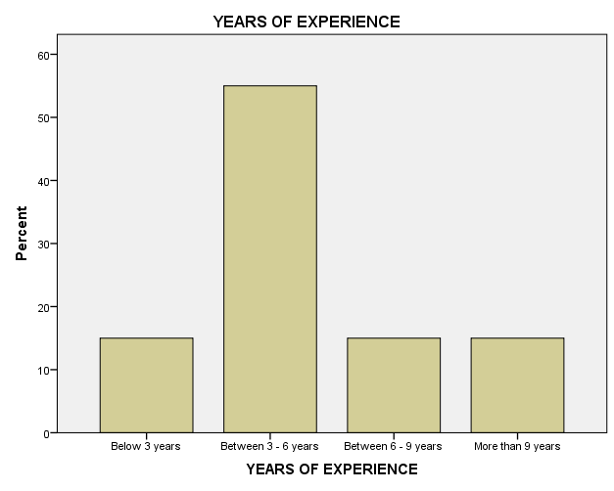

**INTERPRETATION**

Table no.4.1.1 shows that most of the respondents have between 3 to 6 years of experience as freight forwarder. 15% of them have below 3 years, another 15% have between 6 to 9 years and rest of the 15% has more than 9 years of experience as freight forwarder.

**TABLE NO.4.1.2**

**NUMBER OF BRANCH OFFICES**

|  |  |  |
| --- | --- | --- |
|  | **Frequency** | **Percentage** |
| 5 - 10 BRANCHES | 80 | 80.0 |
| 10 - 15 BRANCHES | 15 | 15.0 |
| > 15 BRANCHES | 5 | 5.0 |
| **Total** | **100** | **100.0** |

**CHART NO.4.1.2**

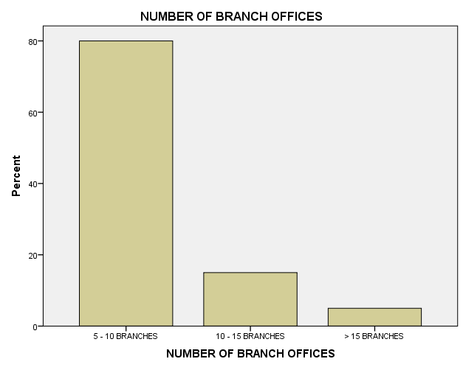

**INTERPRETATION**

Table no.4.1.2 shows that 80% of the respondents replied that they have 5 to 10 branches within India. 15% said 10 to 15 branches and rest of them said that they have above 15 branches within India.

**TABLE NO.4.1.3**

**WAY OF IDENTIFYING CUSTOMERS**

|  |  |  |
| --- | --- | --- |
|  | **Frequency** | **Percentage** |
| REPRESENTATIVES | 15 | 15.0 |
| STATISTICS DATA | 25 | 25.0 |
| SALES CALLS | 60 | 60.0 |
| **Total** | **100** | **100.0** |

**CHART NO.4.1.3**

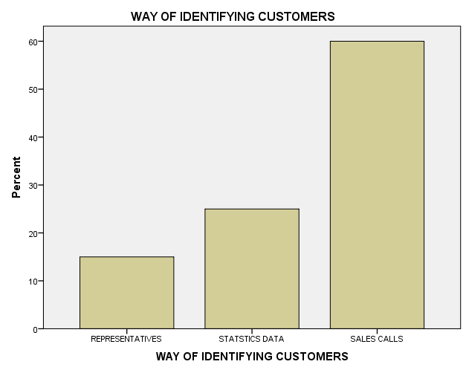

**INTERPRETATION**

Table no.4.1.3 shows that 60% of the respondents identify customer by sales calls. 25% of them identify their customers by statics data and rest of them identifies their customer by their representatives.

**TABLE NO.4.1.4**

**TYPE OF TRANSPORTATION HANDLED BY**

|  |  |  |
| --- | --- | --- |
|  | **Frequency** | **Percentage** |
| OCEAN TRANSPORT | 15 | 15.0 |
| AIR TRANSPORT | 5 | 5.0 |
| ROAD WAYS | 75 | 75.0 |
| RAILWAYS | 5 | 5.0 |
| **Total** | **100** | **100.0** |

**CHART NO.4.1.4**

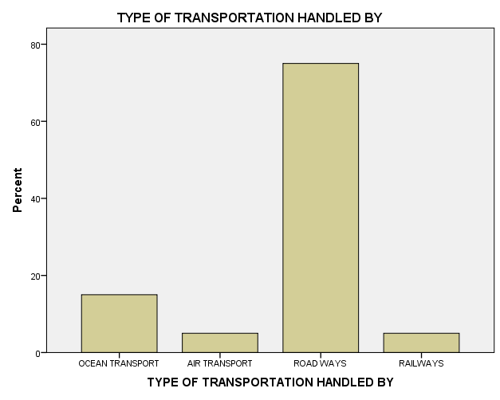

**INTERPRETATION**

Table no.4.1.4 shows that 75% of the respondents mostly use road ways. 15% of them use ocean transport, 5% each use air transport and railways.

**TABLE NO.4.1.5**

**MOSTLY TO WHICH COUNTRIES COMPANY CONCENTRATE ON EXPORTS**

|  |  |  |
| --- | --- | --- |
|  | **Frequency** | **Percentage** |
| EUROPE | 5 | 5.0 |
| FAR EAST | 80 | 80.0 |
| USA | 5 | 5.0 |
| UK | 5 | 5.0 |
| OTHERS | 5 | 5.0 |
| **Total** | **100** | **100.0** |

**CHART NO.4.1.5**

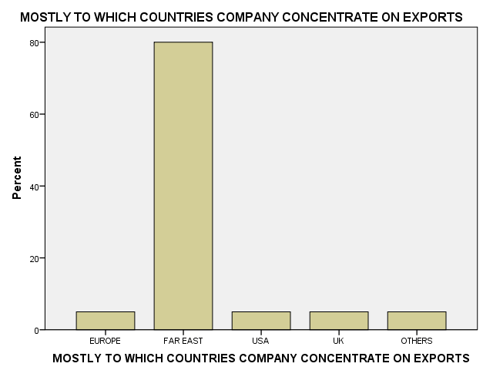

**INTERPRETATION**

Table no.4.1.5 shows that most of the respondents are concentrate Far East for exporting their products. 5% each concentrate Europe, USA, UK and other countries respectively.

**TABLE NO.4.1.6**

**MOSTLY TO WHICH COUNTRIES COMPANY CONCENTRATES ON IMPORT**

|  |  |  |
| --- | --- | --- |
|  | **Frequency** | **Percentage** |
| EUROPE | 10 | 10.0 |
| CANADA | 5 | 5.0 |
| FAR EAST | 70 | 70.0 |
| USA | 5 | 5.0 |
| UK | 5 | 5.0 |
| OTHERS | 5 | 5.0 |
| **Total** | **100** | **100.0** |

**CHART NO.4.1.6**

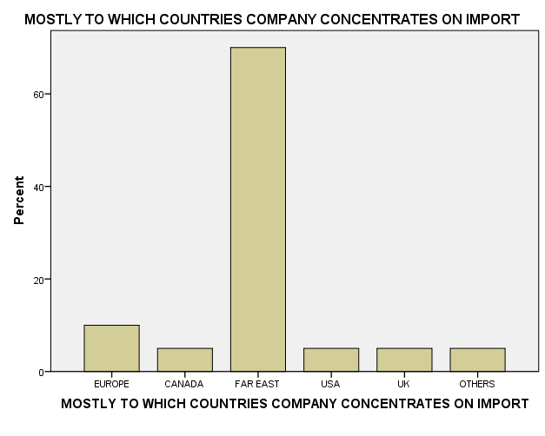

**INTERPRETATION**

Table no.4.1.6 shows that majority of the respondents like to import things from far east. 10% of them concentrate on Europe and 5% each concentrate on Canada, USA,UK and other countries for importing products.

**TABLE NO.4.1.7**

**LOGISTICS SERVICES OFFERED BY THE COMPANY**

|  |  |  |
| --- | --- | --- |
|  | **Frequency** | **Percentage** |
| FREIGHT | 60 | 60.0 |
| WAREHOUSING | 30 | 30.0 |
| CROSS DOCKING | 5 | 5.0 |
| OTHER VALUE ADDING SERVICES | 5 | 5.0 |
| **Total** | **100** | **100.0** |

**CHART NO.4.1.7**

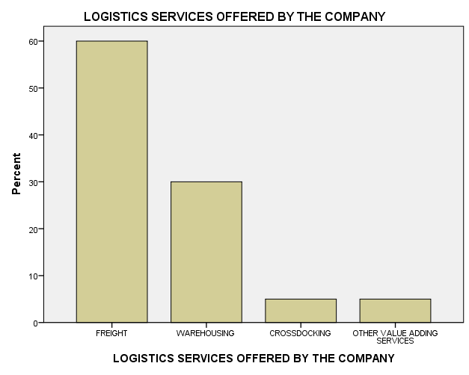

**INTERPRETATION**

Table no.4.1.7 shows that 60% of them said that their company offer freight services. 30% replied that the company offers warehousing, 5% each replied that their company offers cross docking and other value adding services.

**TABLE NO.4.1.8**

**BEST SERVICES OFFERED CATEGORY**

|  |  |  |
| --- | --- | --- |
|  | **Frequency** | **Percentage** |
| FREIGHT | 30 | 30.0 |
| WAREHOUSING | 55 | 55.0 |
| CROSS DOCKING | 5 | 5.0 |
| NETWORK DESIGN | 5 | 5.0 |
| OTHER VALUE ADDING SERVICES | 5 | 5.0 |
| **Total** | **100** | **100.0** |

**CHART NO.4.1.8**

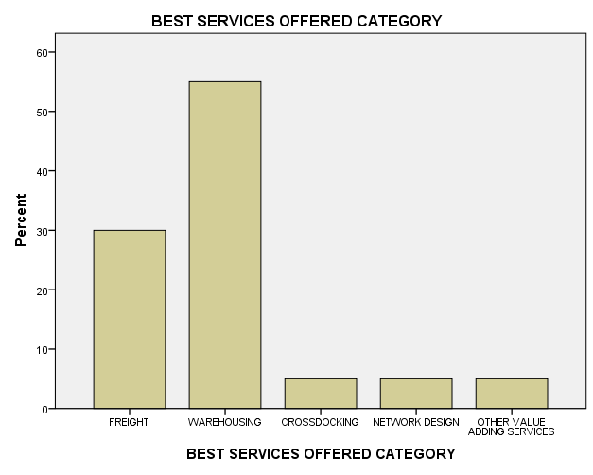

**INTERPRETATION**

Table no.4.1.8 shows that 55% of the respondents replied that warehousing is the best services offered category. 30% said freight, 5% each said that they offer cross docking, network design and other value adding services.

**TABLE NO.4.1.9**

**COMPANY ENSURES IN LOGISTICS**

|  |  |  |
| --- | --- | --- |
|  | **Frequency** | **Percentage** |
| COST SAVING | 10 | 10.0 |
| ERROR FREE | 10 | 10.0 |
| REALIABILITY | 25 | 25.0 |
| TIMELY DELIVERY | 10 | 10.0 |
| ALL OF THE ABOVE | 45 | 45.0 |
| **Total** | **100** | **100.0** |

**CHART NO.4.1.9**

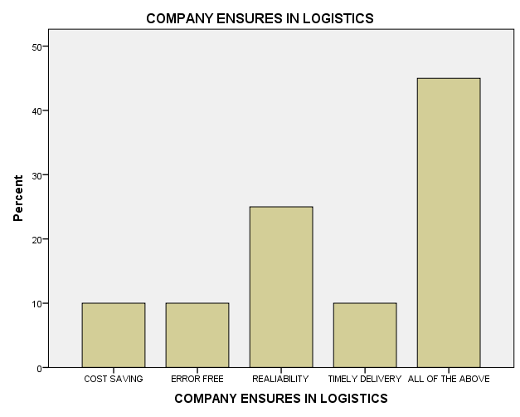

**INTERPRETATION**

Table no.4.1.9 shows that 45% said that the company ensures cost saving, error free, reliability and time delivery logistics to their customers. 25% said that company ensures reliability, 10% each said that the company ensures cost saving, error free and timely delivery to their customers.

**TABLE NO.4.1.10**

**FREQUENCY OF LOGISTICS REVIEW IN THE COMPANY**

|  |  |  |
| --- | --- | --- |
|  | **Frequency** | **Percentage** |
| DAILY | 5 | 5.0 |
| WEEKLY | 10 | 10.0 |
| MONTHLY | 65 | 65.0 |
| QUARTERLY | 20 | 20.0 |
| **Total** | **100** | **100.0** |

**CHART NO.4.1.10**

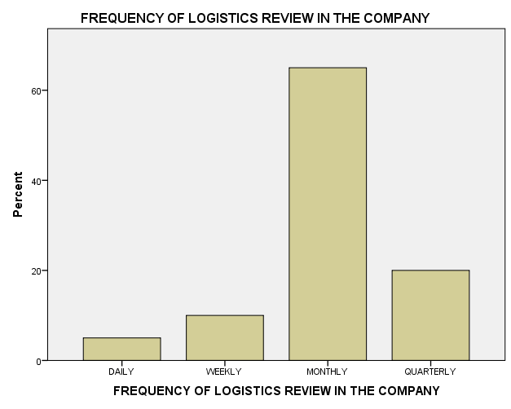

**INTERPRETATION**

Table no.4.1.10 shows that 65% of the respondents said that the company reviews the logistics monthly. 20% said that the company reviews logistics quarterly, 10% said that they review weekly and remaining 5% said that the company reviews logistics daily.

**TABLE NO.4.1.11**

**NEAREST FRIEGHT FORWARDING DESTINATION FROM BRANCH OFFICE**

|  |  |  |
| --- | --- | --- |
|  | **Frequency** | **Percentage** |
| 10 KM | 40 | 40.0 |
| 20 KM | 30 | 30.0 |
| 25 KM | 5 | 5.0 |
| 30 KM | 25 | 25.0 |
| **Total** | **100** | **100.0** |

**CHART NO.4.1.11**

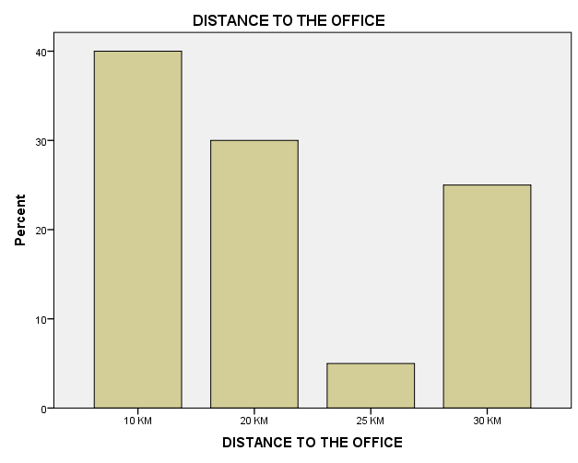

**INTERPRETATION**

Table no.4.1.11 shows that 40% of them replied that their office is 10 km away from their home. 30% said that their office is 20 km away, 25% said 30km and rest of the respondents office is 25km away from their home.

**TABLE NO.4.1.12**

**FUTURE ENHANCE THE PERFORMANCE OF LOGISTICS**

|  |  |  |
| --- | --- | --- |
|  | **Frequency** | **Percentage** |
| RELIABLE | 40 | 40.0 |
| EASY ACCESS | 10 | 10.0 |
| FLEXIBILITY | 15 | 15.0 |
| INTERACTIVE | 15 | 15.0 |
| TIMELINES | 20 | 20.0 |
| **Total** | **100** | **100.0** |

**CHART NO.4.1.12**

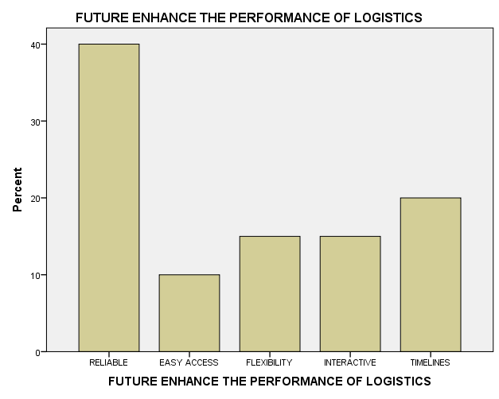

**INTERPRETATION**

Table no.4.1.12 shows that reliability will enhance the performance of logistics provider. 20% said that timelines enhance the performance of logistics provider. 15% each said that flexibility and interactive will enhance the performance of logistics. And rest of them said that easy access help to enhance the performance of logistics.

**TABLE NO.4.1.13**

**LOCATIONS TO WHICH COMPANY CATERS TO**

|  |  |  |
| --- | --- | --- |
|  | **Frequency** | **Percentage** |
| DELHI | 20 | 20.0 |
| MUMBAI | 20 | 20.0 |
| LUDHIANA | 5 | 5.0 |
| CHENNAI | 55 | 55.0 |
| **Total** | **100** | **100.0** |

**CHART NO.4.1.13**

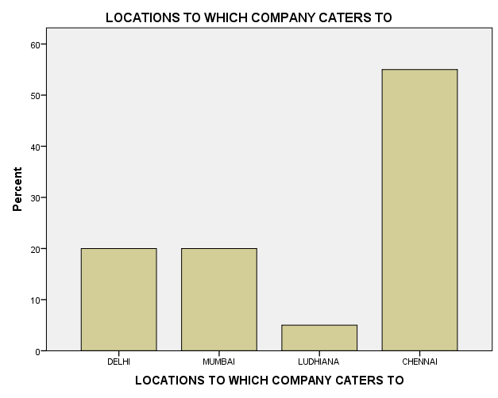

**INTERPRETATION**

Table no.4.1.13 shows that 55% of the respondents said that their company caters to Chennai. 20% each said that the company caters things to Delhi and Mumbai respectively. 5% said that their company caters things to Ludhiana.

**TABLE NO.4.1.14**

**MAJOR PROBLEMS MAY OCCUR DURING DELIVERY OF GOODS**

|  |  |  |
| --- | --- | --- |
|  | **Frequency** | **Percentage** |
| WRONG CURRENCY PAYMENT | 10 | 10.0 |
| INVOICING ERRORS | 70 | 70.0 |
| INCORRECT REBATE | 10 | 10.0 |
| INVALID QUANTITY | 5 | 5.0 |
| OTHER | 5 | 5.0 |
| **Total** | **100** | **100.0** |

**CHART NO.4.1.14**

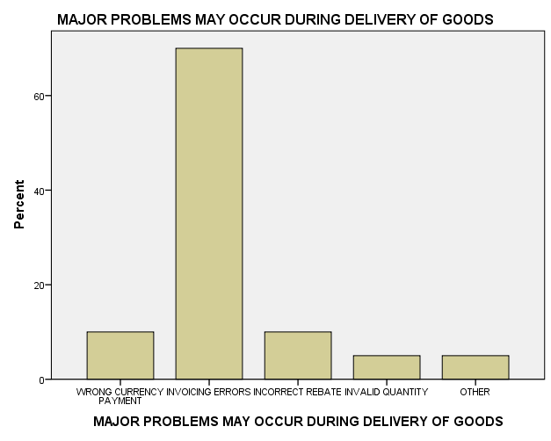

**INTERPRETATION**

Table no.4.1.14 shows that most of the respondents agreed that invoicing errors are the major problem that may occur during delivery of goods. 10% each said that wrong currency and incorrect rebate is the major problems that may occur during delivery of goods. 5% each agreed that invalid quantity and other problems may occur during delivery of goods.

**TABLE NO.4.1.15**

**TIME TAKEN TO RECEIVE BOOK CONFIRMATION**

|  |  |  |
| --- | --- | --- |
|  | **Frequency** | **Percentage** |
| 1 -3 HOURS | 45 | 45.0 |
| 3 - 5 HOURS | 30 | 30.0 |
| 5 - 7 HOURS | 20 | 20.0 |
| NEXT DAY | 5 | 5.0 |
| **Total** | **100** | **100.0** |

**CHART NO.4.1.15**

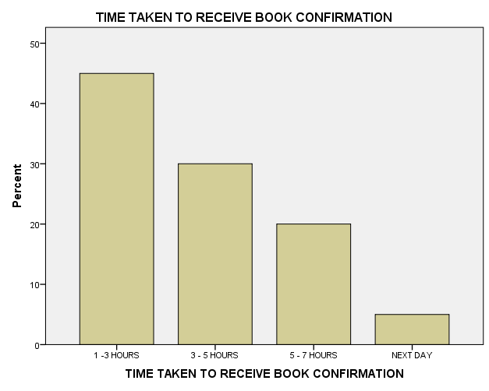

**INTERPRETATION**

Table no.4.1.15 shows that 45% of the respondents said that 1 to 3 hours may take to receive book confirmation. 30% said it takes 3 to 5 hours, 20% said that it may take 5 to 7 hours and rest of them said that the time taken to receive booking confirmation by next day.

**TABLE NO.4.1.16**

**CUSTOMER COMPLAINTS GIVEN PREFERENCE**

|  |  |  |
| --- | --- | --- |
|  | **Frequency** | **Percentage** |
| YES | 90 | 90.0 |
| NO | 10 | 10.0 |
| **Total** | **100** | **100.0** |

**CHART NO.4.1.16**

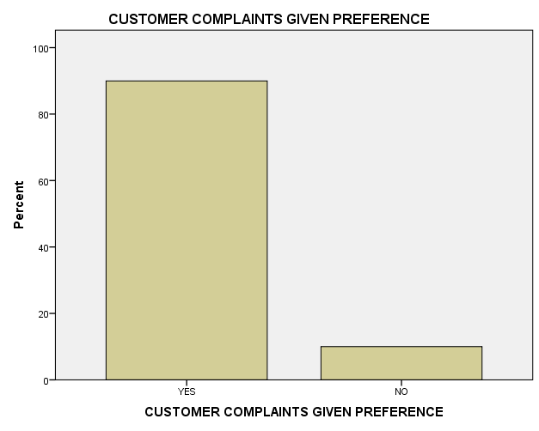

**INTERPRETATION**

Table no.4.1.16 shows that 90% of the respondents agree that the company give preferences to customer complaints. Rest of the disagreed with it.

**TABLE NO.4.1.17**

**WHICH DIVISION OF LOGISTICAL ACTIVITY EARNS THE MAXIMUM RATE OF PROFIT**

|  |  |  |
| --- | --- | --- |
|  | **Frequency** | **Percentage** |
| FREIGHT | 40 | 40.0 |
| WAREHOUSING | 45 | 45.0 |
| CROSS DOCKING | 10 | 10.0 |
| NETWORK DESIGN | 5 | 5.0 |
| **Total** | **100** | **100.0** |

**CHART NO.4.1.17**

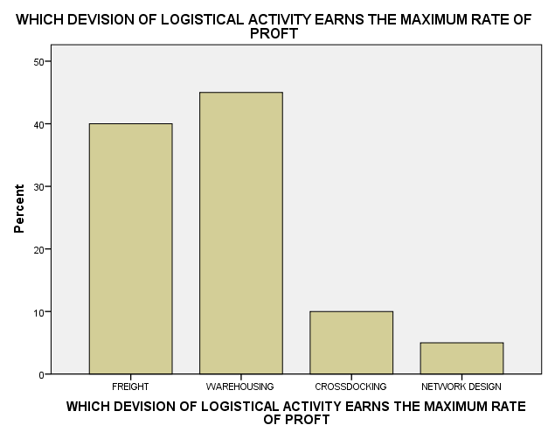

**INTERPRETATION**

Table no.4.1.17 shows that 45% of them said that warehousing earns the maximum rate of profit. 40% replied that freight earns the maxi mum rate of profit while 10% of them said that cross docking earns more and rest of them said that network design is the main activity that earns more profit.

**TABLE NO.4.1.18**

**WAY OF ORGANIZATION RETAIN THE CUSTOMERS**

|  |  |  |
| --- | --- | --- |
|  | **Frequency** | **Percentage** |
| PHONE CALL | 65 | 65.0 |
| NEW SERVICE INTIMATION TO CUSTOMERS | 15 | 15.0 |
| GIFTS | 5 | 5.0 |
| EMAIL | 5 | 5.0 |
| FAX | 5 | 5.0 |
| OTHER METHODS | 5 | 5.0 |
| **Total** | **100** | **100.0** |

**CHART NO.4.1.18**

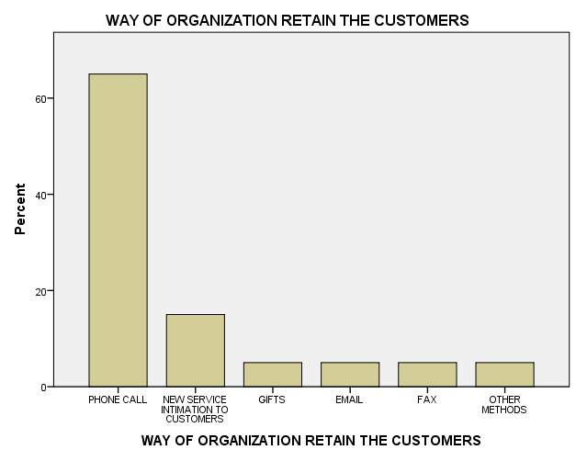

**INTERPRETATION**

Table no.4.1.18 shows that 65% of the respondents said that company retains their customers through phone call. 15% said the company shares new service intimation to customers. 5% each said that the company gives gifts, send e mails, fax and use other methods in order to retains their customers.

**TABLE NO.4.1.19**

**PROPER SYSTEM OF HANDLING CUSTOMER COMPLAINTS**

|  |  |  |
| --- | --- | --- |
|  | **Frequency** | **Percentage** |
| YES | 90 | 90.0 |
| NO | 10 | 10.0 |
| **Total** | **100** | **100.0** |

**CHART NO.4.1.19**

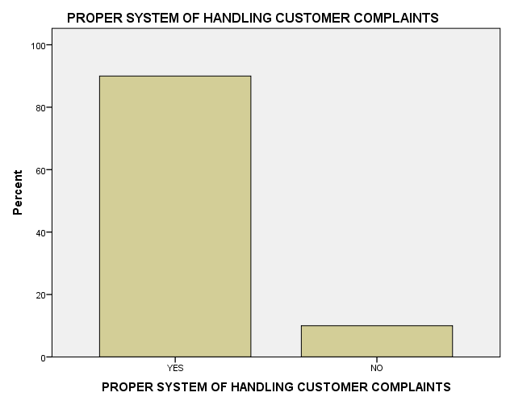

**INTERPRETATION**

Table no.4.1.19 shows that majority of the respondents agree that the company have proper system of handling customer complaints. 10% disagreed.

**TABLE NO.4.1.20**

**SYSTEM OF CONTACTING CUSTOMERS AFTER COMPLETING ALL THE FORMALITIES**

|  |  |  |
| --- | --- | --- |
|  | **Frequency** | **Percentage** |
| YES | 75 | 75.0 |
| NO | 25 | 25.0 |
| **Total** | **100** | **100.0** |

**CHART NO.4.1.20**

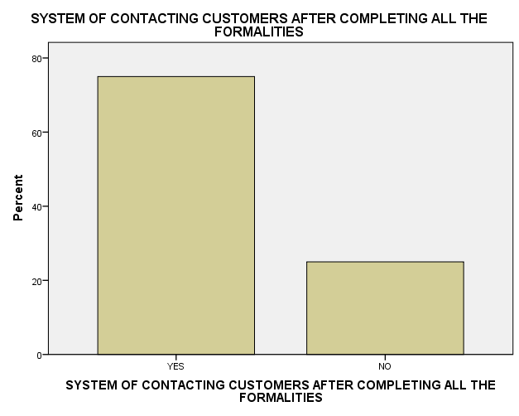

**INTERPRETATION**

Table no.4.1.20 shows that most of the respondents the company have a proper system of contacting customers after competing all the formalities. 25% disagreed with it.

**TABLE NO.4.1.21**

**EASE OF SERVICE**

|  |  |  |
| --- | --- | --- |
|  | **Frequency** | **Percentage** |
| EXCELLENT | 25 | 25.0 |
| GOOD | 40 | 40.0 |
| FAIR | 15 | 15.0 |
| POOR | 10 | 10.0 |
| VERY POOR | 5 | 5.0 |
| **Total** | **100** | **100.0** |

**CHART NO.4.1.21**

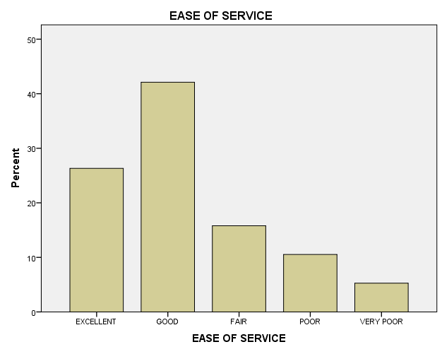

**INTERPRETATION**

Table no.4.1.21 shows that 40% of the respondents rate good for the ease of accessing the company’s services. 25% of them rate excellent, 15% rate fair, 10% rate poor and rest of them rate very poor.

**TABLE NO.4.1.22**

**EASE OF SERVICE**

|  |  |  |
| --- | --- | --- |
|  | **Frequency** | **Percentage** |
| EXCELLENT | 15 | 15.0 |
| GOOD | 35 | 35.0 |
| FAIR | 40 | 40.0 |
| POOR | 5 | 5.0 |
| VERY POOR | 5 | 5.0 |
| **Total** | **100** | **100.0** |

**CHART NO.4.1.22**

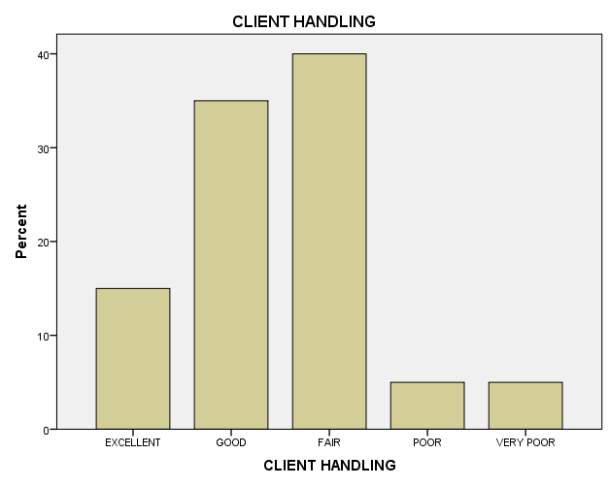

**INTERPRETATION**

Table no.4.1.22 most of them rate fair for the client handling skill of the company. 35% rate good, 15% rate excellent, 5% each rate poor and very poor.

**TABLE NO.4.1.23**

**CUSTOMER SERVICE**

|  |  |  |
| --- | --- | --- |
|  | **Frequency** | **Percentage** |
| EXCELLENT | 50 | 50.0 |
| GOOD | 30 | 30.0 |
| FAIR | 10 | 10.0 |
| POOR | 5 | 5.0 |
| VERY POOR | 5 | 5.0 |
| **Total** | **100** | **100.0** |

**CHART NO.4.1.23**

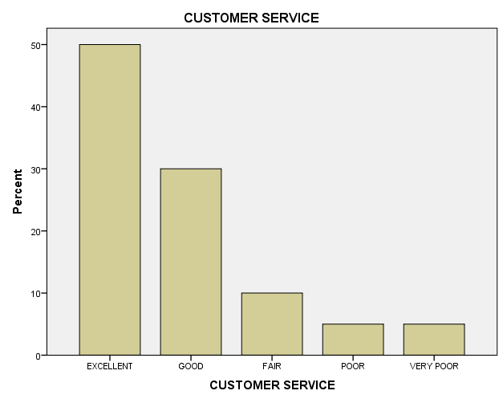

**INTERPRETATION**

Table no.4.1.23 shows that majority of the respondent’s rate excellent for the customer services of the company. 30% rate good, 10% rate fair, 5% each rate poor and very poor for the customer services of the company.

**TABLE NO.4.1.24**

**WEBSITE INFORMATION**

|  |  |  |
| --- | --- | --- |
|  | **Frequency** | **Percentage** |
| EXCELLENT | 15 | 15.0 |
| GOOD | 10 | 10.0 |
| FAIR | 50 | 50.0 |
| POOR | 15 | 15.0 |
| VERY POOR | 10 | 10.0 |
| **Total** | **100** | **100.0** |

**CHART NO.4.1.24**

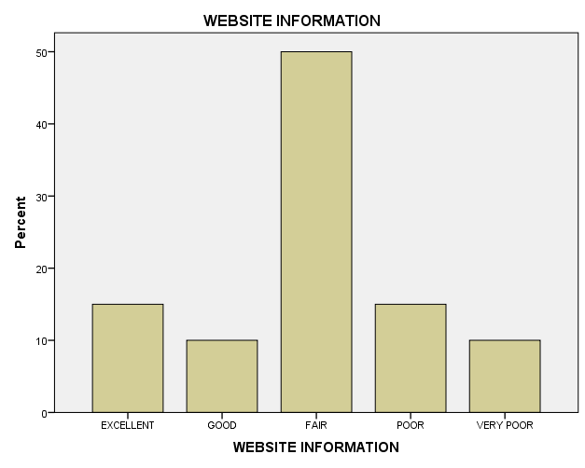

**INTERPRETATION**

Table no.4.1.24 shows that 50% of the respondent’s rate fair for the website information of the company. 15% of them rate excellent, another 15% rate poor, 10% each rate good and very poor for the website information of the company.

**TABLE NO.4.1.25**

**WEBSITE INFORMATION**

|  |  |  |
| --- | --- | --- |
|  | **Frequency** | **Percentage** |
| EXCELLENT | 60 | 60.0 |
| GOOD | 20 | 20.0 |
| FAIR | 5 | 5.0 |
| POOR | 10 | 10.0 |
| VERY POOR | 5 | 5.0 |
| **Total** | **100** | **100.0** |

**CHART NO.4.1.25**

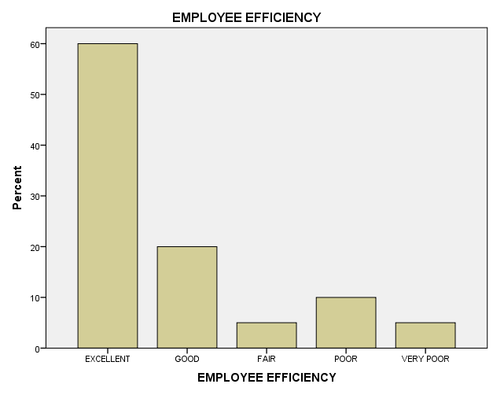

**INTERPRETATION**

Table no.4.1.25 shows that 60% of the respondents rate excellent for the employee’s efficiency of the company. 20% of them rate good, 10% rate poor and 5% each rate fair and very poor for the employee’s efficiency.

**HYPOTHESIS TEST – I**

**CHI-SQUARE**

Analyze if there is any significant relationship between years of experience and which transportation handled by mostly

Ho = There is no significant relationship between years of experience and which transportation handled by mostly

H1 = There is significant relationship between years of experience and which transportation handled by mostly

|  |  |  |  |  |  |  |  |  |  |  |
| --- | --- | --- | --- | --- | --- | --- | --- | --- | --- | --- |
| **YEARS OF EXPERIENCE * TYPE OF TRANSPORTATION HANDLED** | | | | | | | | | | |
| Count | | | | | | | | | | |
|  | | | | TYPE OF TRANSPORTATION HANDLED BY | | | | | | Total |
| OCEAN TRANSPORT | | AIR TRANSPORT | | ROAD WAYS | RAILWAYS |
| YEARS OF EXPERIENCE | Below 3 years | | | 5 | | 0 | | 10 | 0 | 15 |
| Between 3 - 6 years | | | 5 | | 5 | | 45 | 0 | 55 |
| Between 6 - 9 years‎ | | | 5 | | 0 | | 10 | 0 | 15 |
| More than 9 years | | | 0 | | 0 | | 10 | 5 | 15 |
| Total | | | | 15 | | 5 | | 75 | 5 | 100 |
| **Chi-Square Tests** | | | | | | |
|  | | Value | df | | Asymptotic Significance (2-sided) | |
| Pearson Chi-Square | | 43.434a | 9 | | .000 | |
| Likelihood Ratio | | 36.676 | 9 | | .000 | |
| Linear-by-Linear Association | | 7.233 | 1 | | .007 | |
| N of Valid Cases | | 100 |  | |  | |
| a. 11 cells (68.8%) have expected count less than 5. The minimum expected count is .75. | | | | | | |

**INTERPRETATION**

From the chi square test table we can see the observed value is .000 that is >=.05. So we reject H1 and accept Ho. There is no significant relationship between years of experience and which transportation handled by mostly

**HYPOTHESIS TEST – II**

**CHI-SQUARE**

Analyze if there is any significant relationship years of experience and company ensures in logistics

Ho = There is no significant relationship years of experience and company ensures in logistics

H1 = There is There is no significant relationship years of experience and company ensures in logistics

|  |  |  |  |  |  |  |  |  |  |  |  |
| --- | --- | --- | --- | --- | --- | --- | --- | --- | --- | --- | --- |
| **YEARS OF EXPERIENCE * COMPANY ENSURES IN LOGISTICS** | | | | | | | | | | | |
| Count | | | | | | | | | | | |
|  | | | COMPANY ENSURES IN LOGISTICS | | | | | | | | Total |
| COST SAVING | | ERROR FREE | | RELIABILITY | | TIMELY DELIVERY | ALL OF THE ABOVE |
| YEARS OF EXPERIENCE | Below 3 years | | 5 | | 5 | | 0 | | 0 | 5 | 15 |
| Between 3 - 6 years | | 5 | | 0 | | 10 | | 10 | 30 | 55 |
| Between 6 - 9 years‎ | | 0 | | 5 | | 5 | | 0 | 5 | 15 |
| More than 9 years | | 0 | | 0 | | 10 | | 0 | 5 | 15 |
| Total | | | 10 | | 10 | | 25 | | 10 | 45 | 100 |
| **Chi-Square Tests** | | | | | | | |
|  | | Value | | df | | Asymptotic Significance (2-sided) | |
| Pearson Chi-Square | | 60.808a | | 12 | | .000 | |
| Likelihood Ratio | | 65.786 | | 12 | | .000 | |
| Linear-by-Linear Association | | .518 | | 1 | | .472 | |
| N of Valid Cases | | 100 | |  | |  | |
| a. 12 cells (60.0%) have expected count less than 5. The minimum expected count is 1.50. | | | | | | | |

**INTERPRETATION**

From the chi square test table we can see the observed value is .000 that is >=.05. So we reject H1 and accept Ho. There is no significant relationship years of experience and company ensures in logistics

**HYPOTHESIS TEST – III**

**ANOVA**

1. Analyze if there is any significant relationship between years of experience and feature enhance the performance of logistics provider

Ho = There is no significant relationship between years of experience and feature enhance the performance of logistics provider

H1 = There is significant relationship between years of experience and feature enhance the performance of logistics provider

|  |  |  |  |  |  |  |  |  |
| --- | --- | --- | --- | --- | --- | --- | --- | --- |
| **Descriptive** | | | | | | | | |
| YEARS OF EXPERIENCE | | | | | | | | |
|  | N | Mean | Std. Deviation | Std. Error | 95% Confidence Interval for Mean | | Minimum | Maximum |
| Lower Bound | Upper Bound |
| RELIABLE | 40 | 2.00 | .506 | .080 | 1.84 | 2.16 | 1 | 3 |
| EASY ACCESS | 10 | 2.50 | 1.581 | .500 | 1.37 | 3.63 | 1 | 4 |
| FLEXIBILITY | 15 | 2.67 | .976 | .252 | 2.13 | 3.21 | 2 | 4 |
| INTERACTIVE | 15 | 2.33 | .488 | .126 | 2.06 | 2.60 | 2 | 3 |
| TIMELINES | 20 | 2.50 | 1.147 | .256 | 1.96 | 3.04 | 1 | 4 |
| Total | 100 | 2.30 | .905 | .090 | 2.12 | 2.48 | 1 | 4 |

|  |  |  |  |  |  |
| --- | --- | --- | --- | --- | --- |
| ANOVA  YEARS OF EXPERIENCE | | | | | |
|  | Sum of Squares | df | Mean Square | F | Sig. |
| Between Groups | 6.833 | 4 | 1.708 | 2.188 | .076 |
| Within Groups | 74.167 | 95 | .781 |  |  |
| Total | 81.000 | 99 |  |  |  |

**INTERPRETATION**

From the chi square test table we can see the observed value is .000 that is >=.05. So we reject H1 and accept Ho. There is no significant relationship between years of experience and feature enhance the performance of logistics provider

**HYPOTHESIS TEST – IV**

**ANOVA**

Analyze if there is any significant relationship between years of experience and major problems occur when delivery of goods.

Ho = There is no significant relationship between years of experience and major problems occur when delivery of goods.

H1 = There is significant relationship between years of experience and major problems occur when delivery of goods.

|  |  |  |  |  |  |  |  |  |
| --- | --- | --- | --- | --- | --- | --- | --- | --- |
| **Descriptive** | | | | | | | | |
| YEARS OF EXPERIENCE | | | | | | | | |
|  | N | Mean | Std. Deviation | Std. Error | 95% Confidence Interval for Mean | | Minimum | Maximum |
| Lower Bound | Upper Bound |
| WRONG CURRENCY PAYMENT | 10 | 2.00 | .000 | .000 | 2.00 | 2.00 | 2 | 2 |
| INVOICING ERRORS | 70 | 2.36 | .817 | .098 | 2.16 | 2.55 | 1 | 4 |
| INCORRECT REBATE | 10 | 2.00 | 1.054 | .333 | 1.25 | 2.75 | 1 | 3 |
| INVALID QUANTITY | 5 | 1.00 | .000 | .000 | 1.00 | 1.00 | 1 | 1 |
| OTHER | 5 | 4.00 | .000 | .000 | 4.00 | 4.00 | 4 | 4 |
| Total | 100 | 2.30 | .905 | .090 | 2.12 | 2.48 | 1 | 4 |

|  |  |  |  |  |  |
| --- | --- | --- | --- | --- | --- |
| **ANOVA** | | | | | |
| YEARS OF EXPERIENCE | | | | | |
|  | Sum of Squares | df | Mean Square | F | Sig. |
| Between Groups | 24.929 | 4 | 6.232 | 10.559 | .000 |
| Within Groups | 56.071 | 95 | .590 |  |  |
| Total | 81.000 | 99 |  |  |  |

**INTERPRETATION**

From the chi square test table we can see the observed value is .00 0that is >=.05. So we reject H1 and accept Ho. There is no significant relationship between years of experience and major problems occur when delivery of goods.

**HYPOTHESIS TEST – V**

**CORRELATION**

Analyze if there is any significant relationship types of transportation handled by mostly and major problems occur when delivery of goods.

Ho = There is no significant relationship types of transportation handled by mostly and major problems occur when delivery of goods.

H1 = There is significant relationship types of transportation handled by mostly and major problems occur when delivery of goods.

|  |  |  |  |  |  |
| --- | --- | --- | --- | --- | --- |
| **Descriptive Statistics** | | | | | |
|  | Mean | | Std. Deviation | N | |
| TYPE OF TRANSPORTATION HANDLED BY | 2.70 | | .785 | 100 | |
| MAJOR PROBLEMS MAY OCCUR DURING DELIVERY OF GOODS | 2.25 | | .892 | 100 | |
| **Correlations** | | | | | | | |
|  | | | | | TYPE OF TRANSPORTATION HANDLED BY | | MAJOR PROBLEMS MAY OCCUR DURING DELIVERY OF GOODS |
| TYPE OF TRANSPORTATION HANDLED BY | | Pearson Correlation | | | 1 | | -.180 |
| Sig. (2-tailed) | | |  | | .073 |
| N | | | 100 | | 100 |
| MAJOR PROBLEMS MAY OCCUR DURING DELIVERY OF GOODS | | Pearson Correlation | | | -.180 | | 1 |
| Sig. (2-tailed) | | | .073 | |  |
| N | | | 100 | | 100 |

**INTERPRETATION**

From the chi square test table we can see the observed value is -.184 that is <=.05. So we reject Ho H1 and accept H1. There is significant relationship types of transportation handled by mostly and major problems occur when delivery of goods.

**HYPOTHESIS TEST – VI**

**CORRELATION**

Analyze if there is any significant relationship between years of experience and which division of logistical activity earns the maximum rate of profit.

Ho = There is no significant relationship between years of experience and which division of logistical activity earns the maximum rate of profit.

H1 = T There is no significant relationship between years of experience and which division of logistical activity earns the maximum rate of profit.

|  |  |  |  |
| --- | --- | --- | --- |
| **Descriptive Statistics** | | | |
|  | Mean | Std. Deviation | N |
| YEARS OF EXPERIENCE | 2.30 | .905 | 100 |
| WHICH DEVISION OF LOGISTICAL ACTIVITY EARNS THE MAXIMUM RATE OF PROFT | 1.80 | .816 | 100 |

|  |  |  |  |
| --- | --- | --- | --- |
| **Correlations** | | | |
|  | | YEARS OF EXPERIENCE | WHICH DEVISION OF LOGISTICAL ACTIVITY EARNS THE MAXIMUM RATE OF PROFT |
| YEARS OF EXPERIENCE | Pearson Correlation | 1 | -.397** |
| Sig. (2-tailed) |  | .000 |
| N | 100 | 100 |
| WHICH DEVISION OF LOGISTICAL ACTIVITY EARNS THE MAXIMUM RATE OF PROFT | Pearson Correlation | -.397** | 1 |
| Sig. (2-tailed) | .000 |  |
| N | 100 | 100 |
| **. Correlation is significant at the 0.01 level (2-tailed). | | | |

**INTERPRETATION**

From the chi square test table we can see the observed value is -397. that is <=.05. So we reject Ho H1 and accept H1. There is significant relationship between years of experience and which division of logistical activity earns the maximum rate of profit.

**HYPOTHESIS TEST – VII**

**T-TEST**

Analyze if there is any significant relationship between years of experience and rating given to customer service

Ho = There is no significant relationship between significant relationship between years of experience and rating given to customer service

H1 = There is no significant relationship between significant relationship between years of experience and rating given to customer service

|  |  |  |  |  |
| --- | --- | --- | --- | --- |
| **One-Sample Statistics** | | | | |
|  | N | Mean | Std. Deviation | Std. Error Mean |
| YEARS OF EXPERIENCE | 100 | 2.30 | .905 | .090 |
| CUSTOMER SERVICE | 100 | 1.85 | 1.114 | .111 |

|  |  |  |  |  |  |  |
| --- | --- | --- | --- | --- | --- | --- |
| **One-Sample Test** | | | | | | |
|  | Test Value = 0 | | | | | |
| t | df | Sig. (2-tailed) | Mean Difference | 95% Confidence Interval of the Difference | |
| Lower | Upper |
| YEARS OF EXPERIENCE | 25.427 | 99 | .000 | 2.300 | 2.12 | 2.48 |
| CUSTOMER SERVICE | 16.614 | 99 | .000 | 1.850 | 1.63 | 2.07 |

**INTERPRETATION**

From the chi square test table we can see the observed value is .000 that is >=.05. So we reject H1 and accept Ho. There is no significant relationship significant relationship between years of experience and rating given to customer service

**HYPOTHESIS TEST – VIII**

**T-TEST**

Analyze if there is any significant relationship between years of experience and major problems occur during delivery of goods.

Ho = There is no significant relationship between years of experience and major problems occur during delivery of goods.

H1 = There is no significant relationship between years of experience and major problems occur during delivery of goods.

|  |  |  |  |  |
| --- | --- | --- | --- | --- |
| **One-Sample Statistics** | | | | |
|  | N | Mean | Std. Deviation | Std. Error Mean |
| YEARS OF EXPERIENCE | 100 | 2.30 | .905 | .090 |
| MAJOR PROBLEMS MAY OCCUR DURING DELIVERY OF GOODS | 100 | 2.25 | .892 | .089 |

|  |  |  |  |  |  |  |
| --- | --- | --- | --- | --- | --- | --- |
| **One-Sample Test** | | | | | | |
|  | Test Value = 0 | | | | | |
| t | df | Sig. (2-tailed) | Mean Difference | 95% Confidence Interval of the Difference | |
| Lower | Upper |
| YEARS OF EXPERIENCE | 25.427 | 99 | .000 | 2.300 | 2.12 | 2.48 |
| MAJOR PROBLEMS MAY OCCUR DURING DELIVERY OF GOODS | 25.228 | 99 | .000 | 2.250 | 2.07 | 2.43 |

**INTERPRETATION**

From the chi square test table we can see the observed value is .000 that is >=.05. So we reject H1 and accept Ho. There is no significant relationship between years of experience and major problems occur during delivery of goods.

**CHAPTER-5**

**FINDINGS, SUGGESTIONS AND CONCLUSION**

**FINDINGS**

* Most of the respondents have between 3 to 6 years of experience as freight forwarder.
* 80% of the respondents replied that they have 5 to 10 branches within India.
* 60% of the respondents identify customer by sales calls.
* 75% of the respondents mostly use road ways.
* Most of the respondents are concentrate Far East for exporting their products.
* Majority of the respondents like to import things from Far East.
* 60% of them said that their company offer freight services.
* 55% of the respondents replied that warehousing is the best services offered category.
* 45% said that the company ensures cost saving, error free, reliability and time delivery logistics to their customers.
* 65% of the respondents said that the company reviews the logistics monthly.
* 40% of them replied that their office is 10 km away from their home.
* Reliability will enhance the performance of logistics provider.
* 55% of the respondents said that their company caters to Chennai
* Most of the respondents agreed that invoicing errors are the major problem that may occur during delivery of goods.
* 45% of the respondents said that 1 to 3 hours may take to receive book confirmation.
* 90% of the respondents agree that the company give preferences to customer complaints.
* 45% of them said that warehousing earns the maximum rate of profit.
* 65% of the respondents said that company retains their customers through phone call.
* Majority of the respondents agree that the company have proper system of handling customer complaints.
* Most of the respondents the company have a proper system of contacting customers after competing all the formalities
* 40% of the respondent’s rate good for the ease of accessing the company’s services.
* Most of them rate fair for the client handling skill of the company
* Majority of the respondent’s rate excellent for the customer services of the company.
* 50% of the respondent’s rate fair for the website information of the company.
* 60% of the respondent’s rate excellent for the employee’s efficiency of the company.
* There is no significant relationship between years of experience and which transportation handled by mostly.
* There is no significant relationship years of experience and company ensures in logistics
* Analyze if there is any significant relationship between years of experience and feature enhance the performance of logistics provider
* Analyze if there is any significant relationship between years of experience and major problems occur when delivery of goods.
* Analyze if there is any significant relationship types of transportation handled by mostly and major problems occur when delivery of goods.
* Analyze if there is any significant relationship between years of experience and which division of logistical activity earns the maximum rate of profit.
* Analyze if there is any significant relationship between years of experience and rating given to customer service.
* There is no significant relationship between years of experience and major problems occur during delivery of goods.

**SUGGESTIONS**

* The freight forwarding industry is the vital link in the international market. In simple words it is the best place to get and develop in the international bus.
* The individuals can also build up their future in the freight forwarding industry and have the share in the development of the economy of the nation.
* Freight forwarding is the industry where many of the things are under the one roof, like working out with the shipping line industry, working out with manufacturer, NVOCC and Custom House Agents etc.
* The company can improve its sales by improving its quality and promotional activities.
* The company has to improve their infrastructure facilities which will increase the exports.
* If all the processing units are brought under one roof, it will reduce the processing time of goods and it will lead to timely delivery of goods to the customers.

**CONCLUSION**

According to me and my conclusion the freight forwarding industry is the fruitful place for the students of Master of Business Administration. Freight forwarding industry also has the vital role in the development of Nations Economy. The market challenges faced by freight forwarders are quite daunting. In order to become the best freight forwarding service provider, it is best to think and perform outside the box. Convenience and honest service are the key points to make the logistics business a success. It is also essential to establish a customer support or a means of contact between the forwarder and customer at all times.

The freight forwarder plays an important role in the execution of export as they are those who act on behalf of the exporter in arranging ocean or air transport services. They are familiar with the import rules and regulations off foreign countries, methods of shipping, and documents connected with foreign trade.. Logistics includes various aspects, such as the packaging of your products, the mode of transportation, and the export documentation that has to be prepared, i.e. the complete operation of transport & freight forwarders act as the exporter’s agents and perform various functions involved in foreign trade. Freight forwarders can give advice on how the goods should be packaged and the marks and labels that are required, and can make arrangements to have the goods packaged and placed in containers for export. They contract space with ocean, air, and land freight companies on the exporters behalf, to transport the goods to their destination abroad. They can arrange for storage in a warehouse if necessary, while the goods are in transit, and contract insurance to protect the cargo while in transit.

**BIBLIOGRAPHY**

**BOOKS:**

1. Logistical Management – Tata McGraw 2000 Edition. Written by Donald. Bowersox, and David. Closs.
2. The Management of Business Logistics – 7th Edition: Written by Edward J. Bardi, C.John Langley, and John Joseph Coyle
3. Logistics and Supply Chain Management: Creating Value - Adding Networks Written by Martin Christopher.

**WEBSITES:**

* Source: http://www.idsc.com.sg/images/service_logistics_img1.jpg
* http://www.indexuae.com/Top/Business_and_Economy/Services/Logistics
* http://www.lintasfreight.com/
* http://www.uae-shipping.net/Lintas-Freight-Logistics-L.L.C..html

# QUESTIONNAIRE

## A STUDY ON FREIGHT FORWARDING DOCUMENTATION AND EXIM PROCEDURES WITH REFERENCE TO KANNUR INTERNATIONAL FREIGHT FORWARDING & LOGISTICS (KIFFAL)

## Name of the employee

## How many years of experience do you have as freight forwarder?

Between 3 – 6 years

Between 6 – 9 years

More than 9 years

## How many branch offices do you have within India?

< 5 branches

5 – 10 branches

10 – 15 branches

> 15 branches

## How do you identify your customers?

Representatives

Statistics data

Sales calls

Other customers

## What types of transportation handled by you mostly?

Ocean transport

Air transport

Road ways

Railways

## Mostly to which countries do you concentrate on exports?

Europe

Canada

Far East

USA

UK

Others

## Mostly to which countries do you concentrate on import?

Europe

Canada

Far East

USA

UK

Others

## 

7. Which are the various Logistics Services you offer?

Freight  Warehousing  Cross docking  Network Design  Other Value Adding Services if any 

8. Which is the area of activity; you feel you are the best?

Freight  Warehousing  Cross docking 

Network Design  Other Value Adding Services if any 

9. What does the company ensures in logistics?

Cost- saving

Error-free

Reliability

Timely delivery

All of the above

10. How often is logistics review critically at your company ?

Daily

Weakly

Monthly

Quarterly

11. How long is the distance from your branch office to nearest freight forwarding desination ?

10 km

20 km

25km

30km

12 . Which of the following future enhance the performance of logistics provider

Reliable

Easy access

Flexibility

Interactive

Timelines

13. What are the locations to which your company caters to?

Delhi

Mumbai

Bangalore

Ludhiana

Chennai

Ahmadabad

Kolkata

State if any other vocational specialization

## 14. The major problems that may occur during delivery of goods?

Wrong currency payment Invoicing errors

Incorrect rebate Invalid quantity

Other

## 15. Mention the time taken to receive booking confirmation?

1-3 hours 3-5 hours

5-7 hours Next day

## 16. Is customer complaints given preference in organization?

Yes / No

17. Which division of logistical activity earns the maximum rate of profit?

|  |  |
| --- | --- |
|  | Rate them on Scale of 10 (Best 10 Average 5 Worst 0) |
| Freight |  |
| Warehousing |  |
| Cross docking |  |
| Network Design |  |
| Any Other (specify)___________ |  |

## 18. How your organization follow up to retain the customers (Put Number 1 on desired column)

|  |  |  |
| --- | --- | --- |
| No. | Method | Number |
| 1. | Phone Call |  |
| 2. | New Service Intimation to  Customers |  |
| 3. | Gifts |  |
| 4. | Email |  |
| 5. | Fax |  |
| 6. | Other methods if any |  |

## 19. Do you have a proper system of handling customer complaints?

Yes No

## 20. Do you have a system of contacting customers after completing all the formalities of an order, to enquire whether they have any complaint and to ascertain the level of satisfaction the customer enjoyed?.

Yes No

|  |  |  |  |  |  |
| --- | --- | --- | --- | --- | --- |
| Content | Excellent | Good | Fair | Poor | Very Poor |
| Ease of  Service |  |  |  |  |  |
| Client  handling |  |  |  |  |  |
| Customer  Service |  |  |  |  |  |
| Website  Information |  |  |  |  |  |
| Employee  Efficiency |  |  |  |  |  |

## 21. PLEASE RATE THE SERVICE OFFERED BY